
SVKM's Narsee Monjee Institute of Management Studies
Mukesh Patel School of Technology Management and Engineering

FINAL INDUSTRY PROJECT REPORT
Revora: Dynamic Pricing & Demand Intelligence System
Submitted in partial fulfilment of the requirements for B.Tech. Computer Engineering
Table 1: Student and internship details
Particular | Details
Name | Pranay Kumar
Roll No. | A149
SAP ID | 70022200357
Program | B.Tech. Computer Engineering
Faculty Mentor | Dr. Preeti Gupta
Industry Mentor | Mr. Kanwar Pal Singh
Organization | Tech Biz Solutions
Academic Year | 2025-26

May 2026

CERTIFICATE
This is to certify that the industry project report titled "Revora: Dynamic Pricing & Demand Intelligence System" is a bona fide record of the work carried out by Pranay Kumar, Roll No. A149, SAP ID 70022200357, during the B.Tech. Computer Engineering Semester VIII industry project for Academic Year 2025-26.
The work was carried out under the academic guidance of Dr. Preeti Gupta and the industry supervision of Mr. Kanwar Pal Singh at Tech Biz Solutions. The report has been prepared in accordance with the prescribed industry project report format, including methodology, implementation evidence, results, references, and appendices.
Table 2: Certificate sign-off placeholders
Signatory | Name / Designation | Signature / Date
Student | Pranay Kumar
Faculty Mentor | Dr. Preeti Gupta
Industry Mentor | Mr. Kanwar Pal Singh
Program / Department | B.Tech. Computer Engineering

ACKNOWLEDGEMENT
I sincerely thank SVKM's NMIMS, Mukesh Patel School of Technology Management and Engineering, for providing the opportunity to undertake an industry project that connects classroom learning with real software delivery. I am grateful to Dr. Preeti Gupta for academic guidance, review direction, and encouragement throughout the project period.
I express my gratitude to Mr. Kanwar Pal Singh and the team at Tech Biz Solutions for providing industry exposure, technical feedback, and access to practical development problems across TaskOps, NewsTv19, and Revora. Their guidance helped me move from basic MERN development to production-oriented data engineering, analytics, and decision-support design.
I also thank my peers and reviewers whose feedback improved the usability, documentation, and reliability of the implementation. This report is the consolidated outcome of that learning process.

ABSTRACT
Revora is a dynamic pricing and demand intelligence system developed to convert historical sales, product, inventory, customer segment, and competitor context into actionable pricing recommendations. The project addresses a common business problem: pricing teams often have access to large datasets but lack a reliable workflow for converting those records into price-response evidence, safe simulations, and explainable decisions.
The implementation follows a MERN architecture. The frontend is built with React and Vite, while the backend uses Node.js, Express, MongoDB, and Mongoose. CSV ingestion supports staged imports, field mapping, product normalization, duplicate detection, data quality checks, and data fitness labels. The analytics layer estimates demand behavior across price points, simulates revenue and profit outcomes, applies business guardrails, and stores recommendation evidence for reporting and later outcome measurement. A decision-quality assistant extends the system by classifying pricing decisions using engineered features such as previous price, price change percentage, quantity, revenue, profit, competitor price, inventory, promotional flags, and macro/context variables.
The report also records the internship progression through TaskOps and NewsTv19, because these projects supplied the authentication, role management, real-time communication, RSS ingestion, API, and operational engineering experience later applied in Revora. Local verification captured UI evidence for all three applications. Revora checks passed the ML pipeline self-test, reliability suite, and production frontend build. The generated ML artifact contains 157,519 decision-quality rows, with 126,015 training rows and 31,504 testing rows, reaching 86.28 percent accuracy and a 0.7196 macro F1 score.

TABLE OF CONTENTS
Table 3: Contents
Section | Title | Page
 | Certificate | ii
 | Acknowledgement | iii
 | Abstract | iv
 | List of Figures | vi
 | List of Tables | vii
 | Abbreviations | viii
Chapter 1 | Introduction | 1
Chapter 2 | Market Survey | 4
Chapter 3 | Methodology and Implementation | 6
Chapter 4 | Result and Analysis | 12
Chapter 5 | Conclusion and Future Scope | 25
 | References | 27
 | Appendices | 28

LIST OF FIGURES
Table 4: List of figures
Figure No. | Caption
1 | Revora system architecture
2 | Data-to-decision methodology workflow
3 | Internship project timeline
4 | TaskOps admin dashboard evidence
5 | TaskOps task board evidence
6 | TaskOps team and role management evidence
7 | TaskOps chat and communication evidence
8 | NewsTv19 home feed and breaking news evidence
9 | NewsTv19 Rajasthan/state flow evidence
10 | NewsTv19 search and API behavior evidence
11 | Revora home workspace evidence
12 | Revora sales data upload evidence
13 | Revora pricing insights evidence
14 | Revora price decisions evidence
15 | Revora ML Decision Space evidence
16 | Revora performance dashboard evidence
17 | Revora reports and export evidence

LIST OF TABLES
Table 5: List of tables
Table No. | Title
1 | Student and internship details
2 | Certificate sign-off placeholders
3 | Contents
4 | List of figures
5 | List of tables
6 | Abbreviations
7 | Technology stack
8 | Market survey summary
9 | Revora MongoDB data model
10 | Implementation methodology phases
11 | Data quality and guardrail checks
12 | ML decision-quality results
13 | Evidence capture summary
14 | Verification summary
15 | Future scope backlog

ABBREVIATIONS
Table 6: Abbreviations
Abbreviation | Meaning
API | Application Programming Interface
BI | Business Intelligence
CSV | Comma-Separated Values
F1 | Harmonic mean of precision and recall
JWT | JSON Web Token
MERN | MongoDB, Express.js, React, Node.js
ML | Machine Learning
ODM | Object Data Modeling
RBAC | Role-Based Access Control
REST | Representational State Transfer
RSS | Really Simple Syndication
SPA | Single Page Application
UI | User Interface

Chapter 1: Introduction

1.1 Overview of the Industry Project
The industry project was completed at Tech Biz Solutions as part of the Semester VIII B.Tech. Computer Engineering curriculum. The work followed a progressive path: backend fundamentals, TaskOps as an independent role-based task management application, NewsTv19 as a production-style news aggregation contribution, and finally Revora as an analytics-led pricing intelligence platform.
The final project, Revora, focuses on the business problem of pricing decisions under uncertain demand. Instead of treating price changes as manual guesses, the system gathers historical sales and contextual records, normalizes product and segment identity, evaluates data readiness, and produces price recommendations with evidence and guardrail warnings.

1.2 Problem Statement
Retail and service businesses often store sales data in isolated spreadsheets or operational systems. The data may include price, quantity, inventory, discounts, competitor prices, customer segments, region, and calendar effects, but it is rarely converted into a disciplined decision workflow. Manual pricing can therefore miss demand signals, ignore stock risk, overreact to competitors, or recommend prices without a measurable confidence basis.
Revora addresses this by providing a controlled workflow for CSV ingestion, quality review, product matching, demand modeling, pricing simulation, recommendation storage, outcome tracking, and report export.

1.3 Objectives
- Build a final industry-grade report and implementation record for Revora, supported by TaskOps and NewsTv19 evidence.
- Design a MERN-based platform that supports authenticated pricing workflows, CSV ingestion, analytics dashboards, and exportable reports.
- Implement data quality controls for missing values, duplicate rows, invalid pricing values, product matching confidence, and model readiness labels.
- Create price-response and simulation logic that evaluates demand, revenue, profit, competitor distance, and inventory conditions before recommending a price.
- Integrate a decision-quality assistant and record measurable ML results from generated artifacts.
- Document limitations and future scope transparently for academic and industry evaluation.

1.4 Scope of Work
The scope includes the complete software analysis and documentation for three project phases. TaskOps demonstrates authentication, RBAC, task board design, team management, and communication flows. NewsTv19 demonstrates production-style data aggregation with category APIs, search behavior, RSS ingestion, and image enrichment. Revora combines these learnings into a pricing intelligence platform with ingestion, analytics, simulation, ML decision quality, dashboards, and report exports.
Table 7: Technology stack
Layer | Technology / Tool | Purpose in Project
Runtime and API | Node.js, Express.js | Asynchronous backend services and REST endpoints for authentication, ingestion, analytics, recommendations, and exports [1][2].
Frontend | React, Vite | Component-based SPA views, fast local development, and production frontend builds [3][4].
Database | MongoDB, Mongoose | Document storage, schema modeling, validation, indexes, and relations through ObjectId references [5][6].
Real-time / collaboration | Socket.IO | Event-based updates for communication and notifications in TaskOps-style workflows [7].
Styling and visualization | Tailwind CSS, Recharts | Utility-first UI styling and React chart components for dashboards [8][9].
Data ingestion and ML | CSV parsing, generated ML artifacts, scikit-learn concepts | CSV-oriented ingestion, feature engineering, random forest style decision-quality classification, and evaluation metrics [10][11].

1.5 Organization Profile
Tech Biz Solutions is an IT services and consulting organization based in Jodhpur, Rajasthan. The company works on software development, digital transformation, AI-enabled analytics, cloud solutions, and web application delivery. During the internship, the assigned work reflected this service profile: first through task automation and team workflow tooling, then through a news aggregation product, and finally through a data-driven pricing intelligence system.

Chapter Summary
This chapter introduced the internship context, project problem, objectives, scope, organization background, and technology stack. The next chapter surveys the market and technical need for dynamic pricing and demand intelligence.

Chapter 2: Market Survey

2.1 Business Context
Dynamic pricing is the practice of adjusting prices in response to demand, inventory, customer behavior, competition, timing, and business objectives. In practical retail systems, the value of dynamic pricing depends on the quality of demand learning. If the system cannot distinguish between normal seasonality, stockouts, discounts, competitor pressure, and genuine price sensitivity, a price recommendation can be mathematically attractive but operationally unsafe.
Academic and industry literature describes dynamic pricing as a combination of demand estimation and price optimization. Research on pricing with learning highlights that companies often need controlled experimentation and demand feedback before reliable optimization is possible [12][13][14]. Revora follows the same principle at prototype level: it preserves evidence, exposes confidence and limitations, and treats recommendations as decision support rather than automatic price changes.

2.2 Existing Market Pain Points
- Spreadsheet-heavy pricing: price changes are often based on periodic manual review instead of continuous demand evidence.
- Fragmented data: sales, inventory, discounts, competitor prices, and customer segments are not always available in one normalized schema.
- Weak explainability: black-box recommendations are difficult for managers to trust when revenue, profit, and inventory trade-offs are unclear.
- Data quality risk: missing cost, duplicate rows, stockouts, and inconsistent product names can distort demand estimates.
- Limited feedback loop: many tools recommend prices but do not store outcome measurements for later model improvement.

2.3 Market Survey Summary
Table 8: Market survey summary
Area | Observed Need | Revora Response
Demand forecasting | Forecast demand under different price and context conditions. | Uses sales records, segment context, price changes, and generated ML features to evaluate decision quality.
Price optimization | Compare possible prices by expected demand, revenue, and profit. | Runs simulation logic across safe price ranges and stores tested price evidence.
Data operations | Import spreadsheet-style business data safely. | Stages CSV uploads, maps fields, records row issues, and assigns data fitness labels.
Managerial trust | Explain why a recommendation is safe, risky, or blocked. | Adds confidence, guardrail warnings, reliability labels, and exportable reports.
Scalability | Support growing datasets and multiple dashboards. | Uses MongoDB indexes, REST endpoints, React views, and export modules.

2.4 Relevance to Tech Biz Solutions
The market survey indicates a strong fit between Revora and the company's stated focus on data-driven software, AI-enabled analytics, and business process modernization. Revora can be positioned as a prototype for clients who require pricing dashboards, revenue intelligence, or analytics-led decision support without immediately adopting a fully automated pricing engine.

2.5 Competitive and Ethical Considerations
A pricing intelligence system must be careful about fairness, transparency, and operational control. Revora therefore avoids presenting a recommendation as an absolute truth. It records assumptions, business risk levels, price bands, data fitness scores, and model limitations.

Chapter Summary
The survey shows that dynamic pricing tools require more than charts. They need reliable data ingestion, explainable modeling, guardrails, and feedback loops. These needs directly shape the methodology in Chapter 3.

Chapter 3: Methodology and Implementation

3.1 Methodology Overview
The project methodology followed an iterative engineering cycle: understand the domain, inspect existing code, design schemas and flows, implement modules, seed or import data, verify through local execution, capture evidence, and document results. The final report uses Revora as the main project while retaining TaskOps and NewsTv19 as supporting implementation phases.
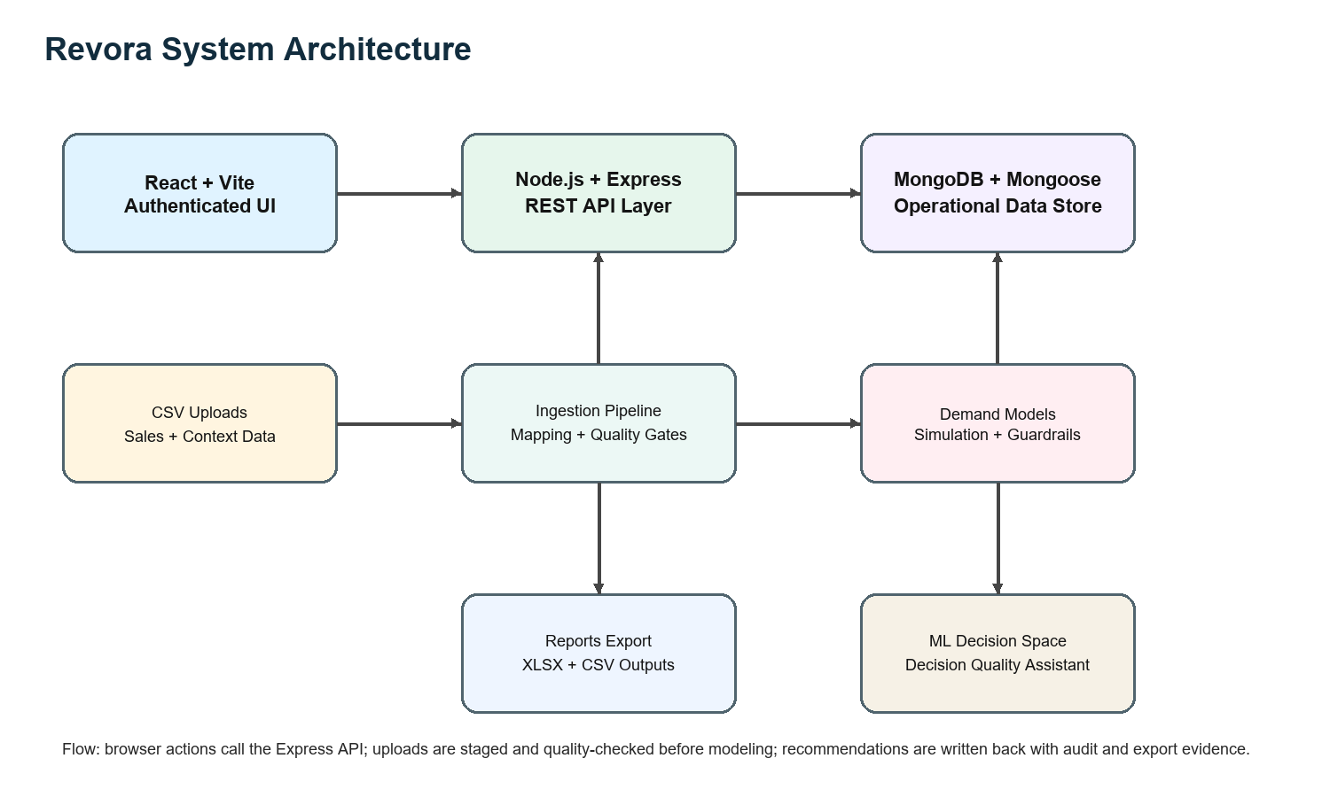
Figure 1: Revora system architecture
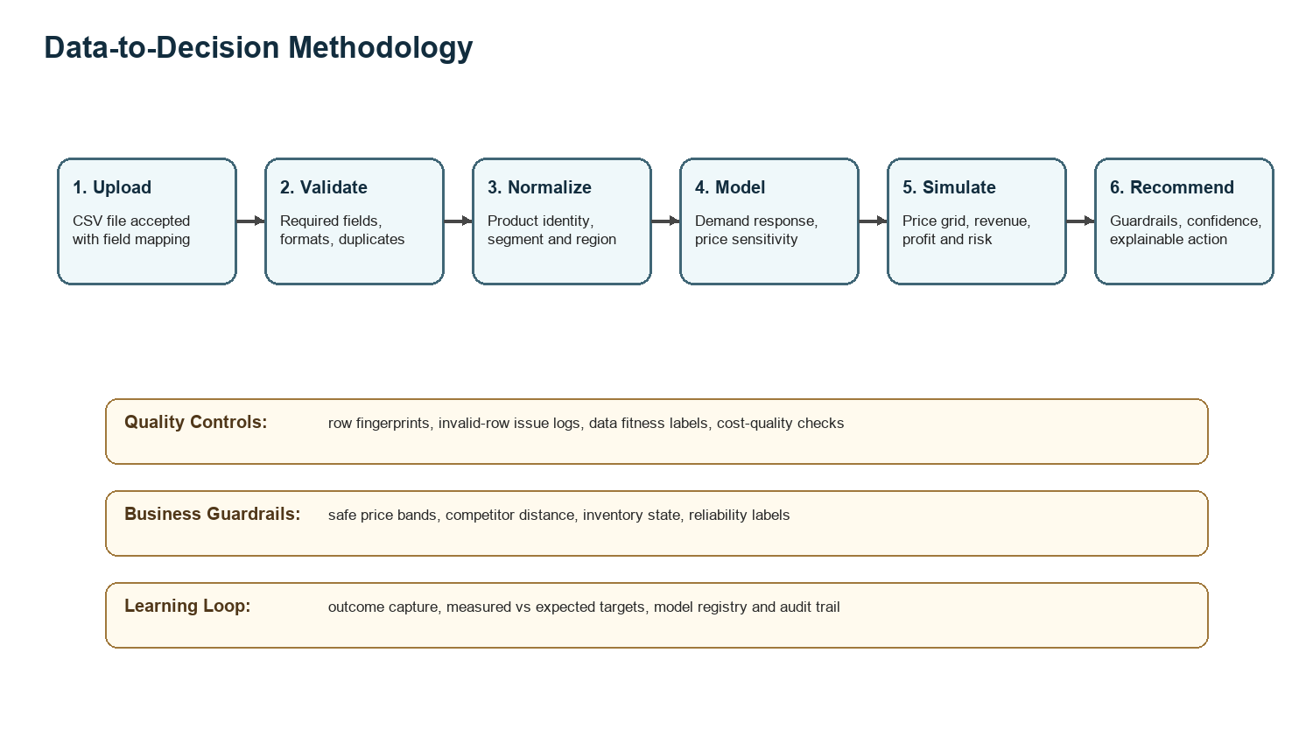
Figure 2: Data-to-decision methodology workflow
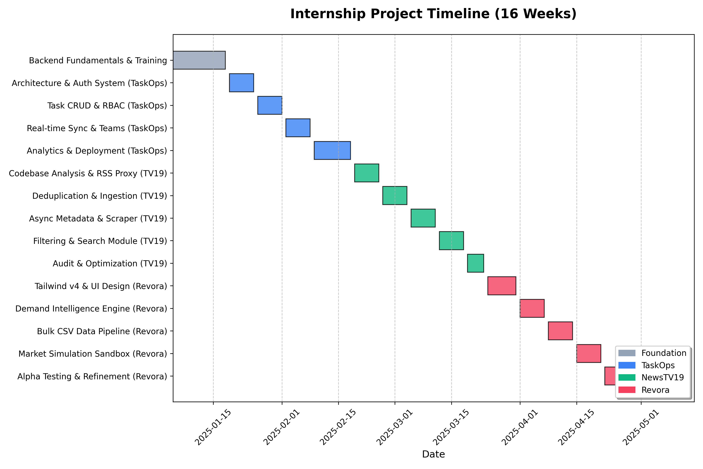
Figure 3: Internship project timeline

3.2 Implementation Phases
Table 9: Implementation methodology phases
Phase | System | Engineering Contribution
1 | TaskOps | Built and verified a role-based task management system with login, dashboard, task board, members, team management, and admin chat evidence.
2 | NewsTv19 | Worked with a production-style news app containing category routes, API search behavior, RSS ingestion, MongoDB storage, and image enrichment.
3 | Revora | Developed the final dynamic pricing intelligence workflow covering CSV upload, data quality, demand modeling, simulation, recommendations, dashboards, ML decision quality, and report export.

3.3 Revora Architecture
Revora uses a browser-based React SPA served by Vite during development. The client calls an Express API that exposes authentication, health, upload, ingestion, analytics, ML, recommendation, model, audit, settings, and report routes. MongoDB stores products, sales records, import batches, row issues, recommendations, outcomes, model registry entries, demand models, assistant decisions, audit logs, users, and workspace settings.
The backend follows a service-oriented structure around Mongoose models. Each model stores timestamps and workspace identifiers so that imported datasets, generated recommendations, and historical state can be filtered or archived. The database design uses indexes on workspace, product, date, segment, status, import batch, and dataset status fields to support dashboard and reporting queries.

Table 10: Revora MongoDB data model
Collection / Model | Key Fields | Purpose
Product | name, sku, category, basePrice, cost, inventory, normalizedSku, normalizedName, matchConfidence | Maintains product identity and matching information for imported sales records.
SalesData | productId, price, quantity, competitorPrice, cost, inventory, revenue, region, channel, promotion, discount, holiday, customerSegment, date | Stores normalized historical sales and contextual features used for analytics and modeling.
ImportBatch | source, status, detectedColumns, mappedFields, rowCounts, productSummary, dataFitnessScore, dataFitnessLabel | Tracks CSV upload state, mapping, row counts, quality summary, and commit/reject workflow.
ImportRowIssue | batch, row number, issue type, raw value | Captures invalid or risky rows without polluting the accepted sales dataset.
DemandModel | model family, features, training records, metrics, reliability | Stores demand model metadata and quality indicators.
Recommendation | productId, objective, basePrice, recommendedPrice, expectedDemand, expectedRevenue, expectedProfit, confidence, guardrailWarnings, testedPrices | Persists price recommendations with simulation evidence and business risk labels.
RecommendationOutcome | actualUnits, actualRevenue, actualProfit, predictionError, targetHit | Supports learning from measured outcomes after a recommendation is applied.
AssistantDecision | draft facts, decision label, extracted prices, advice tags | Records structured decision-quality assistant interactions.

3.4 CSV Ingestion and Data Quality
The CSV workflow is designed as a controlled staging process. A user uploads sales data, maps columns to canonical fields, and the backend validates required fields before records become part of the active dataset. The sample evidence used documents/sales_diverse.csv from the Revora project.
Quality gates check numerical validity, missing fields, duplicate fingerprints, product identity consistency, cost availability, invalid dates, stockout flags, and data volume. Rather than silently accepting all rows, the system records warnings and row-level issues.
Table 11: Data quality and guardrail checks
Control | Implementation Detail | Risk Reduced
Required field validation | Checks product, date, price, quantity, segment, and mapped context fields. | Prevents incomplete rows from entering model-ready data.
Duplicate detection | Uses row fingerprints and import metadata. | Avoids overstating demand through repeated records.
Product matching | Normalizes SKU/name and stores match confidence and aliases. | Reduces product fragmentation caused by inconsistent labels.
Cost quality | Labels real, estimated, missing, or inconsistent cost inputs. | Prevents profit recommendations from relying on hidden assumptions.
Safe price bands | Stores min/max range, tested prices, competitor distance, and business risk. | Prevents recommendations that are too aggressive for available evidence.
Reliability labels | Records model/data fitness scores and reason lists. | Makes weak evidence visible to reviewers.

3.5 Demand Modeling and Simulation Logic
The demand intelligence layer evaluates how quantity responds to price and context. At a product and segment level, the system groups relevant records, inspects distinct prices, estimates response behavior, and simulates nearby prices. Each tested price calculates expected demand, expected revenue, expected profit, and distance from competitor price when available.
The recommendation module does not only choose the highest mathematical score. It attaches confidence, price sensitivity, optimization method, model family, records used, raw rows used, grouped demand points, warnings, safe ranges, model limitations, and calculation steps.

3.6 ML Decision-Quality Assistant
The ML Decision Space extends Revora by classifying whether a pricing decision appears Terrific, Good, Neutral, Bad, or Terrible based on engineered features. The generated dataset includes price, previous price, price change percentage, quantity, revenue and profit before change, competitor price, discount, inventory, holiday flags, macro/context variables, source encoding, category encoding, customer segment encoding, and region encoding.
The generated artifact records a RandomForestLite fallback implementation. Conceptually, random forests combine multiple decision trees over sub-samples to improve predictive accuracy and control over-fitting, which is consistent with ensemble guidance in scikit-learn documentation [11].

3.7 Security, Roles, and Auditability
The implementation uses authenticated access and role-aware views. TaskOps provided earlier practice in RBAC with admin, sub-admin, and employee flows. Revora applies similar role separation for upload, reset, settings, simulation, reporting, and managerial review. Audit logs and model metadata preserve who performed actions and what evidence supported decisions.

3.8 Reporting and Export
Revora includes reports for dashboards, products, sales data, pricing insights, recommendations, outcomes, and examiner-ready exports. Reports are important because business users often need an offline record of assumptions, formulas, limitations, and results.

Chapter Summary
This chapter described the architecture, schemas, ingestion workflow, data quality controls, simulation logic, ML assistant, security model, and reporting workflow. Chapter 4 presents evidence and measured results.

Chapter 4: Result and Analysis

4.1 Implementation Evidence: TaskOps
TaskOps was run locally with backend npm run start:api, frontend npm run dev --prefix client, and demo users seeded through node seed_users.js. The backend connected to MongoDB and the admin login succeeded on the configured localhost origin.
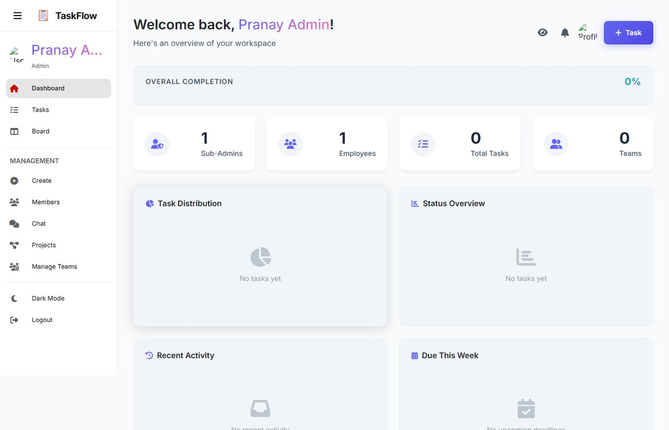
Figure 4: TaskOps admin dashboard evidence
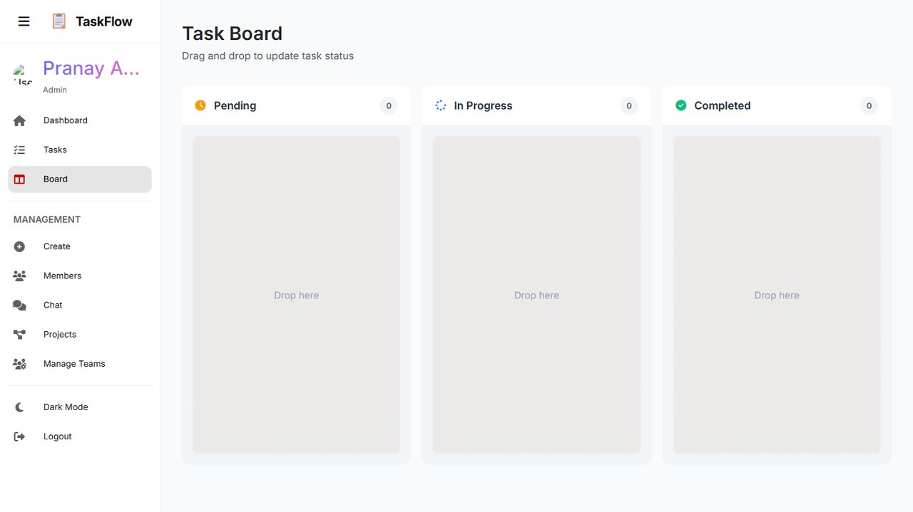
Figure 5: TaskOps task board evidence
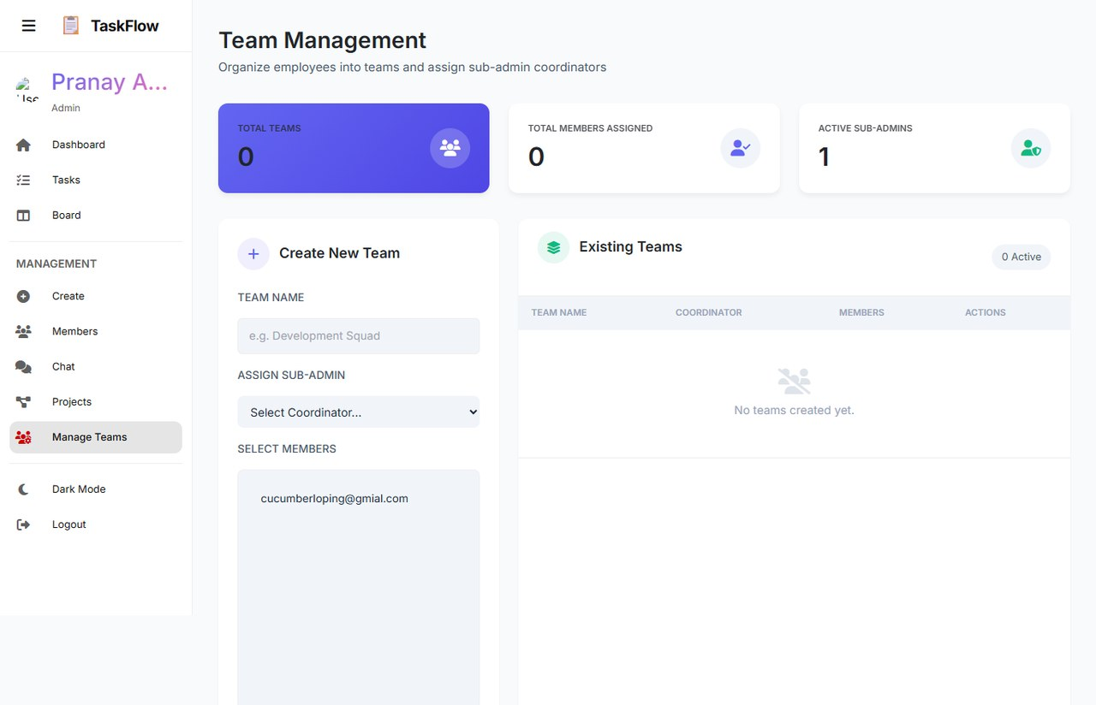
Figure 6: TaskOps team and role management evidence

Figure 7: TaskOps chat and communication evidence

4.2 Implementation Evidence: NewsTv19
NewsTv19 was run locally with its API and Vite frontend. The server connected to MongoDB and started an RSS fetch cycle that saved and enriched articles. Direct API checks returned HTTP 200 for home, search, and category endpoints after startup.


Figure 8: NewsTv19 home feed and breaking news evidence


Figure 9: NewsTv19 Rajasthan/state flow evidence


Figure 10: NewsTv19 search and API behavior evidence

4.3 Implementation Evidence: Revora
Revora was already running on the expected development ports. The health endpoint reported the dynamic-pricing API as online with MongoDB connected. After admin login, the evidence capture covered Home, Sales Data upload using documents/sales_diverse.csv, Pricing Insights, Price Decisions, ML Decision Space, Performance Dashboard, and Reports and Export.
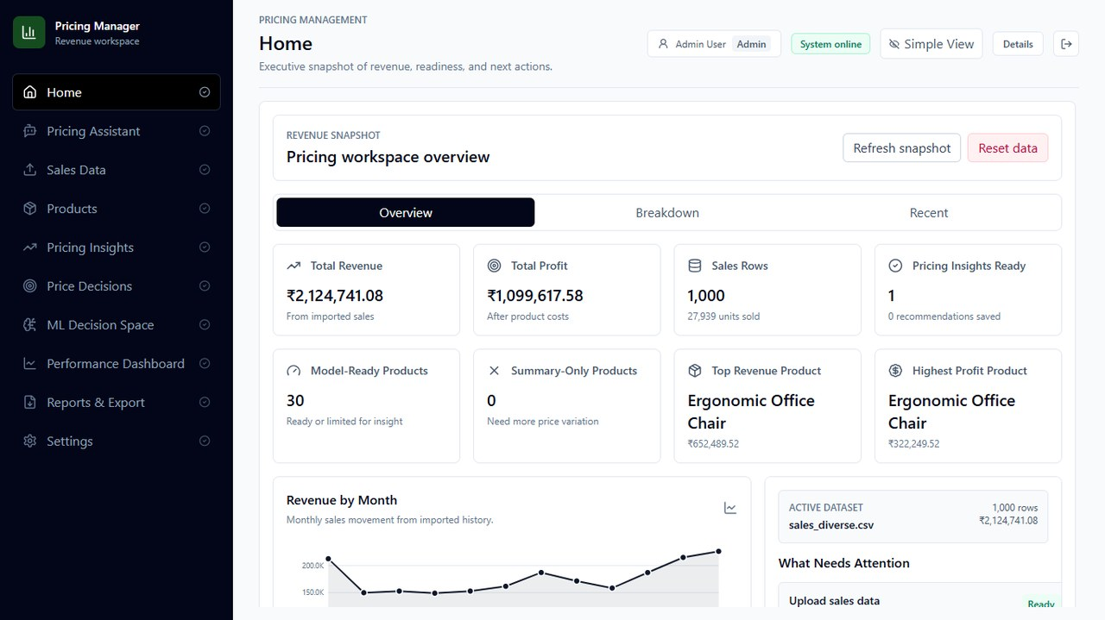
Figure 11: Revora home workspace evidence
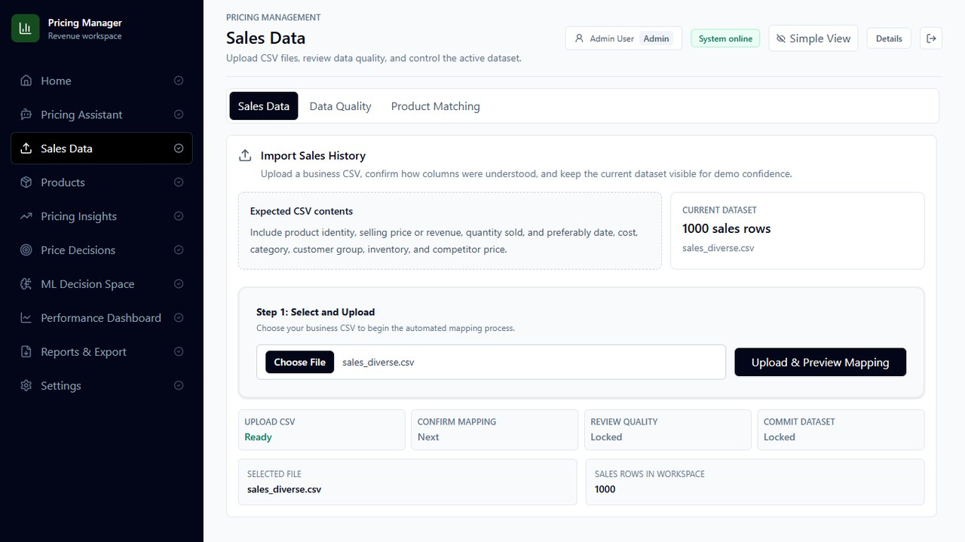
Figure 12: Revora sales data upload evidence
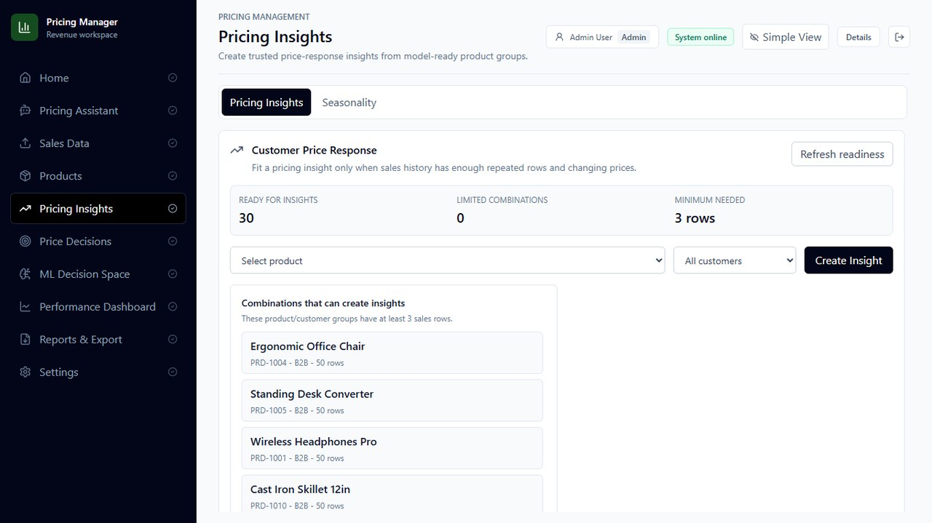
Figure 13: Revora pricing insights evidence
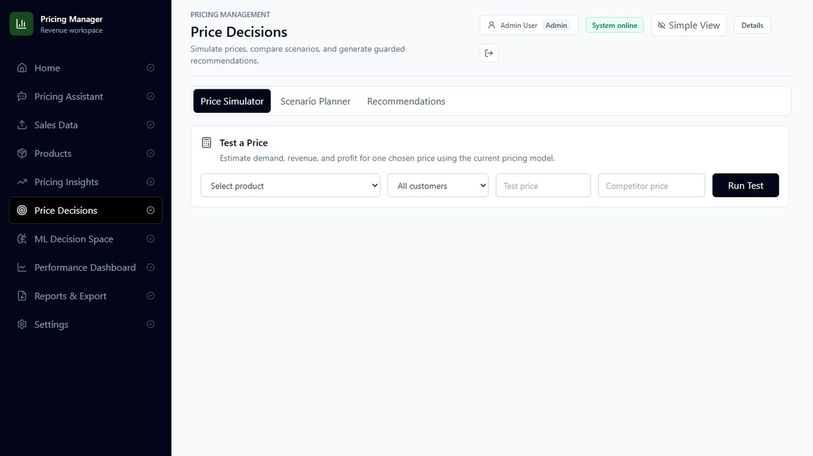
Figure 14: Revora price decisions evidence
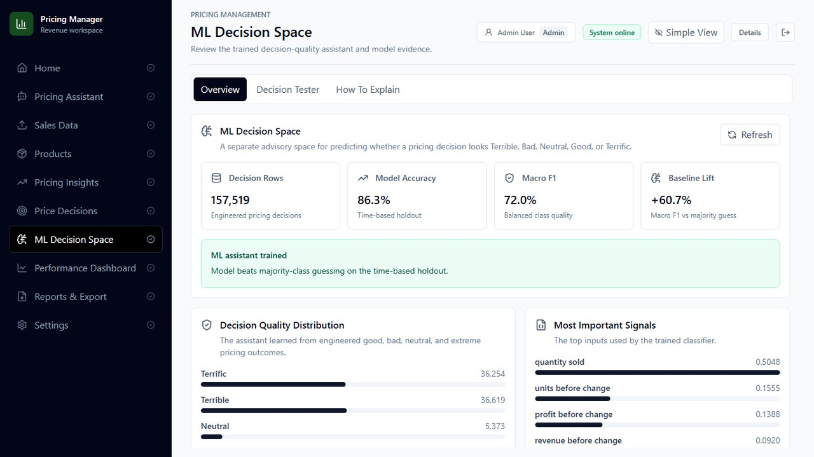
Figure 15: Revora ML Decision Space evidence
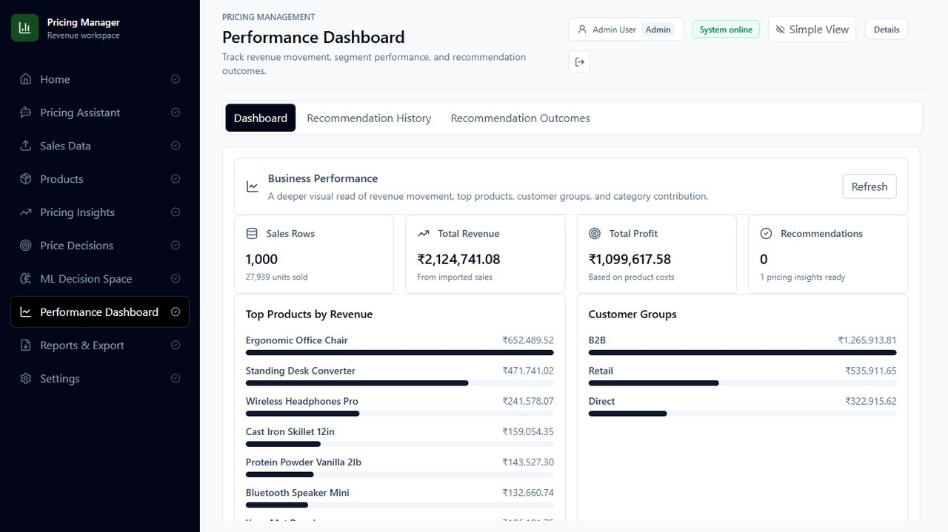
Figure 16: Revora performance dashboard evidence
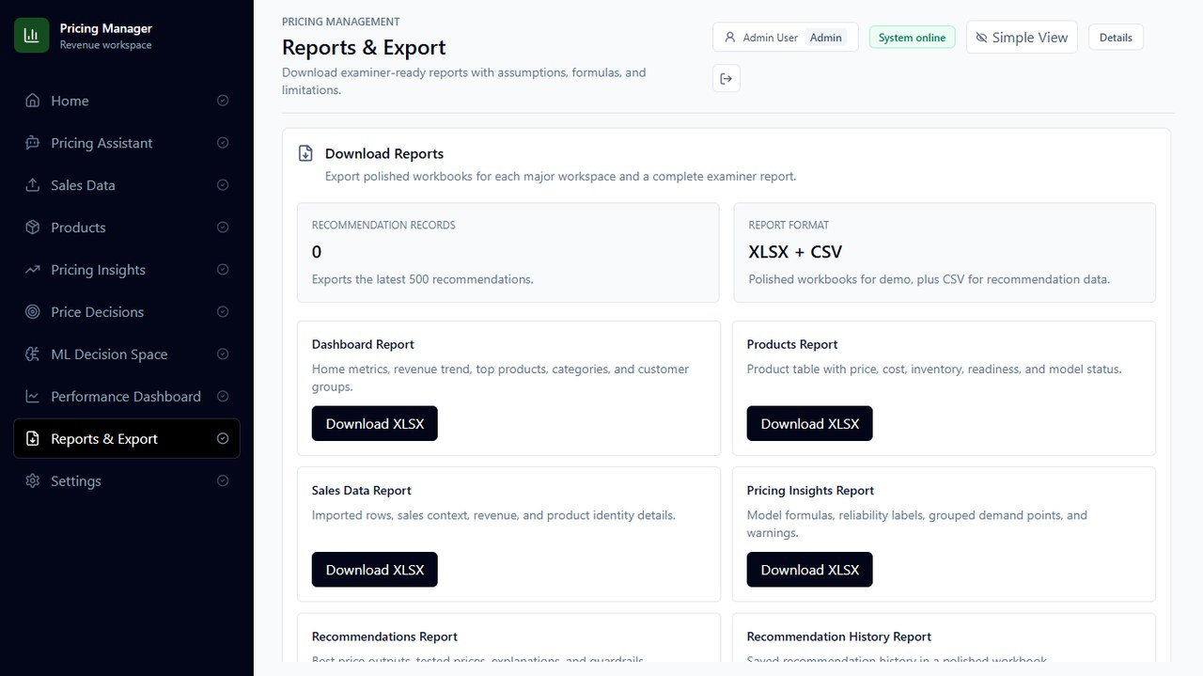
Figure 17: Revora reports and export evidence

4.4 Measured ML Results
Table 12: ML decision-quality results
Metric | Value | Interpretation
Total rows | 157,519 | Generated records available for decision-quality training and evaluation.
Training rows | 126,015 | Rows used for fitting the decision-quality model.
Testing rows | 31,504 | Rows held out for evaluation.
Accuracy | 86.28% | Overall share of correct decision-quality labels.
Macro F1 | 0.7196 | Class-balanced performance indicator across decision labels.
Label distribution | Terrific: 36,254, Terrible: 36,619, Neutral: 5,373, Good: 3,058, Bad: 76,215 | Shows class imbalance, especially the larger Bad class.

The accuracy value is strong for a generated prototype dataset; however, macro F1 is lower than accuracy because the class distribution is imbalanced. This means future work should focus on better class balancing, clearer thresholds between adjacent labels, and validation on real production outcomes.

4.5 Evidence Capture and API Verification
The verification record below consolidates the screens, API samples, local commands, and non-blocking observations used to validate the final implementation evidence.

Table 13: Evidence capture summary
System | Screens / Endpoints Captured | Observation
TaskOps | Login, dashboard, task board, tasks, members, team management, admin chat, notification/dashboard state | Seeded demo users, MongoDB connection, and localhost login flow were verified.
NewsTv19 | Home feed, technology/top categories, Rajasthan/state flow, search behavior, /api/news/home, /api/news/search, /api/categories | API endpoints returned HTTP 200 after backend startup; RSS logs showed article fetch and image scraping activity.
Revora | Home, Sales Data upload, Pricing Insights, Price Decisions, ML Decision Space, Performance Dashboard, Reports and Export, /health | Admin-authenticated workflow was captured; health endpoint reported database connected.

Table 14: Verification summary
Check | Command / Method | Result
Revora ML self-test | npm run test:ml-pipeline | Passed: ML pipeline self-test completed successfully.
Revora reliability suite | npm run test:reliability | Passed: product matching, data fitness, trust policy, quality gate, and assistant tests completed.
Revora frontend build | npm run build | Passed: Vite build completed; non-blocking warning noted for a large JS chunk above 500 kB.
TaskOps seed and run | node seed_users.js; npm run start:api; npm run dev --prefix client | Passed for evidence capture with MongoDB connected and localhost origin.
NewsTv19 run and API sample | npm run server; npm run dev; API request checks | Passed after startup; initial proxy warnings occurred only while the API was warming up.
Screenshot QA | Playwright page capture with console/API monitoring | No blank pages or fatal error overlays were used as final report evidence.

4.6 Result Analysis
The results demonstrate that Revora is more than a static dashboard. It provides a structured path from raw CSV data to quality-reviewed records, model-aware analysis, simulated decisions, dashboard interpretation, and report export. The architecture is modular enough to add better forecasting models, scheduled imports, and deployment controls later.
TaskOps and NewsTv19 evidence also strengthens the final project record. TaskOps proves understanding of authenticated business workflows, role management, task tracking, and communication. NewsTv19 proves experience with data feeds, search APIs, categories, enrichment, and production-style backend behavior.
The main limitation is that the decision-quality metrics come from generated artifacts and prototype data. They are useful for validating the pipeline but should not be treated as final business performance on real client transactions. A second limitation is the Vite bundle-size warning, which is acceptable for the prototype but should be addressed through route-level code splitting before deployment.

Chapter Summary
This chapter presented screenshots, API observations, ML results, and verification outcomes. The project meets the report requirements for implementation evidence, technical results, and transparent limitations.

Chapter 5: Conclusion and Future Scope

5.1 Conclusion
The Revora project successfully demonstrates a dynamic pricing and demand intelligence workflow built with modern full-stack technologies. It combines authenticated UI flows, MongoDB-backed data modeling, CSV ingestion, data quality review, demand-response simulation, pricing recommendations, ML decision-quality analysis, dashboards, and exportable reports.
From a technical perspective, the most important contribution is the conversion of pricing from a manual judgement task into an auditable decision-support workflow. The system records the data used, warnings observed, simulation choices, model readiness, business guardrails, and expected outcomes.

5.2 Future Scope
Table 15: Future scope backlog
Priority | Enhancement | Expected Benefit
High | Deploy route-level code splitting and dashboard lazy loading. | Reduces frontend bundle size and improves production load performance.
High | Train demand models on real client transaction history with periodic retraining. | Improves generalization beyond generated prototype datasets.
High | Add controlled price experiment design and A/B test tracking. | Separates correlation from true price elasticity and improves confidence.
Medium | Integrate scheduled imports from ERP, POS, marketplace, or cloud storage systems. | Reduces manual CSV dependency and improves data freshness.
Medium | Add stronger fairness, compliance, and maximum-change policy controls. | Prevents unsafe or unacceptable automated price behavior.
Medium | Add explainable feature contribution views for each recommendation. | Improves managerial trust and debugging of decision logic.
Low | Add multi-tenant workspace deployment, observability dashboards, and backup policies. | Prepares the prototype for SaaS-style operation.
Low | Add PDF report export and scheduled email summaries. | Improves executive communication and recurring review workflows.

5.3 Learning Outcomes
The project improved practical understanding of asynchronous backend development, Express route design, MongoDB/Mongoose modeling, React component architecture, Vite builds, CSV ingestion, data validation, role-aware application design, dashboard visualization, ML metric interpretation, and professional documentation.

5.4 Final Statement
Revora is a strong base for dynamic pricing intelligence because it treats pricing as a measurable, explainable, and reviewable process. With real data, deployment optimization, and stronger feedback loops, it can evolve from an academic prototype into a practical business decision-support platform.

References
[1] Node.js. "About Node.js." Official documentation. https://nodejs.org/en/about
[2] Express. "Express - Node.js web application framework." Official documentation. https://expressjs.com/
[3] React. "React Documentation." Official documentation. https://react.dev/
[4] Vite. "Getting Started" and "Building for Production." Official documentation. https://vite.dev/guide/ and https://vite.dev/guide/build
[5] MongoDB. "Documents - Database Manual." Official documentation. https://www.mongodb.com/docs/manual/core/document/
[6] Mongoose. "Mongoose ODM Documentation." Official documentation. https://mongoosejs.com/docs/
[7] Socket.IO. "Bidirectional and low-latency communication." Official documentation. https://socket.io/
[8] Tailwind CSS. "Styling with utility classes." Official documentation. https://tailwindcss.com/docs/utility-first
[9] Recharts. "A composable charting library built on React components." Official documentation. https://recharts.github.io/
[10] CSV Parse. "CSV Parser for Node.js." Official documentation. https://csv.js.org/parse/
[11] scikit-learn. "sklearn.ensemble" and RandomForestClassifier documentation. https://scikit-learn.org/stable/api/sklearn.ensemble.html
[12] den Boer, A. V. "Dynamic pricing and learning: Historical origins, current research, and new directions." Surveys in Operations Research and Management Science, 2015. https://www.sciencedirect.com/science/article/pii/S1876735415000021
[13] Dynamic pricing and inventory management with demand learning: A Bayesian approach. Computers and Operations Research, 2020. https://www.sciencedirect.com/science/article/pii/S0305054820301957
[14] Cheung, W. C., Simchi-Levi, D., and Wang, H. "Dynamic Pricing and Demand Learning with Limited Price Experimentation." SSRN. https://papers.ssrn.com/sol3/papers.cfm?abstract_id=2457296

Appendices

Appendix A: Component List
Table 16: Major project components
System | Component | Description
TaskOps | Authentication and RBAC | Admin, sub-admin, and employee access model with seeded demo users.
TaskOps | Dashboard and task board | Workspace status, task views, board-style task handling, member and team administration.
TaskOps | Chat and notification flows | Communication evidence for role-based operational workflows.
NewsTv19 | RSS engine and article storage | Automated fetch cycle, deduplication, MongoDB storage, and image scraping/enrichment logs.
NewsTv19 | Category and search APIs | Home feed, categories, state flow, and search behavior verified with direct API samples.
Revora | CSV ingestion | Upload, mapping, staging, quality scoring, issue logging, and commit/reject workflow.
Revora | Pricing analytics | Demand intelligence, price simulation, recommendations, and performance dashboards.
Revora | ML Decision Space | Decision-quality feature dataset, classifier metrics, assistant state tests, and recommendation quality support.
Revora | Reports export | XLSX/CSV export surfaces for dashboard, products, sales data, insights, recommendations, outcomes, and examiner reports.

Appendix B: Algorithmic Notes
CSV ingestion pseudocode: receive file, detect headers, map fields, validate each row, calculate row fingerprint, normalize product identity, stage accepted rows, record row issues, summarize row counts and data fitness, allow reviewer commit or reject, write accepted rows to SalesData and update Product records.
Pricing simulation pseudocode: select product and segment, gather model-usable historical records, estimate price response, generate candidate price grid, calculate expected demand, revenue, and profit for each candidate, apply safe price band and competitor/inventory guardrails, rank candidates by objective, store recommendation and tested price evidence.
Decision-quality assistant pseudocode: extract product, price, cost, competitor, and demand facts from the conversation; protect confirmed facts; request missing evidence; summarize decision; after user confirmation, produce advice with risk tags, confidence, and an action plan; save structured decision only after confirmation.

Appendix C: Dataset Profile Summary
Table 17: Generated dataset profile
Source | Rows
Retail Price Optimization | 278
Revenue Forecast for Dynamic Pricing | 147,686
E-Commerce Sales Transactions | 9,555

The generated profile also records missing-key notes for external macro series and a supplemental SalesMind-derived note. These items should be treated as prototype context rather than final production data.

Appendix D: Publications / External Dissemination
No publication, patent, or external dissemination has been claimed for this project at the time of final report preparation.

Appendix E: Verification Notes
All three applications were run sequentially because they share backend and frontend ports. Screenshots were captured from local browser sessions. Revora tests passed; TaskOps and NewsTv19 were verified through local execution, API behavior, and rendered UI evidence. Any temporary startup warnings caused by server warm-up or origin mismatch were corrected before final evidence capture.

