SVKM’s Narsee Monjee Institute of Management Studies
(Deemed-to-be University)



SCHOOL OF TECHNOLOGY MANAGEMENT & ENGINEERING

Navi Mumbai

Academic Year: 2025-2026

Revora: Dynamic Pricing & Demand Intelligence System

A report submitted in partial fulfillment of the requirements for the award of four- year B.Tech. program in Computer Engineering/Artificial Intelligence & Data Science at the School of Technology Management & Engineering, NMIMS

by

Mr. Pranay Kumar
Roll Number: A149
SAP Number: 70022200357

Under the supervision of

Dr. Preeti Gupta
STME, NMIMS

Mr. Kanwar Pal Singh Rathore
Manager-HR, TBS

May, 2026


Acknowledgments
I sincerely thank SVKM's NMIMS, Mukesh Patel School of Technology Management and Engineering, for providing the opportunity to complete an industry project that connects academic learning with professional software delivery.
I am grateful to Dr. Preeti Gupta for academic guidance, review direction, and encouragement throughout the project period. I also thank Mr. Kanwar Pal Singh Rathore and the Tech Biz Solution team for providing practical exposure to full-stack development, production workflows, and data-driven application design.
The internship work across TaskOps, NewsTv19, and Revora helped me strengthen backend engineering, frontend implementation, database modeling, analytics design, testing, and documentation discipline.

Abstract
Revora is a dynamic pricing and demand intelligence system designed to convert historical sales, product, inventory, customer segment, and competitor context into explainable pricing recommendations. The problem addressed by the project is that many organizations possess large volumes of sales data but lack a structured workflow for converting those records into price-response evidence, safe simulations, and managerial decisions.
The system follows a MERN-based architecture using React and Vite on the frontend, Node.js and Express on the backend, and MongoDB with Mongoose for document storage. CSV ingestion supports field mapping, staged imports, product normalization, duplicate checks, data quality scoring, and model-readiness labels. The recommendation layer evaluates price candidates using expected demand, revenue, profit, competitor distance, inventory conditions, and business guardrails.
The report also documents TaskOps and NewsTv19 as supporting internship phases. TaskOps contributed experience in authentication, RBAC, task boards, team management, and communication workflows. NewsTv19 contributed experience in RSS ingestion, category/search APIs, MongoDB-backed article storage, and image enrichment. Revora combines these learnings into a pricing intelligence platform.
The generated decision-quality artifact contains 157,519 rows, including 126,015 training rows and 31,504 testing rows. The model reached 86.28 percent accuracy and a 0.7196 macro F1 score. Local verification included browser screenshots, API checks, Revora ML tests, reliability tests, and a production frontend build.

Table of Contents
Table 1: Table of contents
Section | Title | Page
 | Acknowledgments | iii
 | Abstract | iv
 | List of Figures | v
 | List of Tables | vi
 | Abbreviations | vii
Chapter 1 | Introduction | 1
Chapter 2 | Market Survey | 4
Chapter 3 | Methodology and Implementation | 7
Chapter 4 | Results and Analysis | 15
Chapter 5 | Conclusions and Future Work | 24
 | References | 27
 | Appendices | 29

List of Figures
Table 2: List of figures
Figure | Title
3.1 | Revora system architecture
3.2 | Data-to-decision methodology workflow
4.1 | TaskOps admin dashboard evidence
4.2 | NewsTv19 home feed evidence
4.3 | Revora home workspace evidence
4.4 | Revora sales data upload evidence
4.5 | Revora pricing insights evidence
4.6 | Revora ML Decision Space evidence
4.7 | Revora reports and export evidence

List of Tables
Table 3: List of tables
Table | Title
1 | Table of contents
2 | List of figures
3 | List of tables
4 | Abbreviations
5 | Technology stack
6 | Market survey summary
7 | MongoDB data model
8 | ML decision-quality results
9 | Verification summary
10 | Future work backlog

Abbreviations
Table 4: Abbreviations
Abbreviation | Meaning
API | Application Programming Interface
BI | Business Intelligence
CSV | Comma-Separated Values
F1 | Harmonic mean of precision and recall
JWT | JSON Web Token
MERN | MongoDB, Express.js, React, Node.js
ML | Machine Learning
ODM | Object Data Modeling
RBAC | Role-Based Access Control
REST | Representational State Transfer
RSS | Really Simple Syndication
SPA | Single Page Application

Chapter 1
Introduction
1.1 Overview of the Internship
The internship was undertaken at Tech Biz Solution as part of the Semester VIII B.Tech. Computer Engineering curriculum. The work progressed from foundational backend development to independent full-stack implementation and then to data-driven product engineering.
The first phase focused on Node.js, Express.js, MongoDB, authentication, and REST API design. The second phase involved TaskOps, a role-based task management platform. The third phase involved NewsTv19, a production-style news aggregation system. The final phase, Revora, is the main industry project and focuses on dynamic pricing and demand intelligence.
1.2 Objectives and Problem Statement
The central problem is that pricing decisions are often made manually even when sales, inventory, discount, competitor, and customer-segment data are available. Without a structured analytics workflow, price changes can ignore demand sensitivity, stock risk, data quality, and profit impact.
- Build a MERN-based pricing intelligence platform with authenticated workflows.
- Support CSV ingestion, field mapping, validation, and data quality checks.
- Model price-response behavior and simulate demand, revenue, and profit outcomes.
- Generate safe pricing recommendations using guardrails and explainable evidence.
- Document implementation screenshots, measured results, verification, and future scope.
1.3 Company Overview and Role
Tech Biz Solution is an IT services and consulting organization based in Jodhpur, Rajasthan. The company works in custom software development, digital transformation, web applications, AI-enabled analytics, and business automation.
My role as a MERN stack development intern involved API development, frontend implementation, MongoDB schema design, authentication workflows, data processing, dashboard development, testing, and documentation.
Table 5: Technology stack
Layer | Technology | Use in Project
Runtime/API | Node.js, Express.js | REST services for auth, ingestion, analytics, recommendations, and reports [1][2].
Frontend | React, Vite | Single-page interface, dashboards, upload flow, and production build [3][4].
Database | MongoDB, Mongoose | Document schema design, validation, indexing, and references [5][6].
Realtime/UX | Socket.IO, Tailwind CSS | Communication features, notifications, and utility-first styling [7][8].
Charts/ML | Recharts, generated ML pipeline | Dashboard visualizations and decision-quality evaluation [9][10].

Chapter 2
Market Survey
2.1 Data Analysis and Interpretation
Dynamic pricing systems adjust price according to demand, inventory, customer behavior, competitor prices, and business objectives. However, pricing intelligence is useful only when data is reliable and the decision process is explainable. A recommendation should show which data was used, what assumptions were made, and why the suggested price is safe or risky.
2.2 Market Trends
Current software trends show increasing use of data-driven dashboards, demand forecasting, self-service analytics, and machine-learning-assisted recommendations. Businesses want tools that can import spreadsheet data, detect quality issues, and translate records into practical decisions without requiring every user to be a data scientist.
2.3 Impact on the Internship Work
The survey shaped Revora as a decision-support product rather than a black-box automated pricing tool. The system emphasizes traceable data imports, recommendation confidence, safe price bands, model-readiness labels, and report exports.
Table 6: Market survey summary
Need | Market Gap | Revora Response
Demand forecasting | Historical sales exist but are not converted into price-response insight. | Groups sales records and estimates expected demand for candidate prices.
Data quality | Manual spreadsheets contain duplicates, missing costs, and inconsistent product names. | Uses import batches, row issues, product matching, and data fitness labels.
Decision trust | Managers need reasons, not only numerical recommendations. | Stores assumptions, warnings, guardrails, and calculation evidence.
Reporting | Project results must be reviewable outside the running app. | Provides dashboard/report export surfaces and screenshot evidence.

Chapter 3
Methodology and Implementation
3.1 Methodology
The methodology followed an iterative software engineering cycle: understand requirements, inspect existing systems, design schemas and flows, implement modules, run local applications, capture browser/API evidence, execute tests, and document the results.
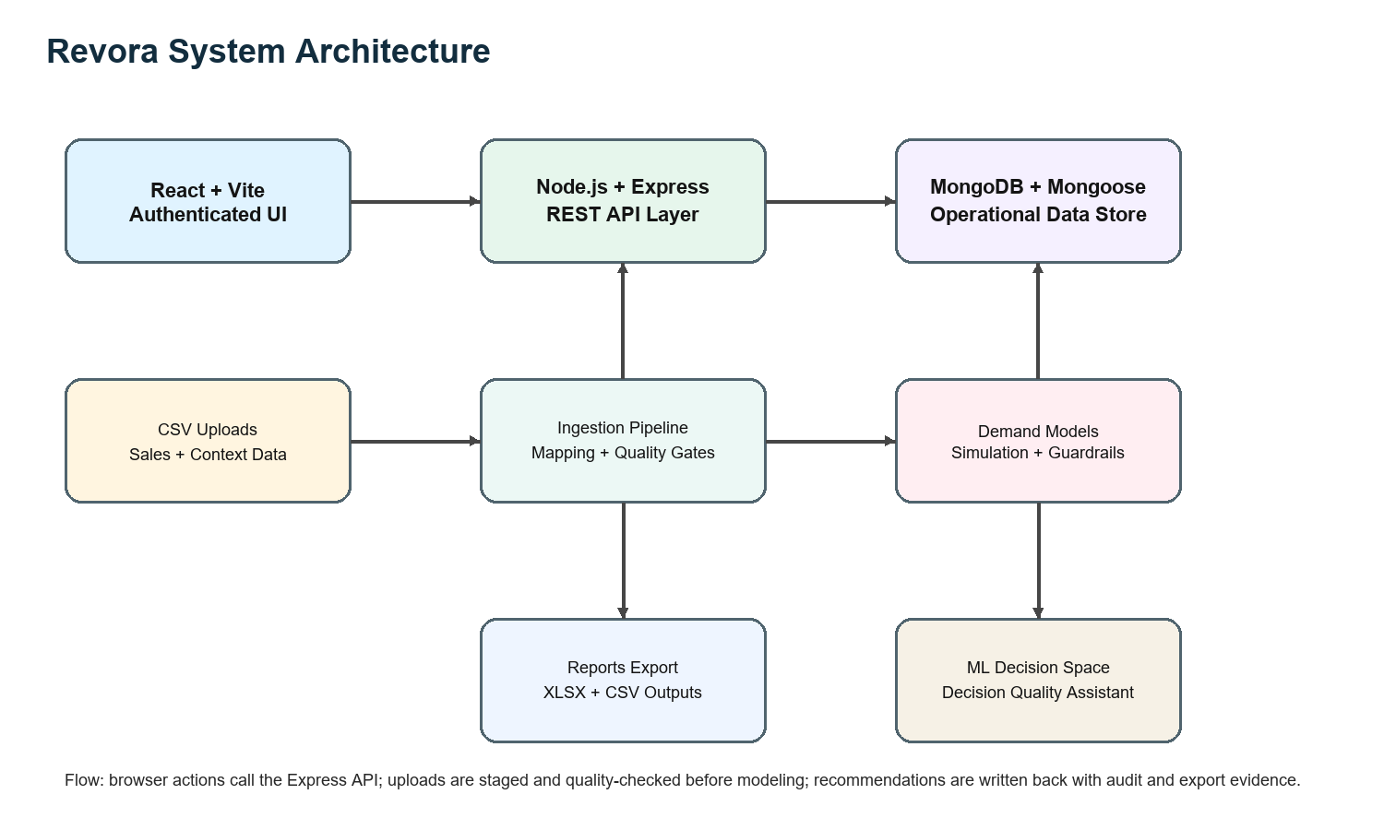
Figure 3.1: Revora system architecture
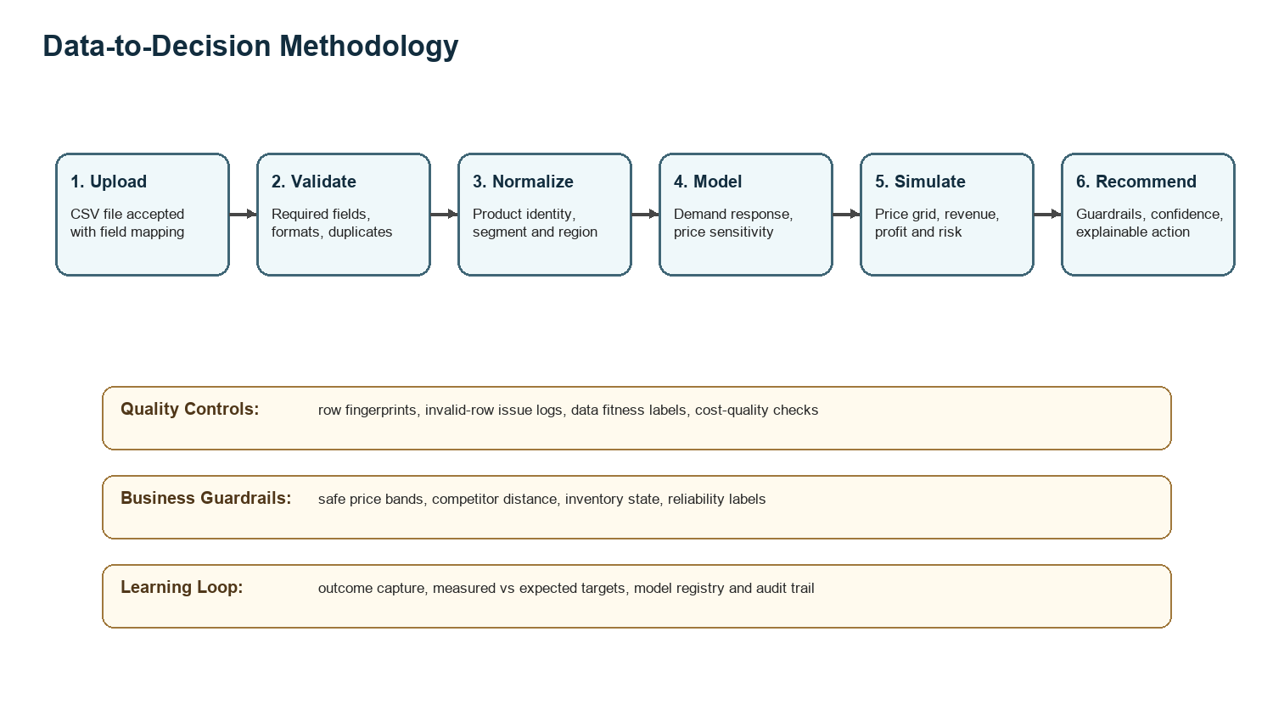
Figure 3.2: Data-to-decision methodology workflow
3.2 Challenges and Solutions
The main challenge was transforming varied sales data into a dependable pricing workflow. Revora addresses this through staged CSV uploads, field mapping, product normalization, duplicate checks, row-level issue tracking, data fitness scoring, and model-readiness labels.
Another challenge was avoiding unsafe recommendations. The implementation therefore records safe price bands, competitor distance, inventory conditions, confidence labels, calculation steps, and model limitations before presenting a decision.
3.3 Technical Knowledge Application
TaskOps applied authentication, RBAC, dashboard design, task boards, team management, and chat workflows. NewsTv19 applied RSS ingestion, category APIs, search behavior, MongoDB-backed article storage, and image enrichment. Revora combined these skills with analytics and ML decision support.
Table 7: MongoDB data model
Model | Key Fields | Purpose
Product | name, sku, category, basePrice, cost, inventory, normalizedSku | Maintains product identity and matching for imported records.
SalesData | productId, price, quantity, competitorPrice, revenue, region, segment, date | Stores normalized sales and context data for analytics.
ImportBatch | source, status, mappedFields, rowCounts, dataFitnessScore | Tracks CSV import mapping, staging, and quality review.
Recommendation | basePrice, recommendedPrice, expectedDemand, expectedRevenue, expectedProfit | Stores tested price evidence and pricing decisions.
AssistantDecision | draft facts, labels, extracted prices, advice tags | Supports the ML decision-quality assistant workflow.

3.4 Pricing and ML Logic
The pricing module selects a product and segment, gathers model-usable records, estimates price response, generates candidate prices, and evaluates expected demand, revenue, profit, and competitor distance. The recommendation is then filtered through guardrails before it is stored.
The ML Decision Space classifies decision quality using engineered features such as price, previous price, price change percentage, quantity, revenue, profit, competitor price, discount, inventory, holiday flags, macro/context variables, category encoding, segment encoding, and region encoding.

Chapter 4
Results and Analysis
4.1 Implementation Screenshots and Results
The following evidence was captured from local browser sessions after running the applications sequentially because they share backend and frontend ports.
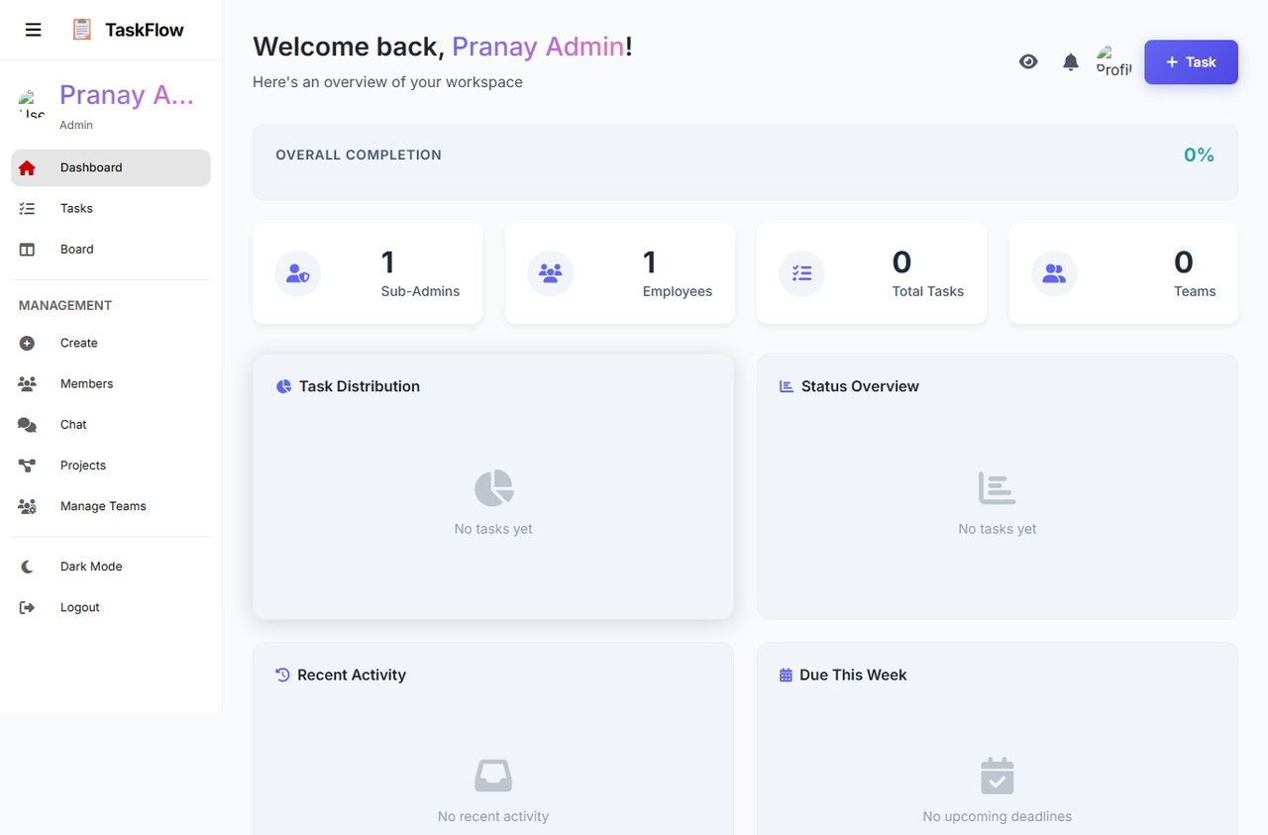
Figure 4.1: TaskOps admin dashboard evidence

Figure 4.2: NewsTv19 home feed evidence
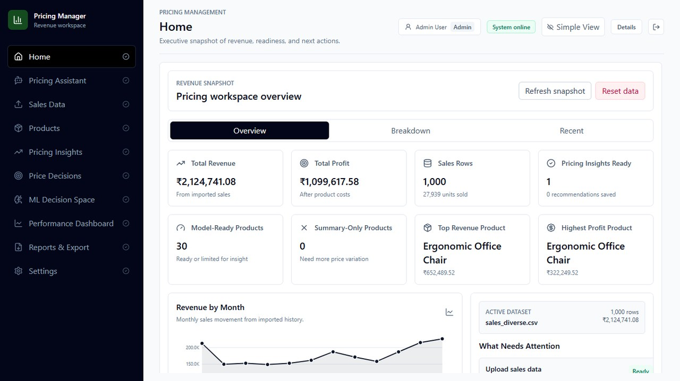
Figure 4.3: Revora home workspace evidence
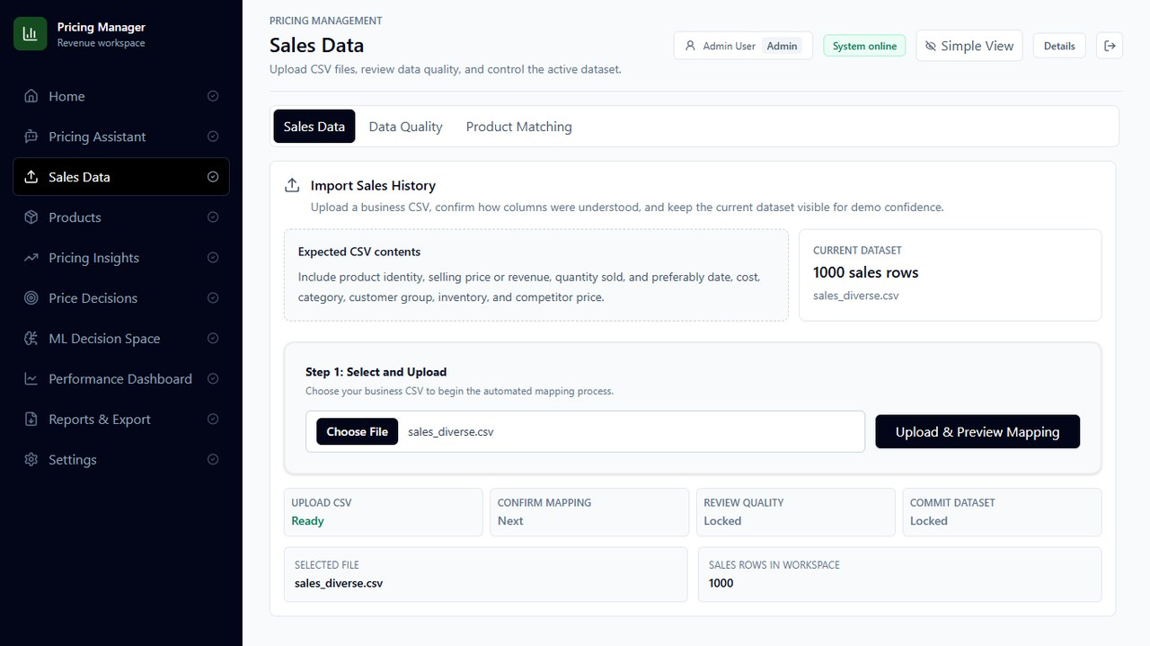
Figure 4.4: Revora sales data upload evidence
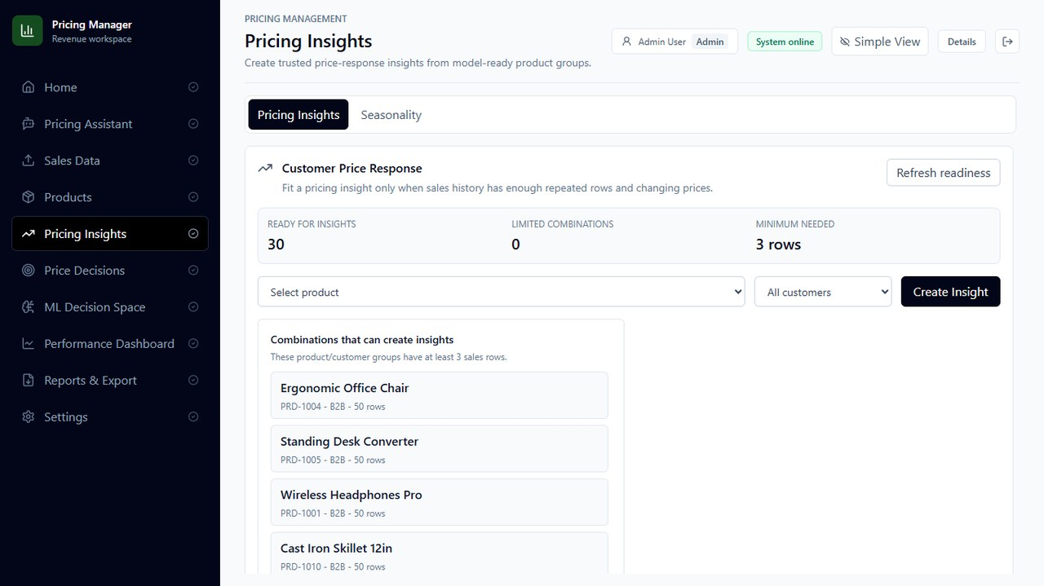
Figure 4.5: Revora pricing insights evidence
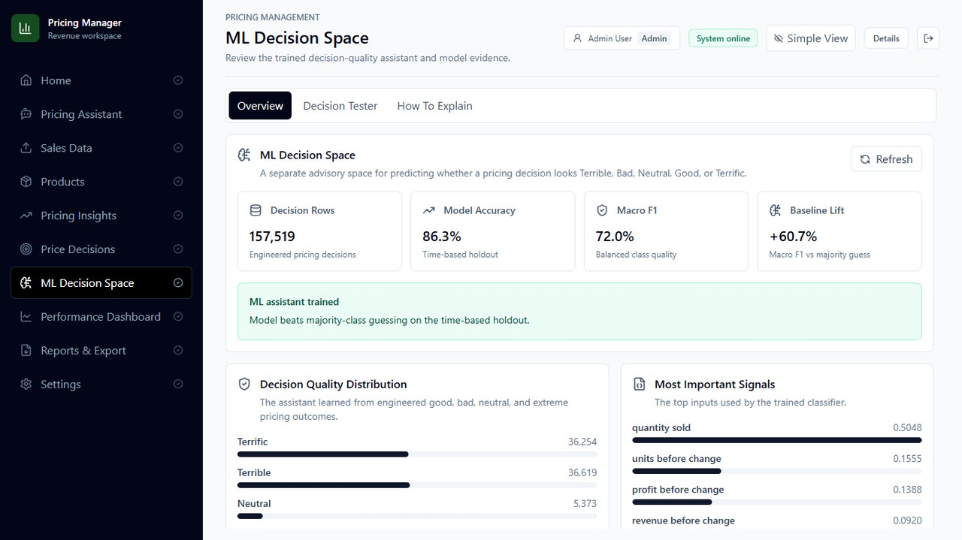
Figure 4.6: Revora ML Decision Space evidence
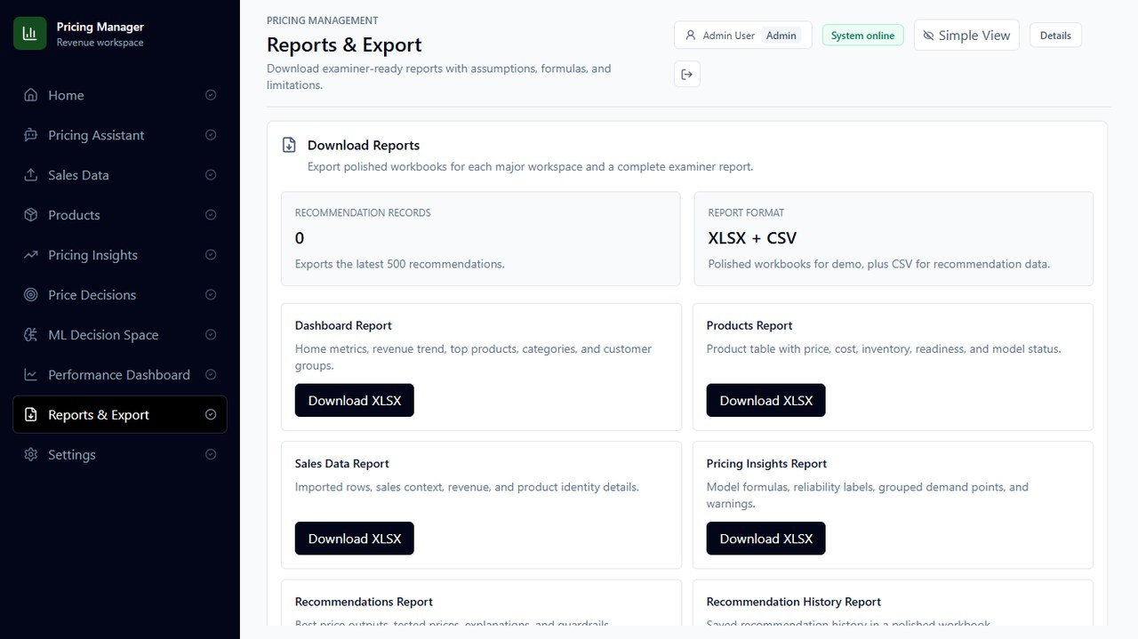
Figure 4.7: Revora reports and export evidence
Table 8: ML decision-quality results
Metric | Value | Interpretation
Total rows | 157,519 | Generated decision-quality dataset size.
Training rows | 126,015 | Rows used for fitting the model.
Testing rows | 31,504 | Rows held out for evaluation.
Accuracy | 86.28% | Overall correct classification rate.
Macro F1 | 0.7196 | Class-balanced decision-quality metric.
Label distribution | Terrific: 36,254, Terrible: 36,619, Neutral: 5,373, Good: 3,058, Bad: 76,215 | Shows class imbalance in the generated dataset.

4.2 Advantages, Limitations and Applications
The key advantage of Revora is that it joins data ingestion, quality checks, simulation, recommendation storage, ML decision-quality analysis, and reporting into one workflow. The system is useful for retailers or service businesses that need pricing support but still require human review.
The main limitation is that the ML result comes from generated/prototype artifacts and should be validated with real client transaction history before production automation. The Revora production build passed, but Vite reported a non-blocking large bundle warning that should be improved through code splitting.
Table 9: Verification summary
Check | Method | Result
Revora ML self-test | npm run test:ml-pipeline | Passed.
Revora reliability suite | npm run test:reliability | Passed product matching, fitness, trust, quality gate, and assistant tests.
Revora frontend build | npm run build | Passed with non-blocking large chunk warning.
TaskOps | seed users, start API, start client, browser capture | MongoDB connected and admin workflow captured.
NewsTv19 | start API/client, browser and API samples | RSS startup logs, home/search/category APIs, and UI evidence captured.

Chapter 5
Conclusions and Future Work
The Revora project successfully demonstrates a dynamic pricing and demand intelligence workflow built with modern full-stack technologies. It combines authenticated UI flows, MongoDB-backed data modeling, CSV ingestion, quality review, demand-response simulation, pricing recommendations, ML decision-quality analysis, dashboards, and report export.
The main technical contribution is the conversion of pricing from a manual judgement task into an auditable decision-support process. The system records the data used, warnings observed, simulation choices, model readiness, business guardrails, and expected outcomes.
Table 10: Future work backlog
Priority | Enhancement | Expected Benefit
High | Train with real client transaction history. | Improves model reliability and production relevance.
High | Add controlled price experiments and A/B testing. | Separates correlation from true price elasticity.
High | Add route-level code splitting. | Improves frontend load performance.
Medium | Integrate ERP/POS/marketplace imports. | Reduces manual CSV dependency.
Medium | Add stronger fairness and maximum-change policies. | Prevents unsafe automated pricing behavior.
Low | Add scheduled executive summaries and PDF export. | Improves reporting workflow.

References
[1] Node.js. About Node.js. https://nodejs.org/en/about
[2] Express. Node.js web application framework. https://expressjs.com/
[3] React Documentation. https://react.dev/
[4] Vite Guide. https://vite.dev/guide/
[5] MongoDB Manual: Documents. https://www.mongodb.com/docs/manual/core/document/
[6] Mongoose Documentation. https://mongoosejs.com/docs/
[7] Socket.IO Documentation. https://socket.io/
[8] Tailwind CSS Documentation. https://tailwindcss.com/docs/utility-first
[9] Recharts Documentation. https://recharts.github.io/
[10] scikit-learn Ensemble Methods. https://scikit-learn.org/stable/api/sklearn.ensemble.html
[11] den Boer, A. V. Dynamic pricing and learning: Historical origins, current research, and new directions. Surveys in Operations Research and Management Science, 2015.
[12] Cheung, W. C., Simchi-Levi, D., and Wang, H. Dynamic Pricing and Demand Learning with Limited Price Experimentation.

Appendix I: Soft Code Flowcharts

Appendix Figure I.1: Revora architecture flowchart

Appendix Figure I.2: Data-to-decision flowchart

Appendix II: Component and Dataset Summary
Table 11: Generated dataset profile
Source | Rows
Retail Price Optimization | 278
Revenue Forecast for Dynamic Pricing | 147,686
E-Commerce Sales Transactions | 9,555

The generated profile records model-ready feature data and supplemental notes. These values should be treated as prototype evidence until validated on production client data.

Appendix III: Source Code Structure
Revora major backend folders include server/src/models, server/src/routes, server/src/services, and server/src/test. Major client areas include dashboard views, sales upload views, pricing insights, recommendations, ML Decision Space, reports, and shared UI components.
Sample route structure
server/src/routes/auth.routes.js
server/src/routes/upload.routes.js
server/src/routes/ingest.routes.js
server/src/routes/recommendation.routes.js
server/src/routes/ml.routes.js
server/src/routes/report.routes.js

Appendix IV: Sample Commands
Verification commands used
npm run test:ml-pipeline
npm run test:reliability
npm run build
node seed_users.js
npm run start:api
npm run dev --prefix client
npm run server
npm run dev

Appendix V: Raw Experimental Observation
Revora health endpoint reported the dynamic-pricing API online with MongoDB connected. TaskOps and NewsTv19 were run sequentially because all applications share local development ports. Screenshots and API samples were captured only after each application rendered a valid page without fatal overlays.
Non-blocking observations: TaskOps initially rejected a 127.0.0.1 origin because the configured origin was localhost; the capture was repeated on localhost. NewsTv19 emitted temporary proxy warnings during backend warm-up, then API samples returned HTTP 200. Revora build completed with a large-bundle warning that should be handled in future production optimization.

