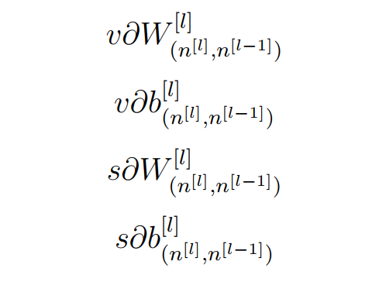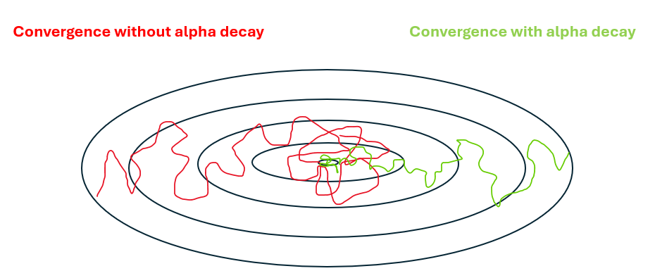When deciding to build a structure in Deep Learning (DL)1 to solve a specific problem, many questions arise for creating a powerful structure with great accuracy, and optimal training time. The most popular questions are: which hyper parameters, such as learning rate2, batch size3, momentum4, and weight decay5, should be used? How to tune them to achieve the desired result? Which optimizer is the optimal one to answer the research problem? Actually, there are no specific guidelines for setting up an optimal DL structure with these parameters suitable for solving all problems or all data sets.
The aim of any optimizer is to minimize the loss function6, which is the difference between the actual output from the structure, and the desired output. There are many types of optimizers that can be used to achieve the minimum value for the loss function. Many papers have proposed new enhancement techniques on the traditional optimizers such as Stochastic Gradient Descent (SGD), AdaGrad, AdaDelta, Nadam, Adam, and RmsProp. They include modification of many aspects such as the momentum, and learning rate.
So far, the vast majority of the deep model training is based on the back propagation algorithm, which propagates the errors from the output layer backward, and uses gradient descent-based optimization algorithms to update the parameters layer by layer. Therefore, in order to achieve an effective model, the suitable optimizer to handle the problem should be chosen. There are different types of optimizers, such as Gradient Descent based Learning (GD), Momentum based Learning, Adaptive Gradient based Learning, and Momentum Adaptive Gradient based Learning Algorithms.
The main difference between Batch Gradient Descent (BGD) and Stochastic Gradient Descent (SGD) is the cost of one example for each procedure in SGD is only computed. In contrast, in BGD, the cost for all training examples in the dataset has to be computed. This extremely quickens the neural networks. Basically, this is what stimulates utilizing SGD. SGD is utilized to update parameters in a DL, as shown in Eq. (1). Besides, this equation is employed to update parameters in a backwards pass, with the help of back propagation17, to compute the gradient. Each parameter, θ, is taken and updated by getting the original parameter and subtracting the learning rate times the ratio of change.

θ = θ - η · ∇F (θ)

It is noteworthy that in order to solve these drawbacks of SGD, an enhancement should be done. Mini Batch Gradient Descent18 would be adopted because it has the best of the two approaches. It also executes an update for each batch of n training examples in every batch. The following sub-section is devoted for discussing the other types of optimization algorithms.

Momentum based learning algorithms. Instead of depending only on the gradient of the current step to steer the search, momentum, the gradient of the previous steps is considers. The gradient descent equations are changed as given in Eq.
µ(τ) = ϒµ(τ - 1) + η∇F(θ)
In the end, the parameters are updated through θτ + 1 = θτ - µτ.
this allows us to fine-tune the updates to the slopes of our error function, which speeds up SGD, as shown in Figure below which illustrates how Momentum speeds up the SGD in training process.
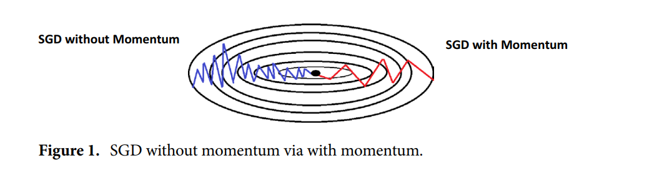

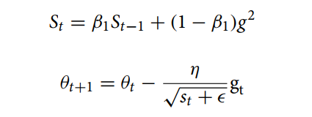

Momentum and adaptive gradient based learning algorithms. This subsection discusses some learning algorithms that incorporate the benefits of the previous two algorithms such as Adaptive Moment Estimation (Adam) which can be defined as another approach which calculates the adaptive learning rates for every parameter. Besides, it keeps the average of all past squared gradients, such as AdaDelta. Adam is one of the effective optimization approaches in adaptive algorithms. It is an SGD algorithm that relies on the concept of momentum to quickly and effectively arrive at the loss function’s global minimum. This aids in efficiently modifying the learning rate for each parameter, hastening the time to convergence to the minimum. Adam calculates distinct adaptive learning rates based on the first and second moment values for various parameters as clarified in Equations bellow.
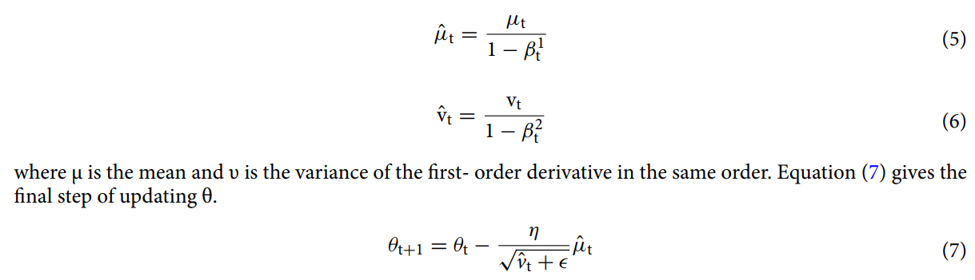

Adam performs well in practice, and provides results that can be favorably compared to other optimization algorithms since it achieves the optima fast, and its performance is quiet quick and so effective. The technique of adaptive algorithms has the ability to also correct and fix each issue that can be confronted in other optimization algorithms that may cause fluctuation in the loss function adaptive techniques. There is an issue concerning the learning rate to be "just right", which is so tricky. If it is selected too small, there will be no progress. On the other hand, if it is too large, the solution will fluctuate, and be in the worst condition; it may even diverge. So, if is specified and selected automatically, or even this step is avoided, the second order techniques, which search not only for the value and gradient of the objective but also for its curvature, can be beneficial in this case.
