Math Major

Matt Rissler

2019-10-01

## The Major

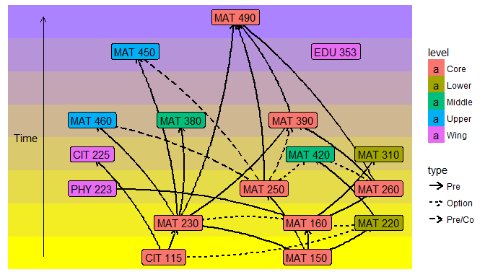

## The Colors

* Everything in the Core
* At least one Wing
* At least one Upper
* At least two of Middle or Upper
* At least four of Lower, Middle, or Uppper

## Rotation of Classes

Courses that are not listed occur every semester.

|  |  |  |
| --- | --- | --- |
| Code | Title | Semester |
| PHY 223 | Physics for Mathematicians | Fall |
| MAT 220 | Prob/Stats | Spring |
| MAT 230 | Discrete Math | Spring |
| MAT 250 | Linear Algebra | Fall |
| MAT 310 | ODEs | Spring |

## Rotation of Classes

|  |  |  |
| --- | --- | --- |
| Code | Title | Semester |
| MAT 380 | Modern Geometry | Odd Falls |
| MAT 420 | Numerical Analysis | Odd Springs |
| EDU 353 | Math Methods | Even Falls |
| MAT 450 | Algebra | Even Falls |
| MAT 460 | Real Analysis | Odd Falls |
| MAT 490 | Capstone | Spring |