**Problem:** Individuals with respiratory conditions like asthma and COPD are sensitive to poor air quality, leading to health issues



**Cheepa**

**"Portable Air Quality Monitor for Respiratory Health"**

Poor air quality can trigger severe symptoms and reduce their quality of life. Current air quality monitoring systems are not portable, personalized, or user- friendly for daily use.

**Solution :**A portable, easy-to-use device that provides real-time air quality feedback, alerts, and data logging for individuals with respiratory conditions. Cheepa is a compact, bird-shaped device that provides **real-time air quality data** through audible chirps and smartphone notifications, offering immediate feedback to help users manage their exposure to harmful environments

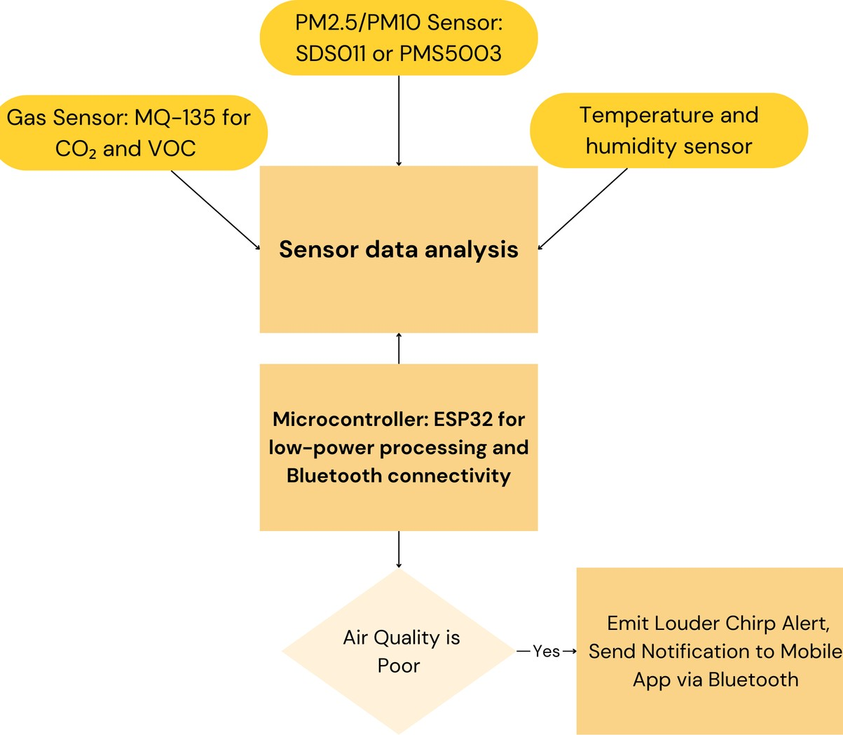**Technical Feasibility** Sensors and Components: **PM2.5/PM10 Sensor**: SDS011

or PMS5003 for real-time

particulate matter detection. **Gas Senso**r: MQ-135 for CO₂ and VOC monitoring.

**Microcontroller**: ESP32 for low-power processing and Bluetooth connectivity.

**Display**: OLED for real-time data display.

**Speaker**: Integrated in the bird’s beak to produce chirps.

# Key Features

Real-Time Feedback

Mobile Connectivity (Bluetooth-enabled )

Health Alerts(Custom Personalized notifications) Rechargeable & Long-Lasting

# Team members

Asutosh Kumar Chouhan Namit singh

Ayushman Das

Agamjot kaur choudhary

Jatin Santosh Naik