Computer Networks Lab (MCP547)

M.C.A.-Semester-II

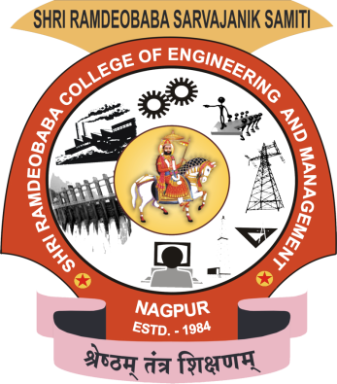

Session: 2023-24

Shri Ramdeobaba College of Engineering and Management, Gittikhadan,Katol Road,

Nagpur 440013 (M.S.)

Shri Ramdeobaba College of Engineering and Management, Nagpur

Department of Computer Application

**SYLLABUS OF SEMESTER-II, M.C.A. (MASTER IN COMPUTER APPLICATION)**

**Index**

|  |  |  |  |
| --- | --- | --- | --- |
| **Sr. No.** | **Aim/Practical Title** | **Date of Submission** | **Remark** |
| 1 | To study network devices and communication channels:  A) Network Devices:  Switches, Hubs, Routers, Repeaters, NIC.  B) Communication Channels:  Wired medium - CAT5/CAT6 cables, Coaxial cable, Fiber optic + Connectors.  Wireless medium - Radio, Microwave, Infrared. Frequency band.  C) IP address (Classification of IP address, Sub netting, Super netting) | 26-01-2024 |  |
| 2 | Implement the Client-Server communication.   1. TCP communication. 2. UDP communication | 16-02-2024 |  |
|  |  |  |  |
|  |  |  |  |
|  |  |  |  |
|  |  |  |  |
|  |  |  |  |
|  |  |  |  |
|  |  |  |  |
|  |  |  |  |
|  |  |  |  |
|  |  |  |  |
|  |  |  |  |
|  |  |  |  |
|  |  |  |  |
|  |  |  |  |
|  |  |  |  |
|  |  |  |  |
|  |  |  |  |

**Name of Student: Jayesh Lalit Nandanwar**

**Division: 2**

**Roll Number: 26**

**Batch No: 2**

**Practical 1**

**Name of Program:** To study network devices and communication channels:

A) Network Devices:

Switches, Hubs, Routers, Repeaters, NIC.

B) Communication Channels:

Wired medium - CAT5/CAT6 cables, Coaxial cable, Fiber optic + Connectors.

Wireless medium - Radio, Microwave, Infrared. Frequency band.

C) IP address (Classification of IP address, Sub netting, Super netting)

**Source Code/Theory:**

1. **Network Devices**
2. **Switches:**
   1. Characteristics:
      * Switches are hardware devices used to connect multiple devices within a local area network (LAN).
      * Operating at the data link layer (Layer 2) of the OSI model, switches use MAC addresses for frame forwarding.
      * Switches can be categorized as managed (configurable) or unmanaged (plug-and-play).
   2. Diagram:

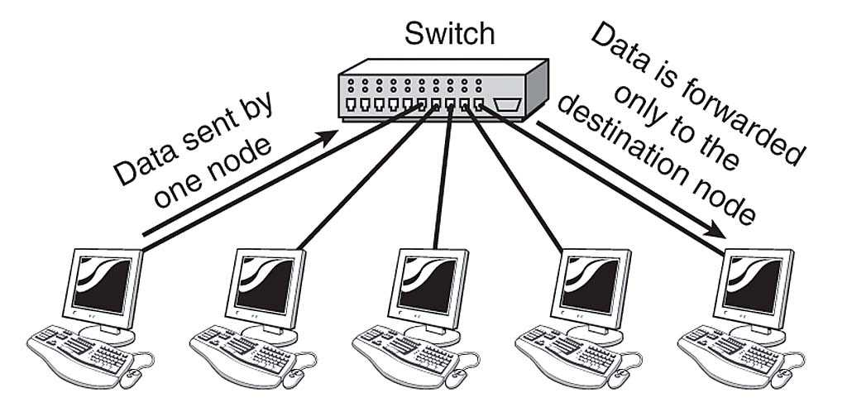

Fig: Switches in Networking.

* 1. Advantages:
     + Dedicated bandwidth to each connected device enhances network performance.
     + Network segmentation improves security and reduces congestion.
     + Managed switches offer features like VLANs and Quality of Service (QoS).
     + Transmission mode is full duplex, i.e. communication in the channel occurs in both the directions at the same time. Due to this, collisions do not occur.
     + Switches can perform some error checking before forwarding data to the destined port.
     + The number of ports is higher – 24/48
  2. Disadvantages:
     + Switches may be more expensive than simpler network devices like hubs.
     + Managed switches require additional configuration and maintenance.
  3. Limitations:
     + Limited number of ports can be a constraint for larger networks.
  4. Technical Details:
     + Utilizes packet switching for data forwarding.
     + Comes in various speeds, including 10/100/1000 Mbps or higher (10/25/40/100 Gbps).

1. **Hubs:**
   1. Characteristics:
      * A hub is a common connection point, also known as a network hub, which is used for connection of devices in a network.
      * It works as a central connection for all the devices that are connected through a hub.
      * Hubs are basic networking devices operating at the physical layer (Layer 1) of the OSI model.
      * They broadcast data to all connected devices without intelligence about the destination.
      * Typically, hubs are unmanaged devices.
   2. Diagram:

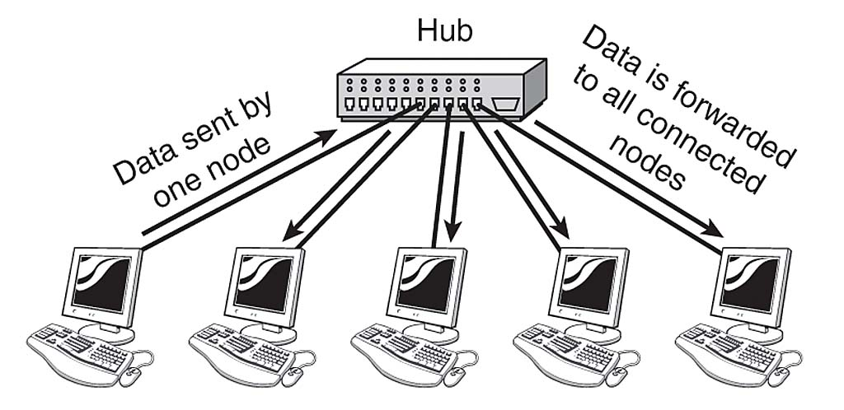

Fig: Hubs in Networking.

* 1. Advantages:
     + Hubs are cost-effective.
     + The use of a hub does not impact on the network performance.
     + Easy to install and require minimal configuration.
  2. Disadvantages:
     + Network congestion and decreased performance due to broadcast nature.
     + Lack security features and network segmentation.
  3. Limitations:
     + Limited number of ports.
  4. Technical Details:
     + Uses broadcast switching for data forwarding.
     + Operates at a fixed speed, e.g., 10 Mbps or 100 Mbps.

1. **Routers:**
   1. Characteristics:
      * Routers connect multiple networks, operating at the network layer (Layer 3) of the OSI model.
      * The router is a physical or virtual internetworking device that is designed to receive, analyze, and forward data packets between computer networks.
      * A router examines a destination IP address of a given data packet, and it uses the headers and forwarding tables to decide the best way to transfer the packets.
      * They use IP addresses for data routing.
      * Can be managed or unmanaged.
      * A router is used in LAN (Local Area Network) and WAN (Wide Area Network) environments. It shares information with other routers in networking.
   2. Diagram:

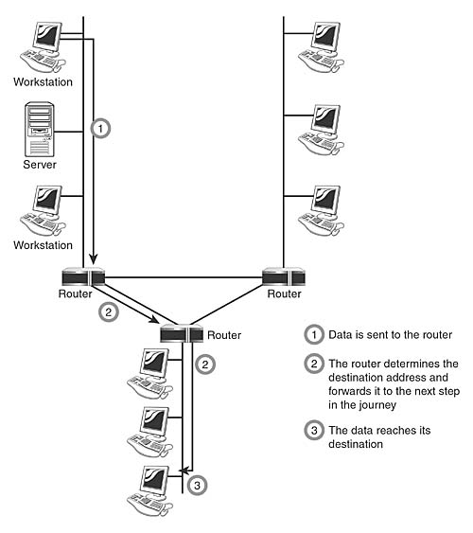

Fig: Routers in Networking.

* 1. Advantages:
     + Provide security and segmentation between networks.
     + Prioritize traffic using Quality of Service (QoS).
     + Can connect different types of networks, such as wired and wireless.
  2. Disadvantages:
     + Routers may be more expensive and require more configuration.
     + Managed routers need ongoing maintenance.
  3. Limitations:
     + Limited number of ports.
  4. Technical Details:
     + Uses packet switching for data forwarding.
     + Available at various speeds like 10/100/1000 Mbps or higher (10/25/40/100 Gbps).

1. **Repeaters:**
   1. Characteristics:
      * Used to extend the range of a network, operating at the physical layer.
      * Repeaters amplifies the attenuated signal and then retransmits it. Digital repeaters can even reconstruct signals distorted by transmission loss. So, repeaters are popularly incorporated to connect between two LANs thus forming a large single.
      * Regenerates and amplifies signals to overcome signal attenuation.
      * Typically unmanaged devices.
   2. Diagram:

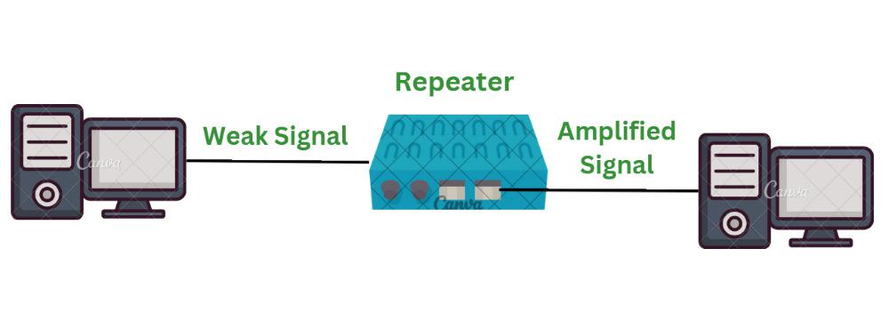

Fig: Repeaters in Networking.

* 1. Advantages:
     + Extends network range without additional cabling.
     + Easy installation and use.
     + Repeaters don’t require any processing overhead. The only time they need to be investigated is in case of degradation of performance.
     + They can connect signals using different types of cables.
  2. Disadvantages:
     + Can cause congestion and slow down network performance.
     + Lack security and segmentation features.
     + Most networks have limitations upon the number of repeaters that can be deployed.
  3. Limitations:
     + Limited range suitable only for short distances.
  4. Technical Details:
     + Regenerates and amplifies signals at the physical layer.

1. **NIC (Network Interface Card):**
   1. Characteristics:
      * NIC is a hardware component connecting a device to a network, operating at the data link layer.
      * Uses MAC addresses for communication.
      * It is a circuit board installed in a computer that provides a dedicated network connection to the computer. It is also called network interface controller, network adapter, or LAN adapter.
      * NIC is used to convert data into a digital signal.
      * In the OSI model, NIC uses the physical layer to transmit signals and the network layer to transmit data packets.
      * NIC offers both wired (using cables) and wireless (using Wi-Fi) data communication techniques.
   2. Diagram:

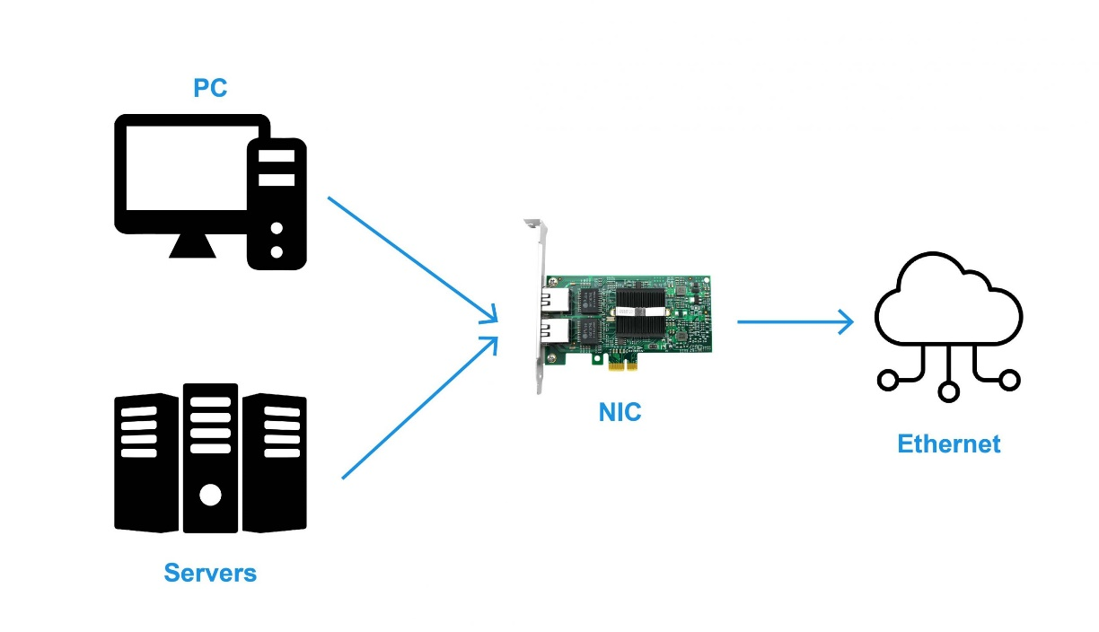

Fig: NIC in Networking.

* 1. Advantages:
     + Provides dedicated connection to a network.
     + Connects various devices to a network.
  2. Disadvantages:
     + May be more expensive.
     + Requires installation and configuration.
     + NIC is inconvenient as compared to the wireless card.
     + NIC cards are not secure, so the data inside NIC is not safe
  3. Limitations:
     + Limited speed, operating at the speed of the device.
     + For wired NIC, a hard-wired connection is required.
  4. Technical Details:
     + Operates at different speeds, e.g., 10/100/1000 Mbps or higher (10/25/40/100 Gbps).

1. **Communication Channels**
2. **Wired Medium:**
   1. **CAT5/CAT6 Cables:**
      1. Characteristics:
         * Transmit data over twisted pairs of copper wires.
         * They are also used to transmit signals over telephones and videos.
         * They mostly connect using punch-down blocks and modular connectors.
         * Most of the cables are unshielded; they do not have any additional insulation coating. They largely rely on the balanced line twisted pair design and differential signaling to ensure noise rejection.
      2. Diagram:

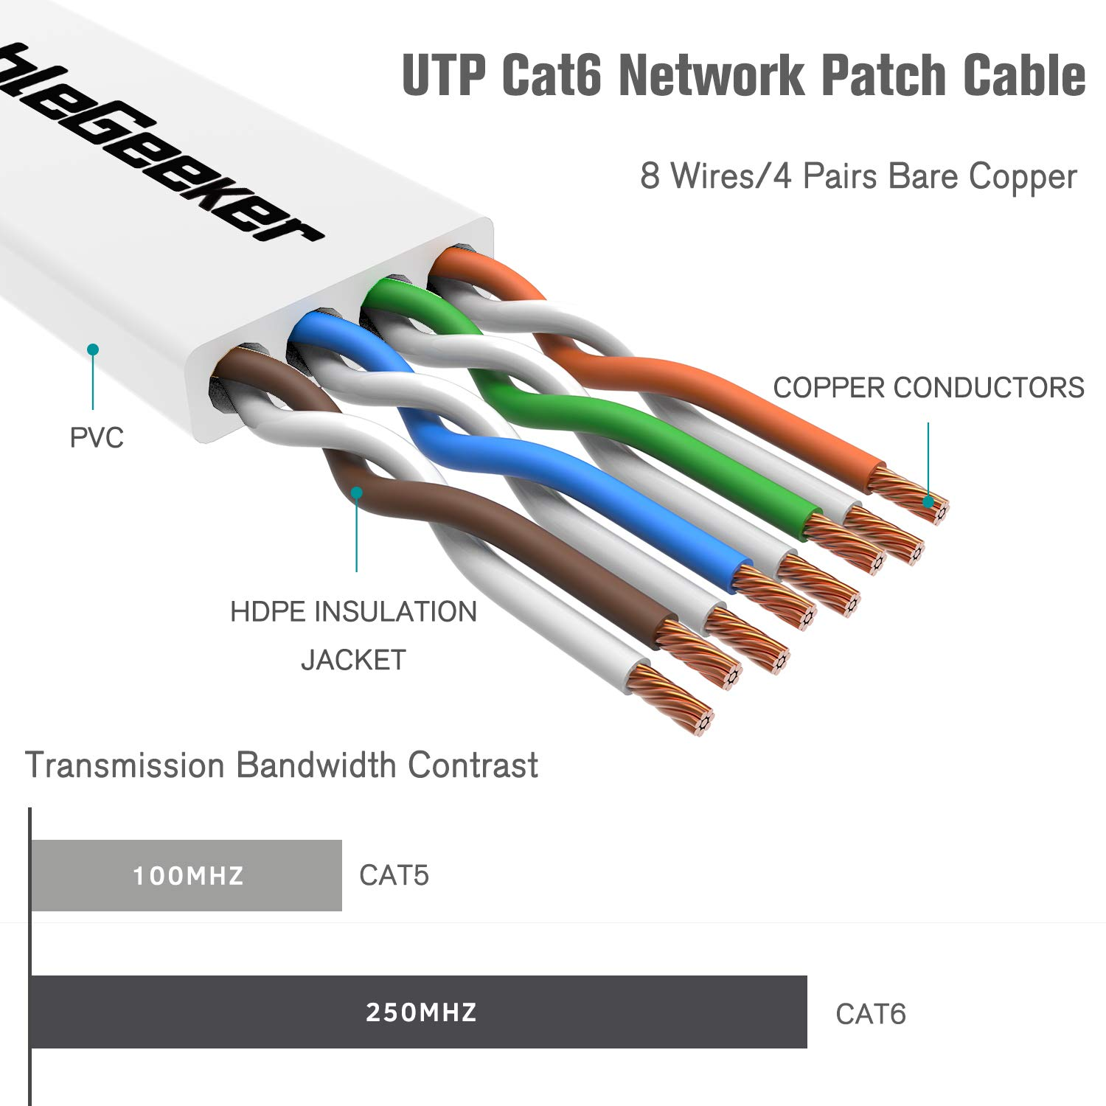

Fig: CAT6 cable.

* + 1. Advantages:
       - Reliable and fast data transmission.
       - Inexpensive and widely available.
    2. Disadvantages:
       - Limited range (up to 100 meters).
       - Susceptible to electromagnetic interference.
    3. Limitations:
       - Maximum length of 100 meters.
    4. Technical Details:
       - Support different speeds (10/100/1000 Mbps or 10/25/40/100 Gbps).
       - Utilizes packet switching for data transmission.
  1. **Coaxial Cable:**
     1. Characteristics:
        + Transmits data using a copper core surrounded by insulation and a braided shield.
        + The core copper conductor is used for the transmission of signals and the insulator is used to provide insulation to the copper conductor and the insulator is surrounded by a braided metal conductor which helps to prevent the interference of electrical signals and prevent cross talk. This entire setup is again covered with a protective plastic layer to provide extra safety to the cable.
     2. Diagram:

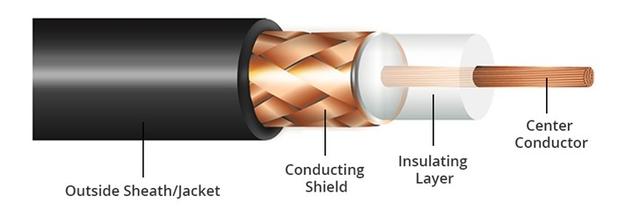

Fig: Coaxial Cable.

* + 1. Structure of Coaxial Cable :
       - Copper conductor: A central conductor, which consists of copper. The conductor is the point at which data transmits.
       - Insulator: Dielectric plastic insulation around the copper conductor. It is used to maintain the spacing between the center conductor and shield.
       - Braided mesh: A braided mesh of copper helps to shield from electromagnetic interference, the braid provides a barrier against EMI moving into and out of the coaxial cable.
       - Protective plastic layer: An external polymer layer, which has a plastic coating. It is used to protect internal layers from damages.
    2. Advantages:
       - Reliable and usable for longer distances than CAT5/CAT6.
    3. Disadvantages:
       - More expensive than CAT5/CAT6.
       - Susceptible to electromagnetic interference.
    4. Limitations:
       - Maximum length of 500 meters.
    5. Technical Details:
       - Uses packet switching for data transmission.
  1. **Fiber Optic + Connectors:**
     1. Characteristics:
        + An Optical Fiber is a cylindrical fiber of glass which is hair thin size or any transparent dielectric medium.
        + The fiber which is used for optical communication is waveguides made of transparent dielectrics.
        + Transmits data using glass or plastic fibers and light signals.
     2. Diagram:

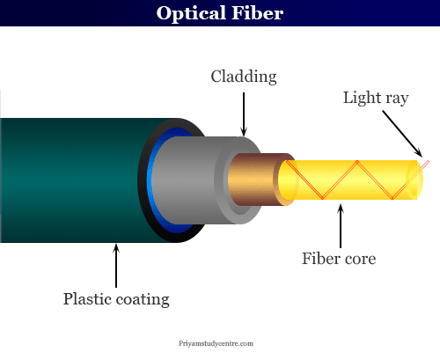

Fig: Optical Fiber Cable.

* + 1. Main element of Fiber Optics :
       - Core: It is the central tube of very thin size made of optically transparent dielectric medium and carries the light transmitter to receiver and the core diameter may vary from about 5um to 100 um.
       - Cladding: It is outer optical material surrounding the core having reflecting index lower than core and cladding helps to keep the light within the core throughout the phenomena of total internal reflection.
       - Buffer Coating: It is a plastic coating that protects the fiber made of silicon rubber. The typical diameter of the fiber after the coating is 250-300 um.
    2. Advantages:
       - Fast and secure data transmission.
       - Suitable for longer distances than copper cables.
    3. Disadvantages:
       - More expensive than copper cables.
       - Requires specialized equipment for installation and maintenance.
    4. Limitations:
       - Maximum length of several kilometers.
    5. Technical Details:
       - Uses packet switching for data transmission.

1. **Wireless Medium:**
   1. **Radio:**
      1. Radio waves can travel large distances as well as they are Susceptible to interference meaning they can penetrate any walls. (Omni-directional, these waves can move in all directions).
      2. These are easy to generate and can penetrate through buildings. The requirement of radio waves is antennas, sending antennas where one can transmit its message and the other is receiving antennas.
      3. The frequency range of radio waves: 3 KHz - 1GHz. Also, radio waves of frequency 300 KHz -30 MHz can travel long distances.

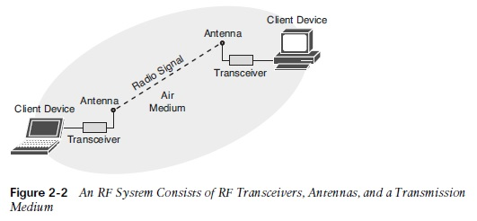

Fig: Radio Waves.

* 1. **Microwaves:**
     1. Microwaves are a line of sight transmission, meaning both the antennas sending and receiving should be properly aligned.
     2. The distance covered by the signal is directly proportional to the height of the antenna.
     3. Microwaves have a frequency Range between 1GHz – 300GHz.
     4. We used Microwaves in mobile phones communication and television distribution.
     5. They are unidirectional, as they can move in only one direction, and therefore it is used in point-to-point communication or unicast communication such as radar and satellite.

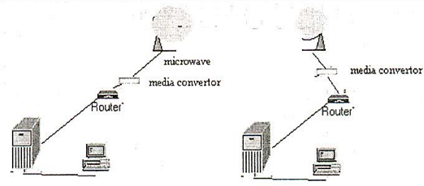

Fig: Microwaves in Networking.

* 1. **Infrared**:
     1. Infrared is used for short-range communication like TV remotes, mobile phones, personal computers etc.
     2. The Infrared is part of a spectrum that is not visible to the human eye.
     3. The limitation of infrared rays is that they cannot penetrate any obstacles and can only use for short-range.
     4. Infrared is used in night vision cameras as it has thermal properties. The frequency range of infrared rays 300GHz – 400THz.
     5. They are used in TV remotes, PC devices like mice.

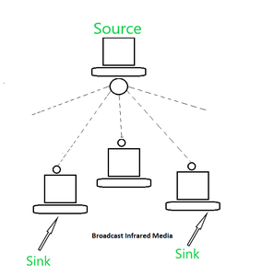

Fig: Infrared Waves.

* 1. **Frequency Band:**
     1. Used to allocate different frequencies for wireless communication.
     2. Regulated by government agencies.

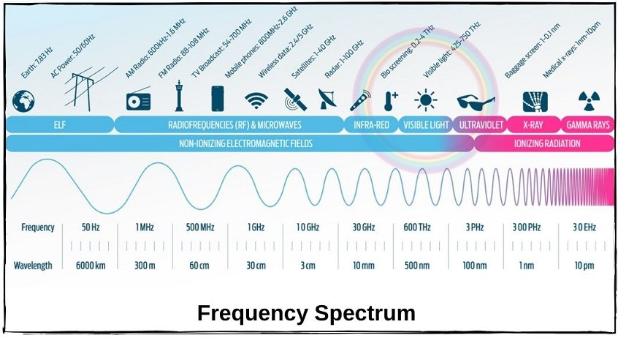

Fig: Frequency Spectrum

1. **IP address (Classification of IP address, Sub netting, Super netting)**

IP addresses are typically classified into two main categories: IPv4 and IPv6.

* 1. IPv4: •
     1. This is the most commonly used version of IP addresses.
     2. It consists of 32 bits, typically represented in decimal format (e.g., 192.168.1.1).
     3. IPv4 addresses are divided into several classes based on the first few bits of the address:
        1. Class A: Addresses in the range 1.0.0.0 to 126.0.0.0
        2. Class B: Addresses in the range 128.0.0.0 to 191.255.0.0
        3. Class C: Addresses in the range 192.0.0.0 to 223.255.255.0
        4. Class D: Reserved for multicast addressing
        5. Class E: Reserved for experimental use
  2. IPv6:
     1. Introduced to address the limitations of IPv4, primarily the exhaustion of available addresses.
     2. Uses 128 bits, providing a vastly larger address space.
     3. Pv6 addresses are typically represented as eight groups of four hexadecimal digits, separated by colons (e.g., 2001:0db8:85a3:0000:0000:8a2e:0370:7334).

**Subnetting:**

1. Subnetting is the process of dividing a larger network into smaller subnetworks, allowing for efficient use of IP addresses and improved network performance.
2. Subnetting involves borrowing bits from the host portion of an IP address to create subnetworks. This process enables better organization and management of network resources.
3. Subnetting is often used to:
   1. Reduce network congestion
   2. Improve network security
   3. Optimize network performance
   4. Allocate IP addresses efficiently

**Supernetting:**

1. Supernetting, also known as route aggregation or route summarization, is the opposite of subnetting.
2. It involves combining multiple contiguous network addresses into a single larger network. This process helps reduce the size of routing tables in routers and simplifies routing processes.
3. Supernetting is commonly used in large-scale networks to:
   1. Decrease routing table size • Improve routing efficiency
   2. Minimize the number of entries in routing tables
   3. Optimize network performance

**Practical 2**

**Name of Program:** Implement the Client-Server communication.

1. TCP communication.
2. UDP communication.

**Code:**

1. **TCP Communication:**
   1. **TCP Client Code:**

package TCP_Connection;

import java.io.*;

import java.net.*;

public class TCPClient {

private Socket socket = null;

private DataInputStream input = null;

private DataOutputStream out = null;

// constructor to put ip address and port

public TCPClient(String address, int port) {

// establish a connection

try {

socket = new Socket(address, port);

System.out.println("Connected");

// takes input from terminal

input = new DataInputStream(System.in);

// sends output to the socket

out = new DataOutputStream(socket.getOutputStream());

} catch (UnknownHostException u) {

System.out.println(u);

return;

} catch (IOException i) {

System.out.println(i);

return;

}

// string to read message from input

String line = "";

String anLine = "";//

// keep reading until "Over" is input

while (true) {

try {

//SEND to Server

System.out.printf(">> ");

line = input.readLine();

out.writeUTF(line);

if (line.equals("END")) {//

break;//

}//

//READ From Server

DataInputStream in = new DataInputStream(new BufferedInputStream(socket.getInputStream()));//

anLine = in.readUTF();//

System.out.println("Server>> "+anLine);//

if (anLine.equals("END")) {//

break;//

}//

} catch (IOException i) {

System.out.println(i);

}

}

System.out.println("-----Connection Ended-----");

// close the connection

try {

input.close();

out.close();

socket.close();

} catch (IOException i) {

System.out.println(i);

}

}

public static void main(String args[]) {

TCPClient client = new TCPClient("127.0.0.1", 5000);

}

}

* 1. **TCP Server Code:**

package TCP_Connection;

import java.net.*;

import java.io.*;

public class TCPServer {

// initialize socket and input stream

private Socket socket = null;

private ServerSocket server = null;

private DataInputStream in = null;

// constructor with port

public TCPServer(int port) {

// starts server and waits for a connection

try {

server = new ServerSocket(port);

System.out.println("Server started");

System.out.println("Waiting for a client ...");

socket = server.accept();

System.out.println("Client accepted");

// takes input from the client socket

in = new DataInputStream(new BufferedInputStream(socket.getInputStream()));

//Initializing another input and out to send Messages

DataInputStream input = new DataInputStream(System.in); //

DataOutputStream out = new DataOutputStream(socket.getOutputStream());;//

String line = "";

String anLine = "";//

// reads message from client until "END" is sent

while (true) {

try {

//READ From Client

line = in.readUTF();

System.out.println("Client>> " + line);

if (line.equals("END")) {//

break;//

}//

//SEND to Client

System.out.printf(">> ");//

anLine=input.readLine();//

out.writeUTF(anLine);//

if (anLine.equals("END")) {//

break;//

}//

} catch (IOException i) {

System.out.println(i);

}

}

System.out.println("-----Closing connection-----");

// close connection

socket.close();

in.close();

} catch (IOException i) {

System.out.println(i);

}

}

public static void main(String args[]) {

TCPServer server = new TCPServer(5000);

}

}

**Output:**

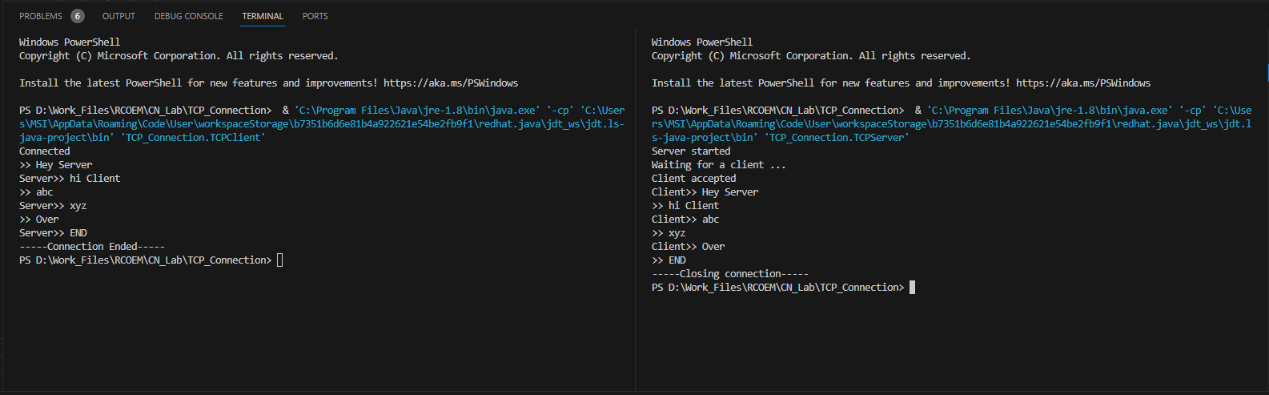

1. **UDP Connection:**
   1. **UDP Client Code:**

import java.io.IOException;

import java.net.DatagramSocket;

import java.net.DatagramPacket;

import java.net.InetAddress;

import java.util.Scanner;

public class UdpConnectionClient{

public static void main(String[] args) throws IOException{

Scanner sc = new Scanner(System.in);

DatagramSocket dataSoc = new DatagramSocket();

InetAddress ip = InetAddress.getLocalHost();

byte buff[] = null;

while(true){

System.out.println(">> ");

String input=sc.nextLine();

buff=input.getBytes();

DatagramPacket dpSend= new DatagramPacket(buff,buff.length,ip,5000);

dataSoc.send(dpSend);

if(input.equals("bye")){

System.out.println("Exiting");

break;

}

byte[] recievedData = new byte[123456];

DatagramPacket dpRecieved =new DatagramPacket(recievedData, recievedData.length);

dataSoc.receive(dpRecieved);

System.out.println("Server >> "+ dataToString(recievedData));

if (dataToString(recievedData).toString().equals("bye")) {

System.out.println("Exiting");

break;

}

}

dataSoc.close();

sc.close();

}

public static StringBuilder dataToString(byte[] byteArray){

if (byteArray == null) {

return null;

}

StringBuilder res = new StringBuilder();

int i = 0;

while (byteArray[i]!=0) {

res.append((char) byteArray[i]);

i++;

}

return res;

}

}

* 1. **UDP Server Code:**

import java.net.DatagramPacket;

import java.net.DatagramSocket;

import java.io.IOException;

import java.net.SocketException;

import java.util.Scanner;

import java.net.InetAddress;

public class UdpConnectionServer extends Thread{

public static void main(String[] args) throws IOException,SocketException{

DatagramSocket ds= new DatagramSocket(5000);

byte[] recievedData = new byte[123456];

DatagramPacket dpRecieved = null;

Scanner sc= new Scanner(System.in);

while(true){

dpRecieved =new DatagramPacket(recievedData, recievedData.length);

ds.receive(dpRecieved);

System.out.println("Client >> "+ dataToString(recievedData));

if (dataToString(recievedData).toString().equals("bye")) {

System.out.println("Exiting");

break;

}

recievedData = new byte[123456];

InetAddress ip = InetAddress.getLocalHost();

System.out.println(">> ");

String input=sc.nextLine();

byte[] buff=input.getBytes();

DatagramPacket dpSend = new DatagramPacket(buff,buff.length,ip,dpRecieved.getPort());

ds.send(dpSend);

if (input.equals("bye")) {

                System.out.println("Exiting");

                break;

            }

}

sc.close();

ds.close();

}

public static StringBuilder dataToString(byte[] byteArray){

if (byteArray == null) {

return null;

}

StringBuilder res = new StringBuilder();

int i = 0;

while (byteArray[i]!=0) {

res.append((char) byteArray[i]);

i++;

}

return res;

}

}

**Output:**

