**Practical 0**

**Aim:** Create data set for the following:

1. Sequential unrepeated one lakh integers to be generated and stored in file1. Display its time in milliseconds.
2. Random unrepeated one lakh integers to be generated and stored in file2. Display its time in milliseconds.
3. Random repeated one lakh integers to be generated and stored in file3. Display its time in milliseconds.

**For file 1:**

**Code:** import java.io.BufferedWriter;

import java.io.FileWriter;

import java.io.IOException;

public class sequentialUnrepeatedNumbers {

public static void main(String[] args) {

long startTime = System.currentTimeMillis();

try (BufferedWriter bw = new BufferedWriter(new FileWriter("sequentialUnrepeatedNumbers.txt"))) {

for (int i = 1; i <= 100000; i++) {

bw.write(Integer.toString(i));

bw.newLine();

}

} catch (IOException e) {

e.printStackTrace();

}

long endTime = System.currentTimeMillis();

System.out.println("Time taken: " + (endTime - startTime) + " milliseconds");

}

}

**Output:**

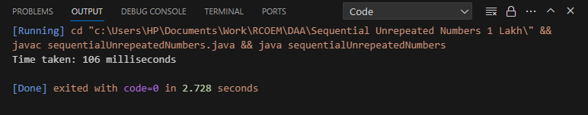

**For File 2:**

**Code:** import java.io.BufferedWriter;

import java.io.FileWriter;

import java.io.IOException;

import java.util.ArrayList;

import java.util.Collections;

public class randomUnrepeatedNumbers {

public static void main(String[] args) {

long startTime = System.currentTimeMillis();

ArrayList<Integer> numbers = new ArrayList<>();

for (int i = 1; i <= 100000; i++) {

numbers.add(i);

}

Collections.shuffle(numbers);

try (BufferedWriter bw = new BufferedWriter(new FileWriter("randomUnrepeatedNumbers.txt"))) {

for (int number : numbers) {

bw.write(Integer.toString(number));

bw.newLine();

}

} catch (IOException e) {

e.printStackTrace();

}

long endTime = System.currentTimeMillis();

System.out.println("Time taken: " + (endTime - startTime) + " milliseconds");

}

}

**Output:**

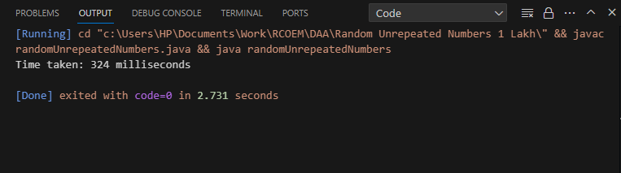

**For File 3:**

**Code:** import java.io.BufferedWriter;

import java.io.FileWriter;

import java.io.IOException;

import java.util.Random;

public class randomRepeatedNumbers {

public static void main(String[] args) {

Random random = new Random();

long startTime = System.currentTimeMillis();

try (BufferedWriter bw = new BufferedWriter(new FileWriter("randomRepeatedNumbers.txt"))) {

for (int i = 1; i <= 100000; i++) {

bw.write(Integer.toString(random.nextInt(0, 100000)));

bw.newLine();

}

} catch (IOException e) {

e.printStackTrace();

}

long endTime = System.currentTimeMillis();

System.out.println("Time taken: " + (endTime - startTime) + " milliseconds");

}

}

**Output:**

