**Shri Ramdeobaba College of Engineering & Management Nagpur-13**

**Department of Computer Application**

**Session: 2023-2024**



**Submission for**

**Course Name:** Design Analysis and Algorithm Lab

**Course Code:** MCP546

**Name of the Student:** Jayesh Lalit Nandanwar

**Class Roll No:** 26

**Semester:** MCA II semester

**Shift:** 2

**Batch:** 2

Under the Guidance of

Prof. Manda Ukey

Date of submission:

**Practical 1**

**Aim:** Perform Linear search on all the three data sets which you have created in practical_0.

Display the time taken to search a key from this file occurring in the first, middle and last position / not found case.

Compare the time taken for all these cases.

**For file 1:**

**Code:** import java.io.FileReader;  
import java.io.IOException;  
import java.util.Scanner;  
  
public class LinearSearchFile1 {  
 public static void main(String[] args) throws IOException {  
 Scanner scanner = new Scanner(System.*in*);  
 int flag = 0;  
 FileReader f = new FileReader("C:\\Users\\HP\\IdeaProjects\\DAA_Practical_1\\src\\sequentialUnrepeatedNumbers.txt");  
 System.*out*.println("Enter element to search : ");  
 String element = scanner.next();  
 long start = 0;  
 Scanner scanner2 = new Scanner(f);  
 start = System.*currentTimeMillis*();  
 while (scanner2.hasNext()) {  
 if (scanner2.next().equals(element)) {  
 long finish = System.*currentTimeMillis*();  
 long timeElapsed = finish - start;  
 System.*out*.println("Element found \nAnd time taken is " + timeElapsed + "ms");  
 flag = 1;  
 break;  
 }  
 }  
 if (flag == 0) {  
 long finish = System.*currentTimeMillis*();  
 long timeElapsed = finish - start;  
 System.*out*.println("Element not found \nAnd time taken is " + timeElapsed + "ms");  
 }  
 scanner.close();  
 scanner2.close();  
 }  
}

**Output:**

Element present at beginning:

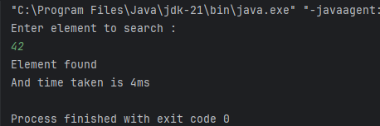

Element present at middle:

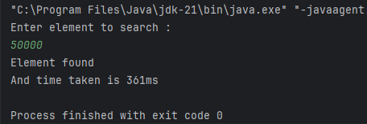

Element present at end:

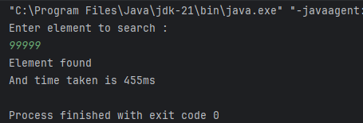

Element not present:

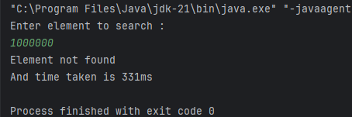

**For File 2:**

**Code:** import java.io.FileReader;  
import java.io.IOException;  
import java.util.Scanner;

public class LinearSearchFile2 {  
 public static void main(String[] args) throws IOException {  
 Scanner scanner = new Scanner(System.*in*);  
 int flag = 0;  
 FileReader f = new FileReader("C:\\Users\\HP\\IdeaProjects\\DAA_Practical_1\\src\\randomUnrepeatedNumbers.txt");  
 System.*out*.println("Enter element to search : ");  
 String element = scanner.next();  
 long start = 0;  
 Scanner scanner2 = new Scanner(f);  
 start = System.*currentTimeMillis*();  
 while (scanner2.hasNext()) {  
 if (scanner2.next().equals(element)) {  
 long finish = System.*currentTimeMillis*();  
 long timeElapsed = finish - start;  
 System.*out*.println("Element found \nAnd time taken is " + timeElapsed + "ms");  
 flag = 1;  
 break;  
 }  
 }  
 if (flag == 0) {  
 long finish = System.*currentTimeMillis*();  
 long timeElapsed = finish - start;  
 System.*out*.println("Element not found \nAnd time taken is " + timeElapsed + "ms");  
 }  
 scanner.close();  
 scanner2.close();  
 }  
}

**Output:**

Element present at beginning:

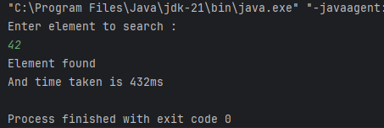

Element present at middle:

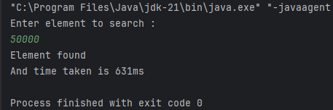

Element present at end:

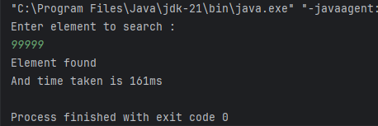

Element not present:

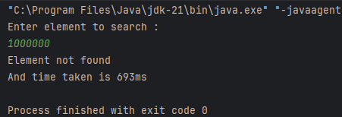

**For File 3:**

**Code:** import java.io.FileReader;  
import java.io.IOException;  
import java.util.Scanner;  
  
public class LinearSearchFile3 {  
 public static void main(String[] args) throws IOException {  
 Scanner scanner = new Scanner(System.*in*);  
 int flag = 0;  
 FileReader f = new FileReader("C:\\Users\\HP\\IdeaProjects\\DAA_Practical_1\\src\\randomRepeatedNumbers.txt");  
 System.*out*.println("Enter element to search : ");  
 String element = scanner.next();  
 long start = 0;  
 Scanner scanner2 = new Scanner(f);  
 start = System.*currentTimeMillis*();  
 while (scanner2.hasNext()) {  
 if (scanner2.next().equals(element)) {  
 long finish = System.*currentTimeMillis*();  
 long timeElapsed = finish - start;  
 System.*out*.println("Element found \nAnd time taken is " + timeElapsed + "ms");  
 flag = 1;  
 break;  
 }  
 }  
 if (flag == 0) {  
 long finish = System.*currentTimeMillis*();  
 long timeElapsed = finish - start;  
 System.*out*.println("Element not found \nAnd time taken is " + timeElapsed + "ms");  
 }  
 scanner.close();  
 scanner2.close();  
 }  
}

**Output:**

Element present at beginning:

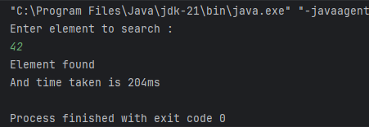

Element present at middle:

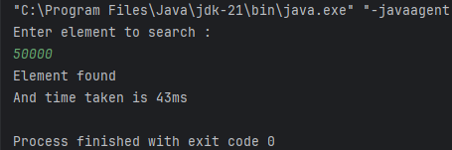

Element present at end:

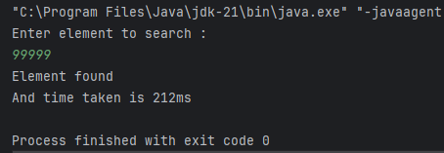

Element not present:

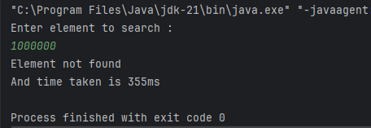

**Comparison between time taken:**

|  |  |  |  |  |  |  |  |  |  |  |  |  |
| --- | --- | --- | --- | --- | --- | --- | --- | --- | --- | --- | --- | --- |
| **File** | **File 1** | | | | **File 2** | | | | **File 3** | | | |
| **Element At** | Start | Middle | End | Not Found | Start | Middle | End | Not Found | Start | Middle | End | Not Found |
| **Time Taken (ms)** | 4 | 361 | 455 | 331 | 432 | 631 | 161 | 693 | 204 | 43 | 212 | 355 |