**Shri Ramdeobaba College of Engineering & Management Nagpur-13**

**Department of Computer Application**

**Session: 2023-2024**



**Submission for**

**Course Name:** Design Analysis and Algorithm Lab

**Course Code:** MCP546

**Name of the Student:** Jayesh Lalit Nandanwar

**Class Roll No:** 26

**Semester:** MCA II semester

**Shift:** 2

**Batch:** 2

Under the Guidance of

Prof. Manda Ukey

Date of submission: 07/04/2024

**Practical 6**

**Aim:** Perform QUICK sort on the data sets that you have created in practical_0.

Display the time taken to sort the elements from the files in ascending order. Consider random repeated and random unrepeated files.

Compare its time with the time taken for selection, insertion and merge sort.

**For file 1 (Sequential unrepeated numbers):**

**Code:** import java.io.FileReader;

import java.io.FileWriter;

import java.io.IOException;

import java.util.Scanner;

public class QuickSortFile1 {

public static void main(String[] args) throws IOException {

String file_name="sequentialUnrepeatedNumbers";

FileReader f = new FileReader("./"+file_name+".txt");

// Reading numbers from file

Scanner fileScanner = new Scanner(f);

int[] array = new int[100001];

int size = 0;

while (fileScanner.hasNextInt()) {

array[size++] = fileScanner.nextInt();

}

fileScanner.close();

long start = System.currentTimeMillis();

quickSort(array, 0, array.length - 1);

long finish = System.currentTimeMillis();

long timeElapsed = finish - start;

writeToFile(array,file_name);

System.out.println("\nTime taken for sorting: " + timeElapsed + " milliseconds");

}

public static void quickSort(int[] array, int low, int high) {

if (low < high) {

int pivotIndex = partition(array, low, high);

quickSort(array, low, pivotIndex - 1);

quickSort(array, pivotIndex + 1, high);

}

}

public static int partition(int[] array, int low, int high) {

int pivot = array[(low + high) / 2];

while (low <= high) {

while (array[low] < pivot) {

low++;

}

while (array[high] > pivot) {

high--;

}

if (low <= high) {

int temp = array[low];

array[low] = array[high];

array[high] = temp;

low++;

high--;

}

}

return low;

}

public static void writeToFile(int arr[],String file_name) throws IOException {

FileWriter writer = new FileWriter("./"+file_name+"SortedOutput.txt");

for (int i = 0; i < arr.length; i++) {

writer.write(arr[i] + "\n");

}

writer.close();

}

}

**Output:**

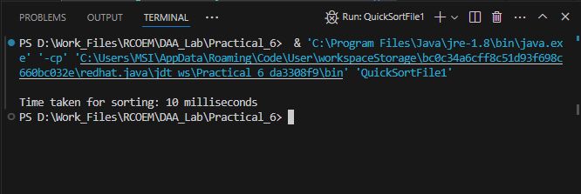

**Time Taken: 10 ms**

**For file 2 (Random unrepeated numbers):**

**Code:** import java.io.FileReader;

import java.io.FileWriter;

import java.io.IOException;

import java.util.Scanner;

public class QuickSortFile2 {

public static void main(String[] args) throws IOException {

String file_name="randomUnrepeatedNumbers";

FileReader f = new FileReader("./"+file_name+".txt");

// Reading numbers from file

Scanner fileScanner = new Scanner(f);

int[] array = new int[100001];

int size = 0;

while (fileScanner.hasNextInt()) {

array[size++] = fileScanner.nextInt();

}

fileScanner.close();

long start = System.currentTimeMillis();

quickSort(array, 0, array.length - 1);

long finish = System.currentTimeMillis();

long timeElapsed = finish - start;

writeToFile(array,file_name);

System.out.println("\nTime taken for sorting: " + timeElapsed + " milliseconds");

}

public static void quickSort(int[] array, int low, int high) {

if (low < high) {

int partitionIndex = partition(array, low, high);

quickSort(array, low, partitionIndex - 1);

quickSort(array, partitionIndex + 1, high);

}

}

public static int partition(int[] array, int low, int high) {

int mid = low + (high - low) / 2;

int pivot = array[mid];

int i = low - 1;

for (int j = low; j < high; j++) {

if (array[j] < pivot) {

i++;

swap(array, i, j);

}

}

swap(array, i + 1, mid);

return i + 1;

}

public static void swap(int[] array, int i, int j) {

int temp = array[i];

array[i] = array[j];

array[j] = temp;

}

public static void writeToFile(int arr[],String file_name) throws IOException {

FileWriter writer = new FileWriter("./"+file_name+"SortedOutput.txt");

for (int i = 0; i < arr.length - 1; i++) {

writer.write(arr[i] + "\n");

}

writer.close();

}

}

**Output:**

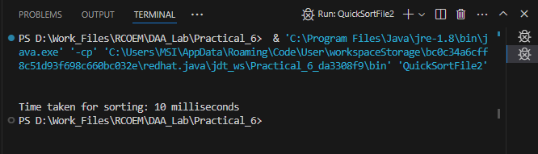

**Time Taken: 10 ms**

**For file 3 (Random repeated numbers):**

**Code:** import java.io.FileReader;

import java.io.FileWriter;

import java.io.IOException;

import java.util.Scanner;

public class QuickSortFile3 {

public static void main(String[] args) throws IOException {

String file_name="randomRepeatedNumbers";

FileReader f = new FileReader("./"+file_name+".txt");

// Reading numbers from file

Scanner fileScanner = new Scanner(f);

int[] array = new int[100001];

int size = 0;

while (fileScanner.hasNextInt()) {

array[size++] = fileScanner.nextInt();

}

fileScanner.close();

long start = System.currentTimeMillis();

quickSort(array, 0, array.length - 1);

long finish = System.currentTimeMillis();

long timeElapsed = finish - start;

writeToFile(array,file_name);

System.out.println("\nTime taken for sorting: " + timeElapsed + " milliseconds");

}

public static void quickSort(int[] array, int low, int high) {

if (low < high) {

int pivotIndex = partition(array, low, high);

quickSort(array, low, pivotIndex - 1);

quickSort(array, pivotIndex + 1, high);

}

}

public static int partition(int[] array, int low, int high) {

int pivot = array[(low + high) / 2];

while (low <= high) {

while (array[low] < pivot) {

low++;

}

while (array[high] > pivot) {

high--;

}

if (low <= high) {

int temp = array[low];

array[low] = array[high];

array[high] = temp;

low++;

high--;

}

}

return low;

}

public static void writeToFile(int arr[],String file_name) throws IOException {

FileWriter writer = new FileWriter("./"+file_name+"SortedOutput.txt");

for (int i = 0; i < arr.length - 1; i++) {

writer.write(arr[i] + "\n");

}

writer.close();

}

}

**Output:**

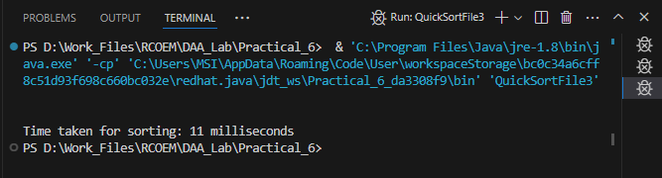

**Time Taken: 11 ms**

**Comparison between time taken:**

|  |  |  |  |
| --- | --- | --- | --- |
| **Sorting Algorithm** | **Time Taken**  **(in ms) For Sorting** | | |
| Sequential Unrepeated Numbers | Random Unrepeated Numbers | Random Repeated Numbers |
| Selection Sort | 1103 | 1591 | 1690 |
| Insertion Sort | 3 | 1830 | 1900 |
| Merge Sort | 24 | 28 | 27 |
| Quick Sort | 10 | 10 | 11 |

**Observations:**

* Time taken to sort Random Unrepeated Numbers and Random Repeated Numbers is minimum in using Quick Sort Algorithm.
* Time taken to sort Sequential Unrepeated Numbers is less in Insertion Sort (3 ms) than Quick Sort(10 ms) and Merge Sort(24 ms) and Selection Sort (1103 ms).