**Shri Ramdeobaba College of Engineering & Management Nagpur-13**

**Department of Computer Application**

**Session: 2023-2024**



**Submission for**

**Course Name:** Database Management Systems Lab

**Course Code:** MCP545

**Name of the Student:** Jayesh Lalit Nandanwar

**Class Roll No:** 26

**Semester:** MCA II semester

**Shift:** 2

**Batch:** 2

Under the Guidance of

Prof. Yoginee Pethe

Date of submission: 05/03/2024

**List of Experiments**

1. Implementation of DDL commands of SQL with suitable examples
   1. Create table b) Alter table c) Truncate table d) Drop table

Implementation of DML commands of SQL with suitable examples

1. Select b) Insert c) Update d) Delete
2. Study and implementation of different types of constraints.
3. Implementation of different types of operators in SQL

a)Arithmetic Operators b) Logical Operators

c) Comparison Operators d) Set Operators

1. Study and Implementation of
   1. Aggregate functions
   2. Group By & Having clause
   3. Order by clause
2. Study and Implementation of different types of joins like cross join, natural join, inner join, and outer joins.
3. Study and Implementation of Sub queries
4. Study and Implementation of views, and synonyms.
5. Study and Implementation of PL/SQL.

**Practical 4**

**Aim:** Study and Implementation of

1. Aggregate functions
2. Group By & Having clause
3. Order by clause

**Table: Furniture**

|  |  |  |  |  |  |
| --- | --- | --- | --- | --- | --- |
| **FCODE** | **NAME** | **MATERIAL** | **PRICE** | **MANUFDATE** | **WCODE** |
| 1002 | Coffee Chair | Wood | 3000 | 19-NOV-2017 | W01 |
| 1003 | Dining table | Wood | 20500 | 12-JAN-2019 | W02 |
| 1004 | Coffee Table | Glass | 5000 | 06-JAN-2019 | W02 |
| 1005 | Chair | Wood | 2500 | 07-MAY-2017 | W01 |
| 1006 | Recliner | Fibre | 12000 | 31-MAR-2018 | W03 |

**Solution:**

1. Find the maximum, minimum, and total price.

**Query:** SELECT MAX(price), MIN(price), SUM(price) FROM Furniture;

**Output:**

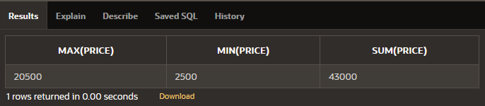

1. Find the total number of furniture.

**Query:** SELECT COUNT(fcode) FROM Furniture;

**Output:**

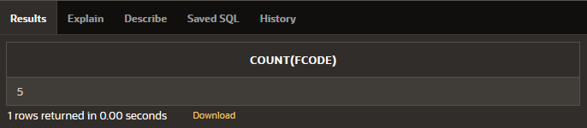

1. List the total price for each material.

**Query:** SELECT material, SUM(price) FROM Furniture GROUP BY (material);

**Output:**

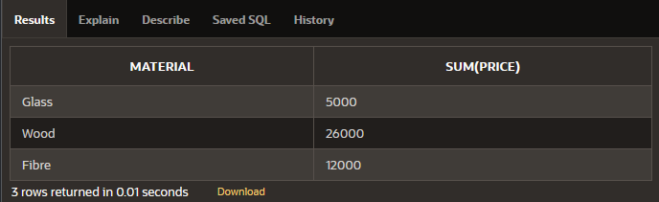

1. Give maximum price for wood.

**Query:** SELECT material, MAX(price) FROM Furniture GROUP BY (material)

HAVING material='Wood';

**Output:**

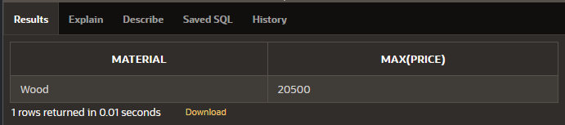

1. Display the average price of each material.

**Query:** SELECT material, AVG(price) AS "Average Price" FROM Furniture

GROUP BY (material);

**Output:**

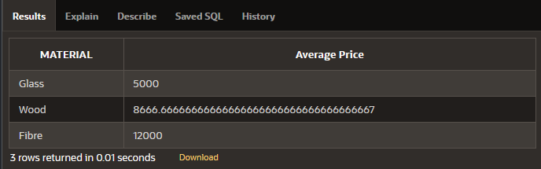

1. List fcode and the amount of all furniture in ascending order of price.

**Query:** SELECT fcode, price FROM Furniture ORDER BY price ASC;

**Output:**

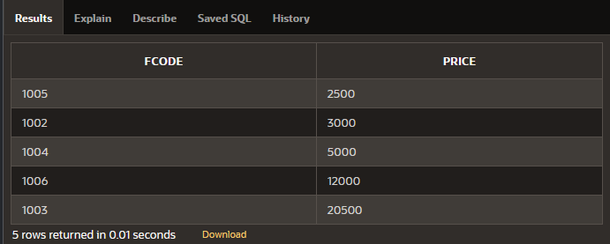

1. List the materials having a sum of price more than 10000.

**Query:** SELECT material, SUM(price) FROM Furniture GROUP BY (material)

HAVING SUM(price)>10000;

**Output:**

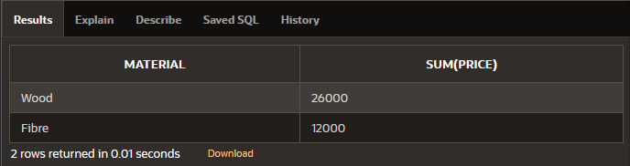

1. Give the name of furniture whose number of wcode is less than 2.

**Query:** SELECT name FROM Furniture

WHERE wcode IN (

SELECT wcode FROM Furniture GROUP BY wcode

HAVING COUNT(wcode) < 2

);

**Output:**

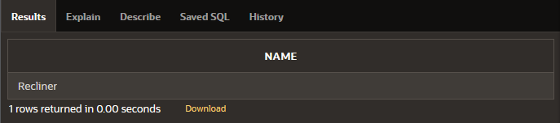

1. Give the name of materials whose average price is greater than 15000.

**Query:** SELECT material, AVG(price) FROM Furniture GROUP BY (material)

HAVING AVG(price)>15000;

**Output:** No data found.

1. Give the name of materials whose total price is less than 6000.

**Query:** SELECT material, SUM(price) FROM Furniture GROUP BY (material)

HAVING SUM(price)<6000;

**Output:**

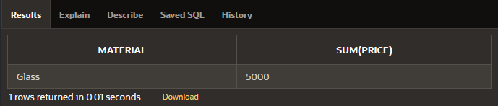

1. Display the name of the furnitures in descending order of manufacturing date.

**Query:** SELECT name FROM Furniture ORDER BY manufdate DESC;

**Output:**

