**TOPIC: TruTime**

|  |  |
| --- | --- |
| **TEAM MEMBERS** | |
| **NAME** | **EMPLOYEE ID** |
| KIRTAN GAJJAR | 2234444 |
| KUNAL KUMAR | 2234542 |
| MERIN CYRIAC | 2234478 |
| RASHMI PATEL | 2235257 |
| SHLOK BARUAOLE | 2234443 |
| VEDIKA KAMDI | 2234485 |

## Table of Contents

Table of Contents ii

Table Of Figures iii

1 WEBSITE 1

2 REQUIREMENTS 2

2.1 Problem Statement: Verify dates and days of current week 2

2.2 Detailed Description: 2

2.3 Key Automation Scope: 2

3 TOOLS AND TECHNOLOGIES USED: 3

3.1 Selenium with Java in Eclipse IDE: 3

3.2 TestNG: 3

3.3 Maven: 3

3.4 WebDriverManager- Boni García: 3

3.5 ExtentReports 4

3.6 Page Factory with POM 4

3.7 BDD Cucumber: 4

4 SCREENSHOTS: 5

4.1 Login using correct Email ID and Password 5

4.2 Searching and Selecting TruTime 7

4.3 Verification of displayed dates 9

## Table Of Figures

Figure 1.1 Website : Landing Page 1

Figure 4.1.1 User enters valid email id and clicks next button 5

Figure 4.1.2 User enters valid password and clicks next button 5

Figure 4.1.3 User selects required login option 6

Figure 4.2.1 User is redirected to homepage after successful login 7

Figure 4.2.2 User clicks on search bar and enters TruTime 7

Figure 4.2.3 User clicks on Apps & Tools 8

Figure 4.2.4 User clicks on TruTime 8

Figure 4.3.1 Current week details like day and date are displayed on the TruTime page. 9

# WEBSITE

URL: <https://be.cognizant.com/>

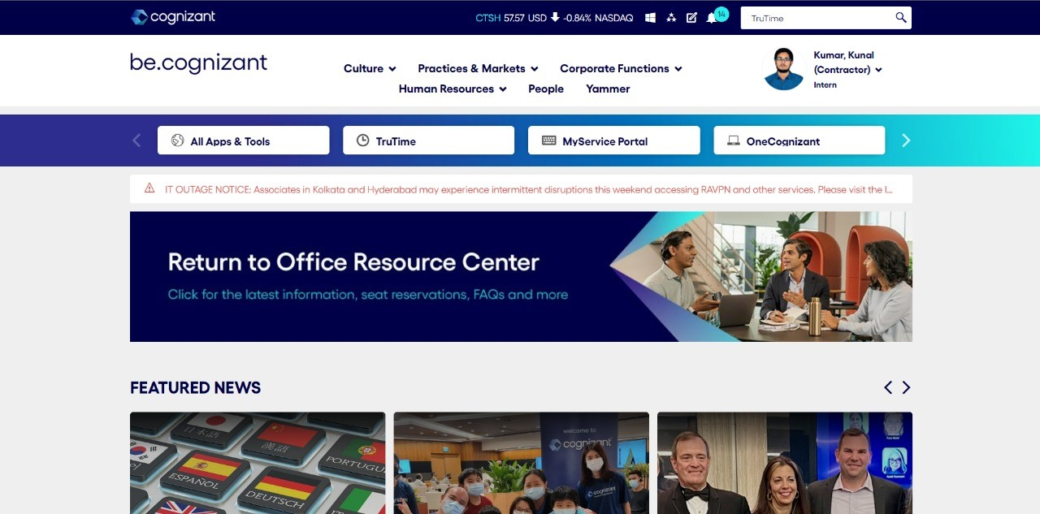

Figure 1.1 Website: Landing Page

# REQUIREMENTS

## Problem Statement: Verify dates and days of current week

Verify the dates and days of the week displayed on TruTime home page. The dates displayed should be in accordance with the current date of system.

## Detailed Description:

1. Login to [be.cognizant.com](https://be.cognizant.com/) with a valid registered Email ID
2. Verify if the name and designation of the employee is displayed on the homepage, and print these details on console.
3. Verify the dates and days of the week displayed on TruTime home page, and print them on console
4. Verify that the date under “Today” section matches the current date of the system.

## Key Automation Scope:

* Filling simple form
* Extract menu items from frames & store in collections
* Handling different browser windows
* Handling search option

# TOOLS AND TECHNOLOGIES USED:

## Selenium with Java in Eclipse IDE:

Selenium is one of the most renowned open-source test automation frameworks.

Selenium Framework is used in this project to interact directly with the browsers through automation testing scripts written in JAVA.

## TestNG:

TestNG is an automation testing framework in which NG stands for “Next Generation”.

In this project, TestNG is used to create, control and the execute the all the test cases. Annotations and attributes in TestNG are used to define the dependency, description and prioritization of test cases. It is also supporting the data-driven testing.

## Maven:

Maven is a built automation tool from Apache Software Foundation and is commonly used to handle Java projects. It is widely used to manage project dependencies and the whole lifecycle of any project. Maven uses the concepts of the project object model (POM) and enables the user to cut down several steps followed in the build process.

Maven builds a project using its project object model (POM) and a set of plugins. Once you familiarize yourself with one Maven project, you know how all Maven projects build. This saves time when navigating many projects.

## WebDriverManager- Boni García:

WebDriverManager is an open-source Java library that carries out the management (i.e., download, setup, and maintenance) of the drivers required by Selenium WebDriver (e.g., chromedriver, geckodriver, msedgedriver, etc.) in a fully automated manner.

WebDriverManager provides a fluent API available using the class WebDriverManager (package io.github.bonigarcia.wdm). This class provides a group of static methods to create *managers*, i.e., objects devoted to providing automated driver management and other features.

## ExtentReports

ExtentReports is a logger-style reporting library for automated tests. A logger is simply an object to log messages or events for a specific system or application. ExtentReports uses the logging style to add information about test sessions, such as creation of tests, adding screenshots, assigning tags, and adding events or series of steps to sequentially indicate the flow of test steps.

In this project ExtentReports has been used to keep a track of success status (PASS/FAIL/SKIP) of each automated test case, and create a report on the same. This HTML report contains pie chart representation, test stepwise report generation, adding screenshots etc., at every test step and a presentable user interface that can be shared with all stakeholders of the project.

## Page Factory with POM

Page Factory in Selenium is an inbuilt Page Object Model framework concept for Selenium WebDriver but it is very optimized. It is used for initialization of Page objects or to instantiate the Page object itself. It is also used to initialize Page class elements without using “FindElement/s.”.

In this project Page Factory is used as to create different classes for each page to be tested.

## BDD Cucumber:

Cucumber is a testing framework that supports Behavior Driven Development (BDD). It is written in plain English text called Gherkin. It is defined as a scenario of inputs, actions and outcomes. Gherkin interprets human input into the software concept of input/process and actions. It is used for describing examples with Given/When/Then in plain text files called feature files.

In this project cucumber is used to create feature file to store high-level description of scenarios and steps and to generate cucumber reports that contain information about what scenarios have passed or failed.

# SCREENSHOTS:

## Login using correct Email ID and Password

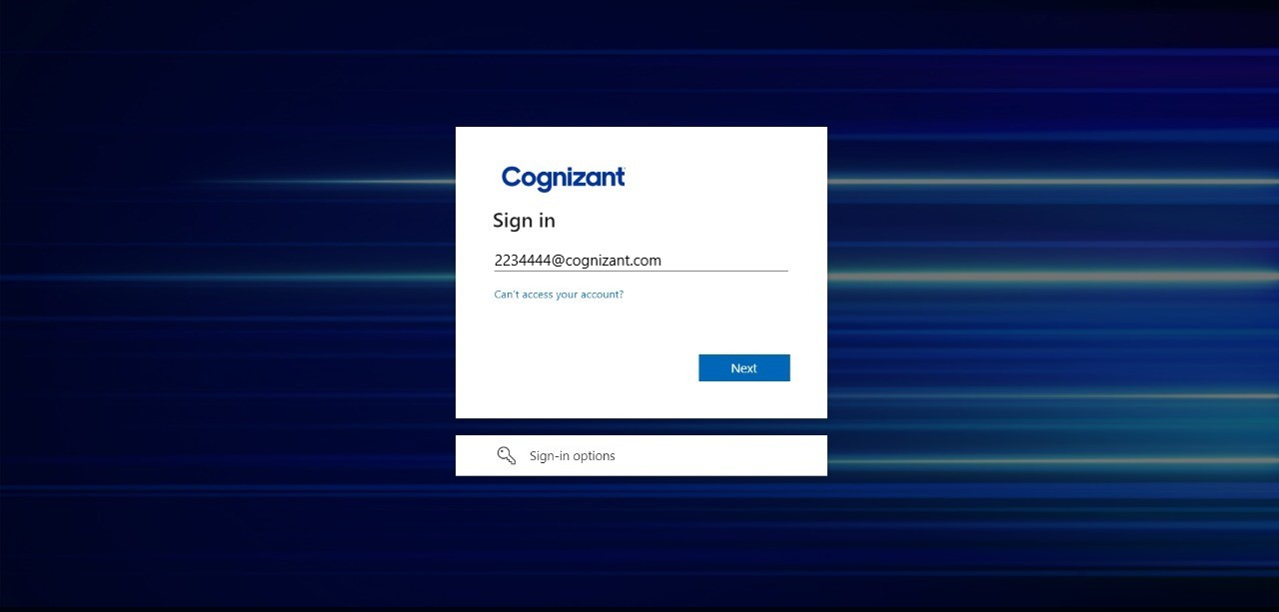

Figure 4.1.1 User enters valid email id and clicks next button

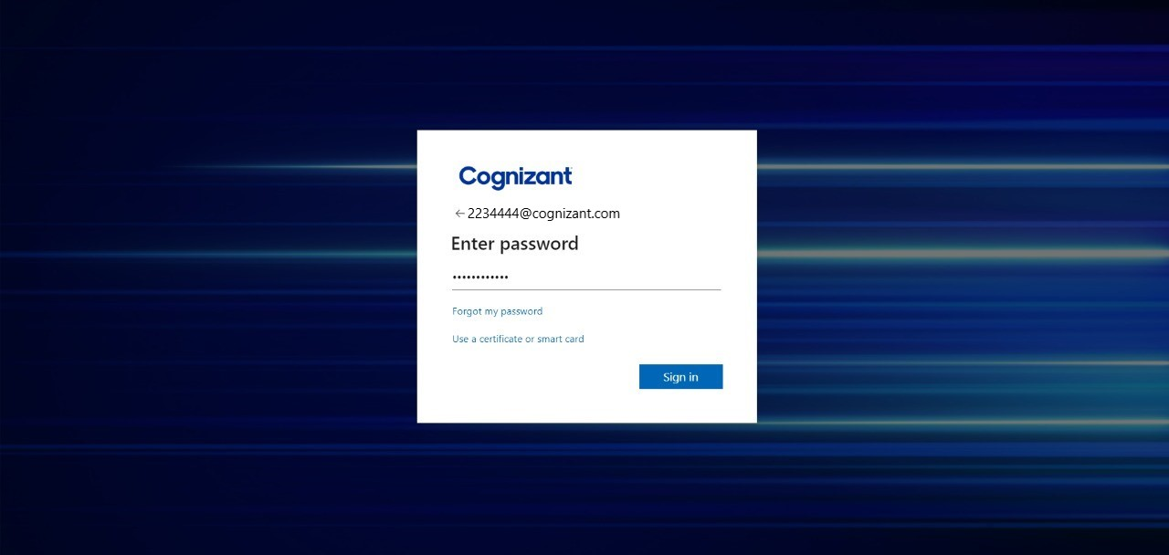

Figure 4.1.2 User enters valid password and clicks next button

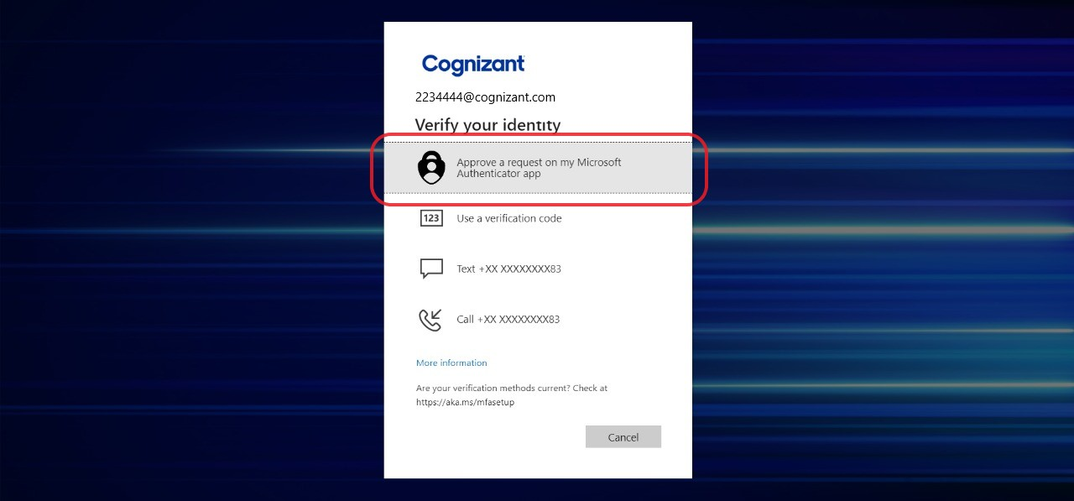

Figure 4.1.3 User selects required login option

## Searching and Selecting TruTime

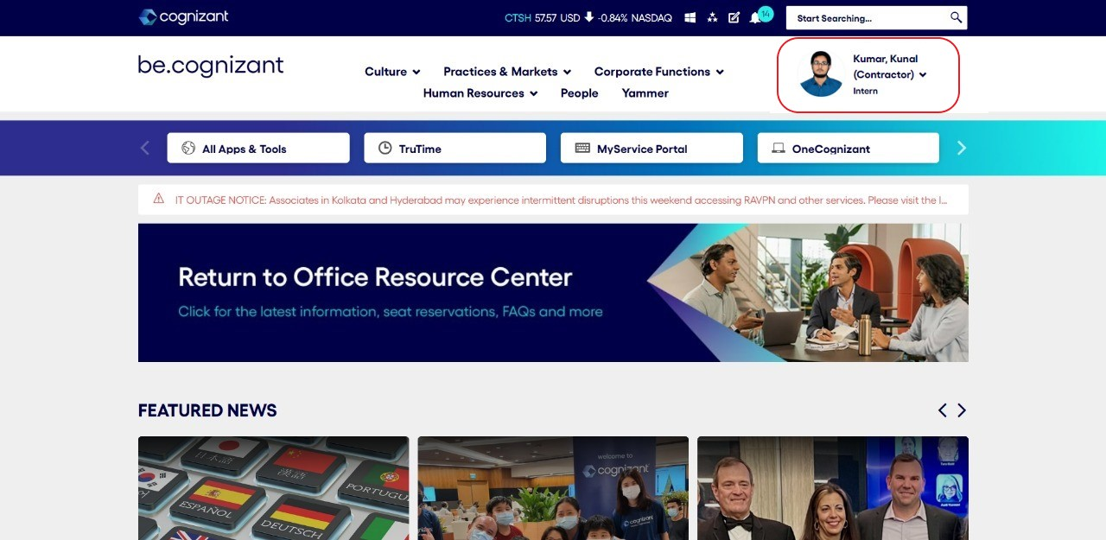

Figure 4.2.1 User is redirected to homepage after successful login

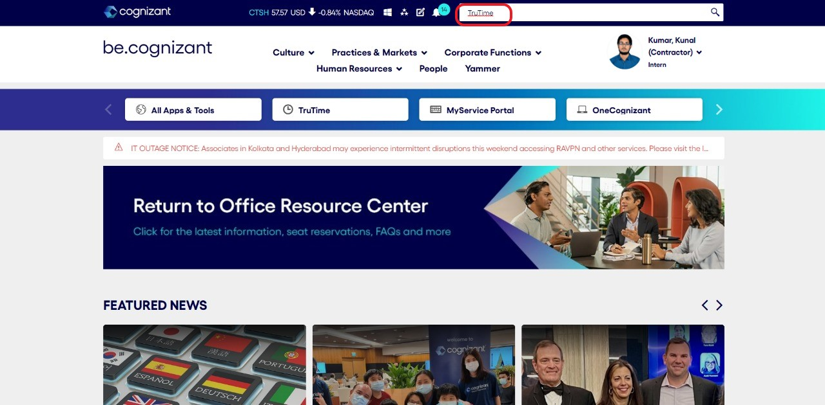

Figure 4.2.2 User clicks on search bar and enters TruTime

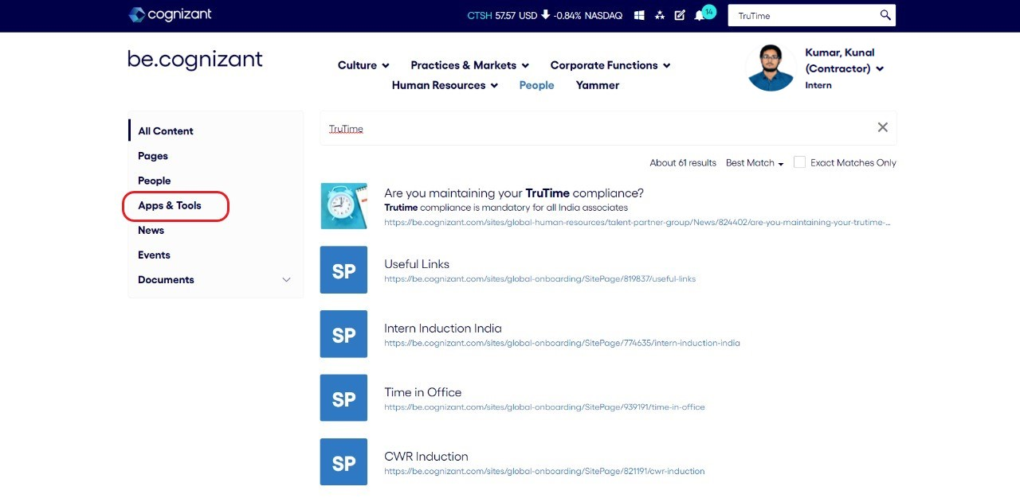

Figure 4.2.3 User clicks on Apps & Tools

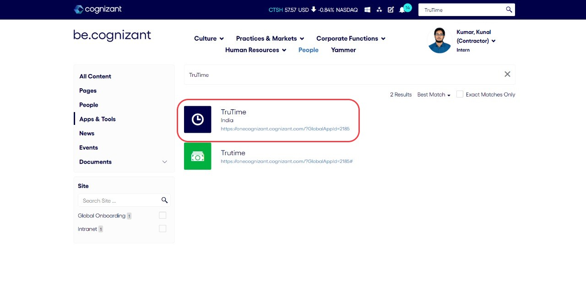

Figure 4.2.4 User clicks on TruTime

## Verification of displayed dates

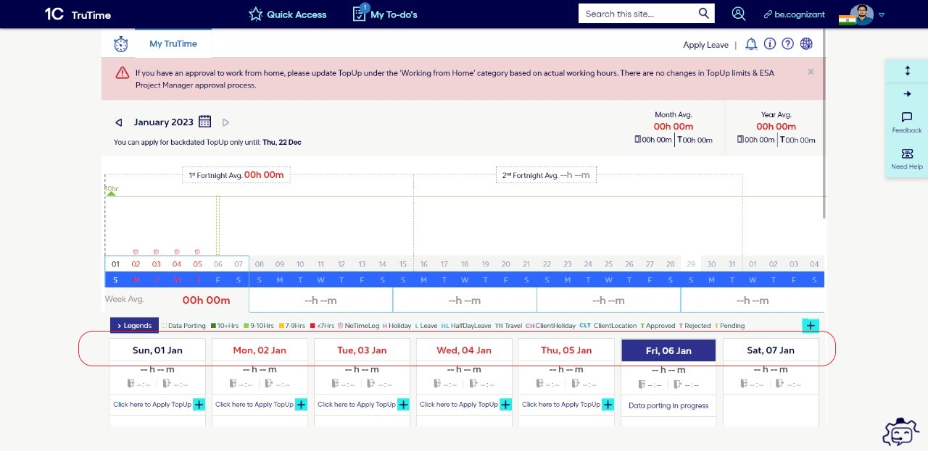

Figure 4.3.1 Current week details like day and date are displayed on the TruTime page.