Always A Bigger Ship

Game Identity / Mantra:
A 2D top down arcade shooter about spaceships battling and plundering each other for parts, with the goal of becoming the strongest ship around

Design Pillars:
Fast
Always Growing
Rouge Like

Genre/Story/Mechanics Summary:
Ships in this game are modular, where each component can be shot off and possibly reattached to the player ship, thus allowing to player to go from a junk ship to the strongest battleship around.

Features:
- Modular ships
  - Ships are a collection of block components that can be freely attached to each other
    - Multiple types of components
      - Thruster – increase travel speed and acceleration in their direction
      - Weapons
        - Auto-firing turrets
        - Special manual weapons
      - Generators – Increase available ship power
      - Hull – Protects other components
  - Partial destruction, instead of being destroyed ship components might fly off
  - Free floating components can be collected and automatically attached to a ship
- Non instant projectiles
  - Projectiles have travel time, requiring the player to lead their shots
  - Projectiles can be dodged
- Enemies
  - The same modular ship like the player
- Environmental hazards
  - Asteroids and other obstacles
- Ship editing mode
  - During the run the player may edit the placements of components
  - Player must balance their hull and firepower against available power and thruster power
- Arcade like runs
  - Each run begins with the player in a junk ship and ends with the player’s destruction
- Missions
  - Special tasks that give the player access to better equipment
  - Pirate missions – gain a specific component out of an enemy ship
  - Defense Mission – Defend a friendly ship from a swarm of enemies
  - Courier mission – go to another place quickly

Interface:
- Movement – Forward and backward thrust (WS), turning (AD)
- Player can choose automatic placements mode (Mouse on UI or R)
- Ship editing done by drag and dropping with mouse
- Special Weapons can be binded to number keys
- Turrets can be manually targeted using the mouse

Art Style:
Gritty utilitarian sci-fi
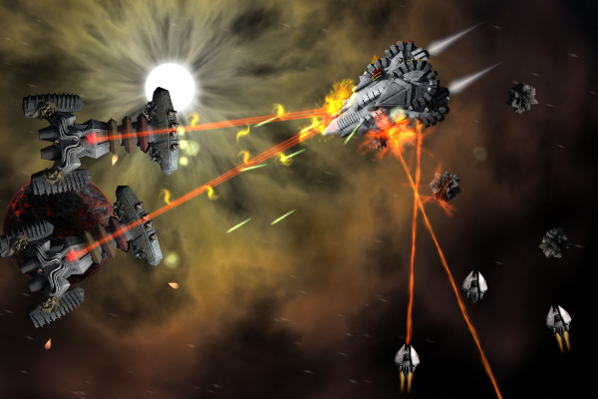
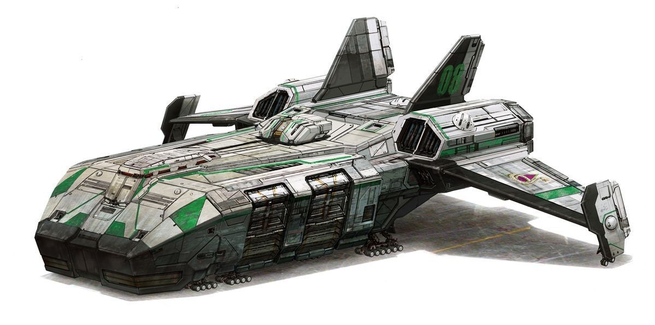

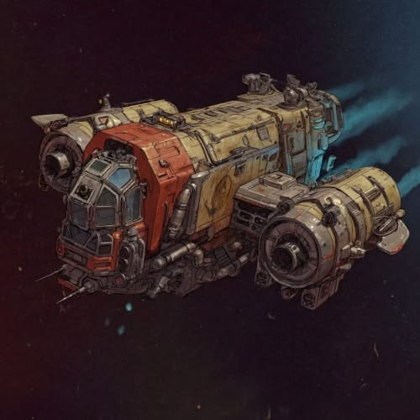
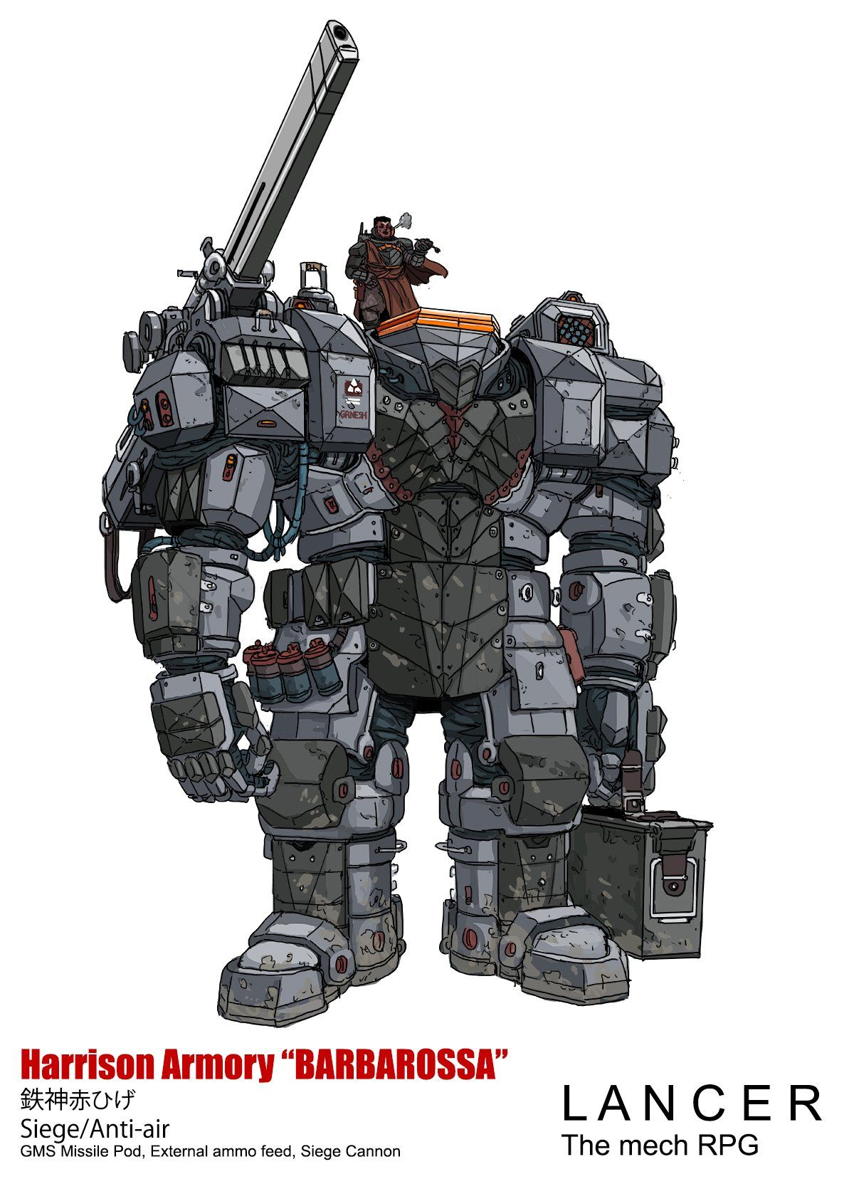
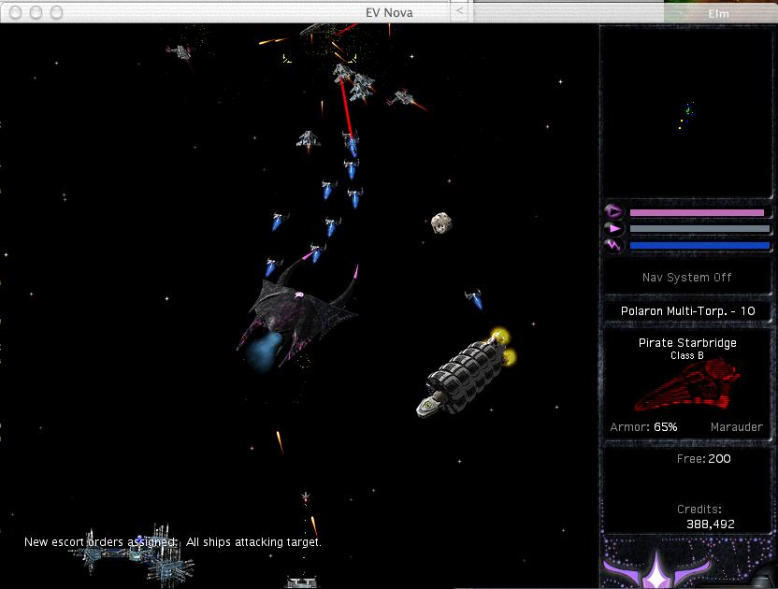

Music/Sound:
- Sci fi techno music to evoke the grandeur of space
  - https://www.youtube.com/watch?v=iEJk8oE7Ag4
  - https://youtu.be/o1YWTrVd7ig
- Quick paced industrial battle music to evoke the mayhem of a space battle
  - https://youtu.be/2M7_r3P1naU
  - https://youtu.be/KEExr_LFHYs

Development Roadmap / Launch Criteria:
Platform: Desktop (Windows, Linux) Audience: Age/gender/interests.

