For the home page, I’m thinking the user would be presented with 3 choices to login as:
- Requester
- Auditor
- Admin
Whatever the choice will be, the user will be led to a login page such as this:

The requester page will look similar to this:
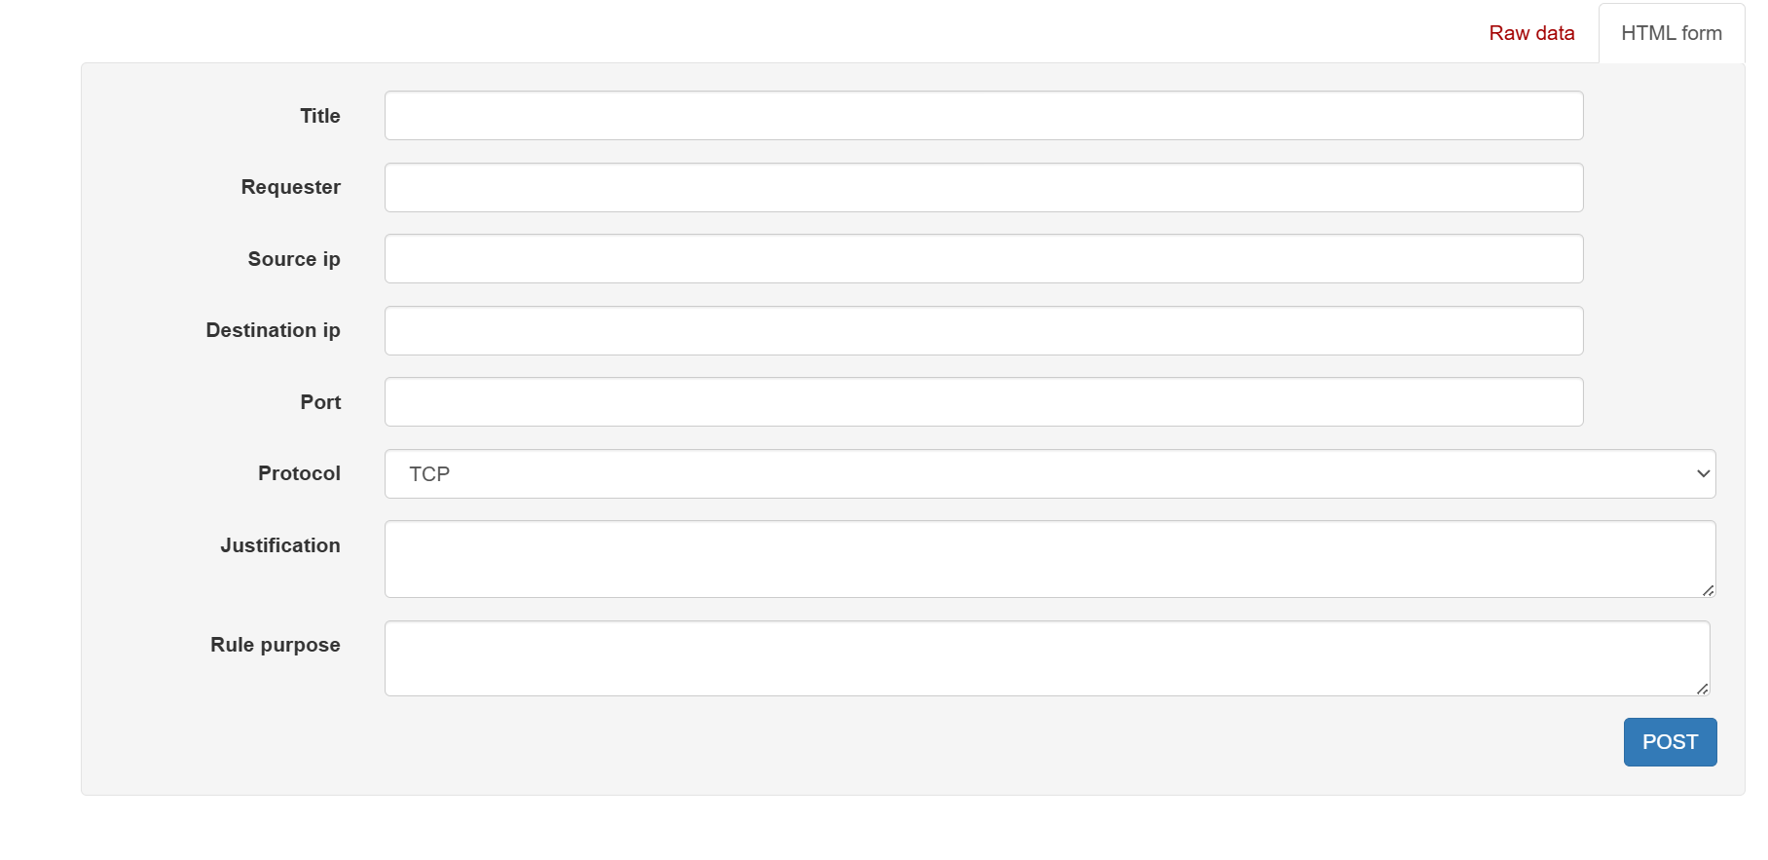
What the audit page could look like for logs, searching and filtering results:
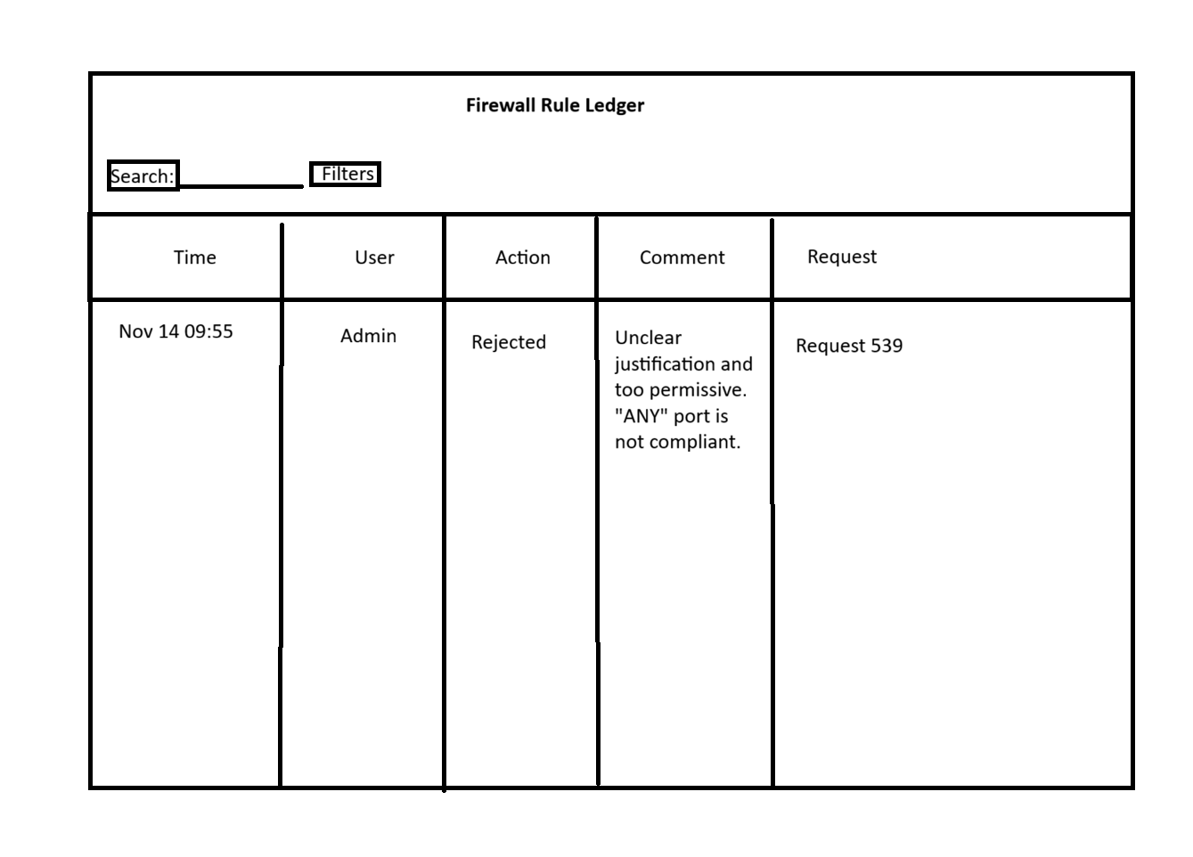

This is what a user management page would look like:
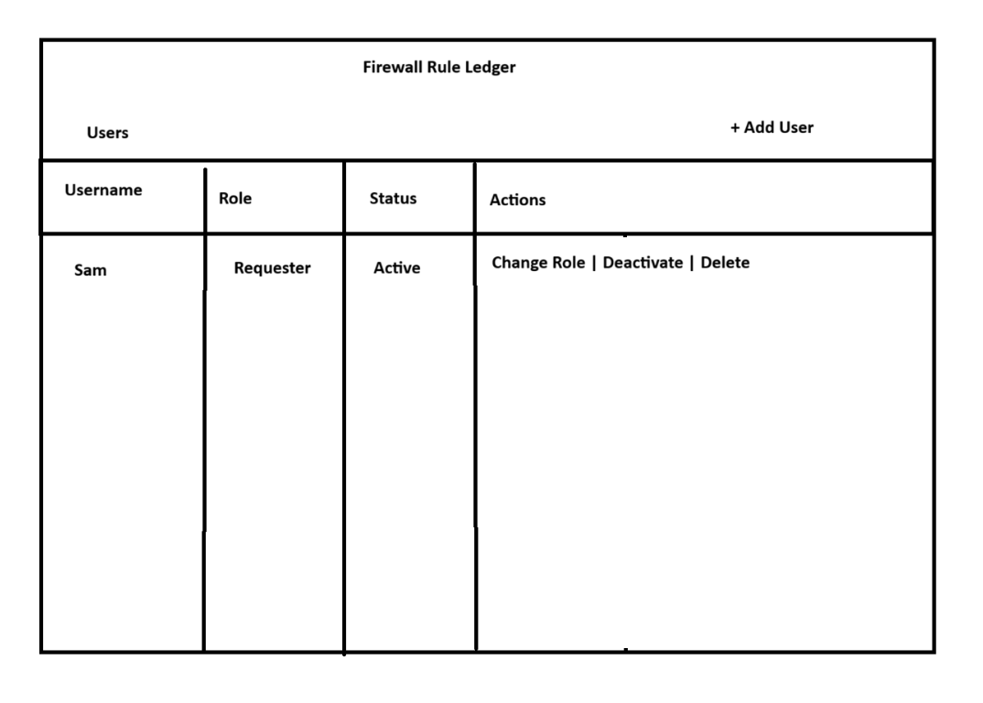

This is what a specific request page could look like to a reviewer, there should also be a list view to navigate through, a table similar to the items above.


