<!DOCTYPE html>

<html>

<head>

<title>Creatwise</title>

<!-- Import bootstrap cdn -->

<link rel="stylesheet" href="https://stackpath.bootstrapcdn.com/bootstrap/4.5.2/css/bootstrap.min.css"

integrity="sha384-JcKb8q3iqJ61gNV9KGb8thSsNjpSL0n8PARn9HuZOnIxN0hoP+VmmDGMN5t9UJ0Z" crossorigin="anonymous" />

<link rel="stylesheet" href="bootstrap/dist/css/bootstrap.css">

<script src="node_modules/jquery/dist/jquery.js"></script>

<script src="node_modules/bootstrap/dist/js/bootstrap.bundle.js"></script>

<link rel="stylesheet" href="https://cdnjs.cloudflare.com/ajax/libs/font-awesome/5.15.3/css/all.min.css"

integrity="sha512-iBBXm8fW90+nuLcSKlbmrPcLa0OT92xO1BIsZ+ywDWZCvqsWgccV3gFoRBv0z+8dLJgyAHIhR35VZc2oM/gI1w=="

crossorigin="anonymous" referrerpolicy="no-referrer" />

<!-- Import jquery cdn -->

<script src="https://code.jquery.com/jquery-3.5.1.slim.min.js"

integrity="sha384-DfXdz2htPH0lsSSs5nCTpuj/zy4C+OGpamoFVy38MVBnE+IbbVYUew+OrCXaRkfj" crossorigin="anonymous">

</script>

<!-- Import popper.js cdn -->

<script src="https://cdn.jsdelivr.net/npm/popper.js@1.16.1/dist/umd/popper.min.js"

integrity="sha384-9/reFTGAW83EW2RDu2S0VKaIzap3H66lZH81PoYlFhbGU+6BZp6G7niu735Sk7lN" crossorigin="anonymous">

</script>

<!-- Import javascript cdn -->

<script src="https://stackpath.bootstrapcdn.com/bootstrap/4.5.2/js/bootstrap.min.js"

integrity="sha384-B4gt1jrGC7Jh4AgTPSdUtOBvfO8shuf57BaghqFfPlYxofvL8/KUEfYiJOMMV+rV" crossorigin="anonymous">

</script>

<script>

{

function CreateClick() {

document.getElementById("name").innerHTML = document.getElementById("txtName").value;

document.getElementById("s_date").innerHTML = document.getElementById("txtStart").value;

document.getElementById("e_date").innerHTML = document.getElementById("txtEnd").value;

document.getElementById("weeks").innerHTML = document.getElementById("txtWeeks").value;

}

function navTeam() {

var x = document.getElementById("side_nav");

if (x.style.display === "none") {

x.style.display = "block";

} else {

x.style.display = "none";

}

}

function Tac() {

var x = document.getElementById("tac");

if (x.style.display === "none") {

x.style.display = "block";

} else {

x.style.display = "none";

}

}

function Dashboard() {

var x = document.getElementById("dashboard");

if (x.style.display === "none") {

x.style.display = "block";

} else {

x.style.display = "none";

}

}

function Tactics() {

var x = document.getElementById("tactics");

if (x.style.display === "none") {

x.style.display = "block";

} else {

x.style.display = "none";

}

}

function Team() {

var x = document.getElementById("team");

if (x.style.display === "none") {

x.style.display = "block";

} else {

x.style.display = "none";

}

}

function Schedule() {

var x = document.getElementById("schedule");

if (x.style.display === "none") {

x.style.display = "block";

} else {

x.style.display = "none";

}

}

function Plans() {

var x = document.getElementById("plans");

if (x.style.display === "none") {

x.style.display = "block";

} else {

x.style.display = "none";

}

}

function Metrics() {

var x = document.getElementById("metrics");

if (x.style.display === "none") {

x.style.display = "block";

} else {

x.style.display = "none";

}

}

function Customization() {

var x = document.getElementById("customization");

if (x.style.display === "none") {

x.style.display = "block";

} else {

x.style.display = "none";

}

}

}

</script>

<!-- CSS stylesheet -->

<style type="text/css">

html,

body {

height: 100%;

}

#side_nav {

height: auto;

max-height: 100%;

background: rgb(12, 145, 12);

color: black;

padding: 150px 20px 105px 10px;

}

.fa-head-side-virus {

font-size: 30px;

}

.col-2 a {

color: white;

text-decoration-line: none;

}

.col-2 a:hover {

color: wheat;

}

nav {

font-weight: bold;

}

#menu1 {

border: none;

display: flex;

}

#day1,

#day2,

#day3,

#day4,

#day5,

#day6,

#day7 {

background-color: white;

color: gray;

margin-left: 15px;

padding: 5px;

width: 150px;

}

.b-icons {

display: flex;

align-self: flex-end;

justify-content: right;

flex-direction: column;

}

</style>

</head>

<body>

<div class="container-fluid h-100">

<!-- h-100 takes the full height

of the container-->

<div class="row h-100">

<div class="col-2" id="side_nav">

<a href="#" onclick="Tac()"><i class="fas fa-head-side-virus">&nbsp;&nbsp;</i>Tac-Tic-Tec</a><br />

<br />

<!-- Navigation links in sidebar-->

<a href="#" onclick="Dashboard()"><i class="fas fa-chart-pie">&nbsp;&nbsp;&nbsp;</i>Dashboard</a><br />

<br />

<a href="#" onclick="Tactics()"><i class="fas fa-chess-board">&nbsp;&nbsp;&nbsp;</i>Tactics Vault</a><br />

<br />

<a href="#" onclick="Team()"><i class="fas fa-users">&nbsp;&nbsp;</i>Teams</a><br />

<br />

<a href="#" onclick="Schedule()"><i class="fas fa-file-alt">&nbsp;&nbsp;&nbsp;&nbsp;</i>Schedule

Generator</a><br />

<br />

<a href="#" onclick="Plans()"><i class="fas fa-calendar-alt">&nbsp;&nbsp;&nbsp;</i>Weekly Training

Plans</a><br />

<br />

<a href="#" onclick="Metrics()"><i class="fas fa-chart-bar">&nbsp;&nbsp;</i>Team Metrics</a><br />

<br />

<a href="#" onclick="Customization()"><i class="fas fa-cog">&nbsp;&nbsp;</i>Customization</a><br />

<br />

<div>

<br><br><br><br><br><br><br><br><br><br>

<b style="color: rgb(250, 250, 250);">Select Your Team</b><br>

<div class="btn-group dropup" style="width: 100px;">

<button type="button" class="btn btn-light dropdown-toggle" data-toggle="dropdown" aria-haspopup="true"

aria-expanded="false">

Team Name

</button>

<div class="dropdown-menu">

<a class="dropdown-item" style="color: rgb(81, 218, 81);" href="#!">Team1</a>

<a class="dropdown-item" style="color: rgb(81, 218, 81);" href="#!">Team2</a>

</div>

</div>

</div>

</div>

<div class="col-10" style="padding: 0;">

<!-- Top navbar -->

<nav class="navbar navbar-expand-lg

navbar-light bg-light">

<a class="navbar-brand" href="#">Creatwise</a>

<!-- Hamburger button that toggles the navbar-->

<button class="navbar-toggler" type="button" data-toggle="collapse" data-target="#navbarNavAltMarkup"

aria-controls="navbarNavAltMarkup" aria-expanded="false" aria-label="Toggle navigation">

<span class="navbar-toggler-icon"></span>

</button>

<!-- navbar links -->

<div class="collapse navbar-collapse" id="navbarNavAltMarkup">

<div class="navbar-nav">

<a class="nav-item nav-link

active" href="#" onclick="navTeam()">Team</a>

<a class="nav-item nav-link" href="#">U23</a>

<a class="nav-item nav-link" href="#">U19</a>

</div>

</div>

</nav>

<br>

<!-- Side-Nav menu's Items -->

<div>

<div>

<div id="tac" class="container-fluid">

<div class="btn btn-light form-control d-flex" data-toggle="collapse" data-target="#tacData">Tac-Tic-Tec

</div>

<div id="tacData" class="collapse">

<hr>

<h2>Write your content Here</h2>

</div>

</div>

<br>

<div>

<div id="dashboard" class="container-fluid">

<div class="btn btn-light form-control d-flex" data-toggle="collapse" data-target="#dashboardData">

Dashboard</div>

<div id="dashboardData" class="collapse">

<hr>

<h2>Write your content Here</h2>

</div>

</div>

</div>

<br>

<div>

<div id="tactics" class="container-fluid">

<div class="btn btn-light form-control d-flex" data-toggle="collapse" data-target="#tacticsData">

Tacktics

Vaults</div>

<div id="tacticsData" class="collapse">

<hr>

<h2>Write your content Here</h2>

</div>

</div>

<br>

<div>

<div id="team" class="container-fluid">

<div class="btn btn-light form-control d-flex" data-toggle="collapse" data-target="#teamData">Team

</div>

<div id="teamData" class="collapse">

<hr>

<h2>Write your content Here</h2>

</div>

<br>

</div>

<div id="schedule" class="container-fluid">

<div class="wts">

<!-- Contains the main content of the webpage-->

<div style="padding: 15px; text-align: justify;">

<button data-toggle="modal" data-target="#createModal" class="btn btn-success"><a href="#"

style="color: cornsilk; text-decoration: none;">Add New Schedule</a></button>

<form action="" method="POST">

<div class="modal fade" id="createModal">

<div class="modal-dialog">

<div class="modal-content">

<div class="modal-header">

<h3>Create New Schedule</h3>

<button data-dismiss="modal" class="btn btn-close"></button>

</div>

<div class="modal-body">

<dl>

<dt>Schedule Name</dt>

<dd>

<input type="text" id="txtName" class="form-control">

</dd>

<dt>Start Date</dt>

<dd>

<input type="date" id="txtStart" class="form-control">

</dd>

<dt>End Date</dt>

<dd>

<input type="date" id="txtEnd" class="form-control">

</dd>

<dt>Enter No. of Weeks</dt>

<dd>

<input type="number" id="txtWeeks" class="form-control">

</dd>

</dl>

</div>

<div class="modal-footer">

<button data-dismiss="modal" class="btn btn-danger form-control">Close</button>

<button data-dismiss="modal" onclick="CreateClick()"

class="btn btn-success form-control" data-toggle="modal" data-target="#order"><a

style="color: white;">Create</a></button>

</div>

</div>

</div>

</div>

</form>

</div>

<div class="accordion" id="parent">

<button type="button" class="btn btn-light form-control d-flex" data-toggle="collapse"

data-target="#collapse1" style="height: max-content; padding: 5px;">Winter Training Schedule

<br>4 weeks | 12 Sessions

</button>

<hr>

<div class="collapse" id="collapse1" data-parent="#parent">

<div class="d-flex justify-content-between">

<div id="cl1" class="d-flex ">

<div class="p-3">

<div>START DATE</div>

<h6>25 January 2020</h6>

</div>

<div class="p-3 pl-5">

<div>END DATE</div>

<h6>19 February 2020</h6>

</div>

</div>

<div>

<button class="btn btn-success text-center text-white pl-4 pr-4 m-3">Update</button>

</div>

</div>

<div>

<button id="day1"><input type="radio" name="days" value="SUNDAY">&nbsp;&nbsp;SUNDAY</button>

<button id="day2"><input type="radio" name="days" value="MONDAY">&nbsp;&nbsp;MONDAY</button>

<button id="day3"><input type="radio" name="days" value="TUESDAY">&nbsp;&nbsp;TUESDAY</button>

<button id="day4"><input type="radio" name="days"

value="WEDNESDAY">&nbsp;&nbsp;WEDNESDAY</button>

<button id="day5"><input type="radio" name="days"

value="THURSDAY">&nbsp;&nbsp;THURSDAY</button>

<button id="day6"><input type="radio" name="days" value="FRIDAY">&nbsp;&nbsp;FRIDAY</button>

<button id="day7"><input type="radio" name="days"

value="SATURDAY">&nbsp;&nbsp;SATURDAY</button>

</div>

</div>

<br>

<button type="button" class="btn btn-light form-control d-flex" data-toggle="collapse"

data-target="#collapse2" style="height: max-content; padding: 5px;">Winter Training Schedule

<br>4 weeks | 12 Sessions

</button>

<hr>

<div class="collapse" id="collapse2" data-parent="#parent">

<div class="d-flex justify-content-between">

<div id="cl1" class="d-flex ">

<div class="p-3">

<div>START DATE</div>

<h6>25 January 2020</h6>

</div>

<div class="p-3 pl-5">

<div>END DATE</div>

<h6>19 February 2020</h6>

</div>

</div>

<div>

<button class="btn btn-success text-center text-white pl-4 pr-4 m-3">Update</button>

</div>

</div>

<div>

<button id="day1"><input type="radio" name="days" value="SUNDAY">&nbsp;&nbsp;SUNDAY</button>

<button id="day2"><input type="radio" name="days" value="MONDAY">&nbsp;&nbsp;MONDAY</button>

<button id="day3"><input type="radio" name="days" value="TUESDAY">&nbsp;&nbsp;TUESDAY</button>

<button id="day4"><input type="radio" name="days"

value="WEDNESDAY">&nbsp;&nbsp;WEDNESDAY</button>

<button id="day5"><input type="radio" name="days"

value="THURSDAY">&nbsp;&nbsp;THURSDAY</button>

<button id="day6"><input type="radio" name="days" value="FRIDAY">&nbsp;&nbsp;FRIDAY</button>

<button id="day7"><input type="radio" name="days"

value="SATURDAY">&nbsp;&nbsp;SATURDAY</button>

</div>

</div>

<br>

<button type="button" class="btn btn-light form-control d-flex" data-toggle="collapse"

data-target="#collapse3" style="height: max-content; padding: 5px;">Winter Training Schedule

<br>4 weeks | 12 Sessions

</button>

<hr>

<div class="collapse" id="collapse3" data-parent="#parent">

<div class="d-flex justify-content-between">

<div id="cl1" class="d-flex ">

<div class="p-3">

<div>START DATE</div>

<h6>25 January 2020</h6>

</div>

<div class="p-3 pl-5">

<div>END DATE</div>

<h6>19 February 2020</h6>

</div>

</div>

<div>

<button class="btn btn-success text-center text-white pl-4 pr-4 m-3">Update</button>

</div>

</div>

<div>

<button id="day1"><input type="radio" name="days" value="SUNDAY">&nbsp;&nbsp;SUNDAY</button>

<button id="day2"><input type="radio" name="days" value="MONDAY">&nbsp;&nbsp;MONDAY</button>

<button id="day3"><input type="radio" name="days" value="TUESDAY">&nbsp;&nbsp;TUESDAY</button>

<button id="day4"><input type="radio" name="days"

value="WEDNESDAY">&nbsp;&nbsp;WEDNESDAY</button>

<button id="day5"><input type="radio" name="days"

value="THURSDAY">&nbsp;&nbsp;THURSDAY</button>

<button id="day6"><input type="radio" name="days" value="FRIDAY">&nbsp;&nbsp;FRIDAY</button>

<button id="day7"><input type="radio" name="days"

value="SATURDAY">&nbsp;&nbsp;SATURDAY</button>

</div>

</div>

<br>

<button type="button" class="btn btn-light form-control d-flex" data-toggle="collapse"

data-target="#collapse4" style="height: max-content; padding: 5px;">Winter Training Schedule

<br>4 weeks | 12 Sessions

</button>

<hr>

<div class="collapse" id="collapse4" data-parent="#parent">

<div class="d-flex justify-content-between">

<div id="cl1" class="d-flex ">

<div class="p-3">

<div>START DATE</div>

<h6>25 January 2020</h6>

</div>

<div class="p-3 pl-5">

<div>END DATE</div>

<h6>19 February 2020</h6>

</div>

</div>

<div>

<button class="btn btn-success text-center text-white pl-4 pr-4 m-3">Update</button>

</div>

</div>

<div>

<button id="day1"><input type="radio" name="days" value="SUNDAY">&nbsp;&nbsp;SUNDAY</button>

<button id="day2"><input type="radio" name="days" value="MONDAY">&nbsp;&nbsp;MONDAY</button>

<button id="day3"><input type="radio" name="days" value="TUESDAY">&nbsp;&nbsp;TUESDAY</button>

<button id="day4"><input type="radio" name="days"

value="WEDNESDAY">&nbsp;&nbsp;WEDNESDAY</button>

<button id="day5"><input type="radio" name="days"

value="THURSDAY">&nbsp;&nbsp;THURSDAY</button>

<button id="day6"><input type="radio" name="days" value="FRIDAY">&nbsp;&nbsp;FRIDAY</button>

<button id="day7"><input type="radio" name="days"

value="SATURDAY">&nbsp;&nbsp;SATURDAY</button>

</div>

</div>

<br>

<button type="button" class="btn btn-light form-control d-flex" data-toggle="collapse"

data-target="#collapse5" style="height: max-content; padding: 5px;">Winter Training Schedule

<br>4 weeks | 12 Sessions

</button>

<hr>

<div class="collapse" id="collapse5" data-parent="#parent">

<div class="d-flex justify-content-between">

<div id="cl1" class="d-flex ">

<div class="p-3">

<div>START DATE</div>

<h6>25 January 2020</h6>

</div>

<div class="p-3 pl-5">

<div>END DATE</div>

<h6>19 February 2020</h6>

</div>

</div>

<div>

<button class="btn btn-success text-center text-white pl-4 pr-4 m-3">Update</button>

</div>

</div>

<div>

<button id="day1"><input type="radio" name="days" value="SUNDAY">&nbsp;&nbsp;SUNDAY</button>

<button id="day2"><input type="radio" name="days" value="MONDAY">&nbsp;&nbsp;MONDAY</button>

<button id="day3"><input type="radio" name="days" value="TUESDAY">&nbsp;&nbsp;TUESDAY</button>

<button id="day4"><input type="radio" name="days"

value="WEDNESDAY">&nbsp;&nbsp;WEDNESDAY</button>

<button id="day5"><input type="radio" name="days"

value="THURSDAY">&nbsp;&nbsp;THURSDAY</button>

<button id="day6"><input type="radio" name="days" value="FRIDAY">&nbsp;&nbsp;FRIDAY</button>

<button id="day7"><input type="radio" name="days"

value="SATURDAY">&nbsp;&nbsp;SATURDAY</button>

</div>

</div>

<br>

<button type="button" class="btn btn-light form-control d-flex" data-toggle="collapse"

data-target="#collapse6" style="height: max-content; padding: 5px;">Winter Training Schedule

<br>4 weeks | 12 Sessions

</button>

<hr>

<div class="collapse" id="collapse6" data-parent="#parent">

<div class="d-flex justify-content-between">

<div id="cl1" class="d-flex ">

<div class="p-3">

<div>START DATE</div>

<h6>25 January 2020</h6>

</div>

<div class="p-3 pl-5">

<div>END DATE</div>

<h6>19 February 2020</h6>

</div>

</div>

<div>

<button class="btn btn-success text-center text-white pl-4 pr-4 m-3">Update</button>

</div>

</div>

<div>

<button id="day1"><input type="radio" name="days" value="SUNDAY">&nbsp;&nbsp;SUNDAY</button>

<button id="day2"><input type="radio" name="days" value="MONDAY">&nbsp;&nbsp;MONDAY</button>

<button id="day3"><input type="radio" name="days" value="TUESDAY">&nbsp;&nbsp;TUESDAY</button>

<button id="day4"><input type="radio" name="days"

value="WEDNESDAY">&nbsp;&nbsp;WEDNESDAY</button>

<button id="day5"><input type="radio" name="days"

value="THURSDAY">&nbsp;&nbsp;THURSDAY</button>

<button id="day6"><input type="radio" name="days" value="FRIDAY">&nbsp;&nbsp;FRIDAY</button>

<button id="day7"><input type="radio" name="days"

value="SATURDAY">&nbsp;&nbsp;SATURDAY</button>

</div>

</div>

</div>

</div>

</div>

</div>

<br>

<div>

<div id="plans" class="container-fluid">

<div class="btn btn-light form-control d-flex" data-toggle="collapse" data-target="#plansData">Weekly

Training Plans</div>

<div id="plansData" class="collapse">

<hr>

<h2>Write your content Here</h2>

</div>

</div>

<br>

<div>

<div id="metrics" class="container-fluid">

<div class="btn btn-light form-control d-flex" data-toggle="collapse" data-target="#metricsData">

Team

Metrics</div>

<div id="metricsData" class="collapse">

<hr>

<h2>Write your content Here</h2>

</div>

</div>

<br>

<div>

<div id="customization" class="container-fluid">

<div class="btn btn-light form-control d-flex" data-toggle="collapse"

data-target="#customizationData">

Customization</div>

<div id="customizationData" class="collapse">

<hr>

<h2>Write your content Here</h2>

</div>

</div>

<!-- Validation Table -->

<div class="modal" id="order">

<div class="modal-dialog">

<div class="modal-content">

<div class="modal-header">

<h2 class=" text-info">Customer Info</h2>

</div>

<div class="modal-body" style="background-image: none;">

<table class="table table-hover" style="font-weight: bolder;">

<tr>

<td>Schedule Name</td>

<td id="name"></td>

</tr>

<tr>

<td>Start Date</td>

<td id="s_date"></td>

</tr>

<tr>

<td>End Date</td>

<td id="e_date"></td>

</tr>

<tr>

<td>No. of weeks</td>

<td id="weeks"></td>

</tr>

</table>

</div>

<div class="modal-footer">

<button class="btn btn-success" data-dismiss="modal"> Ok</button>

<button class="btn btn-secondary" data-dismiss="modal">cancel</button>

</div>

</div>

</body>

</html>

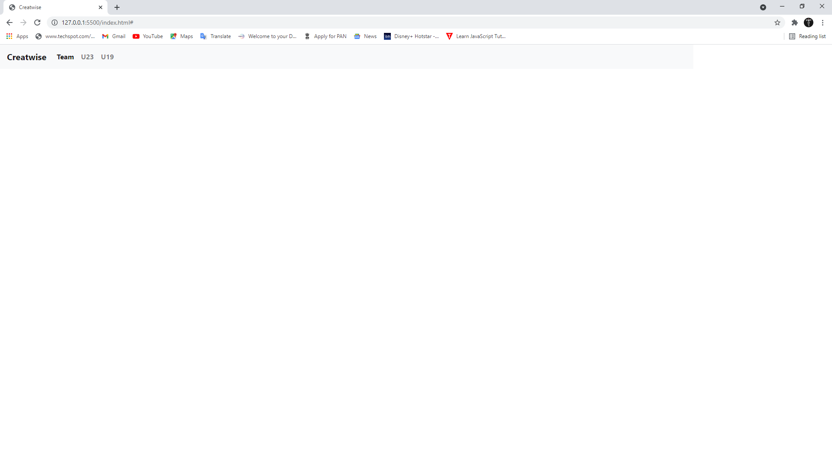The First Page be like this which contains only the “Top Navigation Bar”.

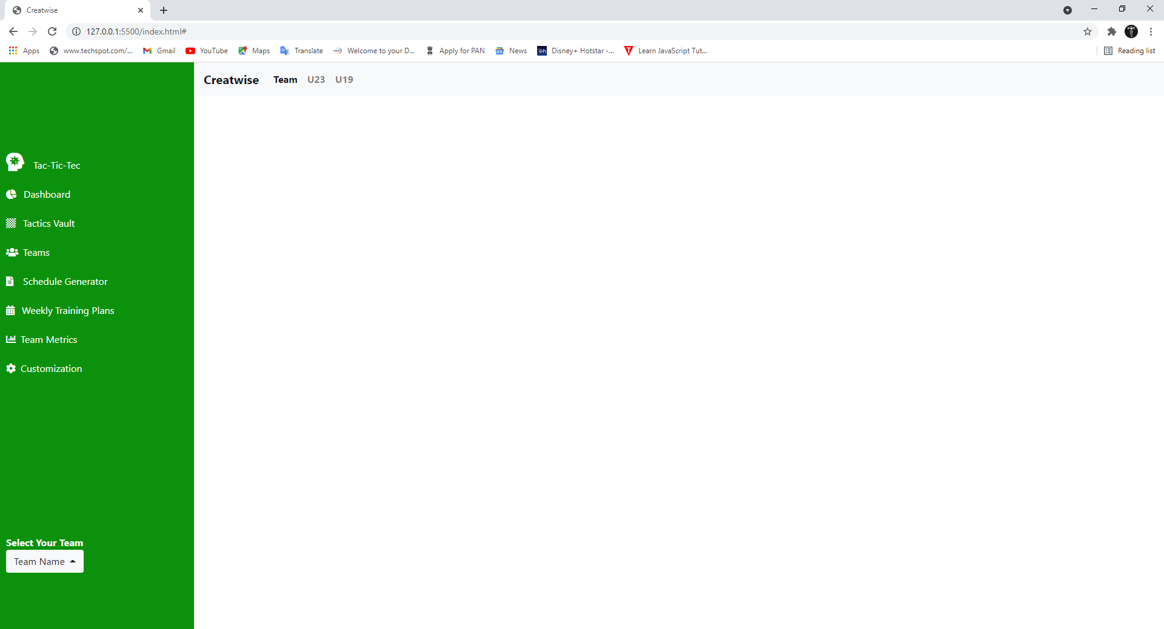When you click on “Team”, you will get a side nav bar with more options.

All options are working but you will find the content in “Schedule Generator” only.

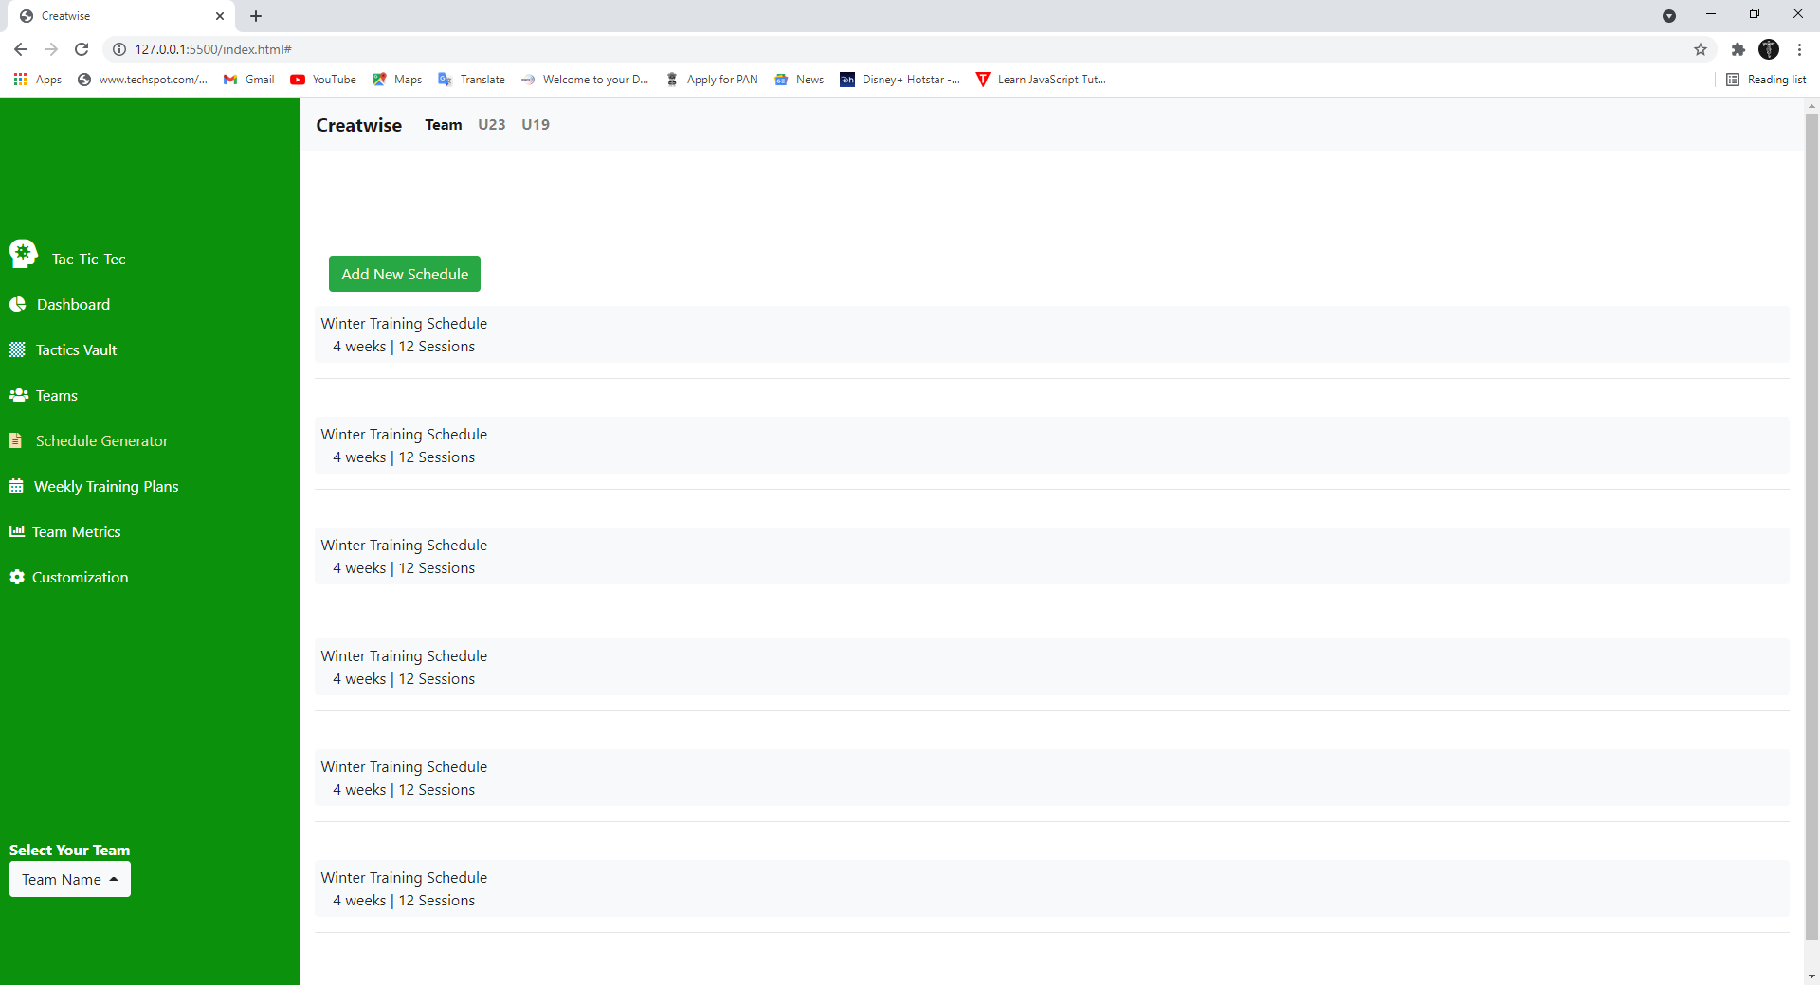

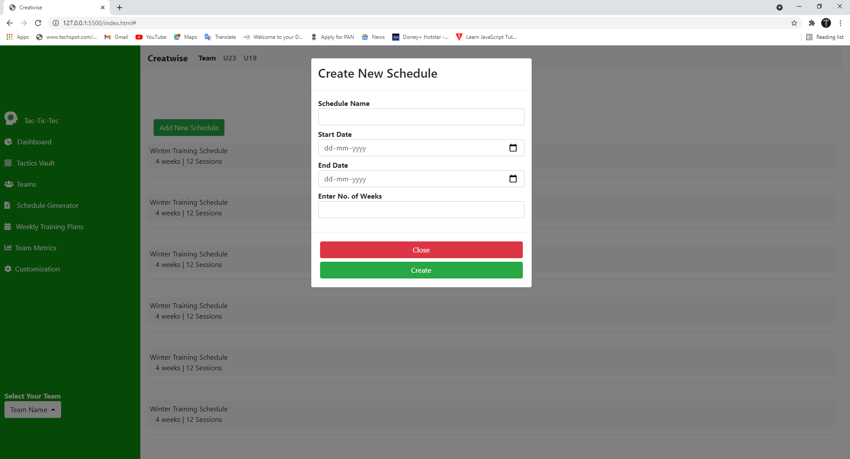Click on “Add New Schedule”, a Modal will come and you can fill the details, then click on create.

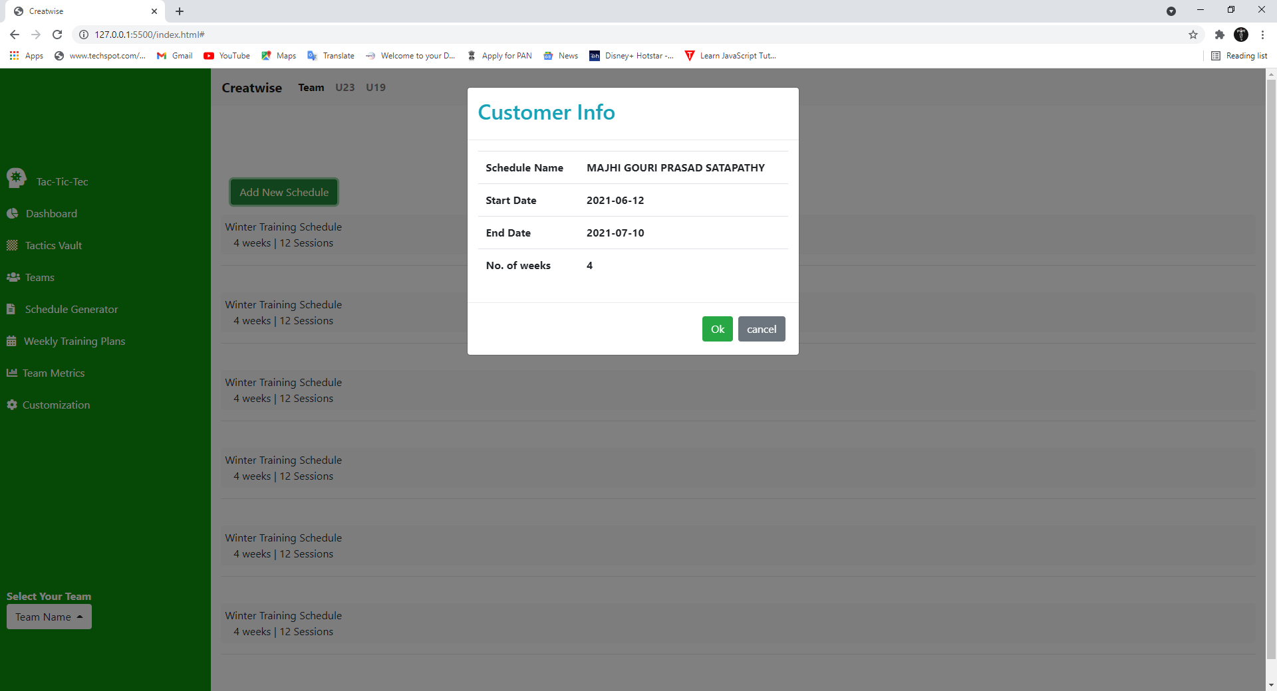After you create another Modal will show up which contains the details you have entered.

This project has only one page (index.html) and also its a SINGLE PAGE APPLICATION (It works and shows the information without reloading the page again and again).

**Technologies Used**

* HTML 5
* CSS 3
* JAVASCRIPT
* BOOTSTRAP
* JQUERY

This project may not work without internet because of CDN. So make sure you have a good internet connection before run the codes.