# Screenshots File for Part A (No. 1/3)

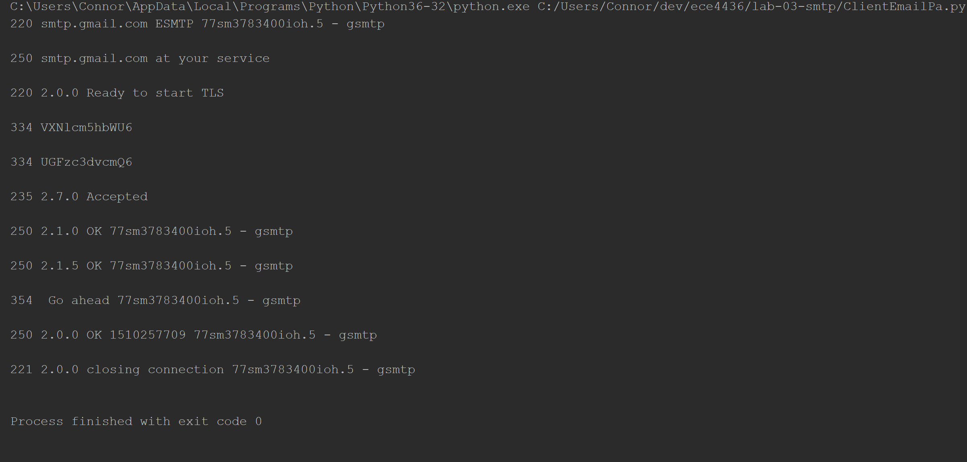

*Terminal responses from server.*

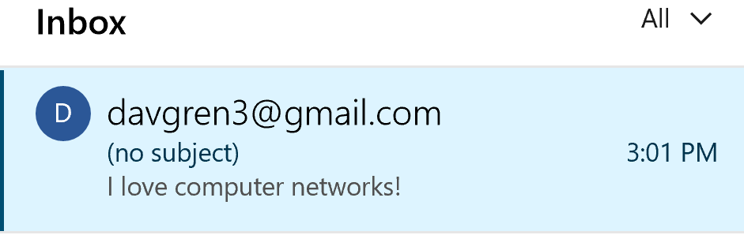

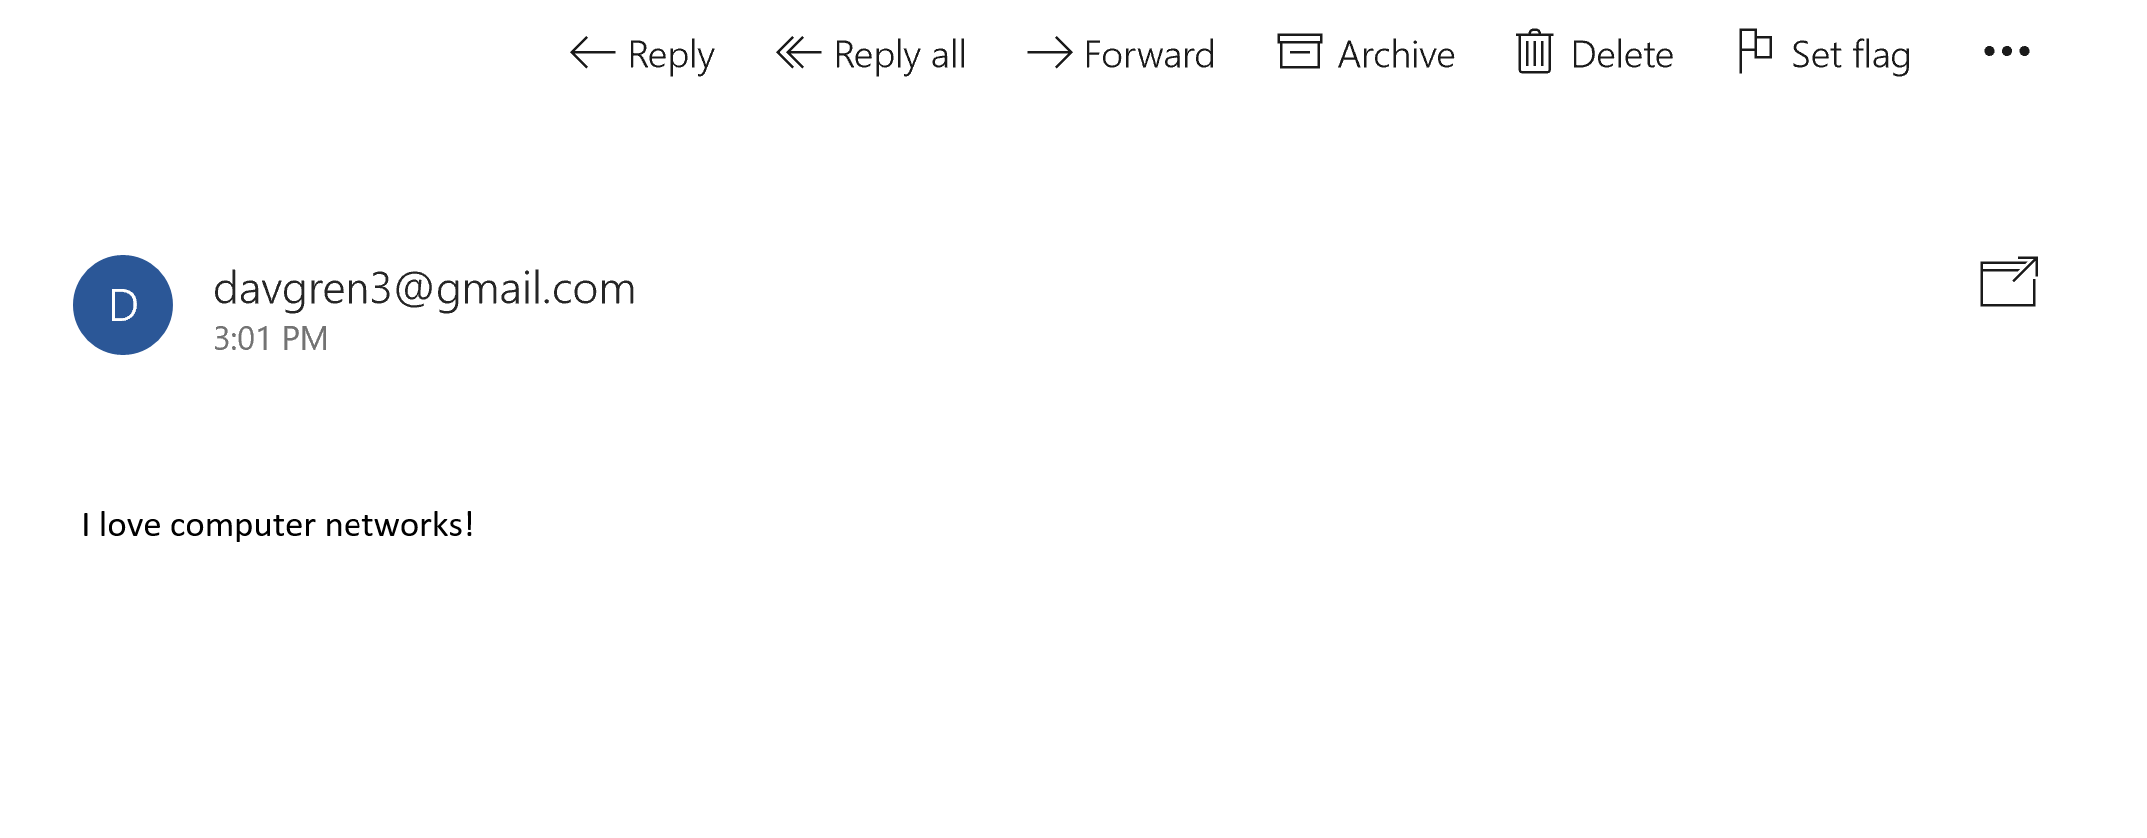

*Email text only Message as received.*