# Screenshots File for Part C (No. 3/3)

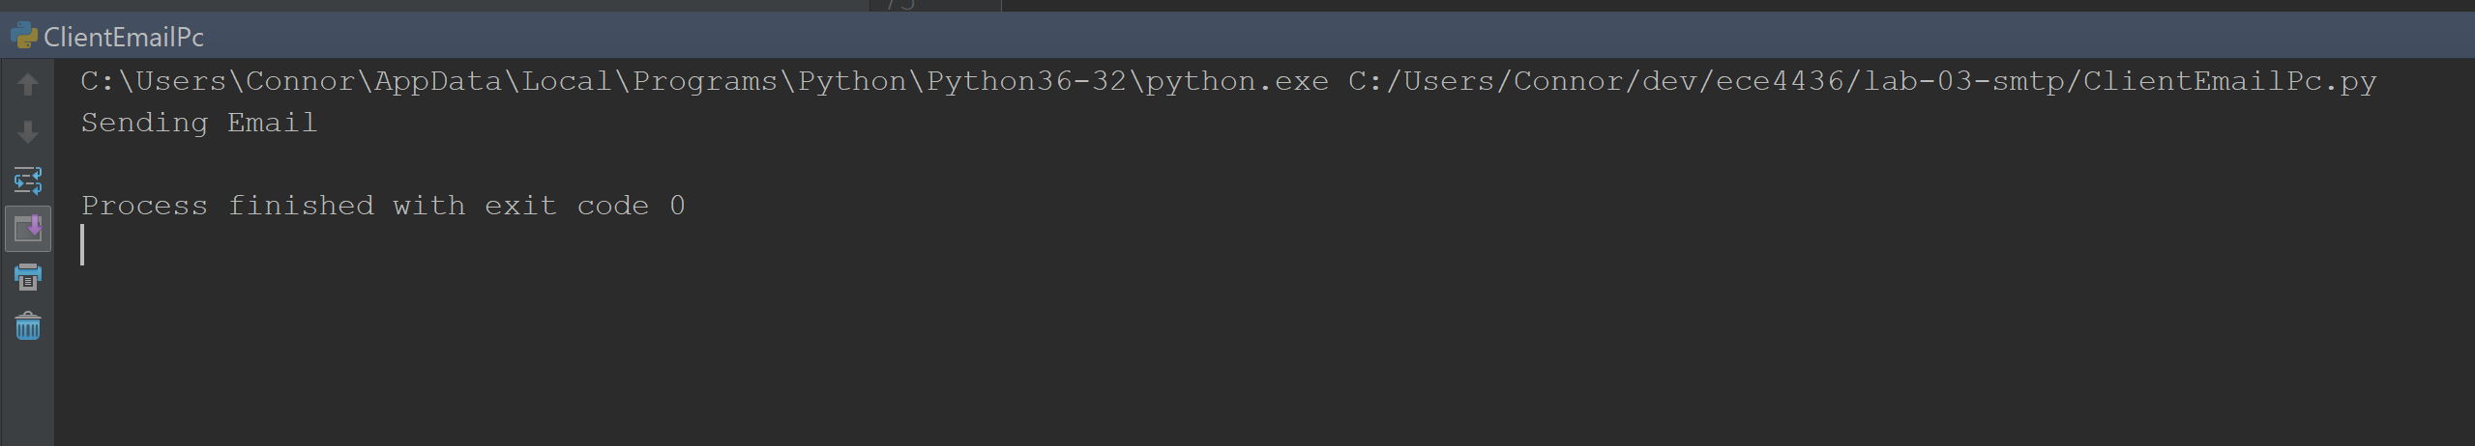

*Terminal run data*

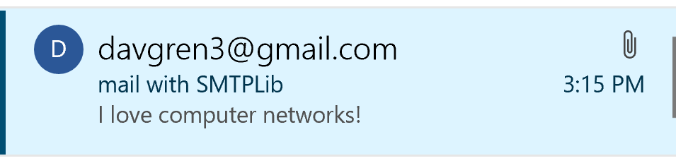

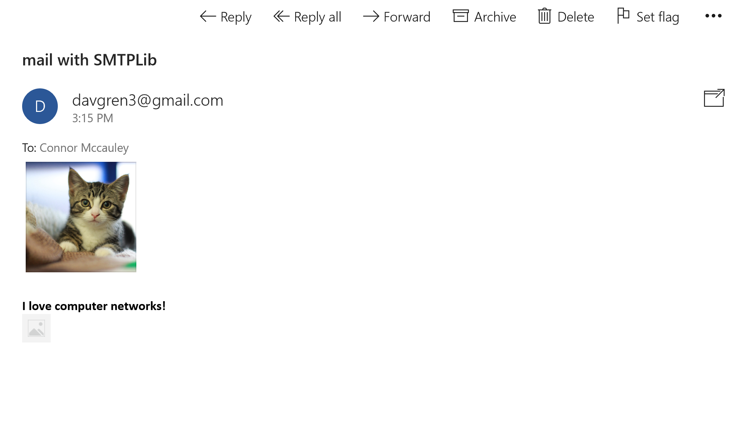

*Email with image and text*