**Java GUI & JDBC**

Q : AWT / Swing ? https://sites.google.com/a/mis.nsysu.edu.tw/cheng-shi-zi-xun-wang/java-jin-jie-pian/gui-pian/1-java-degui-gai-nian

A: AWT : **heavyweight** , underlying OS to paint object for you , limited .

Swing : **lightweight** , implemented in Java , don`t underlying OS , limited few .

如果你：

* 需要快速的 GUI，或者
* 需要在 IA 上開發 Java 程式

那麼，你應該多花一點時間把 AWT 學好。否則，你應該直接去學 Swing，會比較實際些。

**AWT is faster than Swing**

Q: How to use oracle ? <http://pclevin.blogspot.tw/2014/05/oracledboracle-sqldeveloper.html>

Step1 : download oracle SqlServer from oracle website , download version 11 , version 12 have some unexpected errors

Step2 : download oracle GUI interface , **sqldeveloper**

Step3 : Username : System , Password : install password

SID :

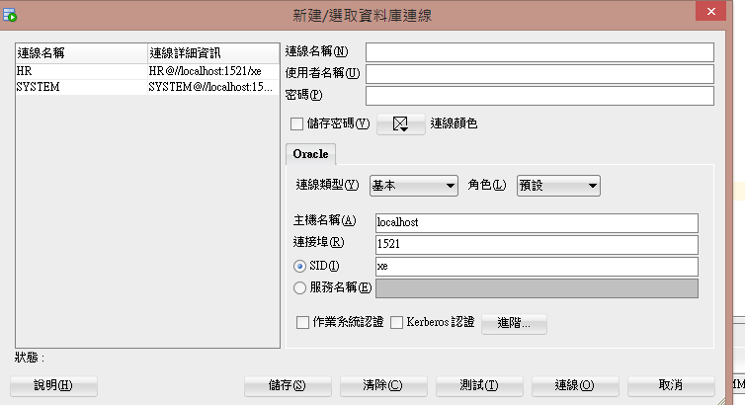

Step4 : setting Other Users , we can use other Users to sign in . 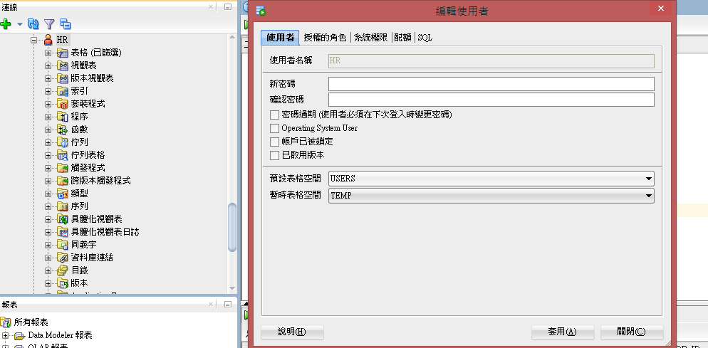

Step5 : Log in new user

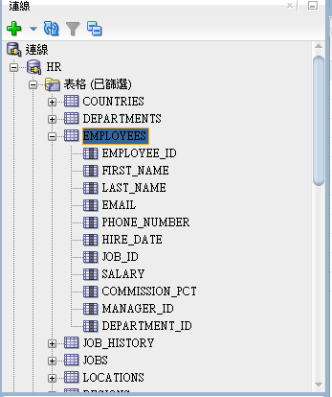

Step6 : use SQL statement

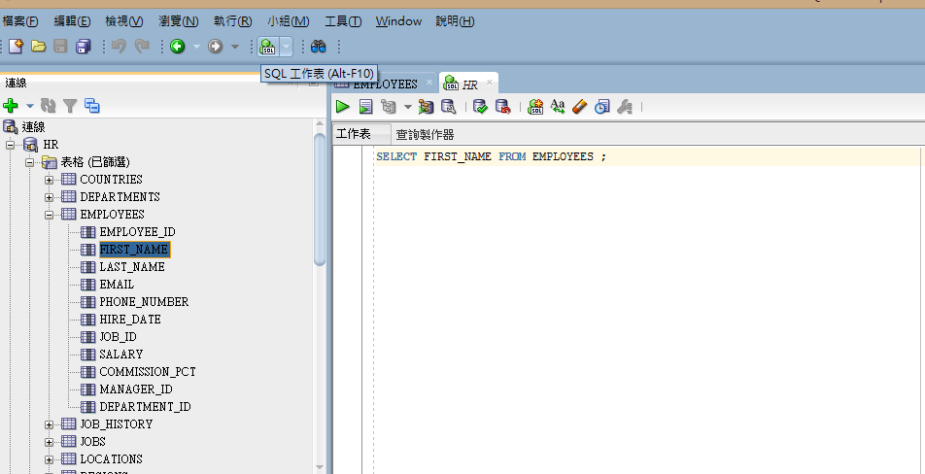

Q: How to use oracle JDBC in java ? http://aeoluslu.blogspot.tw/2013/06/oraclejdbcoracle-11g.html

Step1 : Download JDBC from oracle website , oracle JDBC driver ,

Step2 : add JDBC driver in IDE Project (maybe *. jar ) , library – add library

Step3 : coding ODBC

Basic Swing & JDBC , implement in **JDBCSwing Project**

public class JDBCSwing extends JFrame implements ActionListener

extends JFrame , static method like setDefaultCloseOperation

implements ActionListener , should implement ActionPerformed method

Netbeans java開發預設註解文件更改

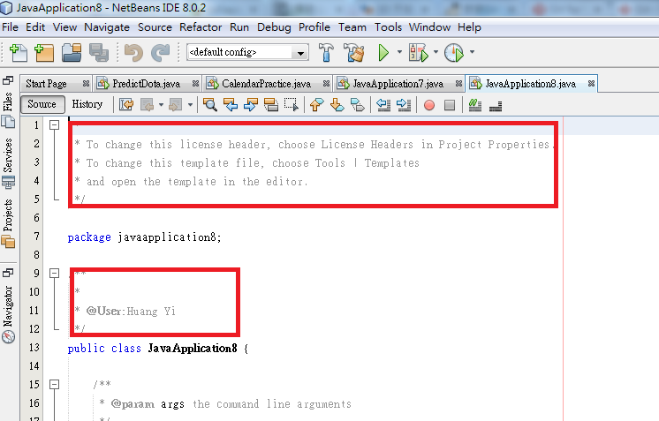

如上圖預設註解要改設定

1.tools->Templates

2. 如圖 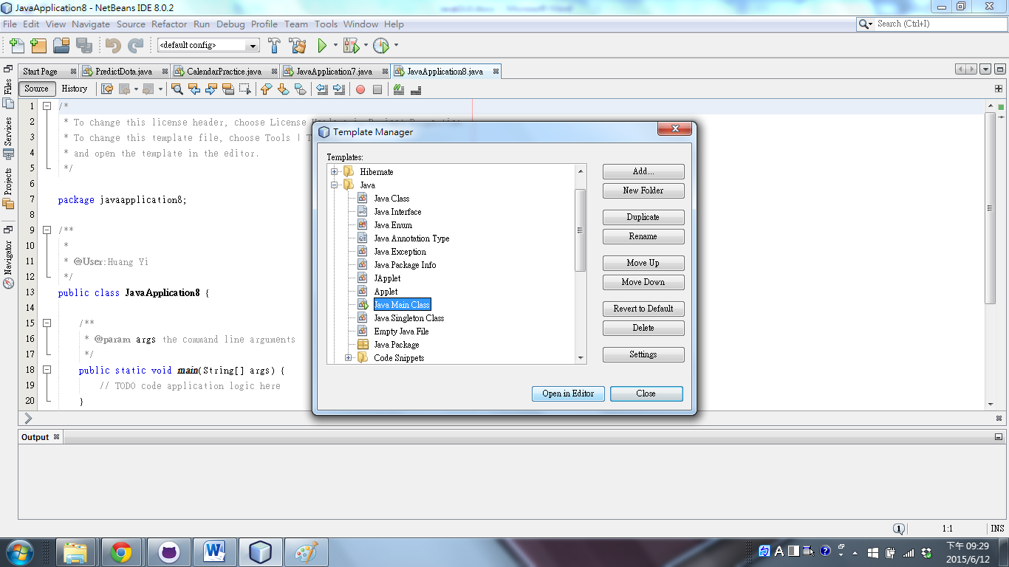

3.

如圖紅框處可修改預設註解

