**Java GUI & JDBC**

Q : AWT / Swing ? https://sites.google.com/a/mis.nsysu.edu.tw/cheng-shi-zi-xun-wang/java-jin-jie-pian/gui-pian/1-java-degui-gai-nian

A: AWT : **heavyweight** , underlying OS to paint object for you , limited .

Swing : **lightweight** , implemented in Java , don`t underlying OS , limited few .

如果你：

* 需要快速的 GUI，或者
* 需要在 IA 上開發 Java 程式

那麼，你應該多花一點時間把 AWT 學好。否則，你應該直接去學 Swing，會比較實際些。

**AWT is faster than Swing**

Q: How to use oracle ? <http://pclevin.blogspot.tw/2014/05/oracledboracle-sqldeveloper.html>

Step1 : download oracle SqlServer from oracle website , download version 11 , version 12 have some unexpected errors

Step2 : download oracle GUI interface , **sqldeveloper**

Step3 : Username : System , Password : install password

SID :

1. The Oracle System ID ([SID](http://www.orafaq.com/wiki/SID)) is used to uniquely identify a particular database on a system.

http://www.orafaq.com/wiki/ORACLE_SID

1. SID is a unique name for an Oracle database instance. ---> To switch between Oracle databases, users must specify the desired SID .

<https://community.oracle.com/thread/282913>

**SID查詢方法:**

1. oracle安裝路徑下搜尋”Tnsnames.ora”,此檔中有一個名稱為Service_Name就是SID
2. Oracle的安裝目錄下，例如D:\oracle\product\10.2.0\db_1\dbs，看文件名如SPFILEXE.ORA，文件名稱的開頭＂SPPILE＂拿掉，剩下的字串為＂XE＂就是SID
3. PL/SQL中輸入查詢語句：＂select instance_name from v$instance; ＂, 若要看SID的全部資訊可以下”select * from v$instance”, instance_name就是SID

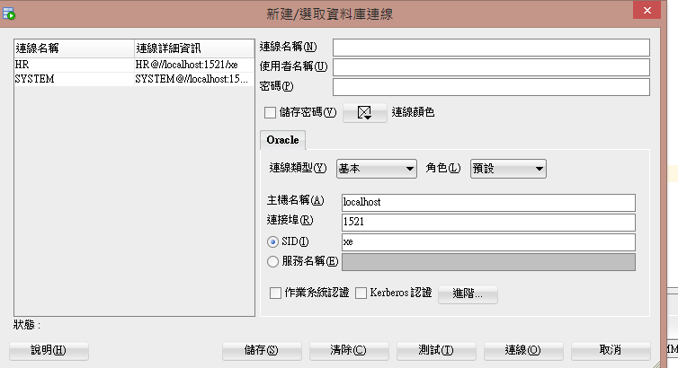

Step4 : setting Other Users , we can use other Users to sign in . 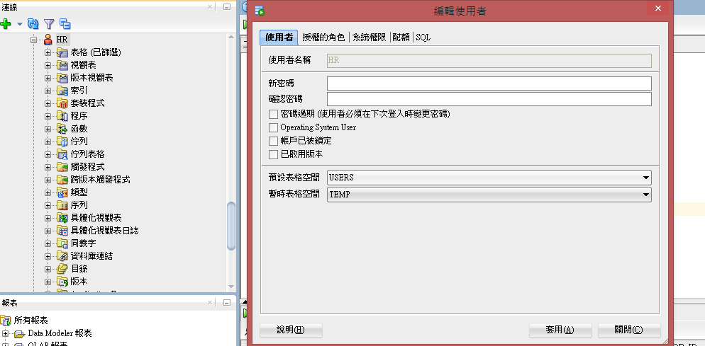

Step5 : Log in new user

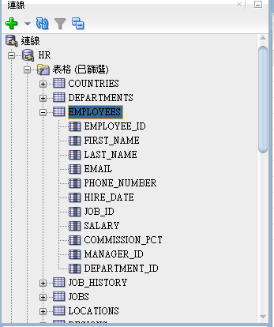

Step6 : use SQL statement

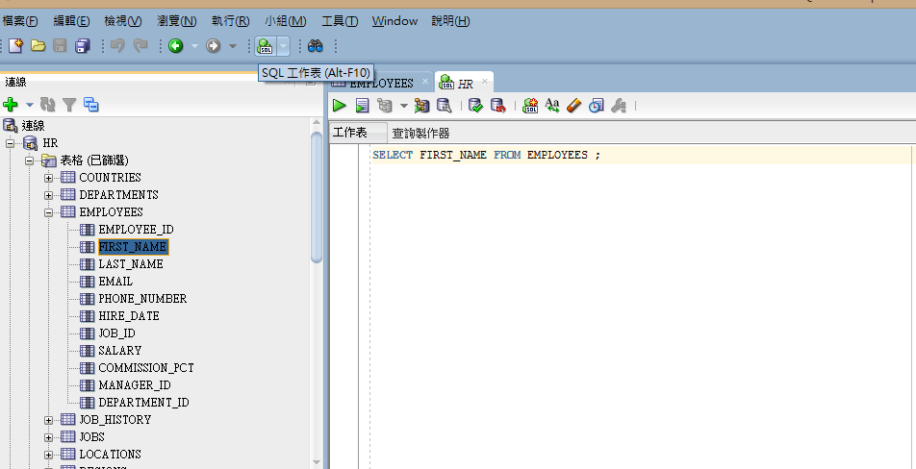

Q: How to use oracle JDBC in java ? http://aeoluslu.blogspot.tw/2013/06/oraclejdbcoracle-11g.html

Step1 : Download JDBC from oracle website , oracle JDBC driver ,

Step2 : add JDBC driver in IDE Project (maybe *. jar ) , library – add library

Step3 : coding ODBC

Basic Swing & JDBC , implement in **JDBCSwing Project**

public class JDBCSwing extends JFrame implements ActionListener

extends JFrame , static method like setDefaultCloseOperation

implements ActionListener , should implement ActionPerformed method