HowTo: Events

Table of Contents

REGULAR EVENTS 3

View Event Information 4

Editing Event Information 5

Changing the Icon 6

UPCOMING EVENTS 9

# REGULAR EVENTS

The regular events area allows you to change the event information for weekly events.

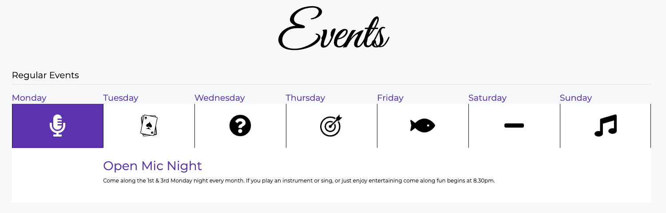

These can be changed by going to: Events 🡪 Regular Events:

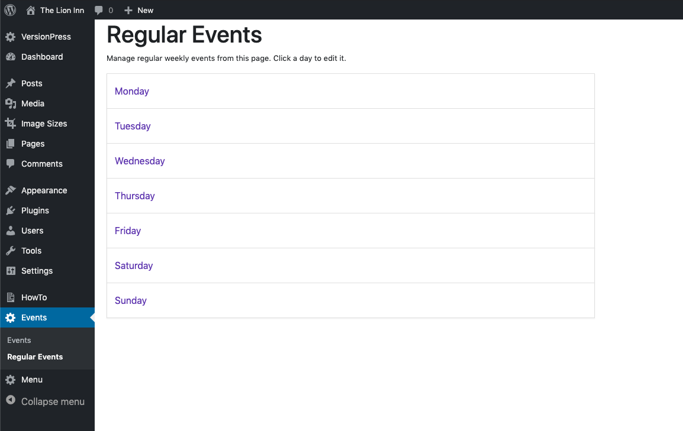

## View Event Information

To view a day’s event information, click on the day:

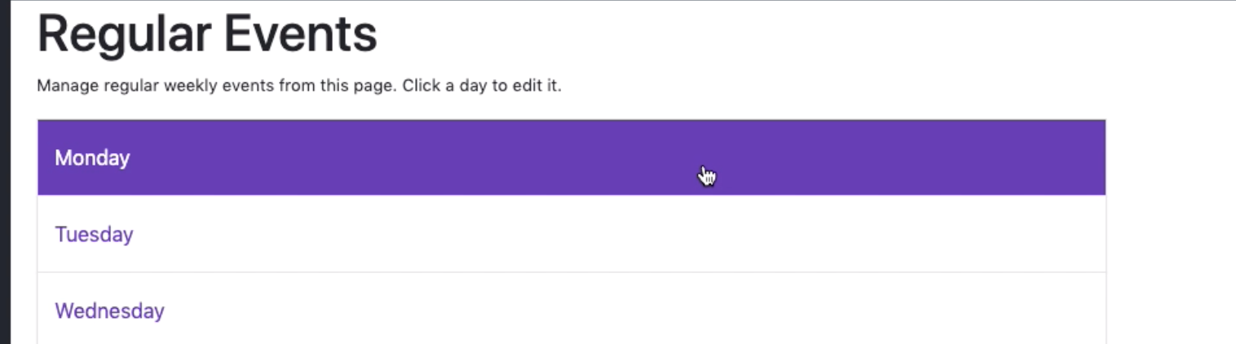

It should then appear like so:

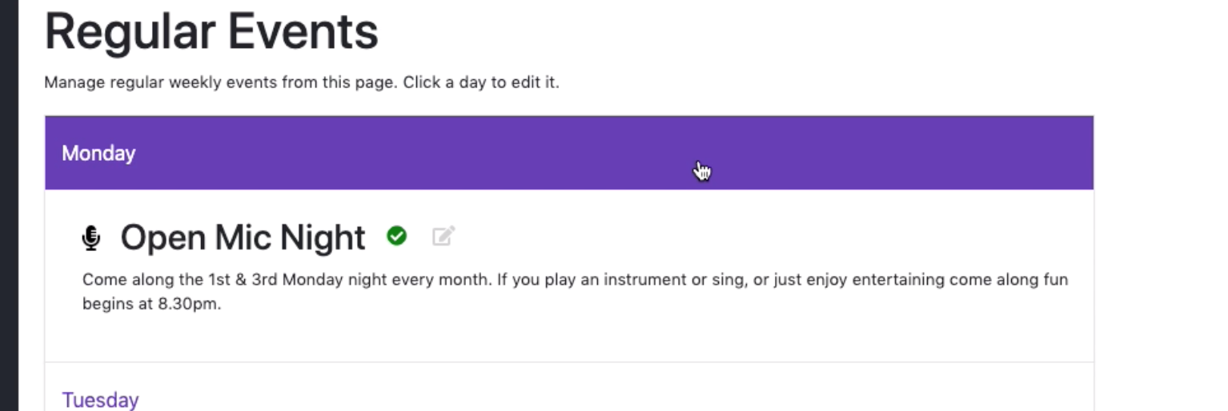

This shows:

* The name of the event
* The event icon
* The description of the event

All of which are displayed on the website.



## Editing Event Information

To edit any of this information, click the ‘Edit Icon’:

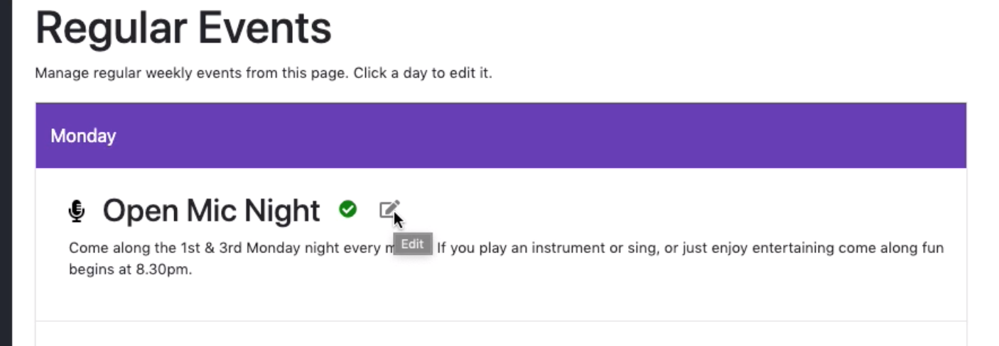

When you click this, you should see this screen:

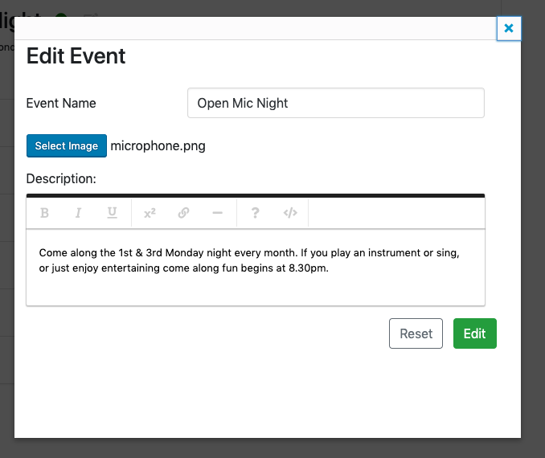

Here you can change the event name, the description and select a different icon.

When done, click the big green ‘Edit’ button.

### Changing the Icon

To change the icon, click the ‘Select Image’ button:



You should then see this screen:

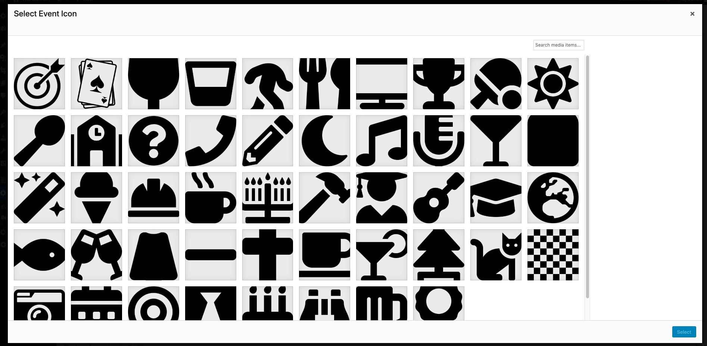

Select an image and click ‘Select’:

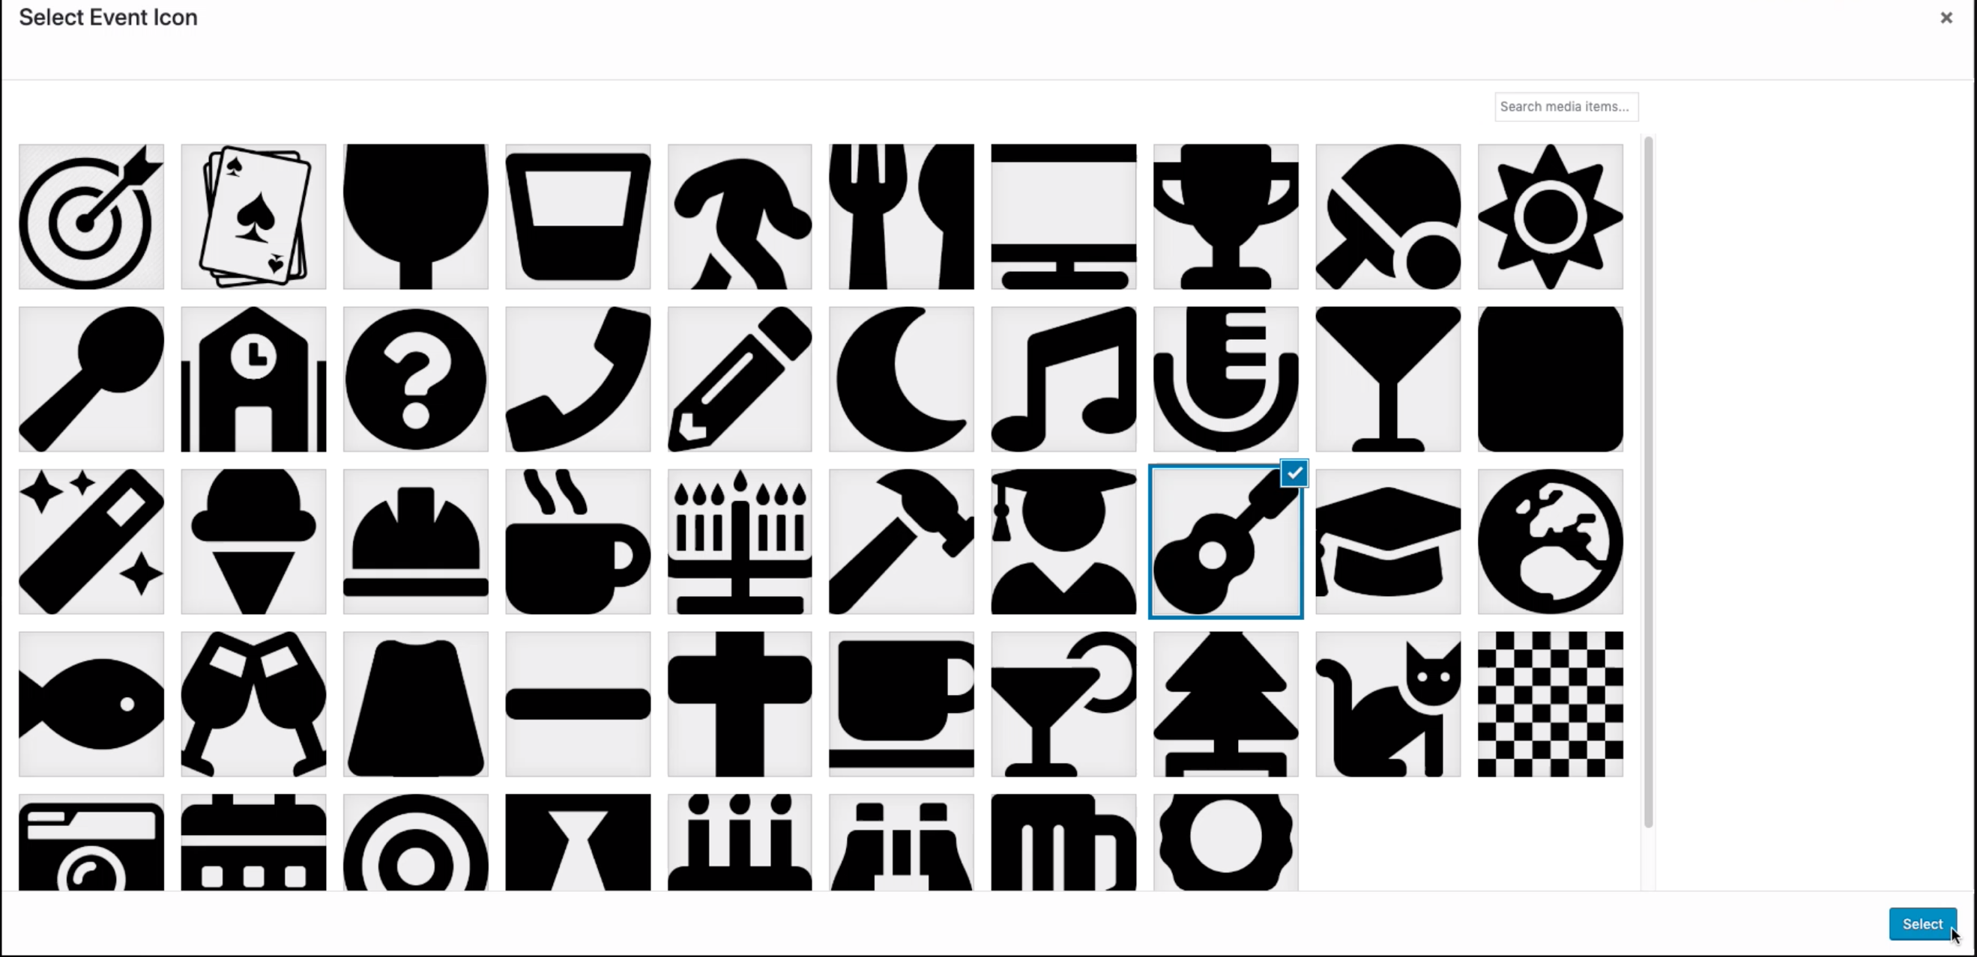

You should then see that the name next to the ‘Select Image’ button has changed:

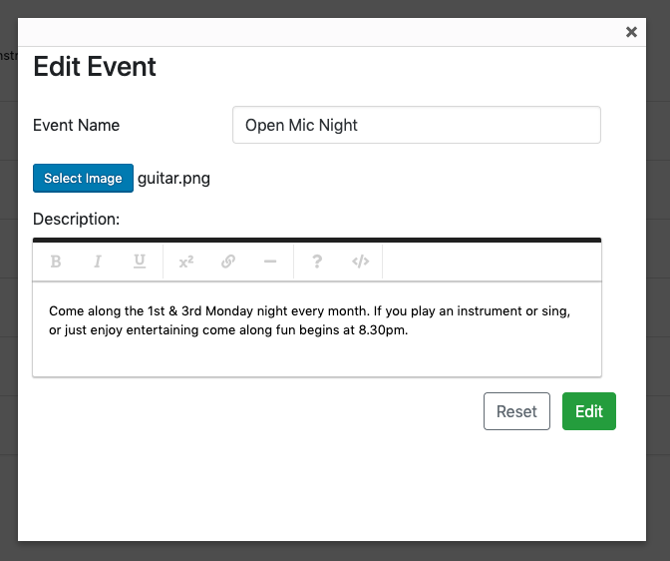

Click ‘Edit’.

You should see the new icon next to the title:

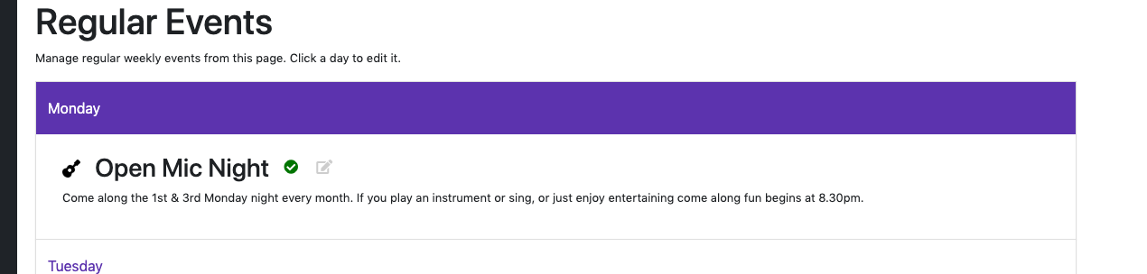

# UPCOMING EVENTS