### Changing the Icon

Click ‘Event’ and then ‘Regular Events’ on the side-bar menu to bring up this page:

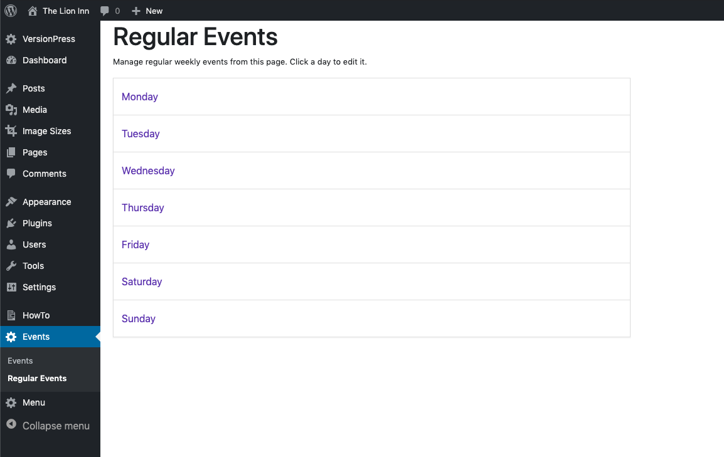

Click on a day:

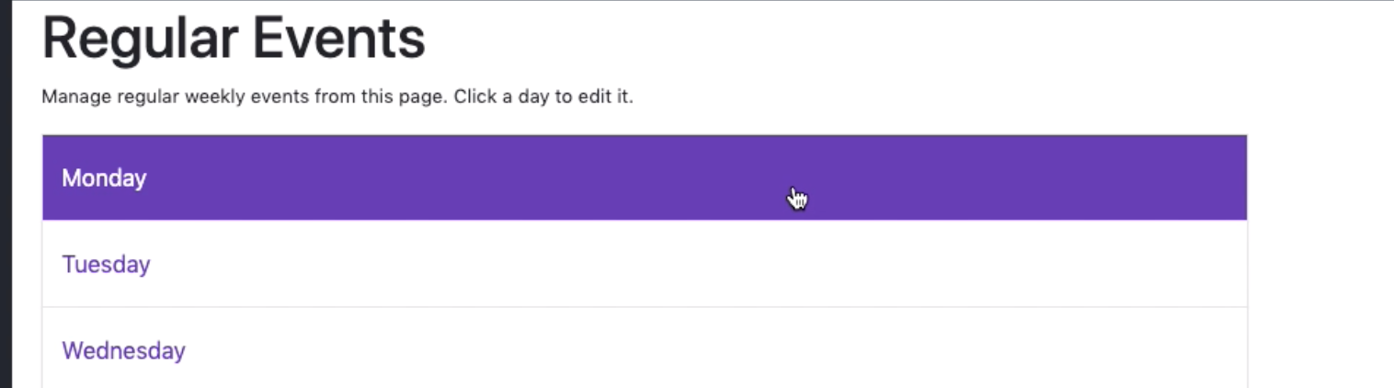

Click the ‘Edit Icon’:

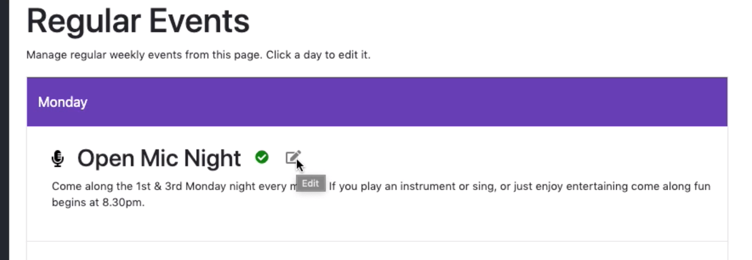

To change the icon, click the ‘Select Image’ button:

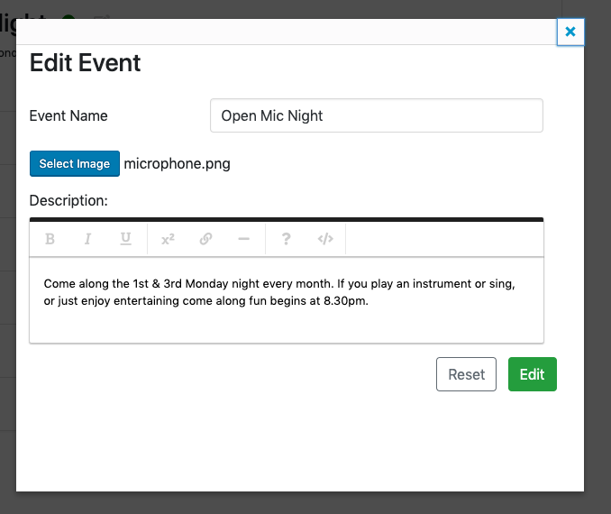

You should then see this screen:

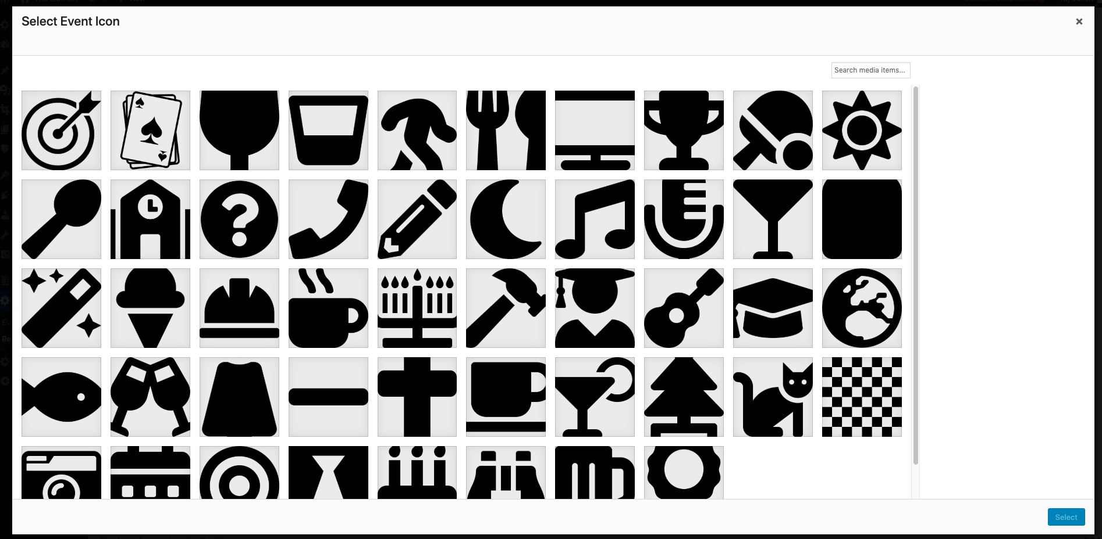

Select an image and click ‘Select’:

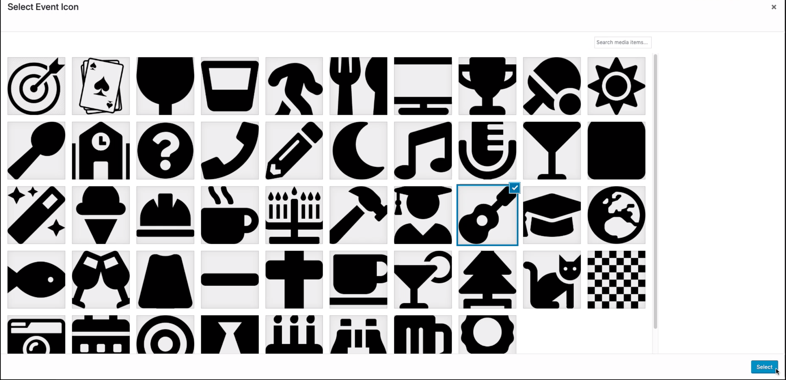

You should then see that the name next to the ‘Select Image’ button has changed:

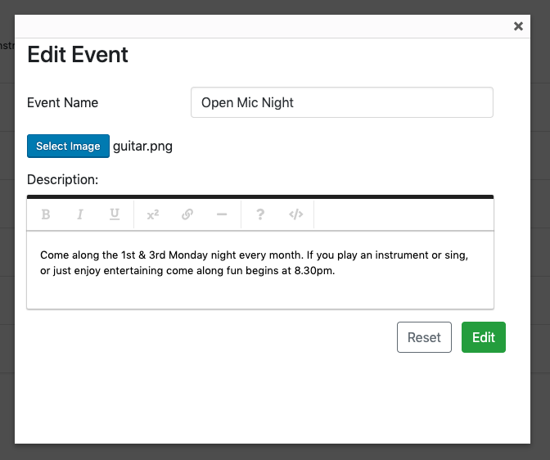

Click ‘Edit’.

You should see the new icon next to the title:

