## Editing Event Information

Click ‘Event’ and then ‘Regular Events’ on the side-bar menu to bring up this page:

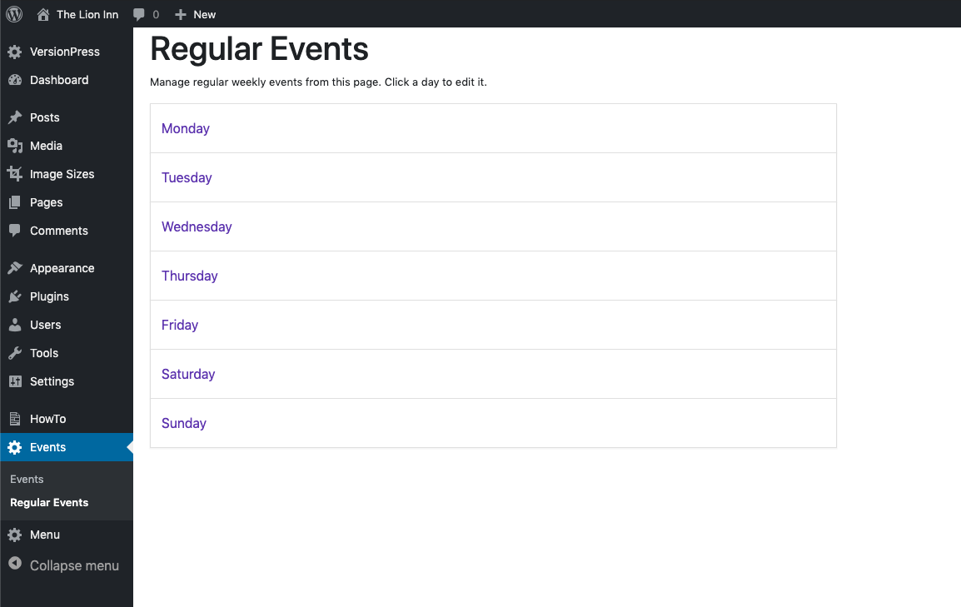

Click on a day:

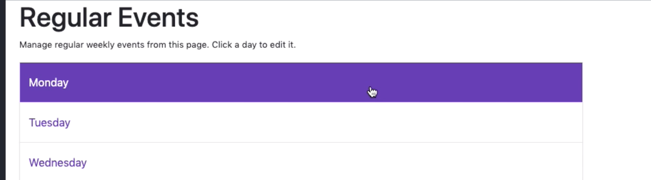

Click the ‘Edit Icon’:

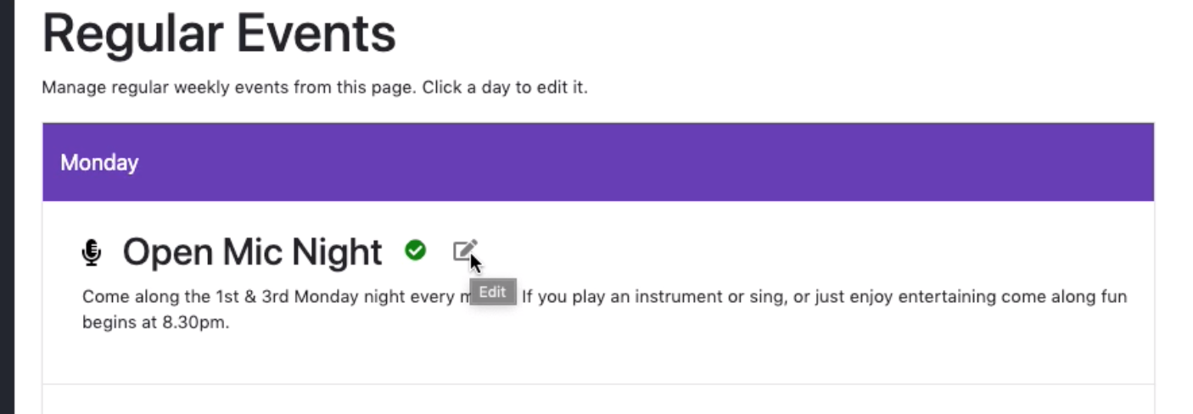

When you click this, you should see this screen:

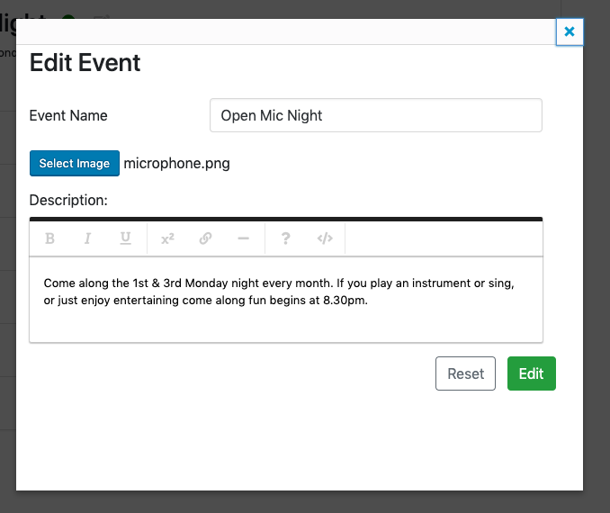

Here you can change:

* Event name
* The description
* The icon

Change it to this:

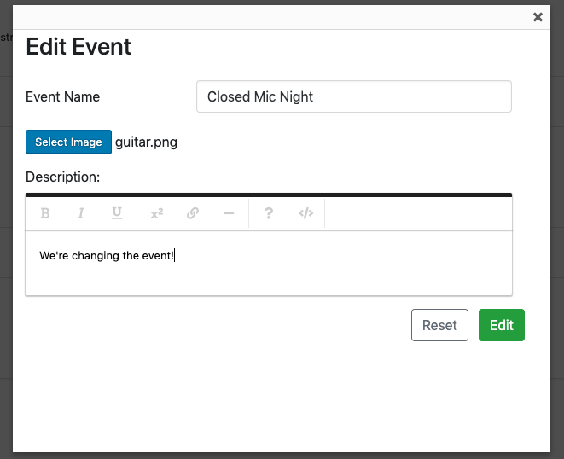

*Note: I haven’t changed the icon yet. This will be shown in the next section.*

When done, click the big green ‘Edit’ button.

You should return to this screen:

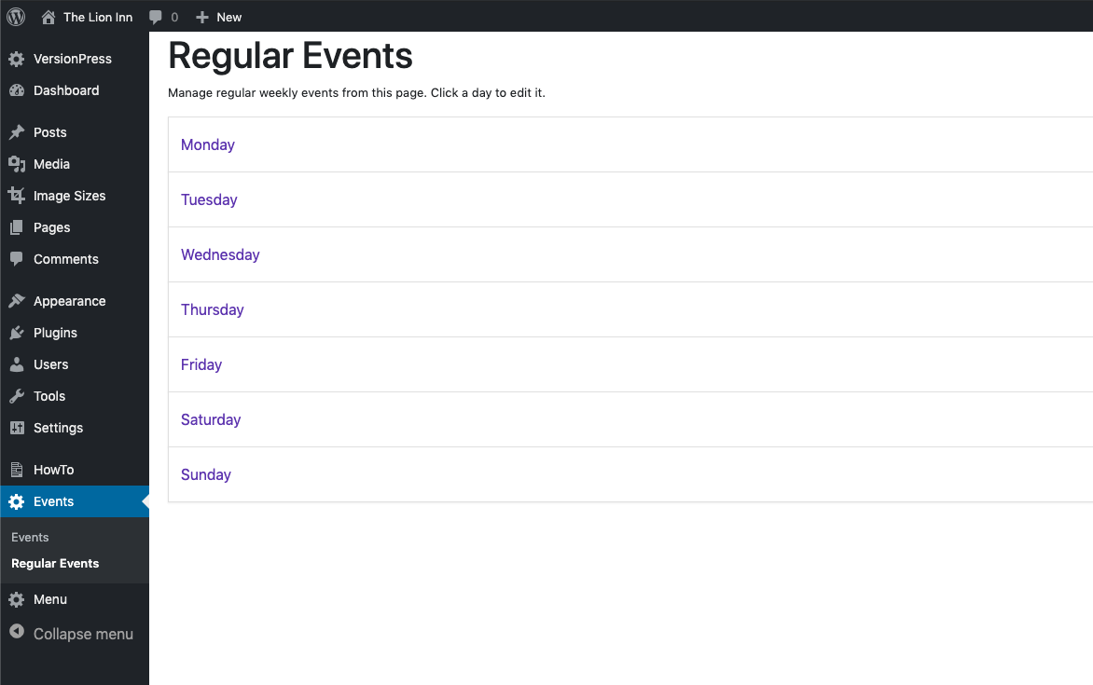

Click the event you just changed (in our case – Monday). You should see this:

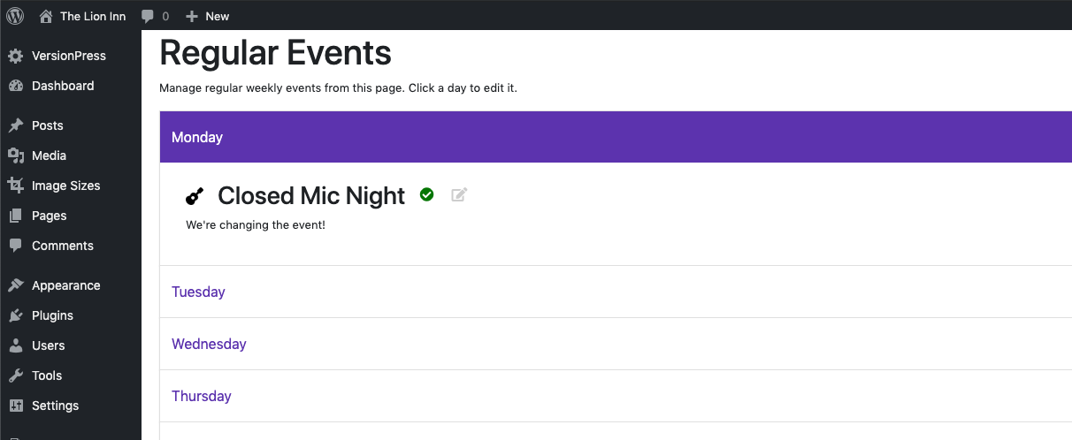

Notice the information that we changed.