## Overview

The regular events area allows you to change the event information for weekly events.

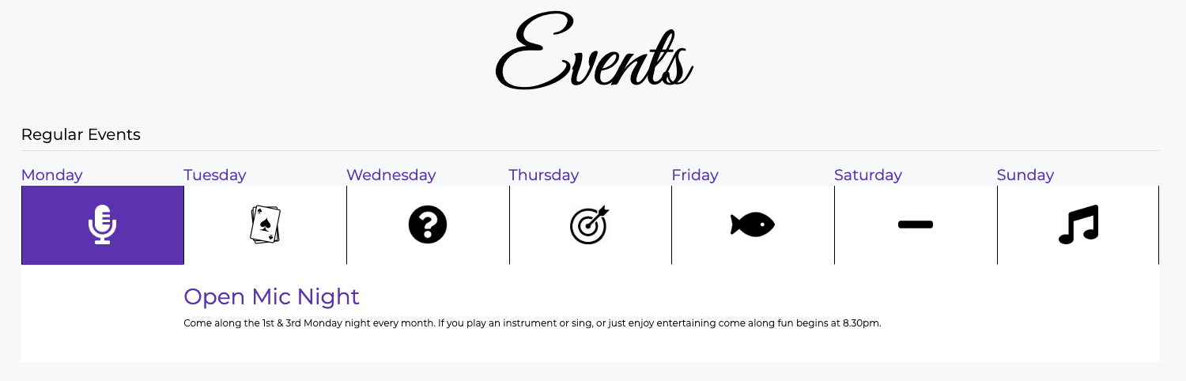

These can be changed by going to: Events 🡪 Regular Events:

