## View Event Information

Click ‘Event’ and then ‘Regular Events’ on the side-bar menu to bring up this page:

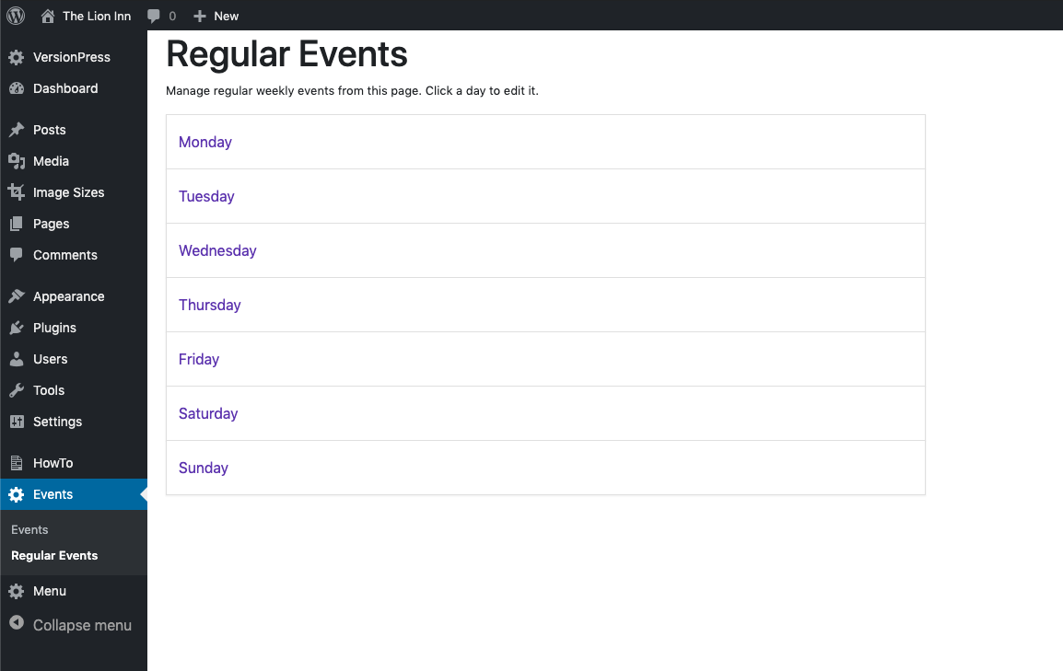

To view a day’s event information, click on the day:

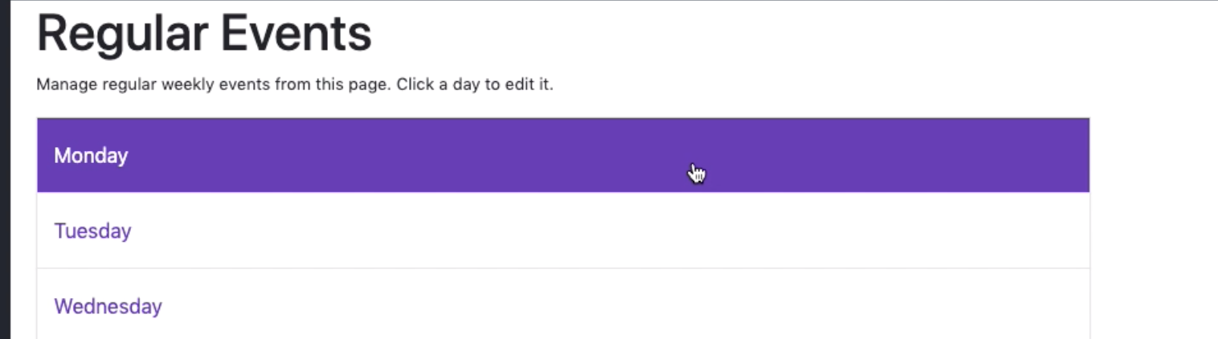

It should then appear like so:

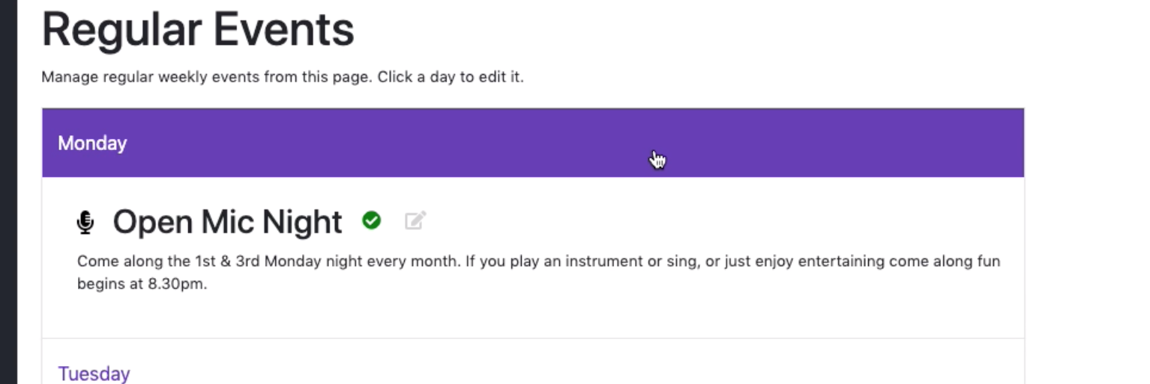

This shows:

* The name of the event
* The event icon
* The description of the event

All of which are displayed on the website, like this:

