## Add Event

Open the ‘Events’ page:

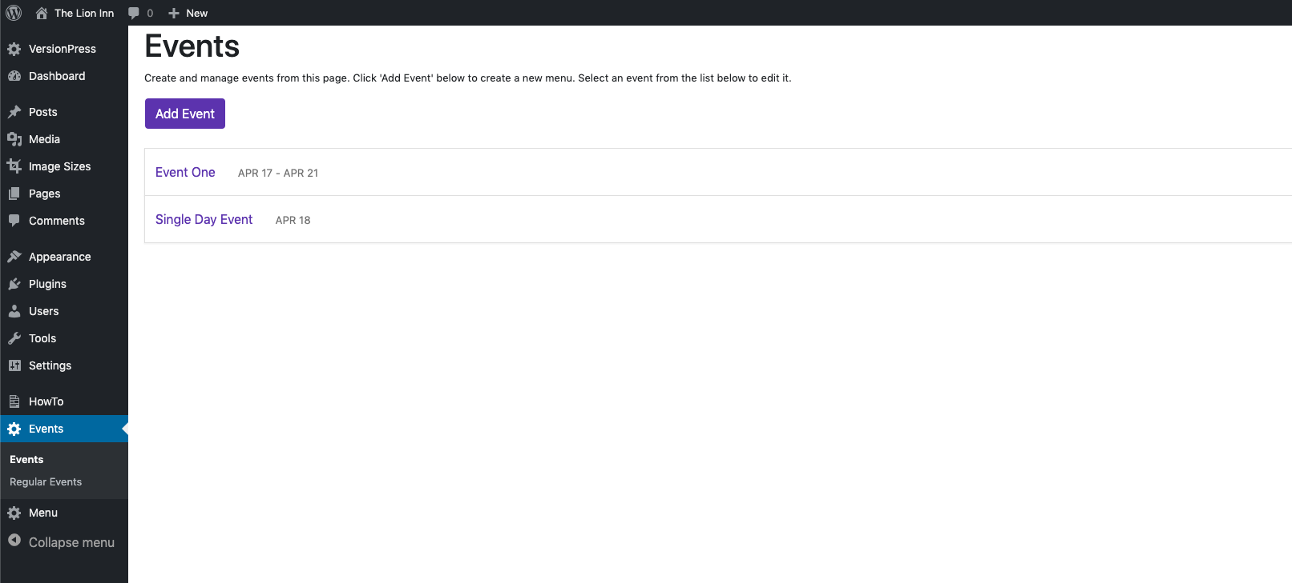

Click the purple ‘Add Event’ button. You should see this:

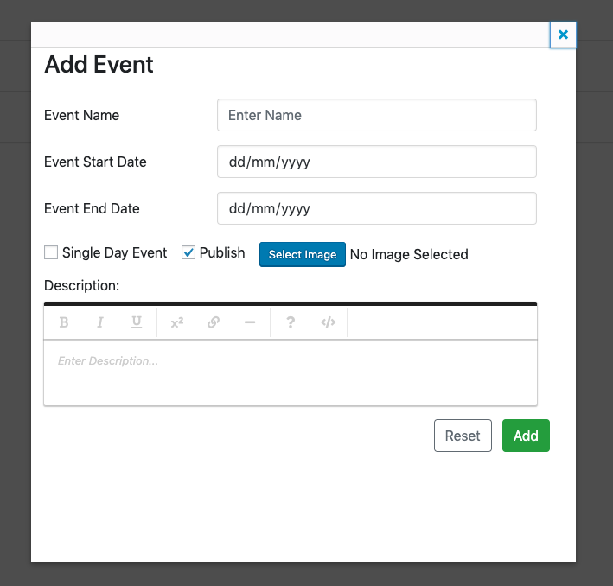

From this screen, you can add:

* Event name
* Event start date
* Event end date
* Select if an event is one day
* Publish / Not Publish
* Select an image
* Enter a description for the event

Enter this information into each section:

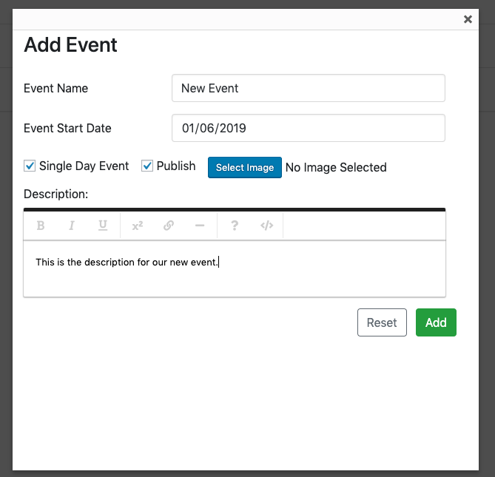

Note that we haven’t selected an image. Click the ‘Select Image’ button. You should see this:

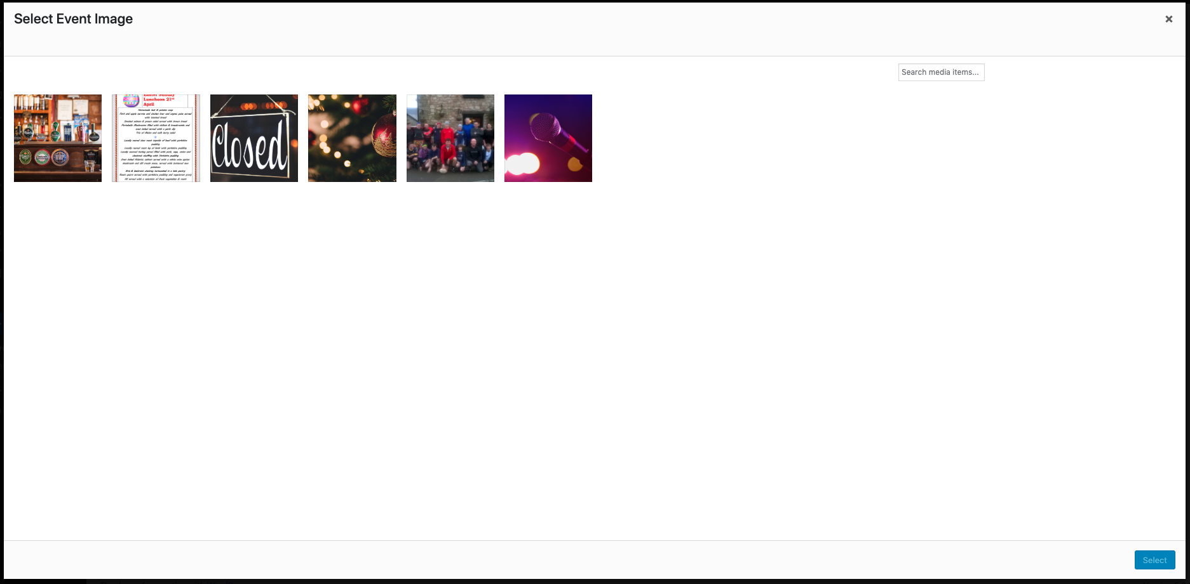

Click an image to select it (it will have a blue box around it) and click the ‘Select’ button in the bottom right:

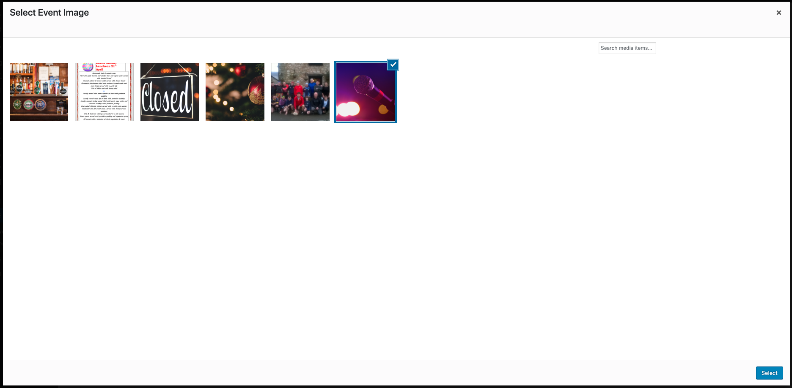

You should return to this screen and see that the image name is next to the ‘Select Image’ button:

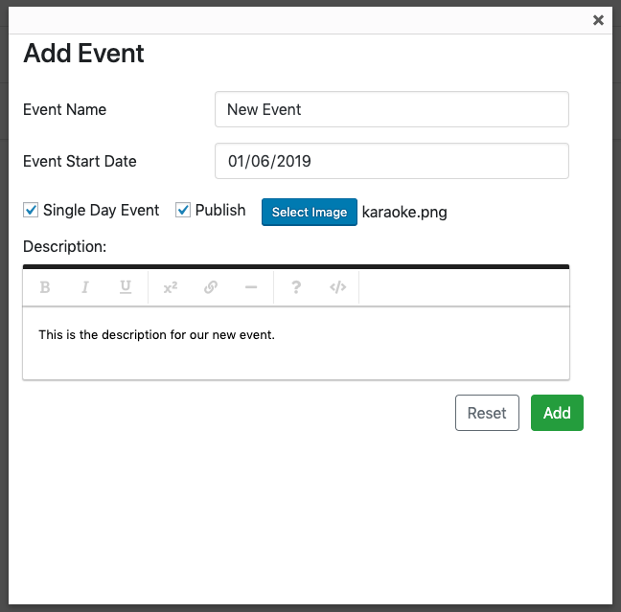

Click ‘Add’. You should see the new event appear in the list:

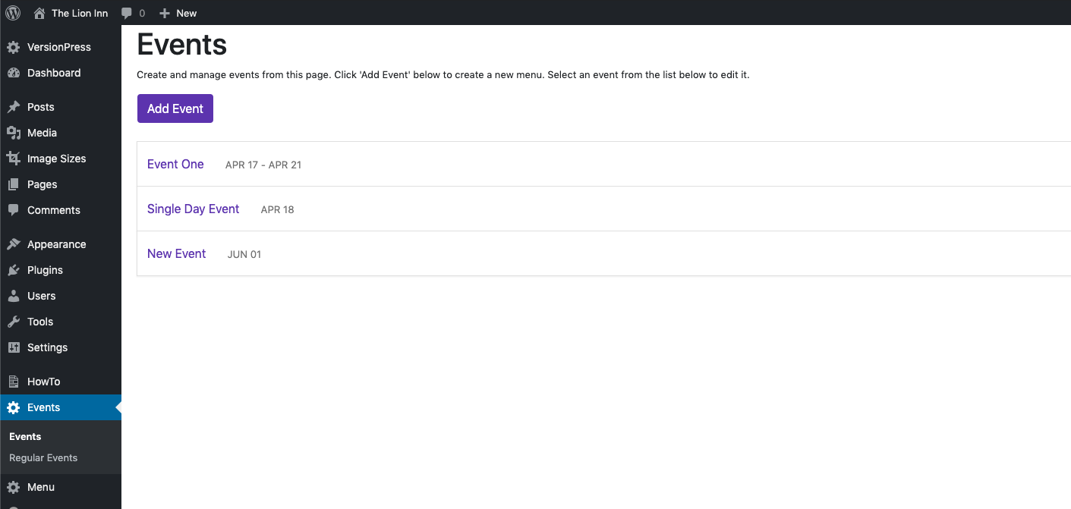

The ‘New Event’ is in the list. To view the rest of the event information, click the ‘New Event’ bar:



It should turn purple, and its information should appear:

