### Change the Image

Open the ‘Events’ page:

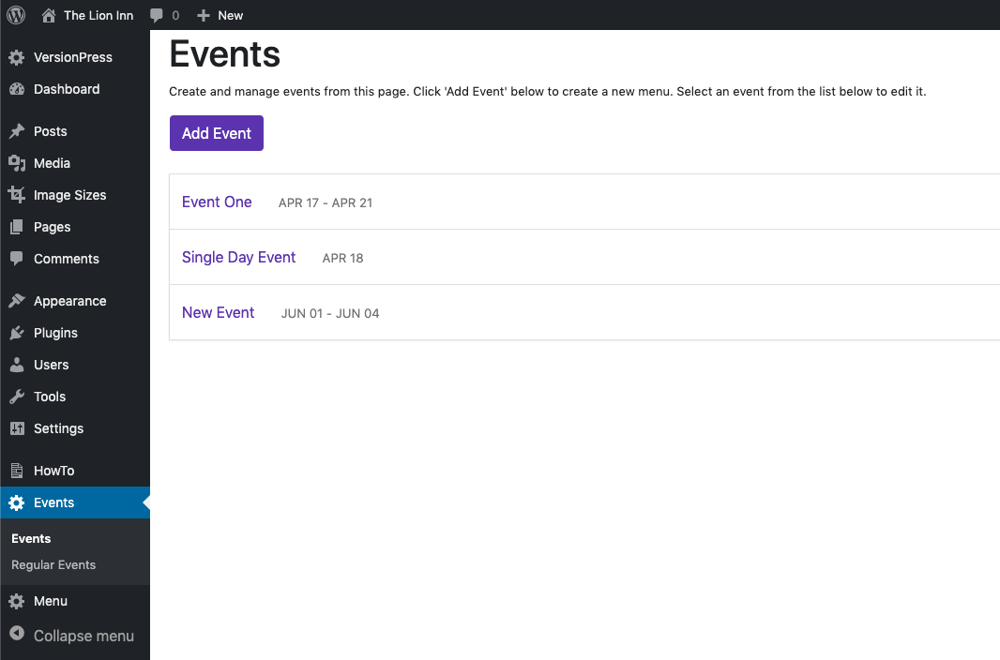

Click an event to view its information. It should show this:

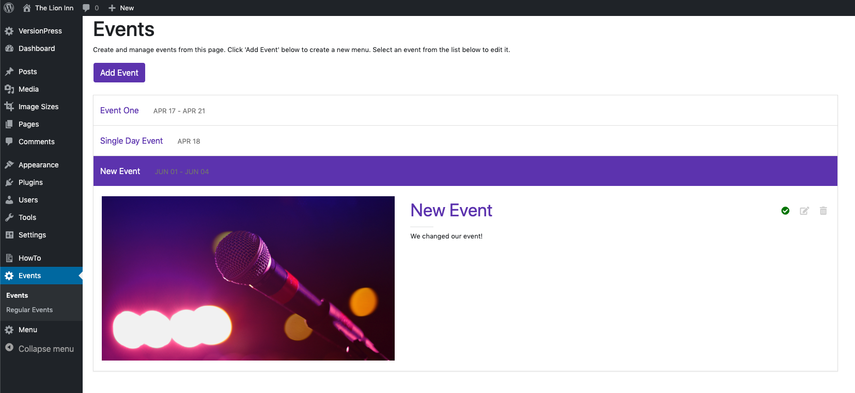

To edit an event, click the ‘Edit Event’ icon.

It should show this:

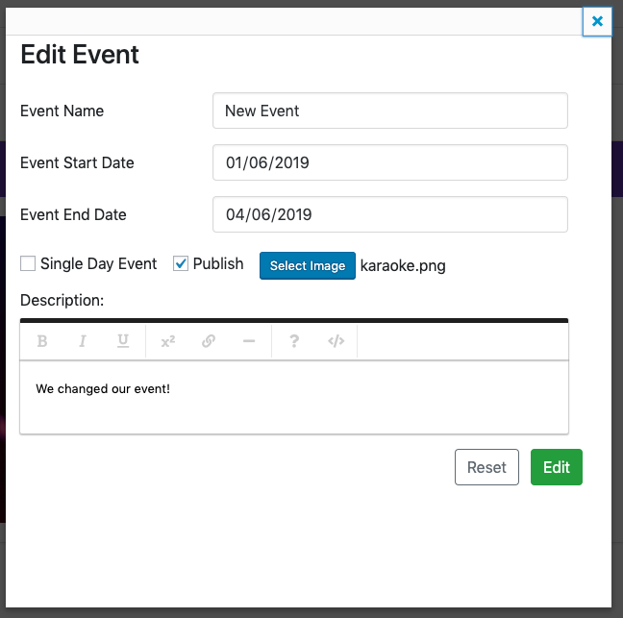

To change the image, click ‘Select Image’. You should see this:

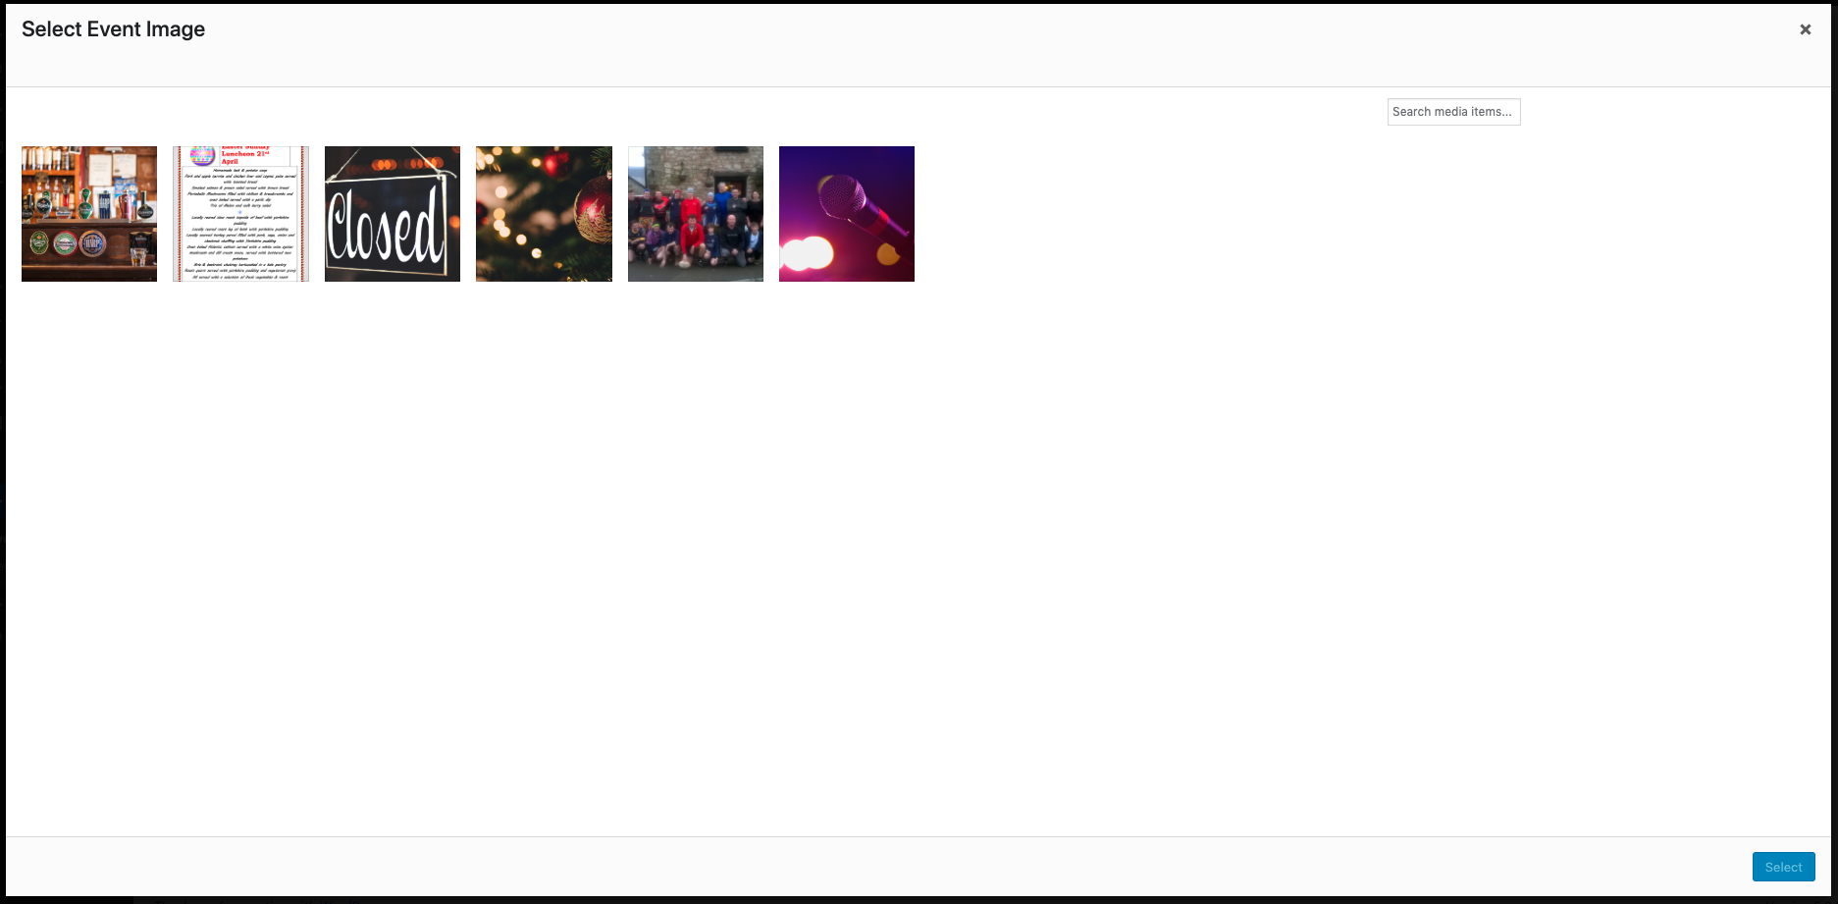

Select a new image (a blue box around it) and click the ‘Select’ button:

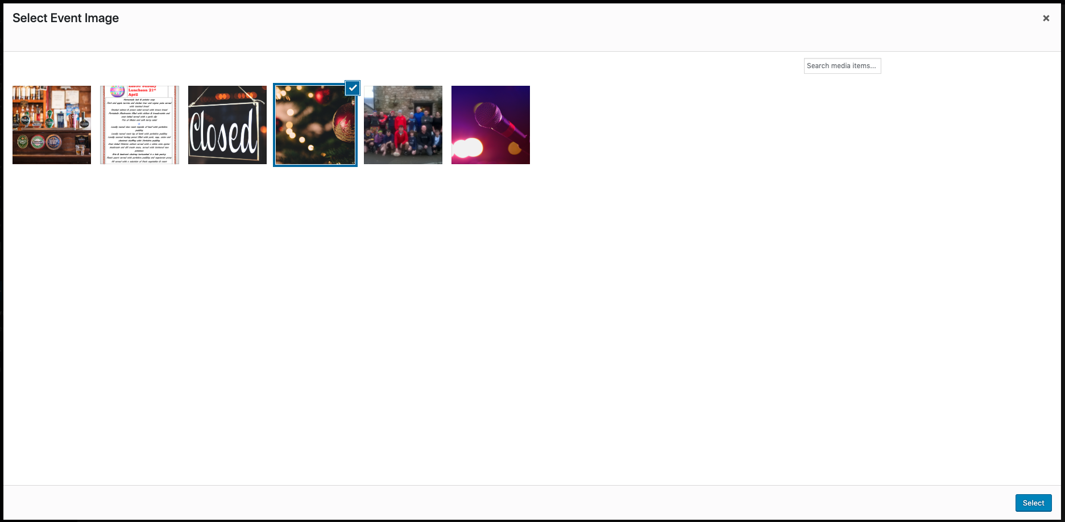

You should return to this screen:

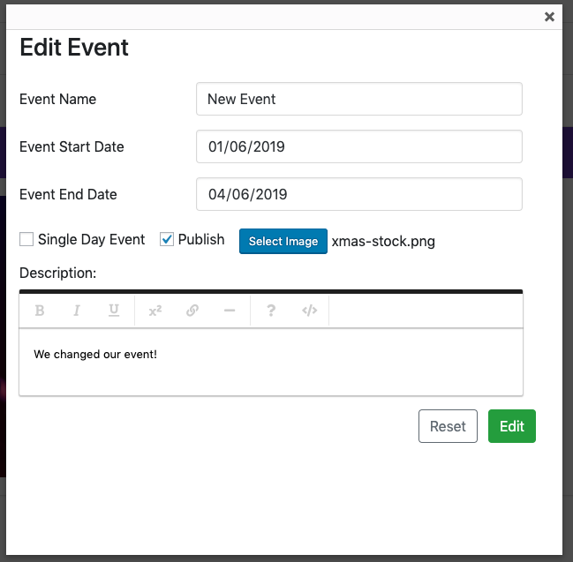

Note that the image name has changed. Click ‘Edit’.

Click the event to see the image has changed as well:

