## Delete Event

Open the ‘Events’ page:

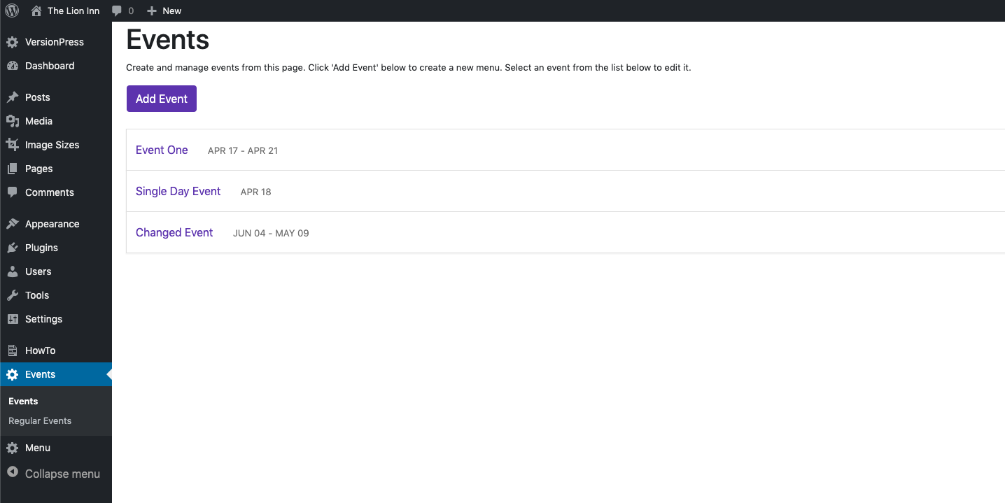

Click an event to view its information. It should show this:

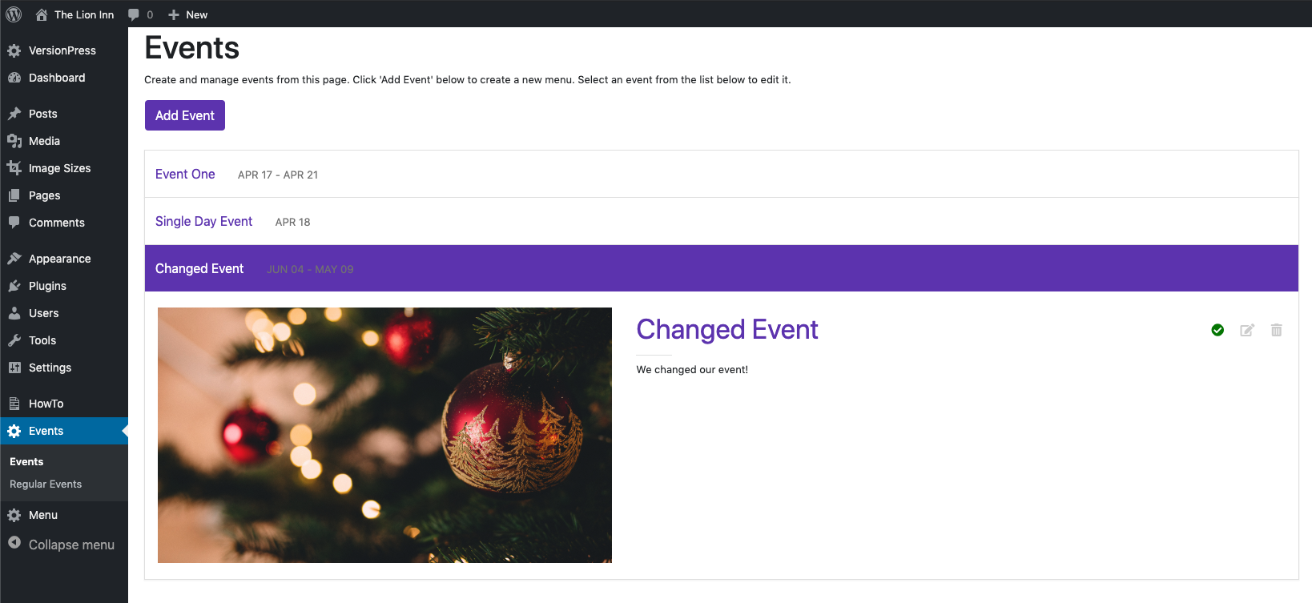

To edit an event, click the ‘Delete Event’ icon.

It should show this:

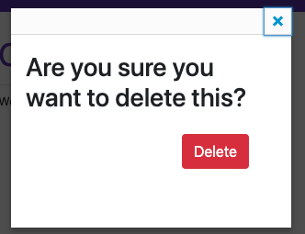

Click ‘Delete’. You should then see that the event is no longer listed:

