## Edit Event

Open the ‘Events’ page:

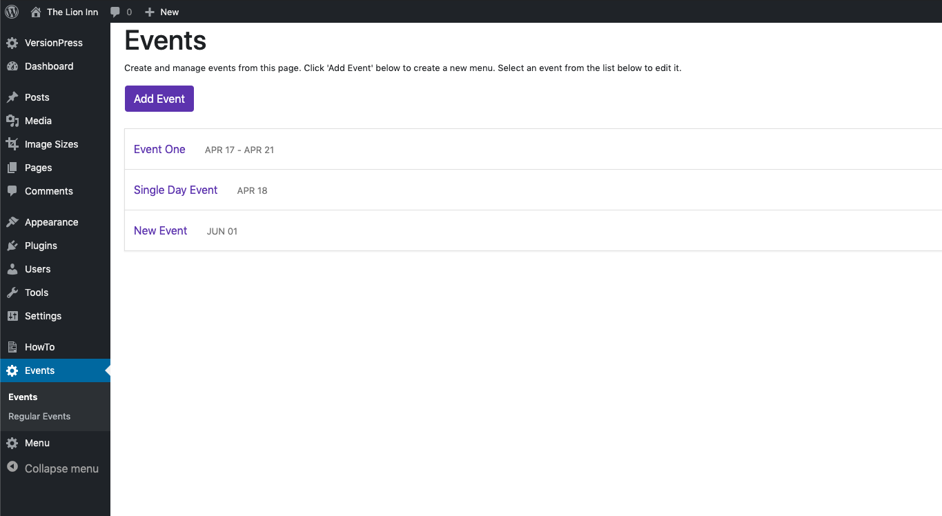

Click an event to view its information. It should show this:

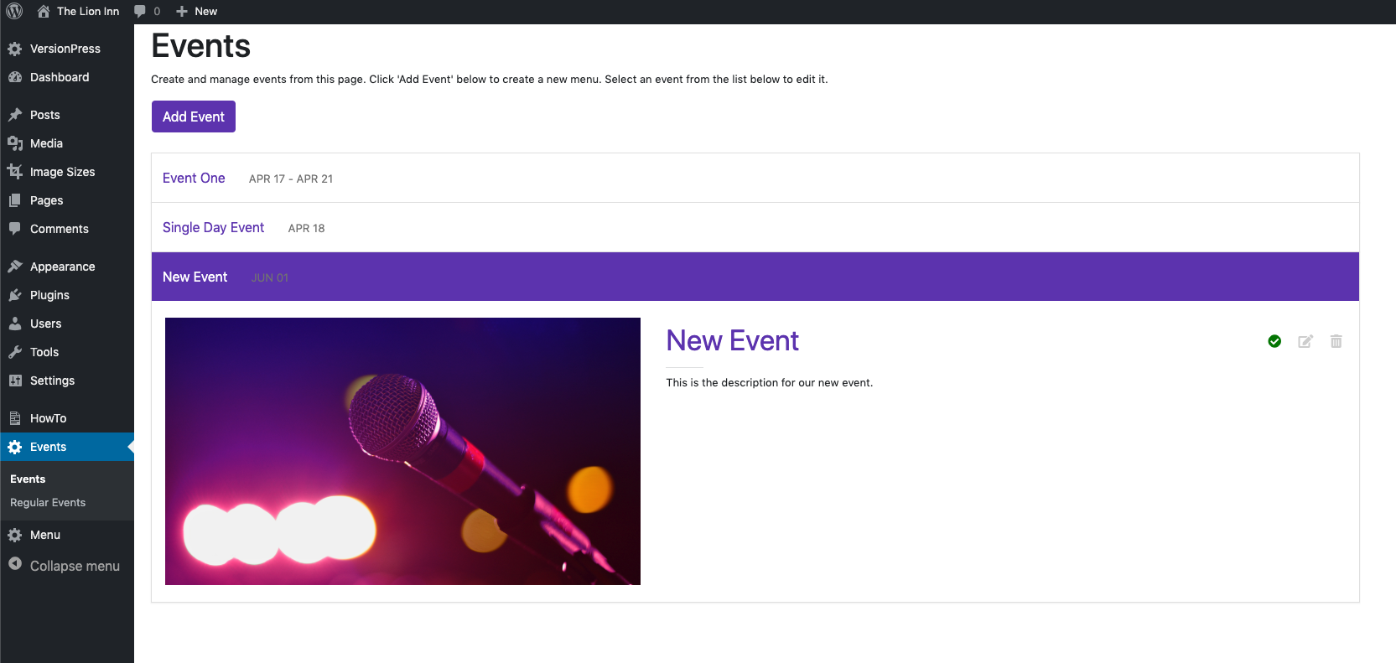

To edit an event, click the ‘Edit Event’ icon. It should show this:

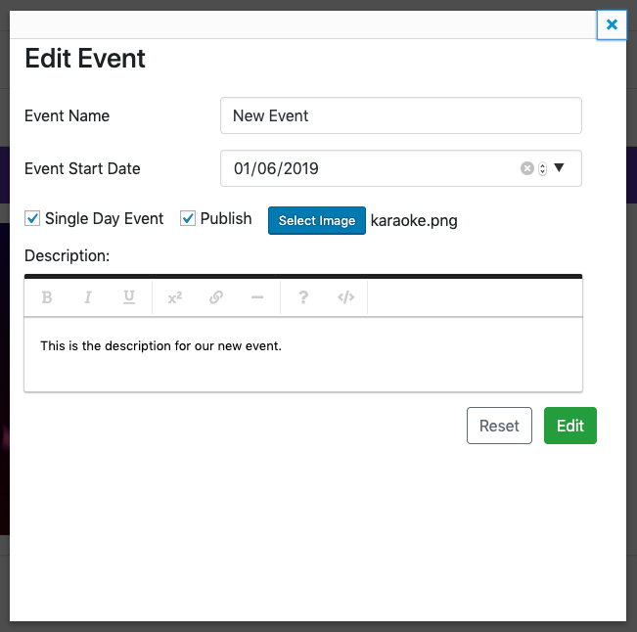

From this screen, you can edit:

* Event name
* Event start date
* Event end date
* Select if an event is one day
* Publish / Not Publish
* Select an image
* Enter a description for the event

Change it to this:

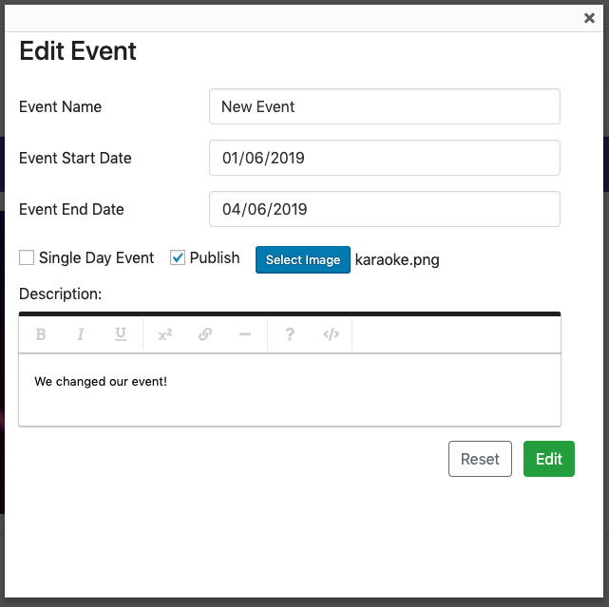

Click ‘Edit’.

You should return to the list and see the changed information. Click the event to display its information:

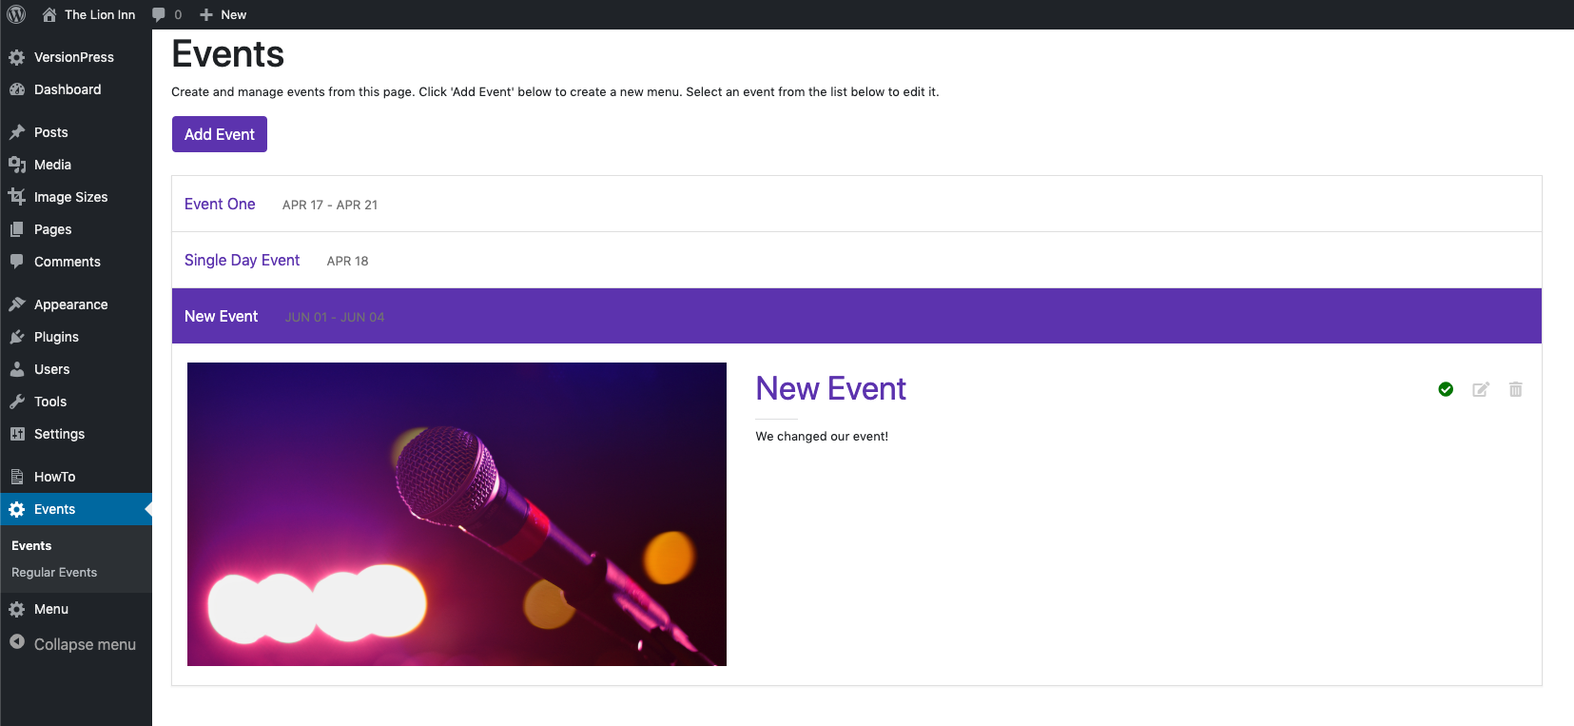

*Note:*

* *I unticked ‘Single Day Event’ so that we could set an end date (useful for festivals).*
* *I didn’t change the image*