## Overview

The upcoming events area allows you to add, edit and delete upcoming events.

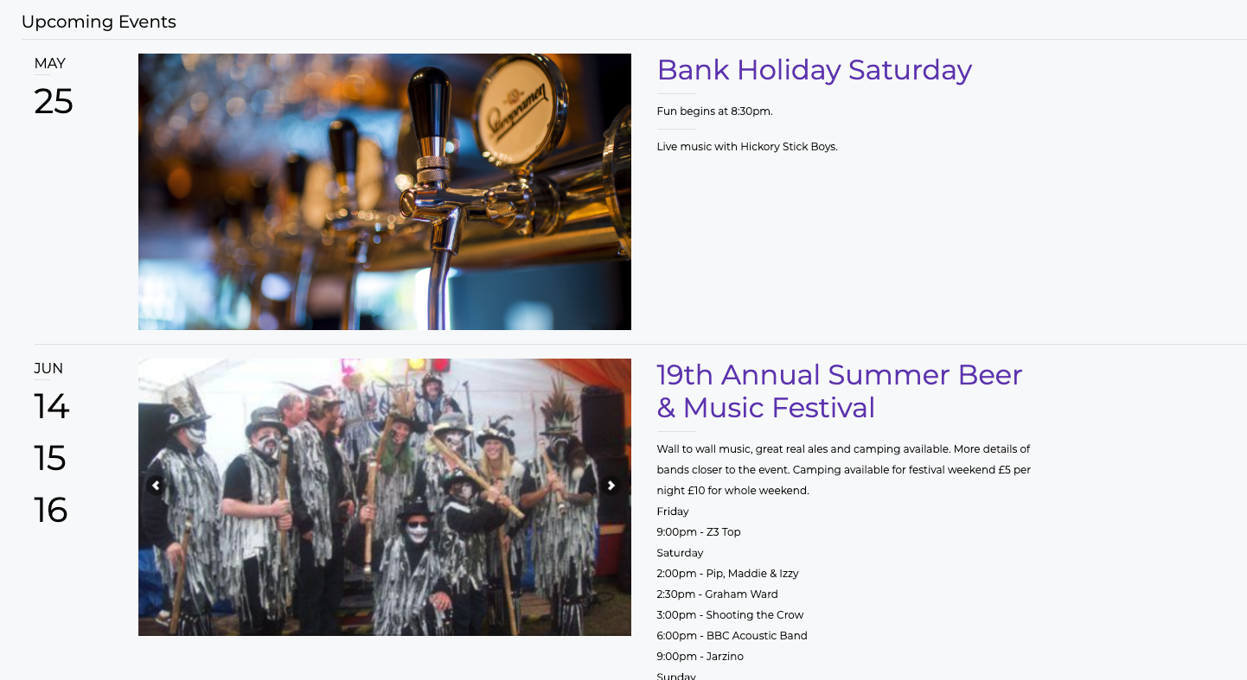

These can be changed by clicking ‘Events’ on the left-side bar:

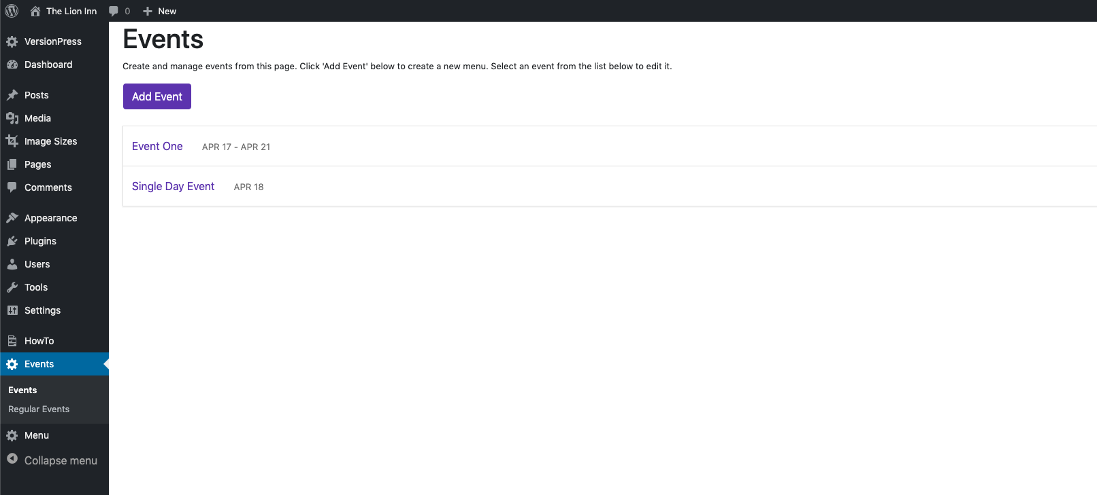

You can see that it looks very similar to the ‘Regular Events’ section.