## Accessing the Admin Panel

To access the normal website (like a customer would), go to:

* [www.lioninn.co.uk](http://www.lioninn.co.uk)

To access the admin panel (to edit the website), go to:

* [www.lioninn.co.uk/login/](http://www.lioninn.co.uk/login)

You should then see this:

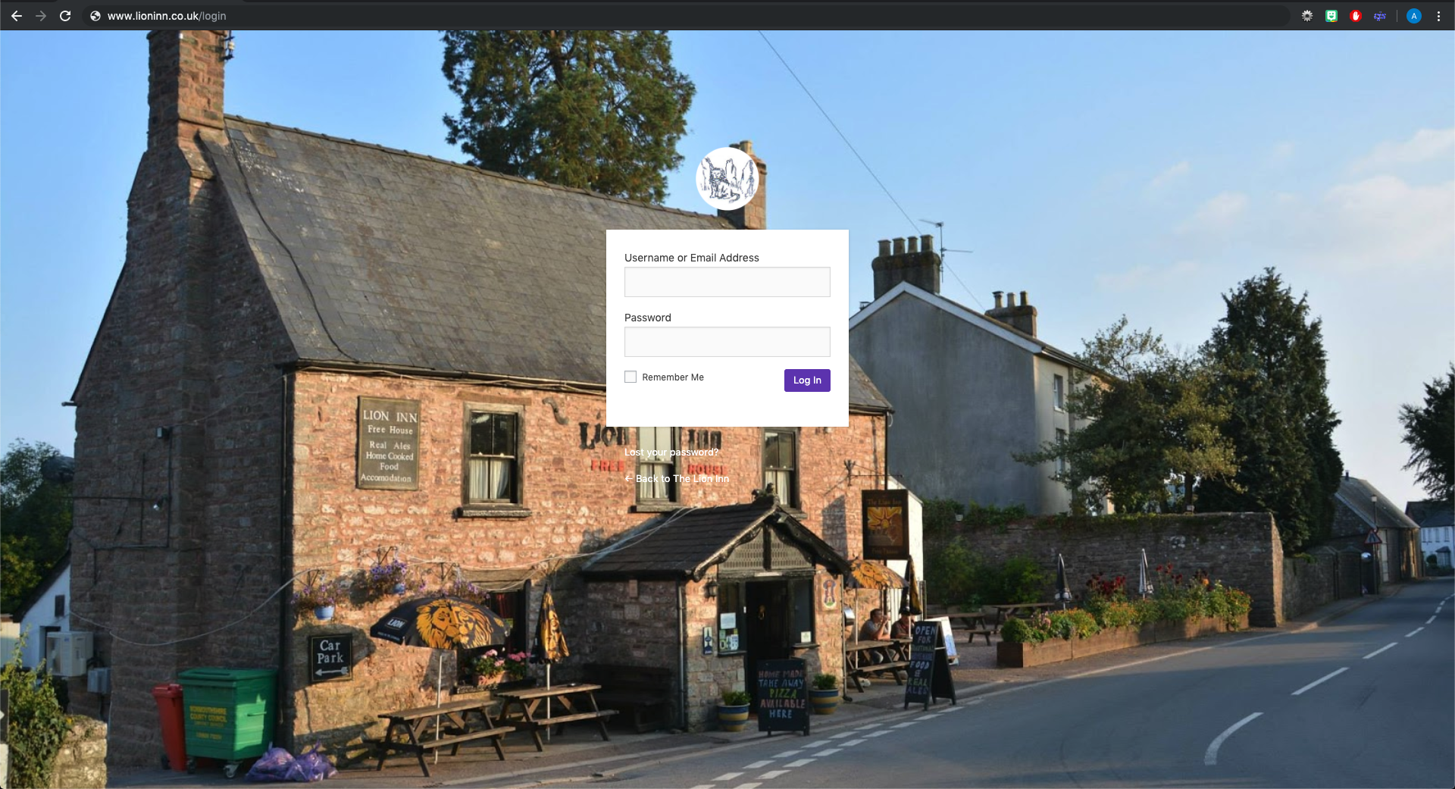

The login form:



*Login details will have been given to you.*

Enter your username & password. Click ‘Log in’. You should be presented with this screen:

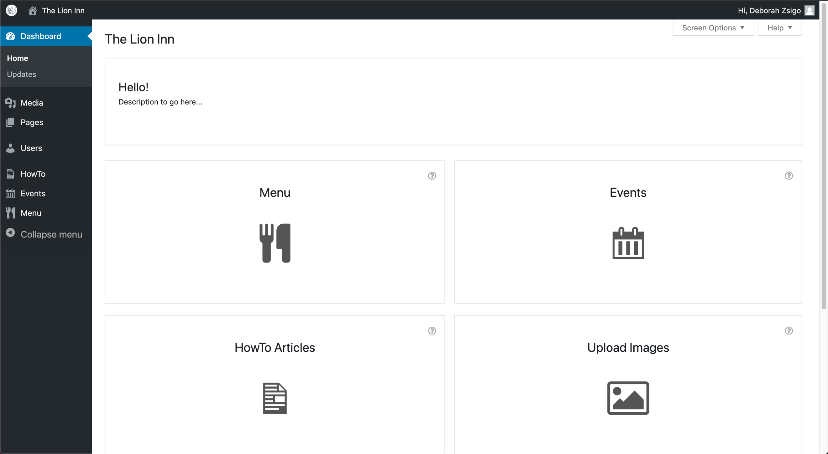

This is the **Dashboard**.

From here you can navigate to the main parts of the site. Click an icon to navigate to that page:

