### Going to Different Pages

From this page:

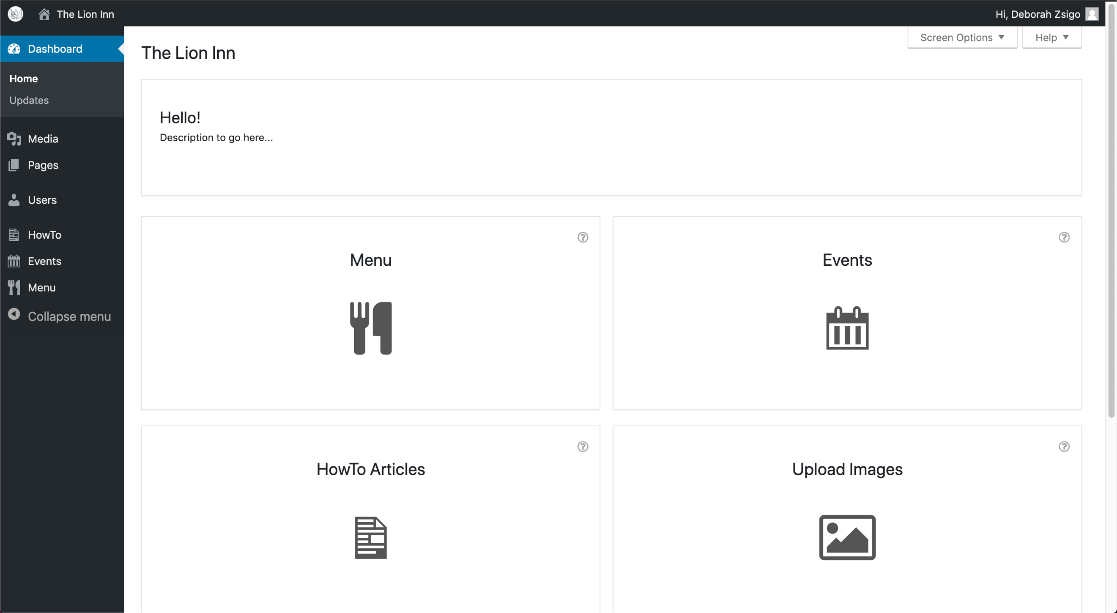

Click an icon to navigate to that page.

For example, clicking the cutlery icon for the menu will bring up this page:

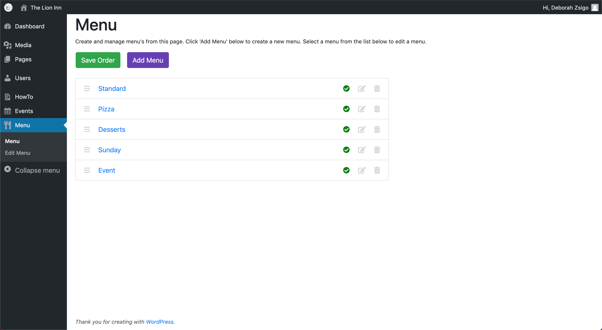

Notice that the ‘**Menu**’ item has been highlighted blue on the left. This shows which page you are on.

You can also access pages from the left-side bar:



For example, clicking ‘**Events**’ from the left side menu will show the events page:

