### Introduction

Once you have logged in, you will reach this page:

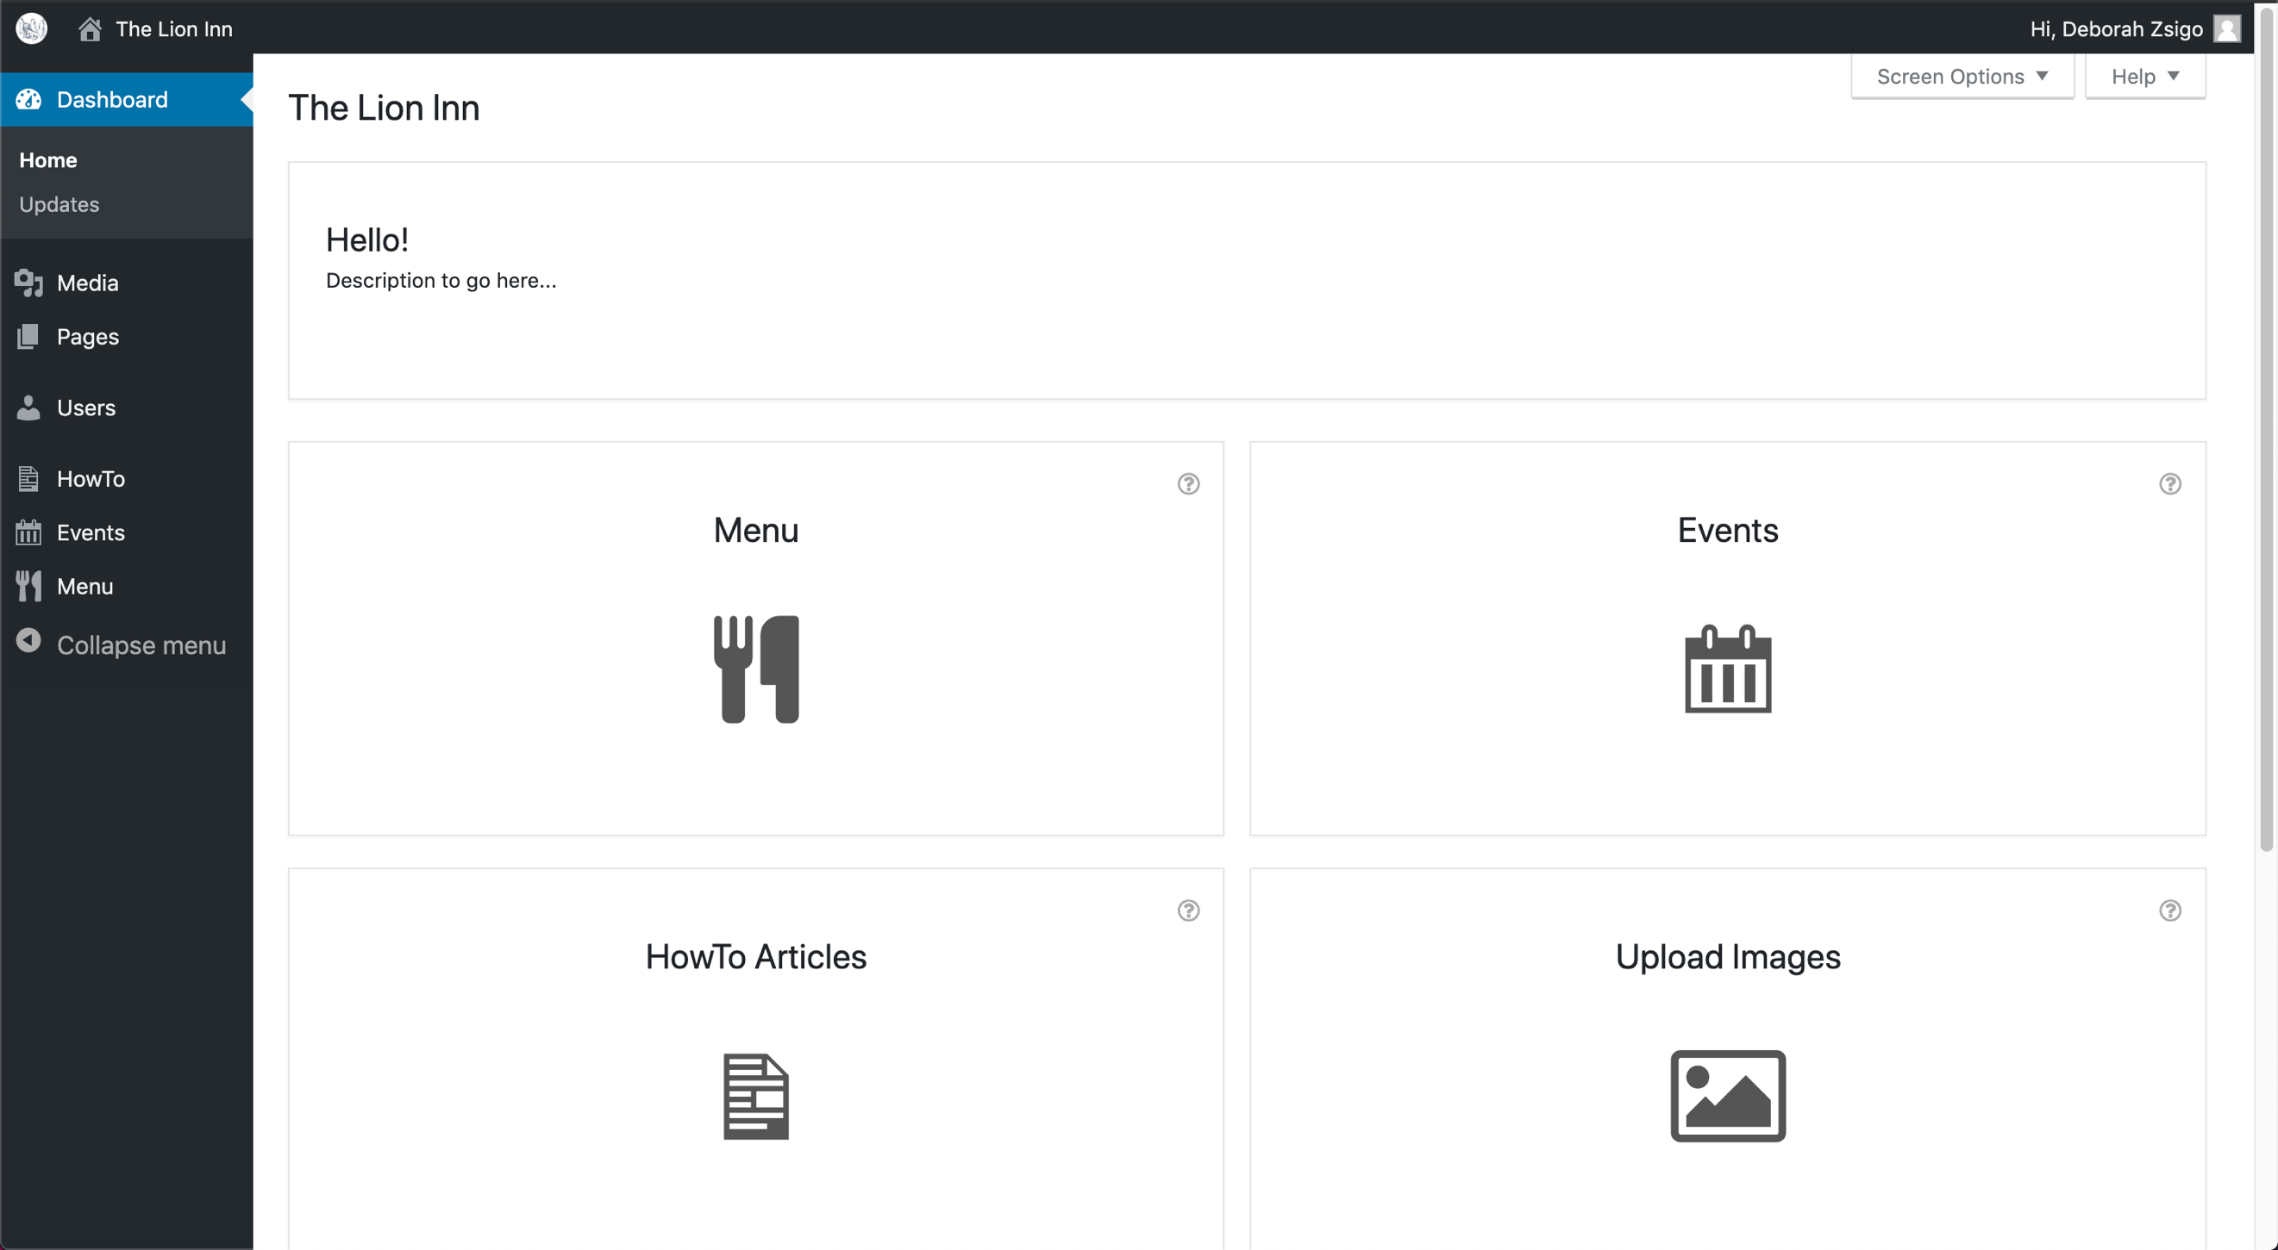

From here, you can:

* Go to a different page:
  + ‘**Menu**’ page to edit the menu
  + ‘**Events**’ page to edit the events
  + ‘**HowTo**’ articles page to look at how-to articles for the site
  + ‘**Media’** (images) page to add and delete images
  + ‘**Pages**’ page to edit what it shown on the main website
  + ‘**Users**’ page to add, edit or delete a user
* View the actual website
* Logout