### Logout

To logout, hover over ‘**Hi, *name***’ in the top right, and click ‘**Logout**’:

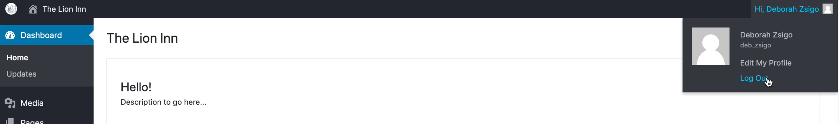

Zoomed in:



*NOTE: Don’t click ‘Hi, name’ as this will take you to edit your profile. Hover over it and then click ‘Log out’.*