### View the Actual Website

To view the actual website (that customers see), click ‘**The Lion Inn**’ in the top left:

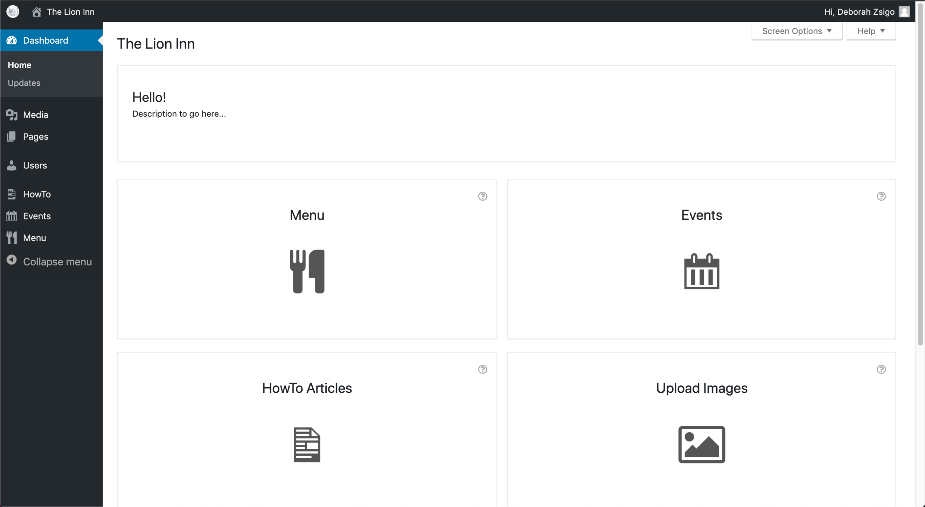

It looks like this:

