### Add New User

Click ‘Add New’ at the top of the ‘**Users**’ screen:

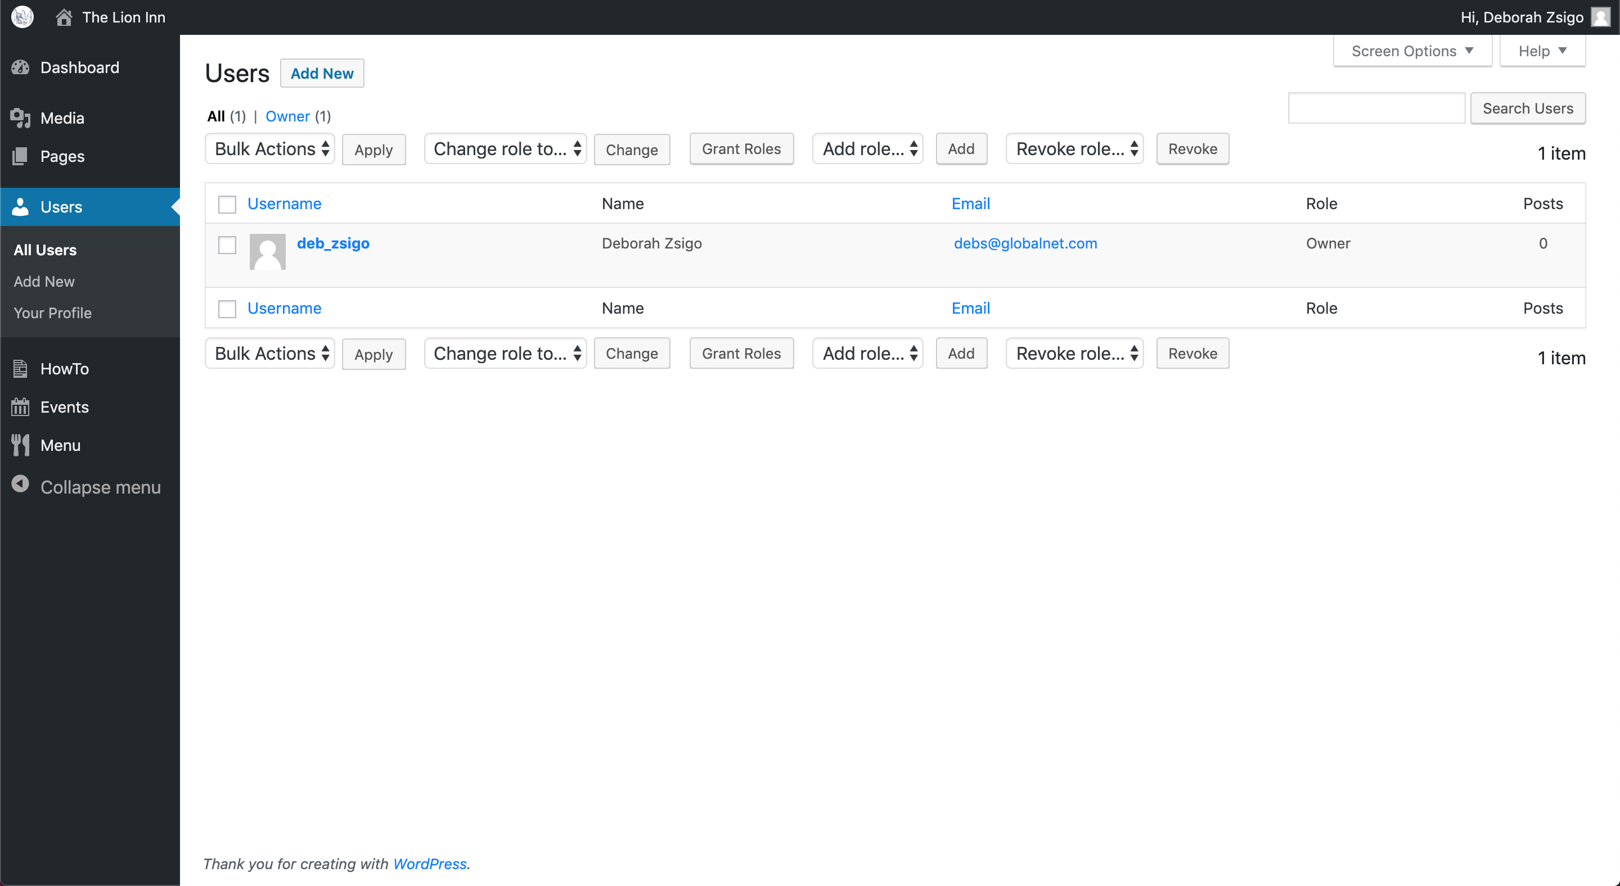



You should see this screen:

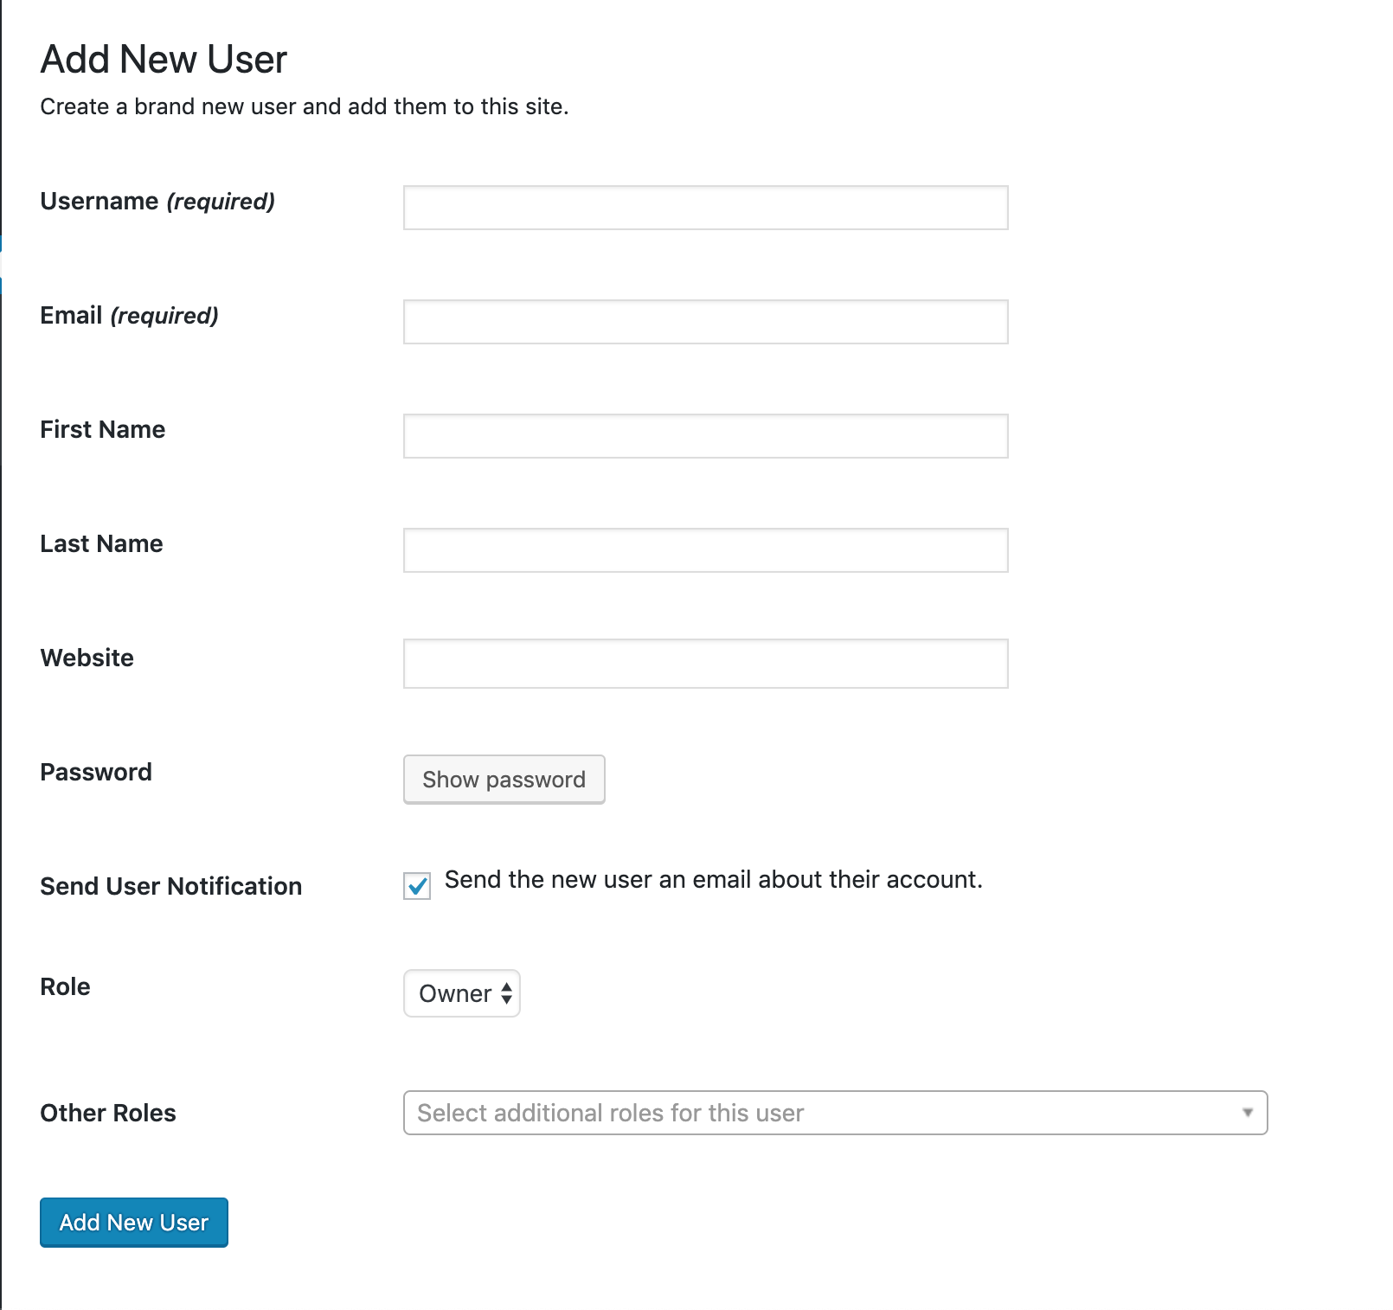

**Username**

The username can be whatever you want, but I have been creating them as ‘firstname_lastname’ (hence deb_zsigo and alex_lord).

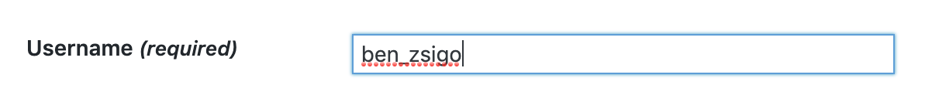

**Email**

Email is their email address. This should only be needed if their password is forgotten.



**First name & Last name**

Pretty self-explanatory – just their name.

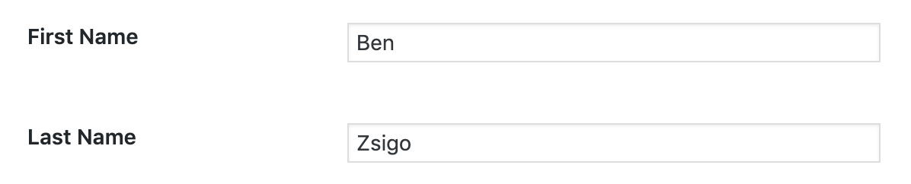

**Leave website blank.**

**Password**

Click ‘Show password’:

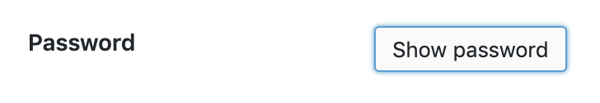

This should appear:

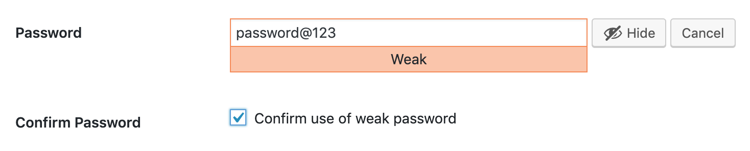

Set the password to ‘password@123’ and tick ‘Confirm use of weak password’. They can change this password when they first sign in.

**Send User Notification**

Leave ticked.

**Role**

Set the ‘Role’ to ‘Editor’ if it is not already set to that. The only difference between ‘Editor’ and ‘Owner’ is that ‘Owner’ can add and delete users.

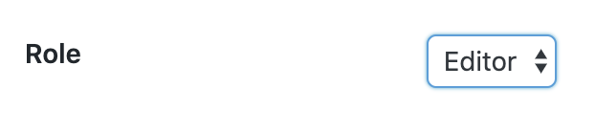

**Leave ‘Other Roles’ blank.**

We should have this:

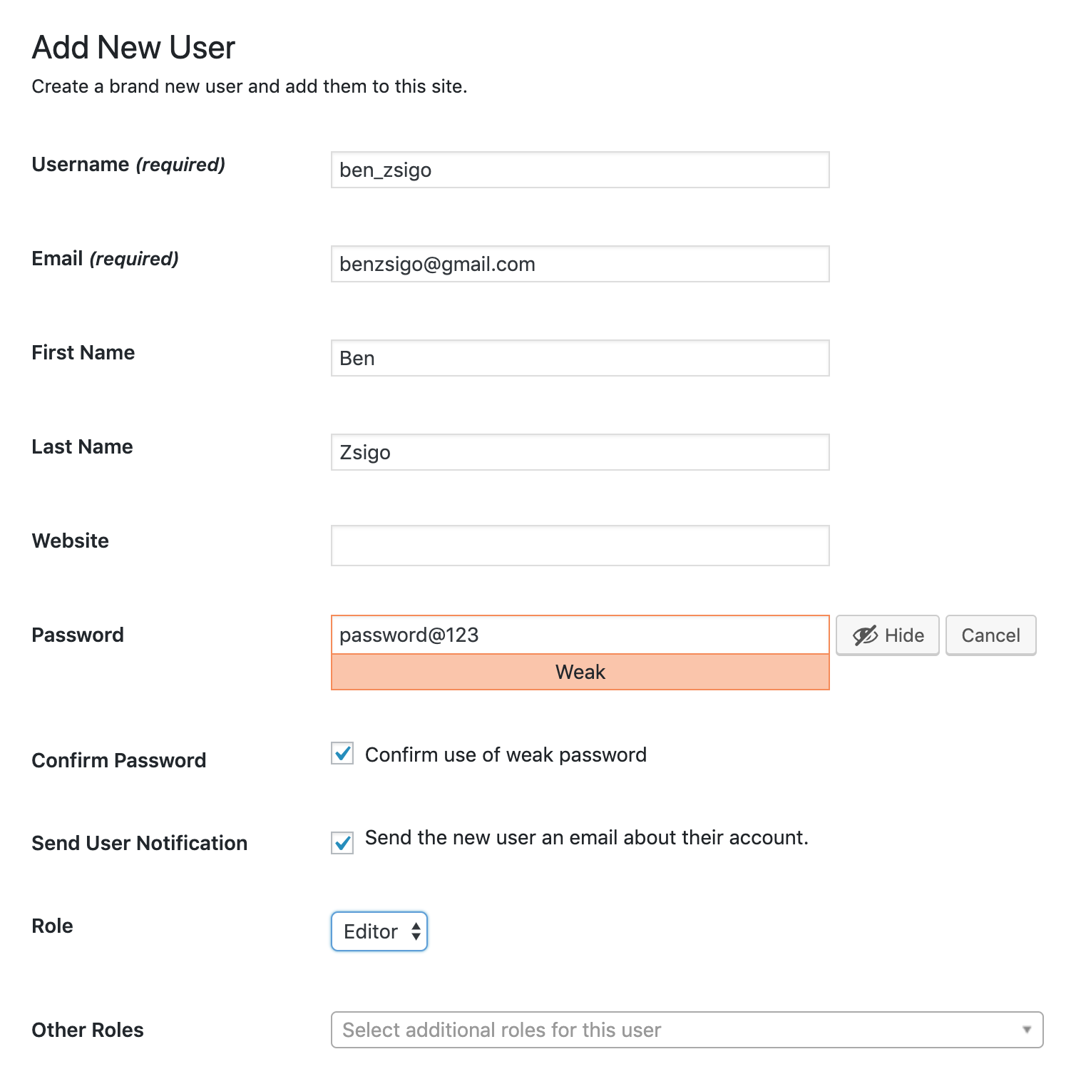

Click ‘Add New User’.

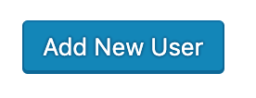

You should return to this screen and see the new user in the list:

