### Delete User

From this screen:

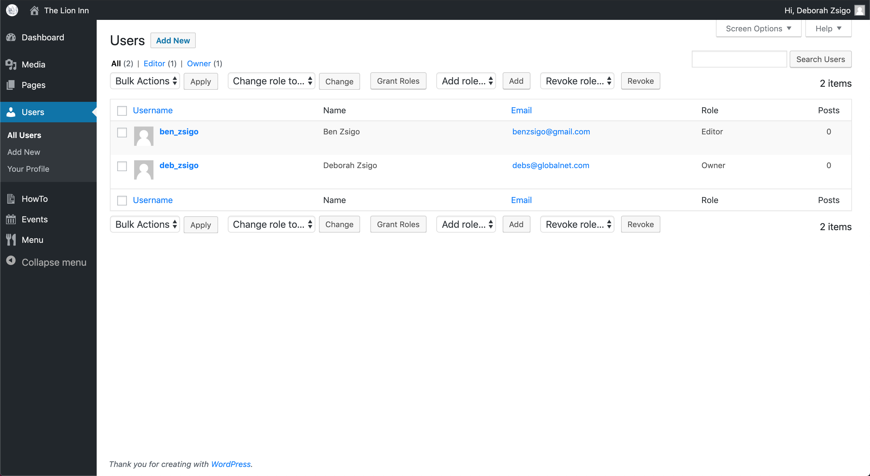

Hover your mouse over a user to see the ‘Delete’ button:

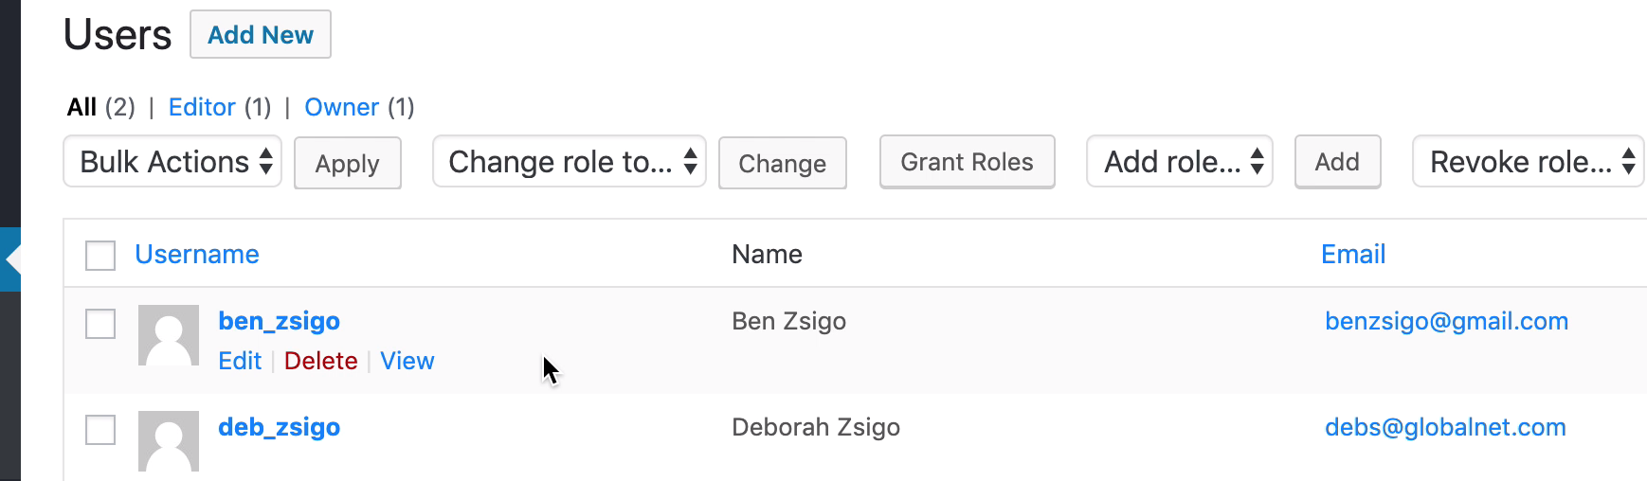

Click the ‘Delete’ button:

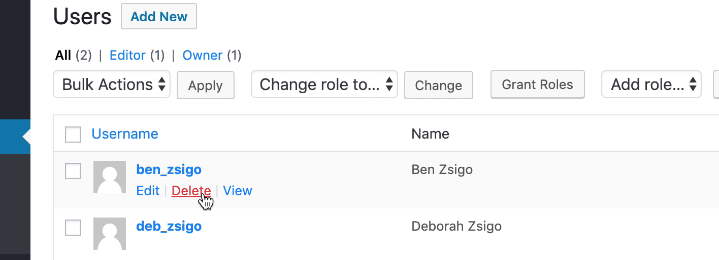

You should be asked for confirmation:

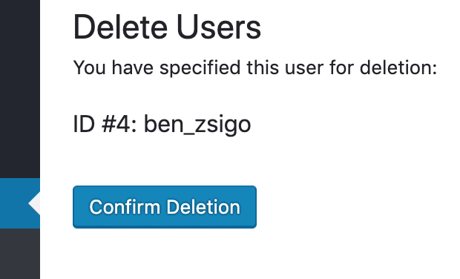

Click ‘Confirm Deletion’.

You should return to the user list and see that the user has been deleted:

