### Editing Roles

You may need to change someone’s role. To do this, go the ‘**Users**’ screen:

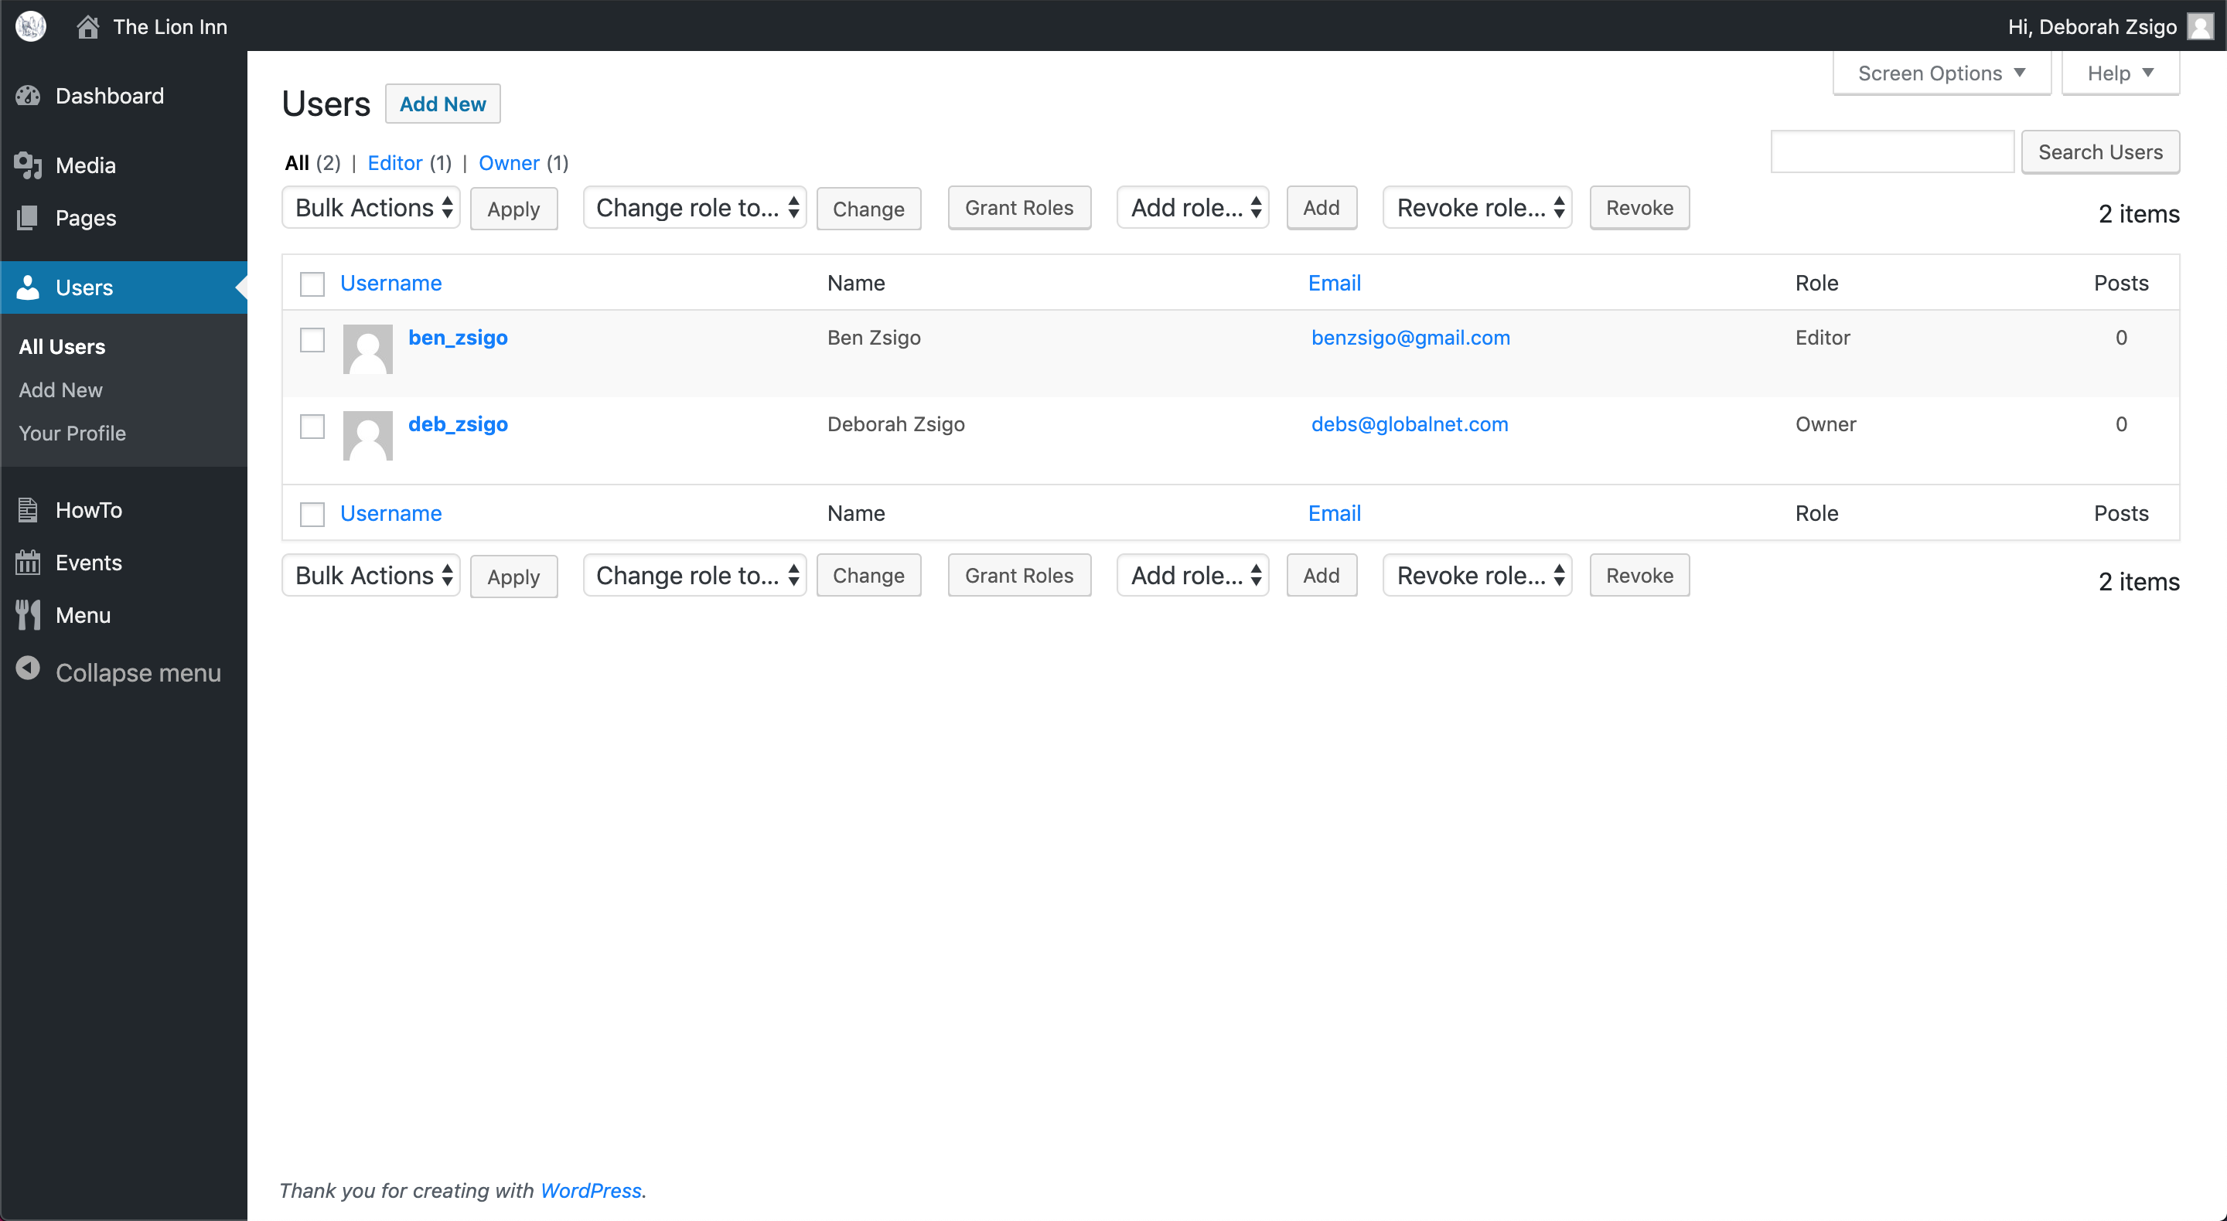

Hover your mouse over a user to see the ‘Edit’ button:

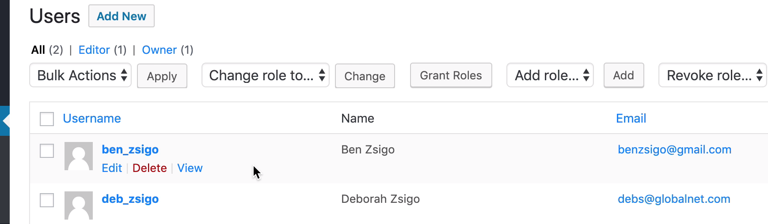

Click the ‘Edit’ button:

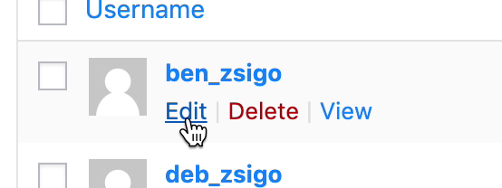

You should this screen:

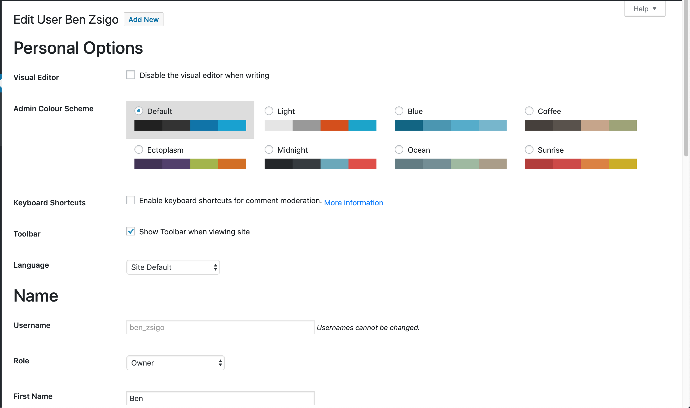

You’ll notice the ‘Role’ option near the bottom.

If you scroll down the page, you will notice that there are a lot of options to edit as well.

Select the desired new role from the dropdown:

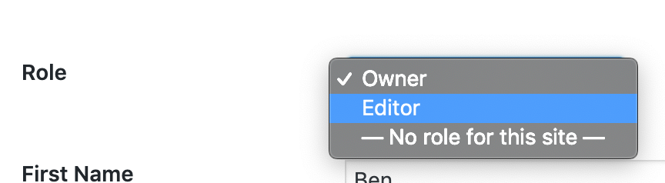

Scroll down to the bottom of the page and click the blue ‘Update User’ button:

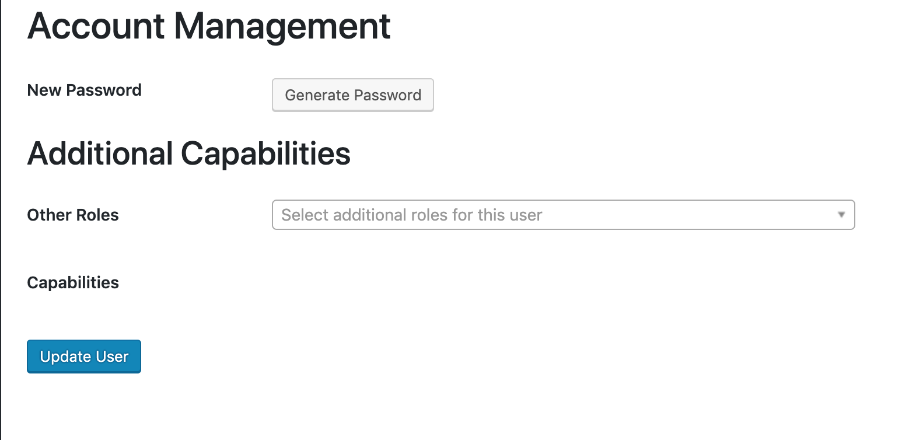

You should return to the top of the same page, but notice that the role has changed:

