### Introduction

When new people start at the pub, you may need to add a new user, so that they can make changes to the site. Similarly, when people leave, you may need to delete their accounts.

Once you have logged in, click the ‘**Users**’ from the dashboard or from the left side menu:

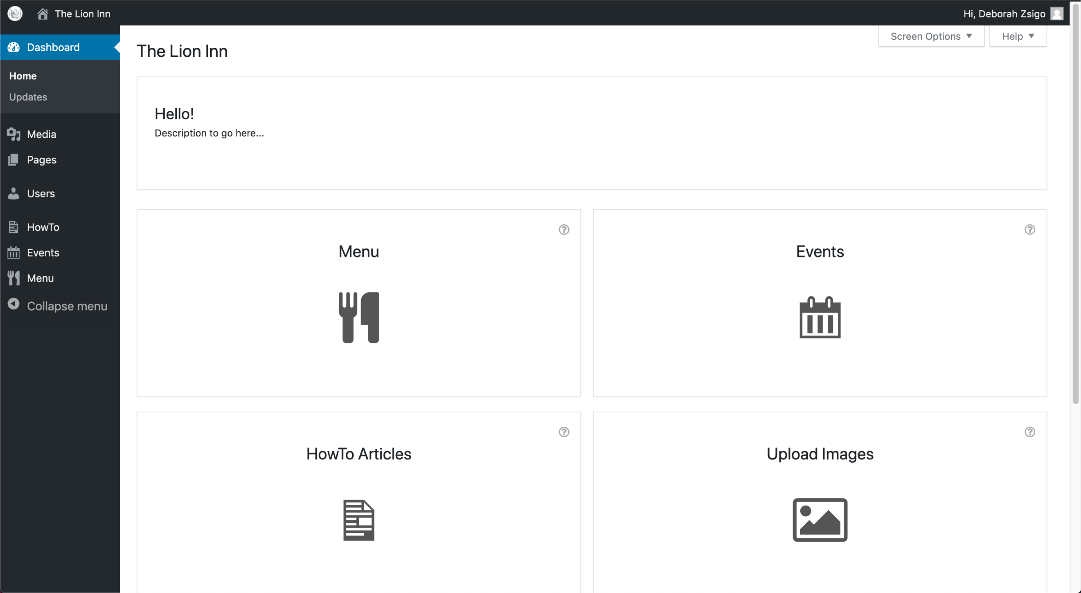

You should see something similar to this screen (there will probably be more users):

