### User ‘Roles’

Different users will need to do different things. When creating a new user, you are given the option of assigning a ‘Role’:

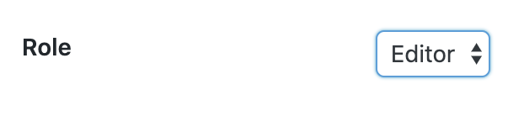

There are 3 roles:

1. **Administrator** – complete access to everything on the site.
2. **Owner** – access to everything required to manage the site.
3. **Editor** – the same access as an owner, but editors cannot add or delete users.

You have to a certain access level to grant that access level to someone else (which is why you probably cannot see ‘Administrator’ in the list).