Website Information

Normal Website – [www.lioninn.co.uk](http://www.lioninn.co.uk)

Edit Website – [www.lioninn.co.uk/login](http://www.lioninn.co.uk/login)

Username – deb_zsigo

Default Password – password@123

New Password –

HowTo Help Documents:

1. Go to [www.lioninn.co.uk/login](http://www.lioninn.co.uk/login)
2. Enter login info above to login
3. Click ‘HowTo’ on left-hand side”:

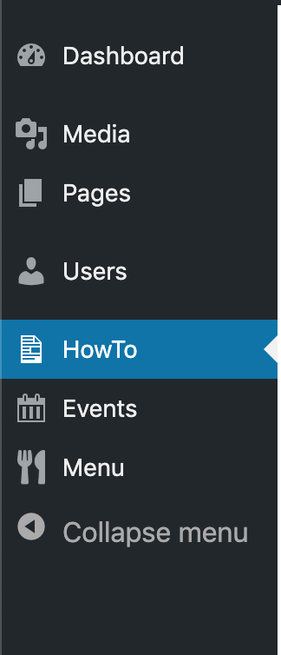

1. Select whichever HowTo article you need, and it *should* appear on the right-hand side.

Forgot Password?

1. Go to [www.lioninn.co.uk/login](http://www.lioninn.co.uk/login)
2. Click ‘Lost your password?’
3. Enter your username / email address and click ‘Get New Password’.
4. Check your email inbox for an email.
5. Click the link in the email and follow it through to reset your password.
6. Go back to [www.lioninn.co.uk/login](http://www.lioninn.co.uk/login)
7. Enter username and new password to login

Website Information – New Starter

Normal Website – [www.lioninn.co.uk](http://www.lioninn.co.uk)

Edit Website – [www.lioninn.co.uk/login](http://www.lioninn.co.uk/login)

Username –

Default Password –

New Password –