## The Text Editor

On several screens when editing any events, you will come across this:

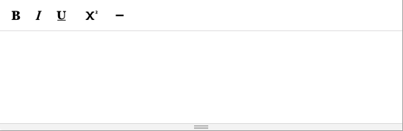

This is mainly used to enter descriptions for events and give more flexibility whilst doing so.

From left to right:

1. 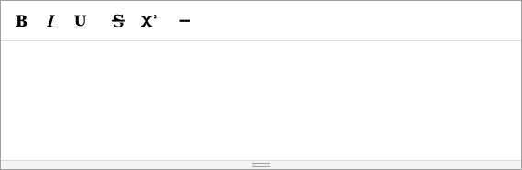

This makes text **bold**.

1. 

This makes text *italic*.

1. 

Underline text.

1. 

This adds a superscriptlikethis

1. 

This will add a horizontal line, that will appear like the lines on the events section:

