## Upload Images

You will need to upload images before you can use them for event images and icons.

Either click the ‘Upload Images’ icon or click ‘Media’ on the left.

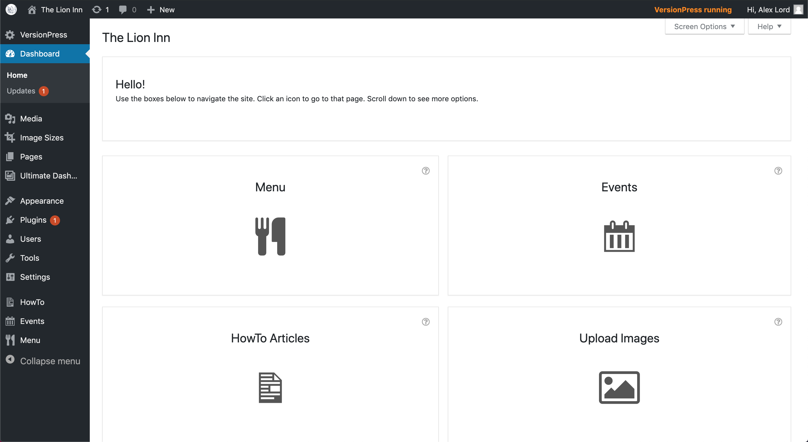

You should see this:

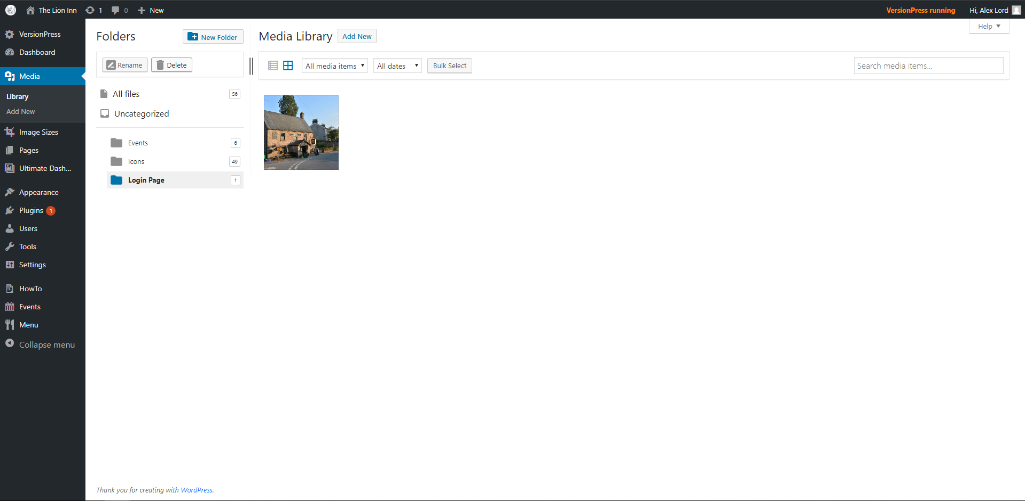

Click the ‘Add New’ button at the top.

You should see this drop-down:

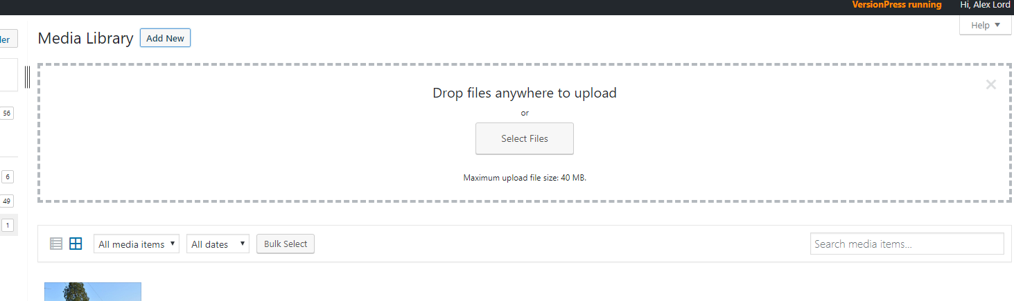

Click ‘Select Files’. The file selector will appear:

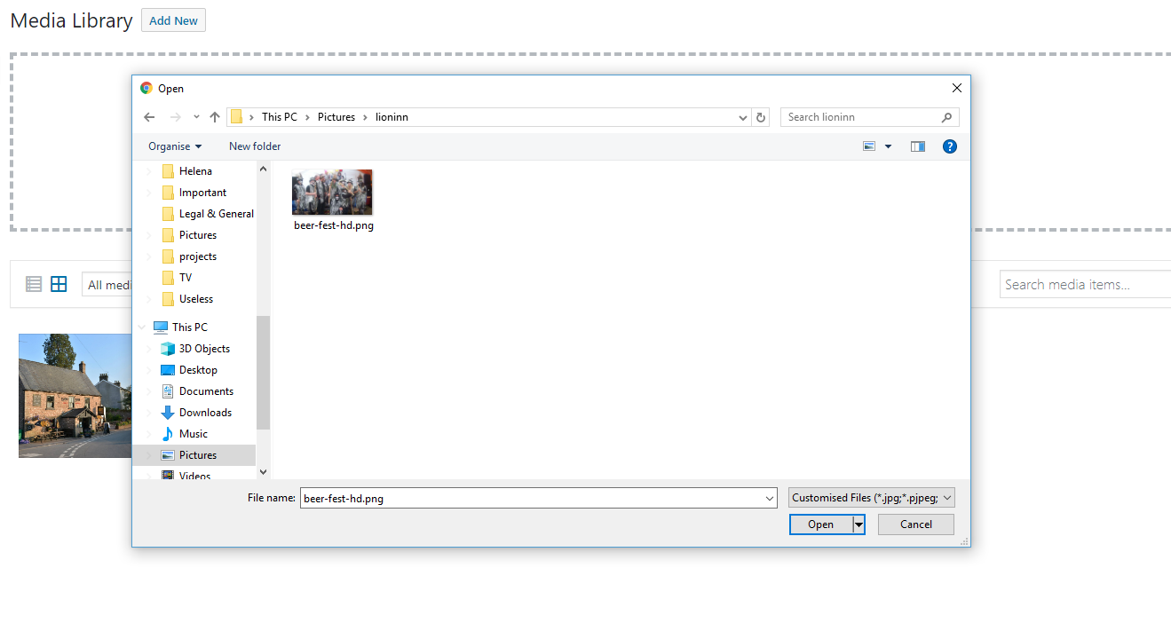

Find your image(s). They’re probably inside your ‘Pictures’ folder. Click the image(s) so they highlight blue, and click ‘Open’:

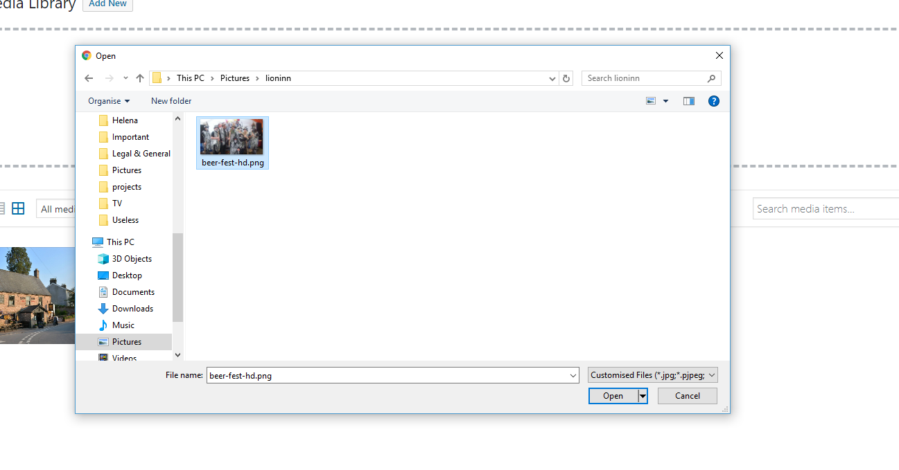

You will return to the media page, and you should see your newly uploaded image:

