HowTo: Menu

Table of Contents

OVERVIEW 3

How to Access the Menu’s 3

Menu’s, Sections, Items & Subitems 5

Published & Not Published 5

CREATING 6

Add Menu 6

Add Section 8

Adding to the Right Side 9

Add Item 11

Food Item 11

Subtitle Item 13

Note Item 15

How These Look on the Website 17

Add Subitem 18

EDITING 20

Edit Menu 20

Edit Section 20

Edit Item 20

Edit Subitem 20

DELETING 21

Delete Menu 21

Delete Section 21

Delete Item 21

Delete Subitem 21

REORDERING 22

Reordering Menu’s 22

Reordering Menu Content (Sections, Items & Subitems) 22

# OVERVIEW

## How to Access the Menu’s

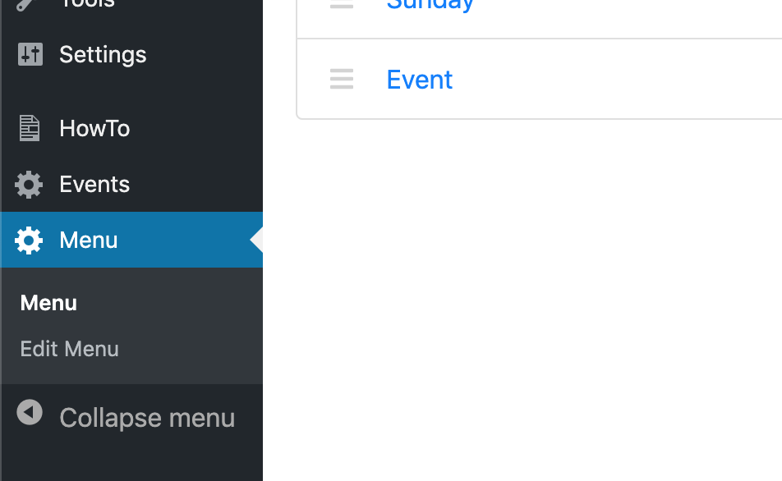

The menus can be accessed by clicking ‘Menu’ in the left-side bar. The two sub-menu items; Menu and Edit Menu, will appear when you click ‘Menu’. It will default to the sub-menu item, also called ‘Menu’.

‘Menu’ shows a list of the menus that have currently been created.

‘Edit Menu’ is used to add, edit and delete sections, items and subitems for a specific menu (more on this in the next section – Menu’s, Sections, Items & Subitems).

Clicking on a menu on the ‘Menu’ page will load the ‘Edit Menu’ page so that you can edit the menu that you clicked on.

For example, clicking ‘Standard’ from the list:

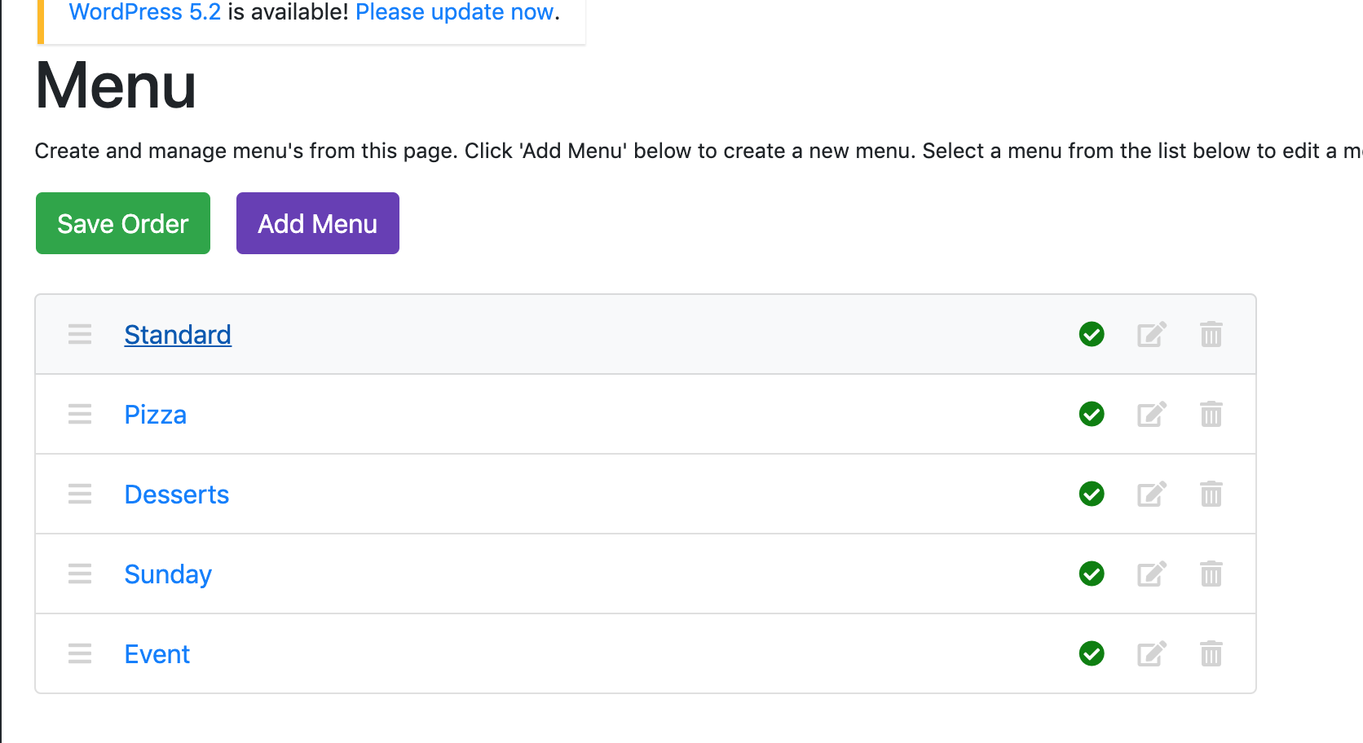

Will load this page:

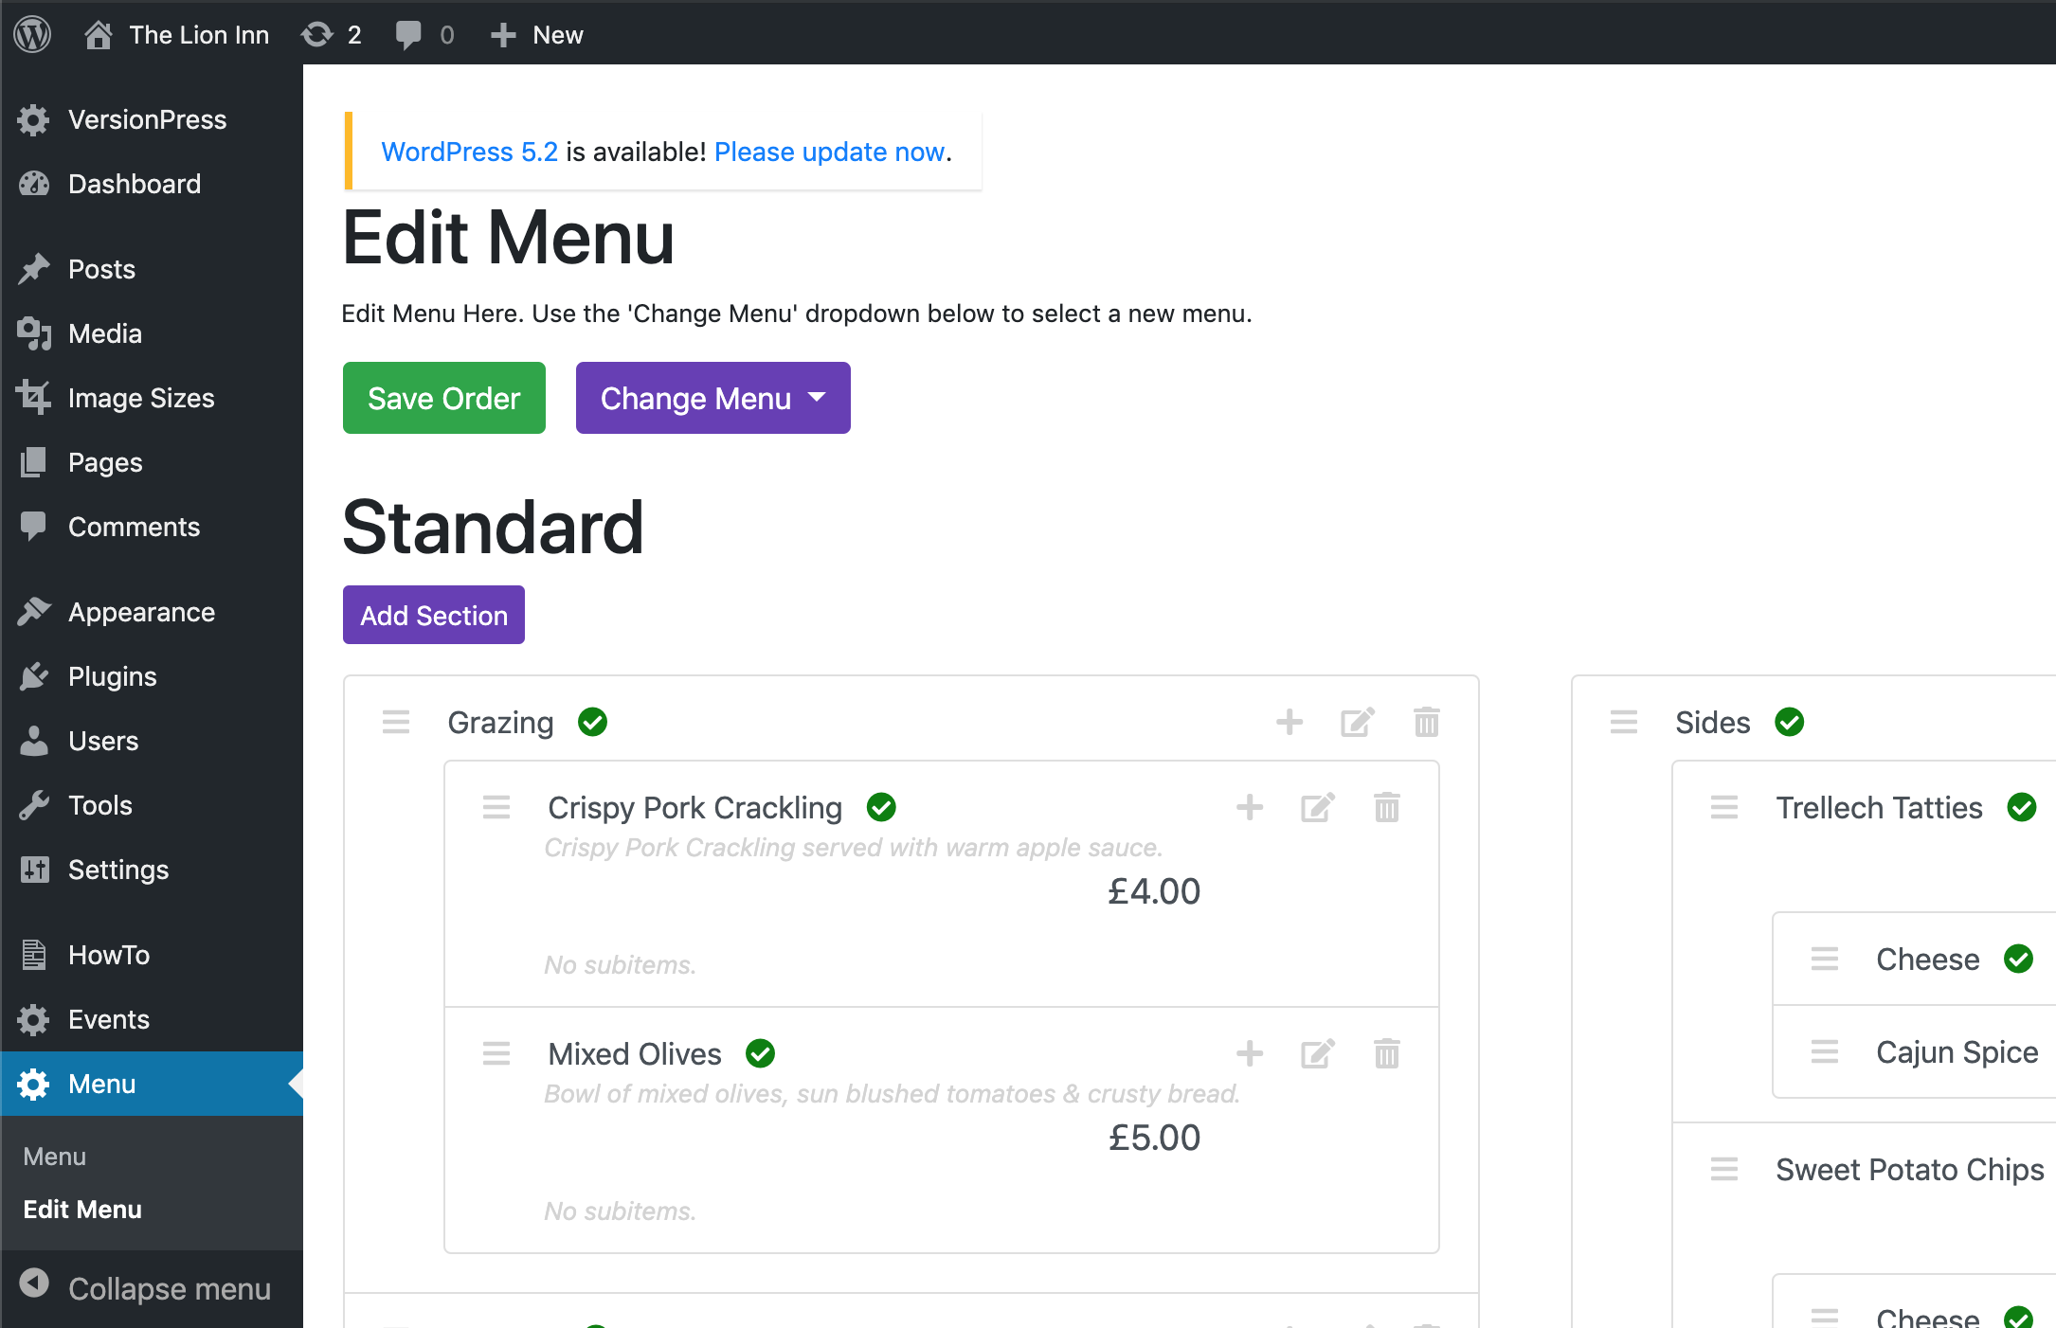

Notice that the menu title (Standard) is shown at the top and that we are on the ‘Edit Menu’ page now.

Clicking ‘Edit Menu’ directly from the left-side bar will bring up this page:

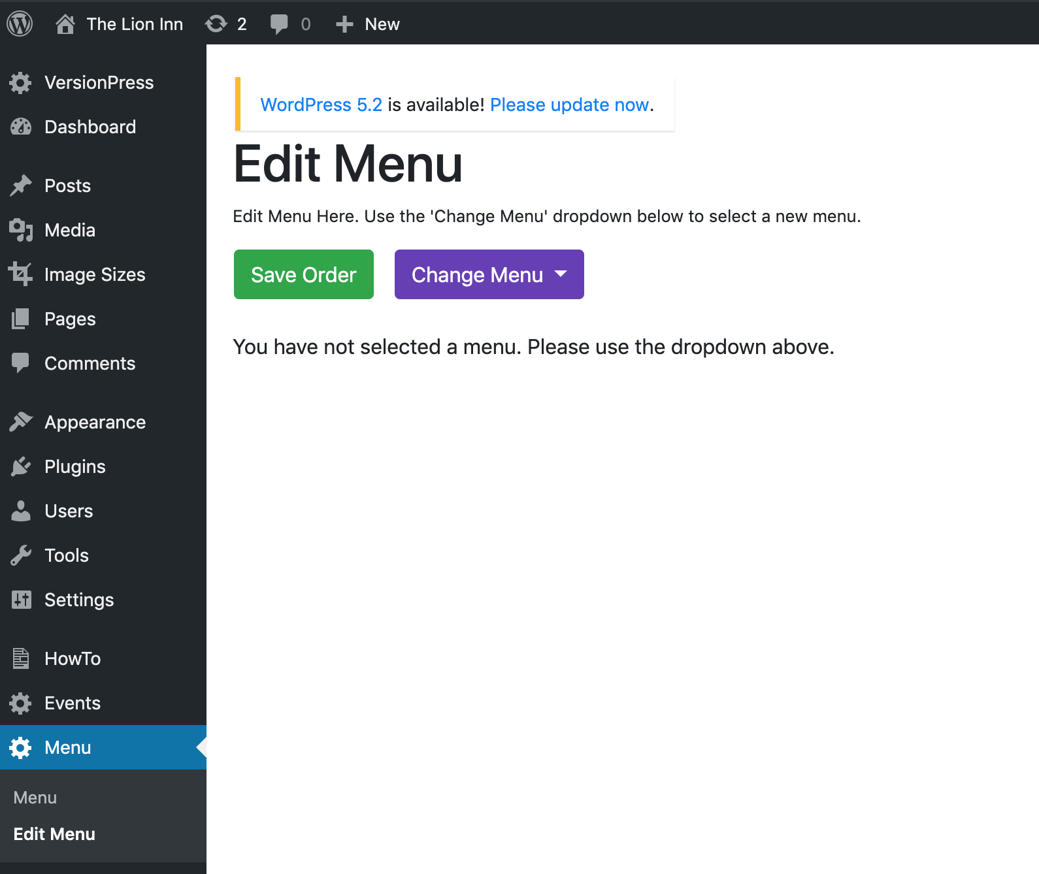

To choose a menu, click the purple ‘Change Menu’ button, and select a menu from the list.

## 

## Menu’s, Sections, Items & Subitems

The menu functionality is very loose and flexible. The different types (Menu, Section, Item and Subitem) can be whatever you want. Below are some vague examples of what they will probably be, based off of how the menu currently looks.

**Menu** – Standard, Desserts, Sunday, An Event Menu

**Section** – Grazing, Starters, Mains, Coffee, Sides

**Item**

Items get slightly more complicated. An item can be one of 3 things:

1. A **FOOD** item like Olives, Spaghetti Carbonara or Filter Coffee
2. A **SUBTITLE** item like Pasta, From the Sea or Burgers.
3. A **NOTE** item like ‘*All of our grills are served with sauteed mushrooms, pan friend tomato, beer battered onion rings and Trellech tatties or sweet potato chips.*’

**Subitem**

Subitems *can* be applied to all **FOOD** items but are mainly used for extra’s for sides.

For example, ‘Cheese’ and ‘Cajun Spice’ for chips and tatties, etc.

## Published & Not Published

‘Published’ refers to whether an item can be seen on the customer facing site or not.

If an item is **published** (which is the **default**), it will have this icon next to it:



If an item is **not published**, it will have this icon next to it:



This can be useful for saving menu’s or items that are no longer be needed at the moment but may be needed again in the future.

It will also be useful for creating menu’s in advance of an event. For example, if Mother’s Day is coming up, and you want to create the menu several months in advance but don’t want to publish it to the site until a few weeks before.

# CREATING

## Add Menu

To create a new a menu, click ‘Menu’ on the left-side bar so that we are on this page:

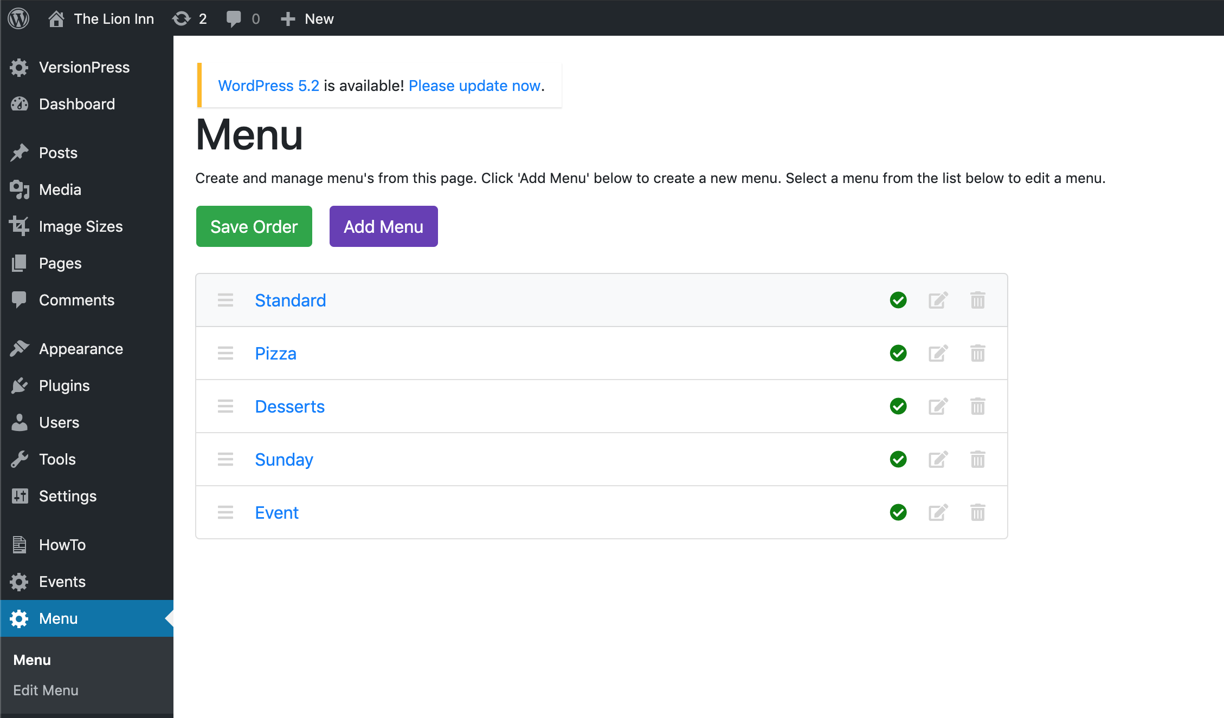

Click the purple ‘Add Menu’ button. You should then see this:

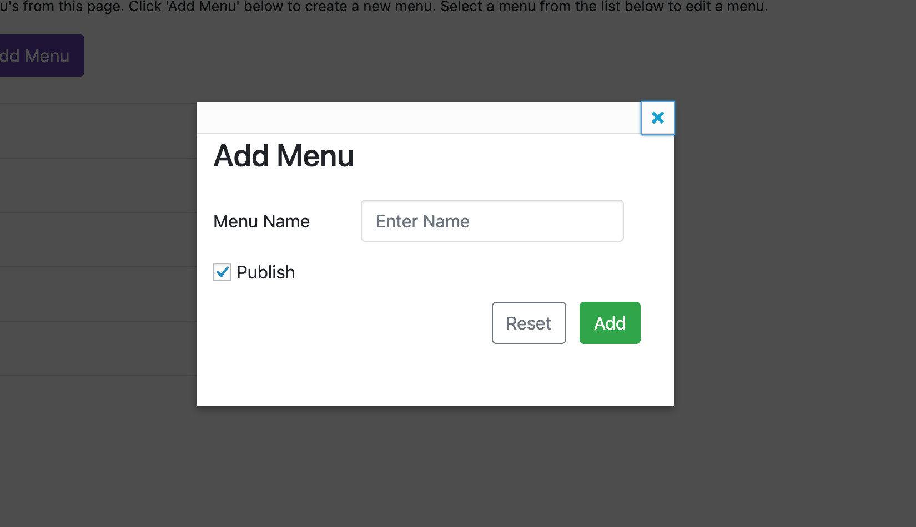

Enter a menu name and untick ‘Publish’ if you don’t want it to be seen on the site. Click ‘Add’. You should then see the new menu in the list.

For example, I will create a new menu called ‘NewMenu’:

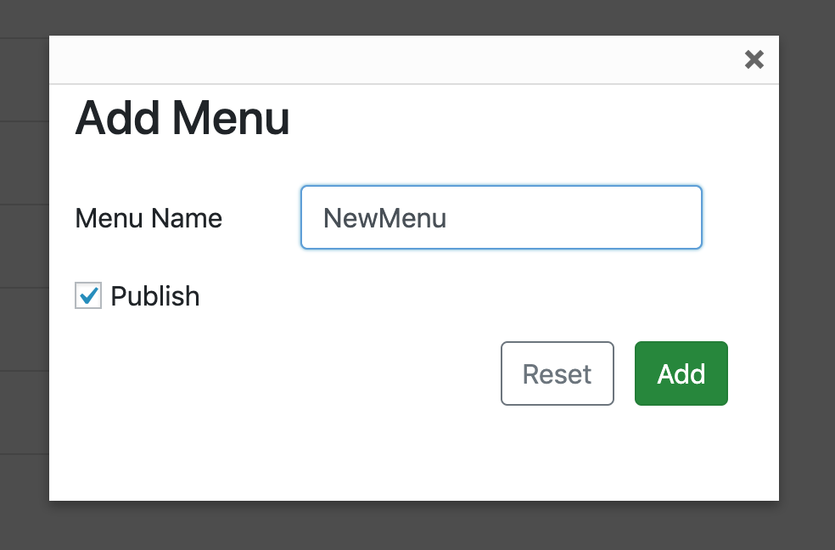

Click ‘Add’.

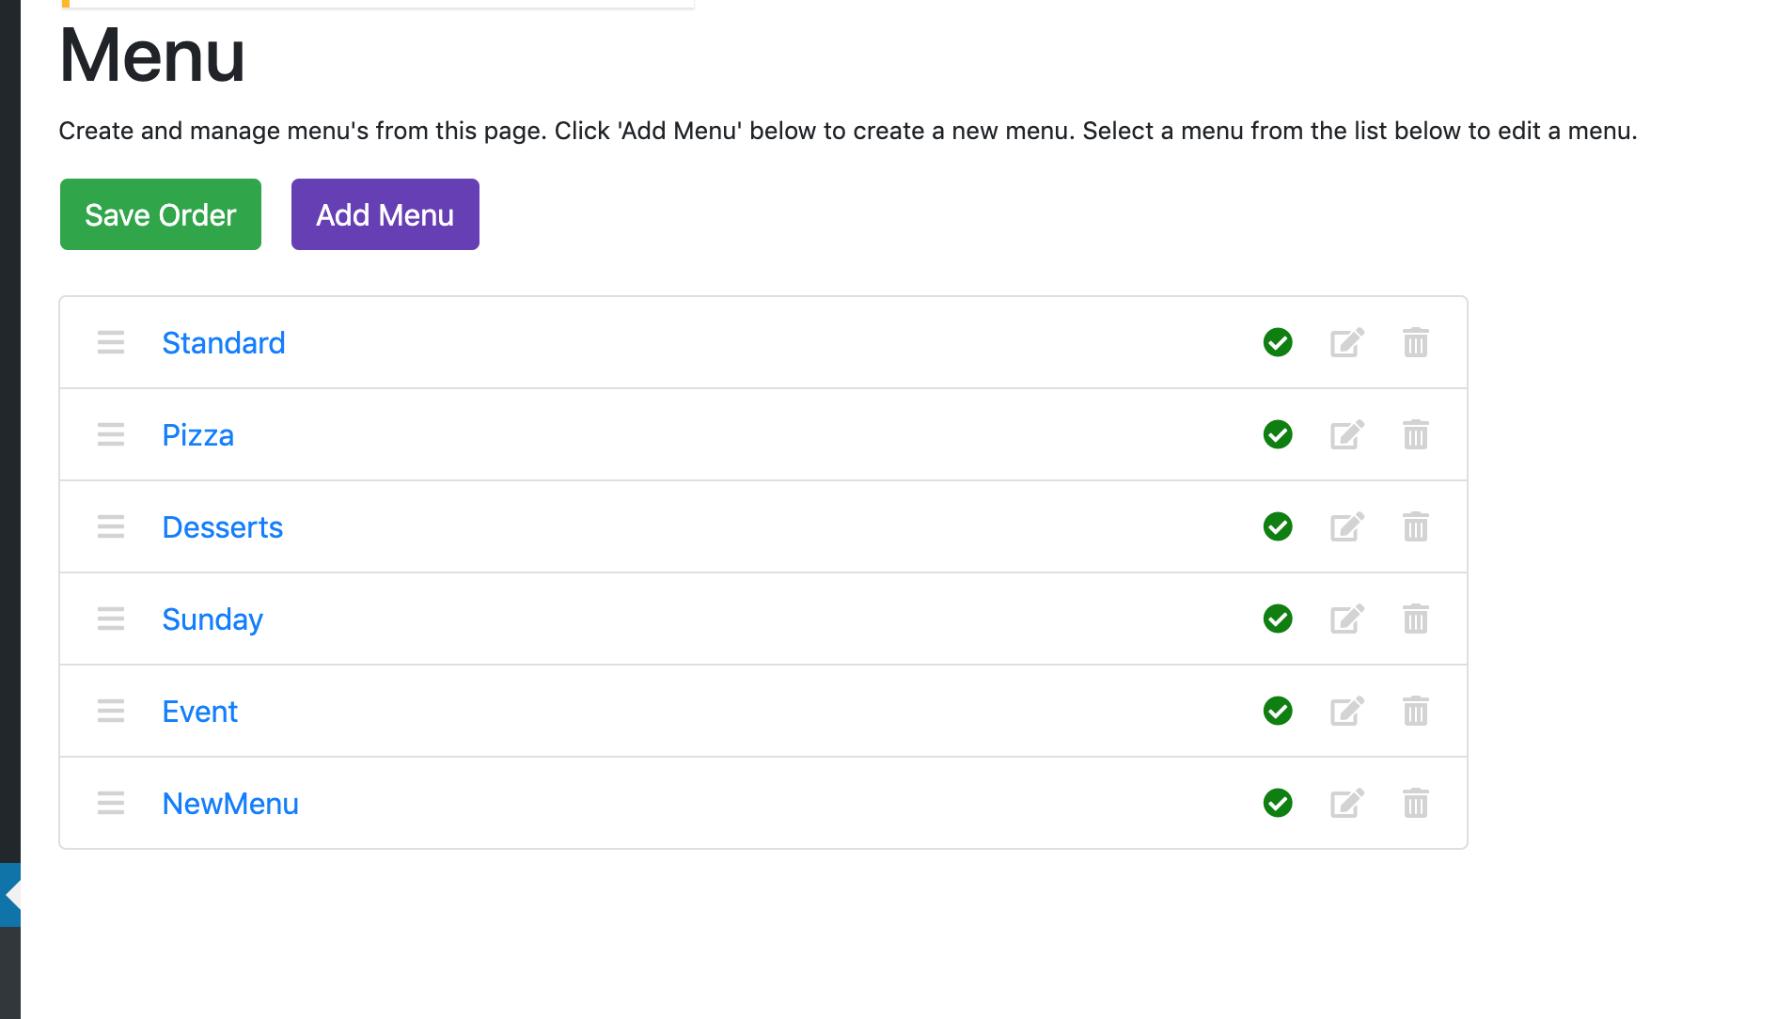

We can now see ‘NewMenu’ in the list above.

## Add Section

Creating a new menu section is very similar to creating a new menu.

Select a menu from the list of menus. For the sake of continuity, we’ll use the ‘NewMenu’ created in the previous section (but you can and will need to add new sections to other menus).

You should be on the ‘Edit Menu’ page, once you have selected a menu.

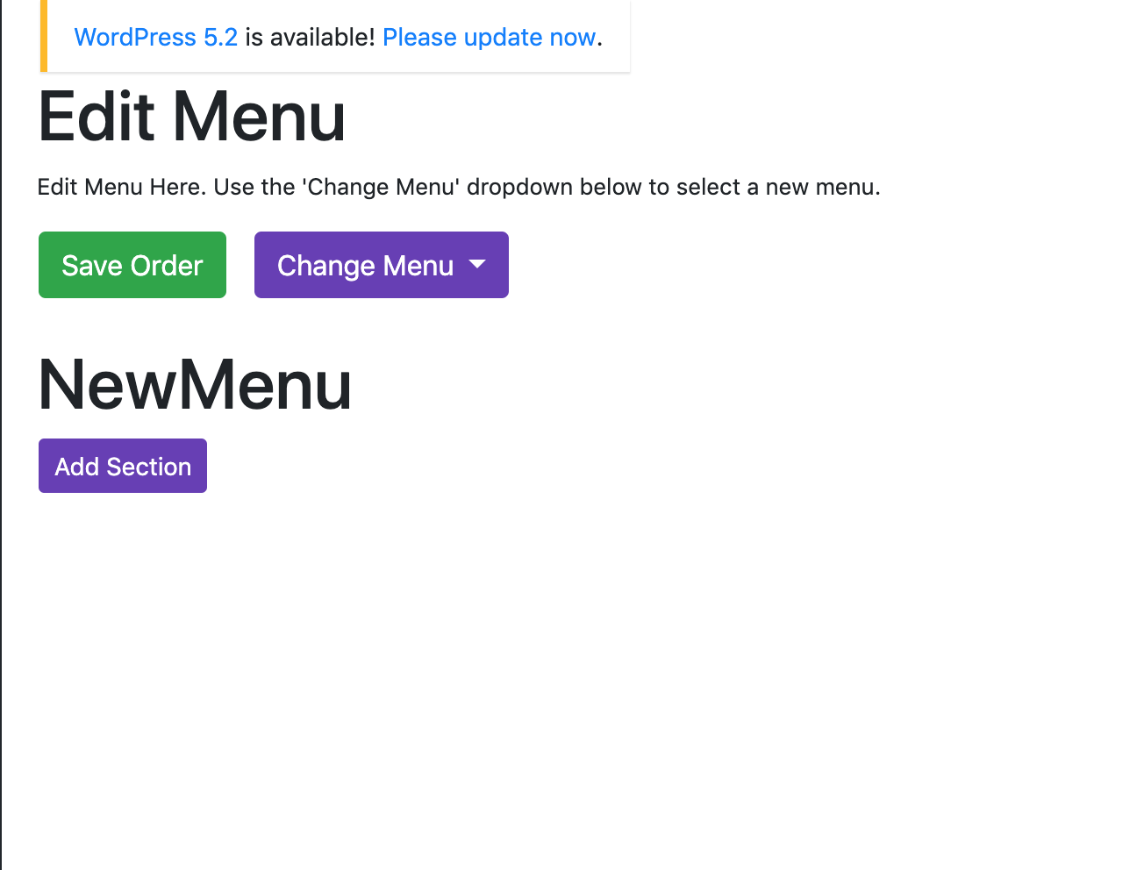

Click the purple ‘Add Section’ button. You should see this:

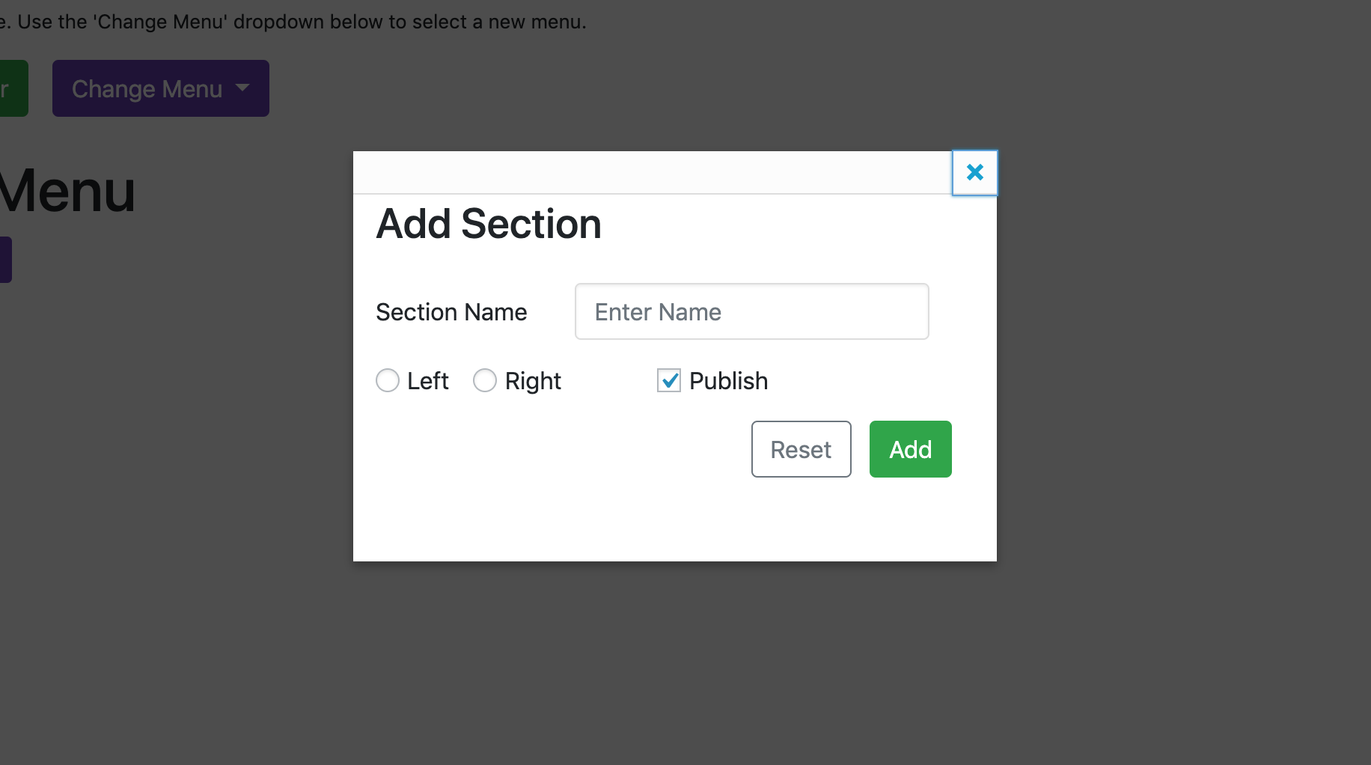

Enter a section name, select which side you want the section to appear on, and decide whether you want to publish it. Click ‘Add’.

For example, I will create a section called ‘NewSection’, and put it on the left side.

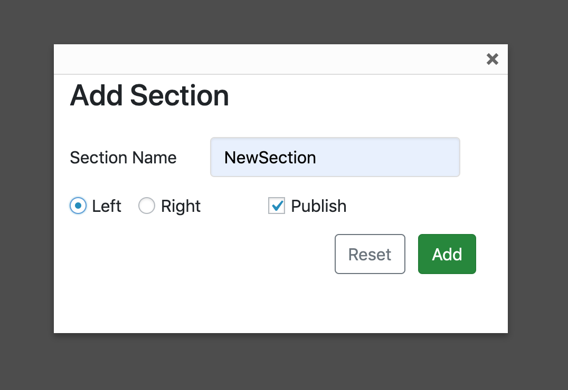

*By default, sections will be on the left side. The menu functionality has been created with the idea that main food dishes are on the left (starters, mains, etc) and ‘extras’ are on the right (sides, coffee, event prices). However, you can put whatever you like on either side.*

The NewSection should appear on the page now:

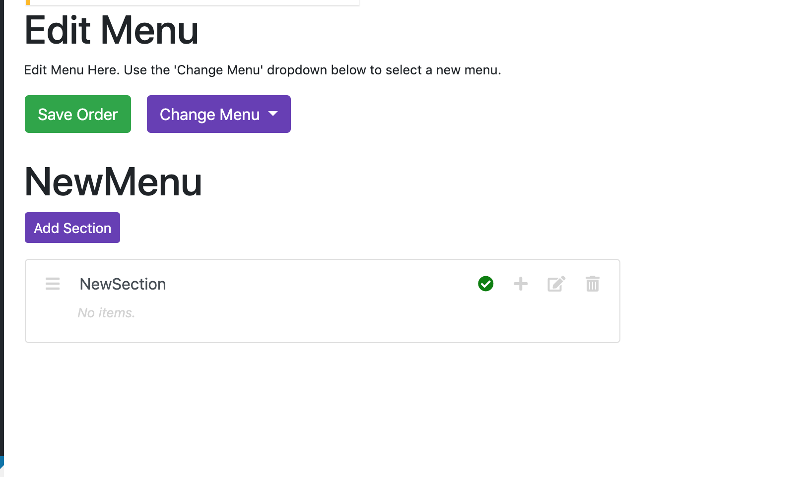

### Adding to the Right Side

Adding to the right-hand side of the menu is exactly the same as adding to the left, we just need to make sure we tick ‘Right’ instead of ‘Left’ in the ‘Add Section’ form.

Click the purple ‘Add Section’ button again and fill out the form as desired. **Make sure you tick ‘Right’ instead of left.**

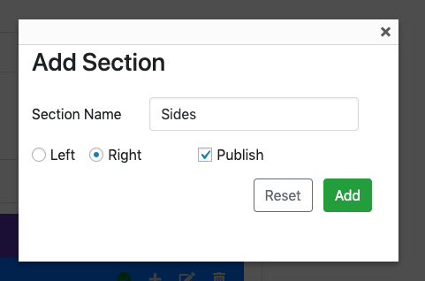

Click ‘Add’. You should now see your newly added section on the right side of the screen:

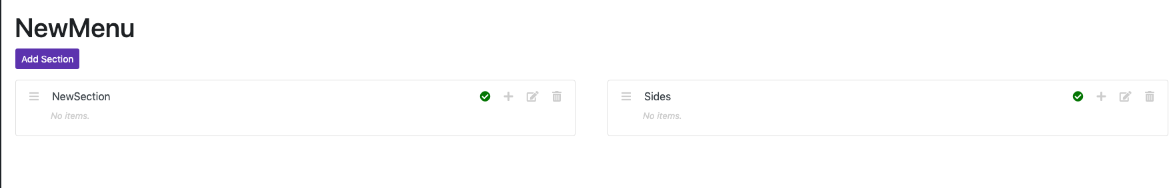

## Add Item

You now have 3 options:

1. Create a **FOOD** item
2. Create a **SUBTITLE** item
3. Create a **NOTE** item

Below are detailed instructions on each.

### Food Item

Food items are normal dishes on the menu. They appear like so on the website:

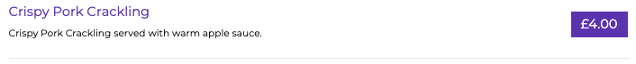

You’ll notice that there is a + symbol on any section:

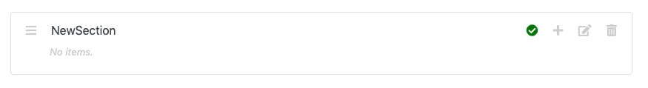

If you hover your mouse over this icon, it *should* display ‘Add Item’, like so:

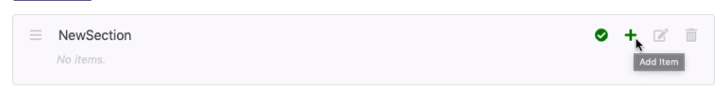

Click this icon. It should display this screen:

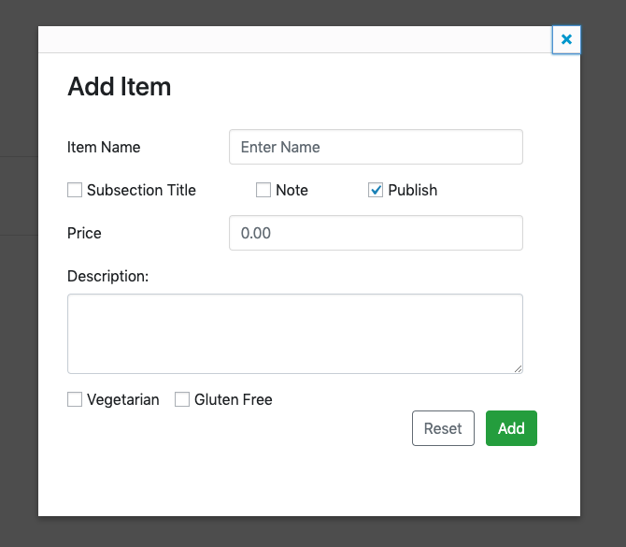

Enter an item name, a price for the item, a description for the item and tick whether or not it is vegetarian and / or gluten free. Like so:

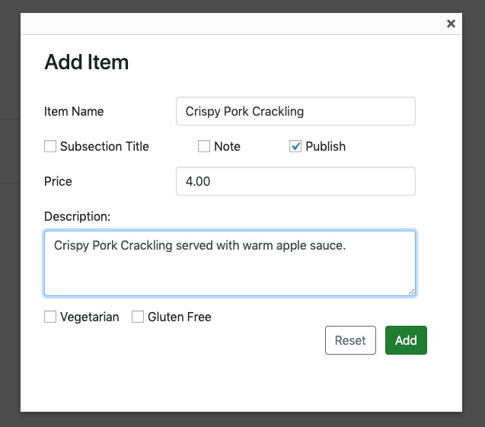

We’re creating a ‘Crispy Pork Crackling’ item.

Click ‘Add’. The item should then show up within that section:

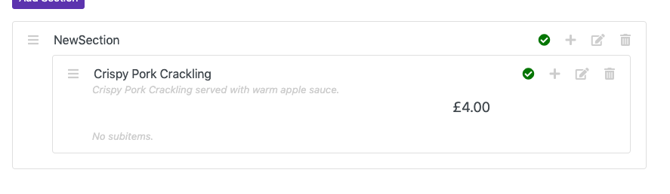

### Subtitle Item

Subtitle items can be used to split sections up. Currently, they are used within the ‘mains’ section to separate out ‘Pasta’, ‘From the Sea’, etc. They appear like this on the website menu:



You’ll notice that there is a + symbol on any section:



If you hover your mouse over this icon, it *should* display ‘Add Item’, like so:



Click this icon. It should display this screen:



Tick ‘Subsection Title’ and you should now see this:

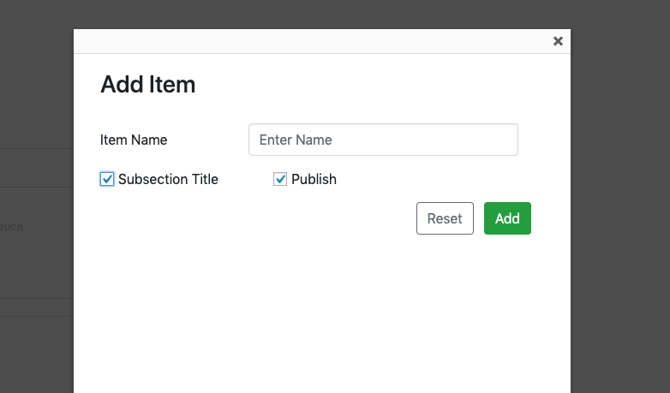

Everything else is removed, as we don’t need anything else for a subtitle.

Enter a name for the subtitle:

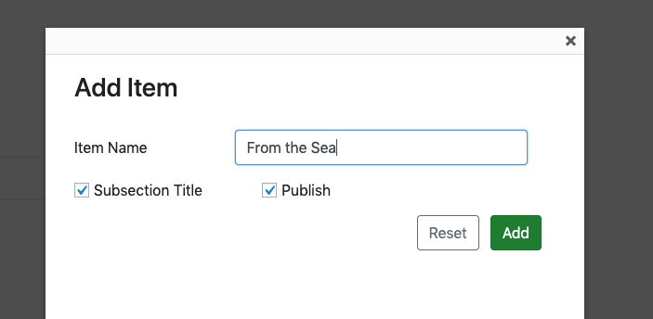

Click ‘Add’. You should see the item appear in the list, with a purple background:

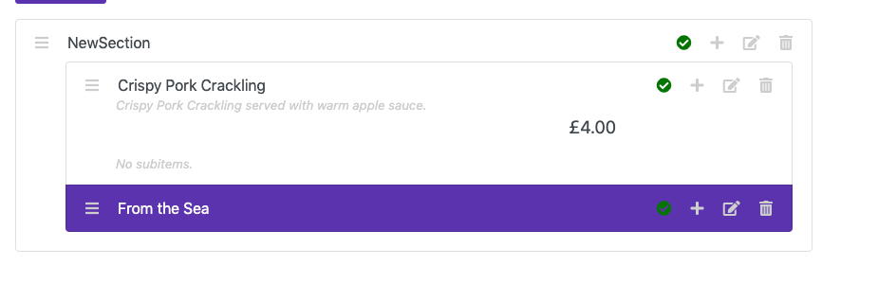

The purple background is to show that it is a subtitle.

### Note Item

Note items are used to give additional information. They appear like this on the website menu:



You’ll notice that there is a + symbol on any section:



If you hover your mouse over this icon, it *should* display ‘Add Item’, like so:



Click this icon. It should display this screen:



Tick ‘Note’, and you should now see this:

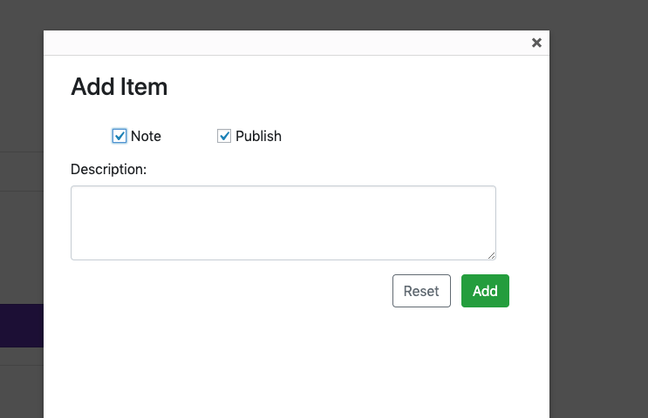

Everything else is removed, as we don’t need anything else for a note.

Enter your note:

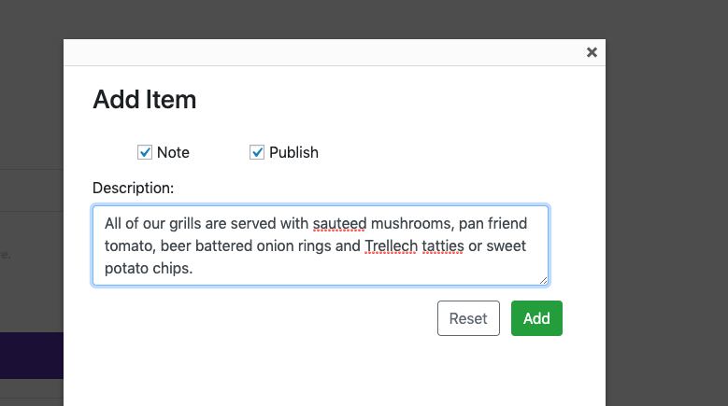

Click ‘Add’. You should see the note appear in the list, with a blue background:

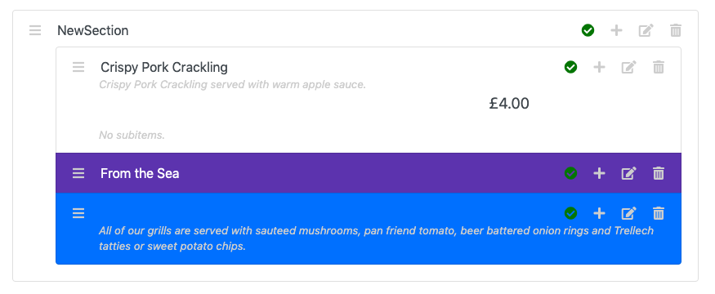

The blue background is to show that it is a note.

### How These Look on the Website

Based off of what we’ve added in the previous 3 sections, it will look like this on the actual site:

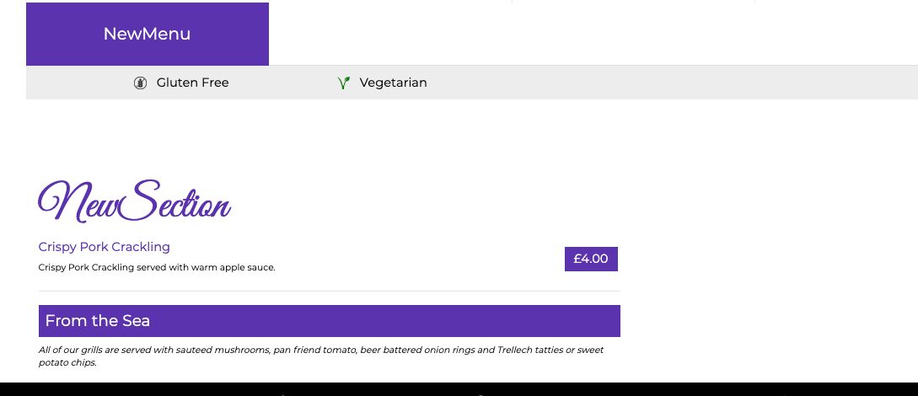

## Add Subitem

Subitems provide optional extras for dishes. If there is no monetary difference, or something isn’t optional, it can be added in the description of an item.

For example, apple sauce comes with Crispy Pork Crackling, but we have added it in the description rather than adding a new subitem for it, because it’s part of the dish, rather than being an optional extra:

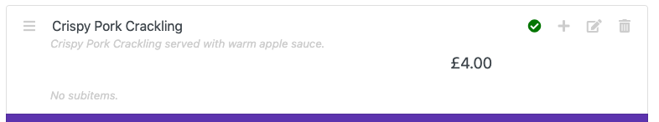

As you can see, it says ‘No subitems’.

Subitems are optional extras, like ‘Cheese’ or ‘Cajun Spice’ for chips or tatties.

Adding a subitem is very similar to adding an item. We use the + icon, but on a FOOD item, rather than a section:

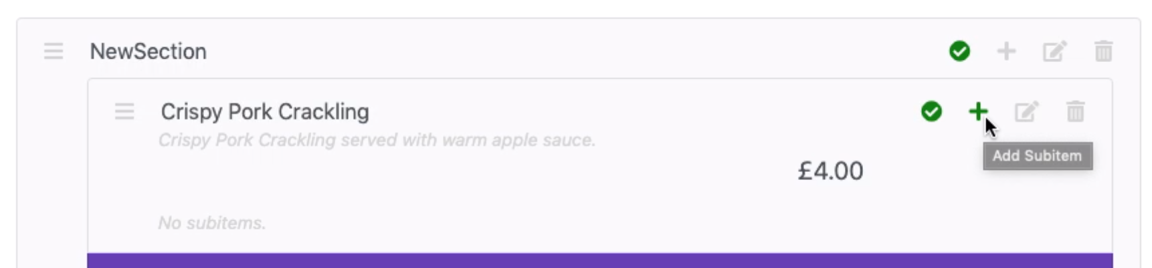

When you hover over it, it should say ‘Add Subitem’. Click this icon and you should see this:

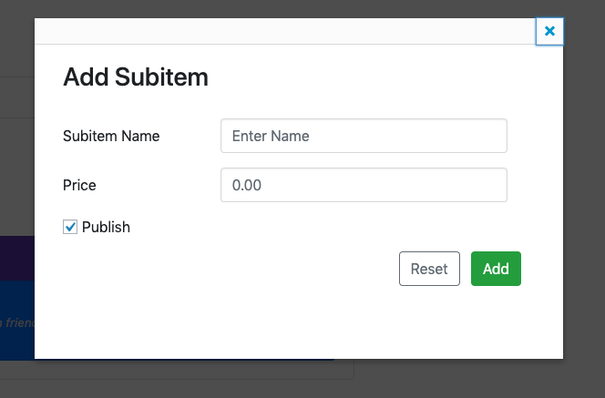

Enter a subitem name and price for the subitem:

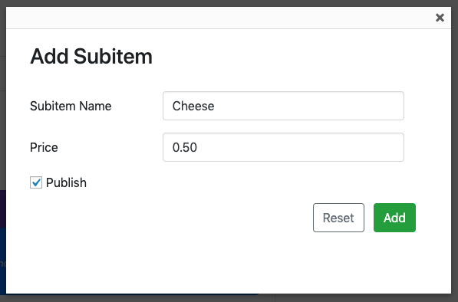

*For items under £1.00, make sure you enter them as 0.50. Otherwise, they may be set to £50.00.*

Click ‘Add’. The subitem should have been added to that item:

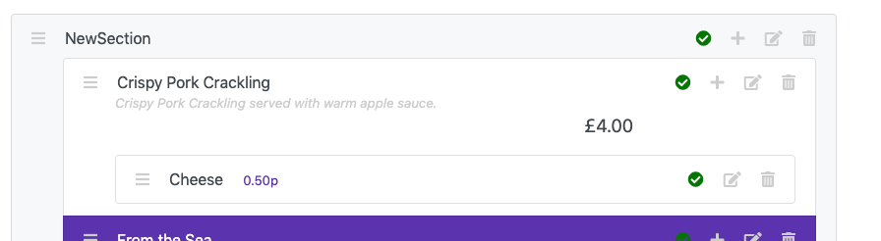

# EDITING

## Edit Menu

Click ‘Menu’ on the left-side bar to bring up the list of menus:

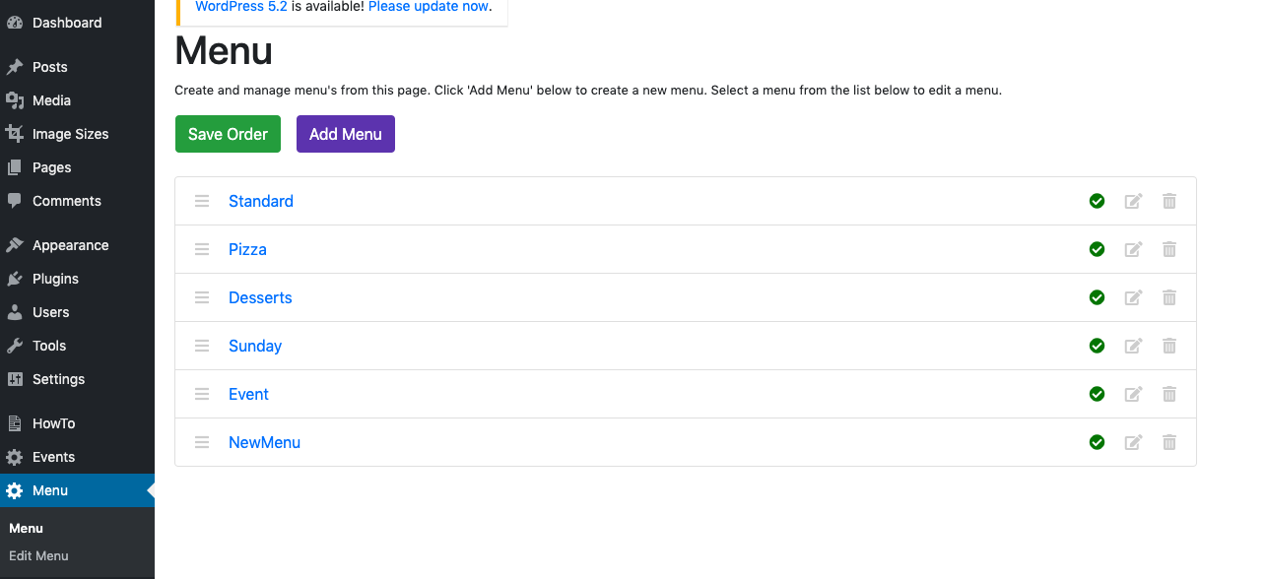

The only ‘menu editing’ that you can do from here, is editing a menu’s name, and whether or not it is published.

If you hover your mouse over *this* icon, you will see ‘Edit’:

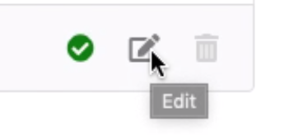

Click this icon, and you should see this screen:

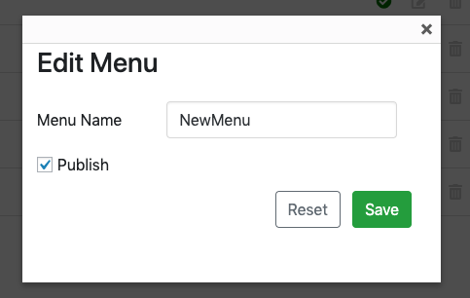

*The Menu Name field will be replaced with the name of whatever menu you have clicked on.*

Change the name to something different:

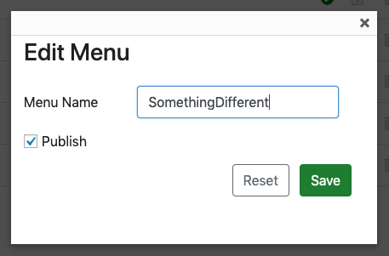

Click ‘Save’. You will now see the name changed in the list of menus:

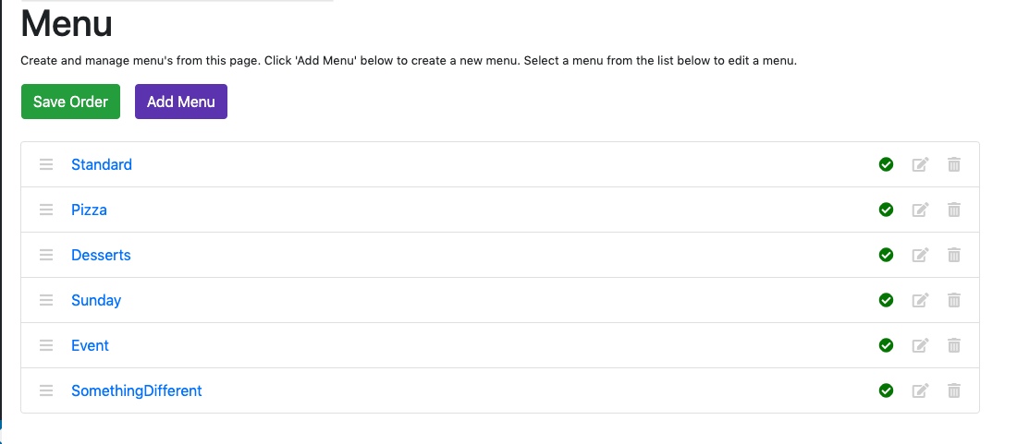

And on the actual website, it will have changed to something like this:

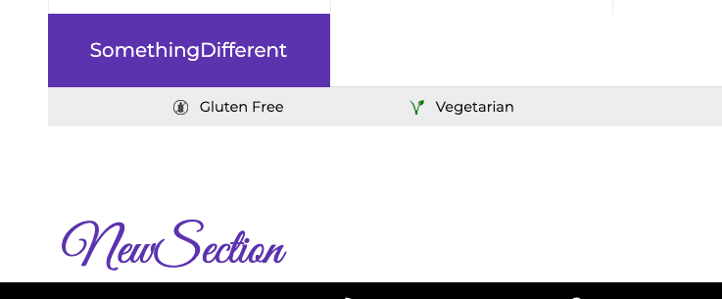

## Edit Section

Editing a section is very similar.

Click a menu from the list:



We should now be on the Edit Menu screen:

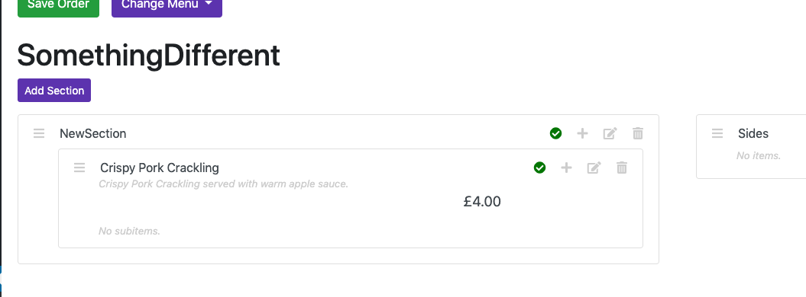

To edit any section on a menu, click the ‘Edit’ icon. You should now see this:

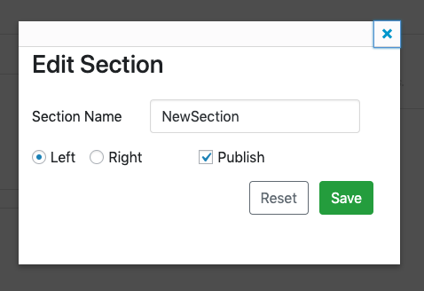

From here you can:

* Change the name
* Change which side it appears on
* Change whether or not it is published

For example, let’s change the name to DifferentSectionName, change it to the right-hand side, and not publish it:

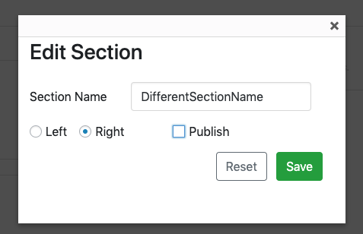

Click ‘Save’ and you should see something like this:

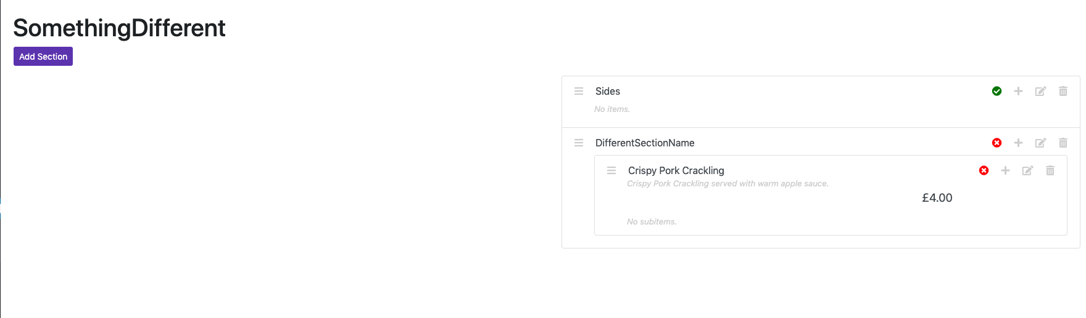

Note the changed section name, the right-hand side and the not published icon now.

*You will notice that Crispy Pork Crackling is also showing the not published icon. If you make a section not published, it’s items will also not be published. Similarly, making a menu not published will make its sections and items not published. The same applies for items and subitems.*

## Edit Item

Editing an item is similar to editing a section or menu.

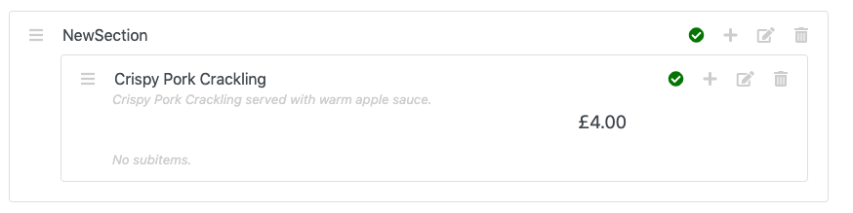

Click the ‘Edit’ icon. You should then see something like this:

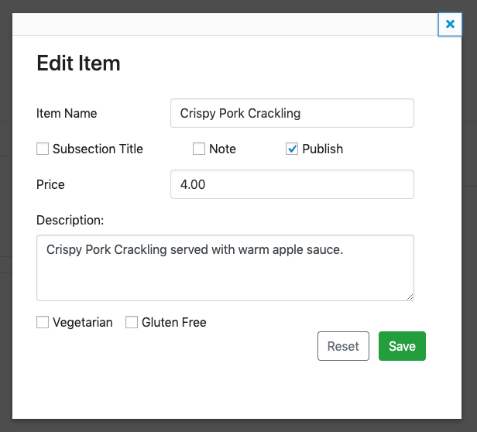

This looks very similar to ‘Add Item’ form. From here you can:

* Change the item name
* Turn the item into a subtitle
* Turn it into a note
* Publish / Unpublish it
* Change its price
* Change its description
* Change it vegetarian / gluten free status.

For example:

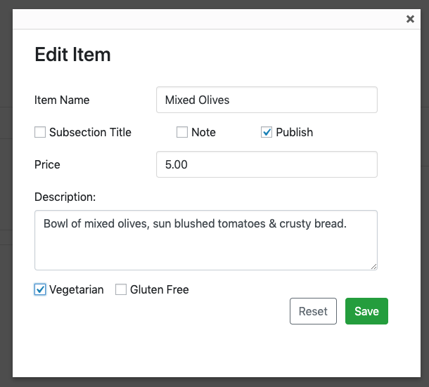

Click ‘Save’. You should the changes reflected in the list:

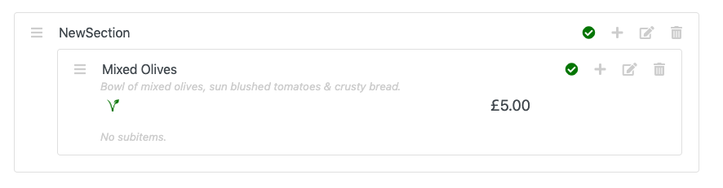

*Notice that as we selected ‘Vegetarian’, we can see the vegetarian icon.*

## Edit Subitem

Editing a subitem is also similar to the others.

Say we’ve got a Sides section, with a Chips item, which has the option for a Cheese subitem:

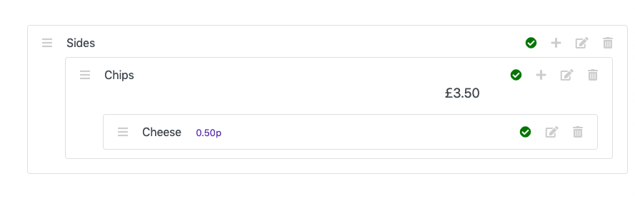

Click the ‘Edit’ icon for the Cheese subitem. You should then see something like this:

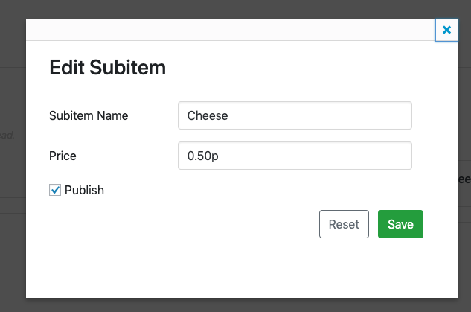

From here you can:

* Change the subitem name
* Change its price
* Change whether or not it is published

For example:

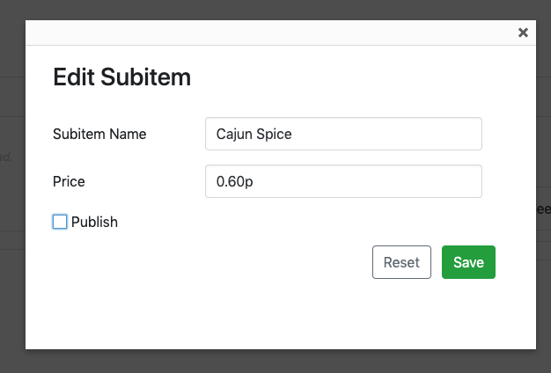

Click ‘Save’. You should then see these changes reflected in the list:

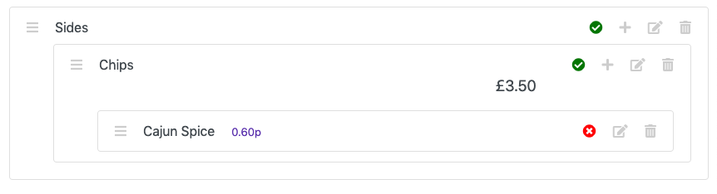

# DELETING

## Delete Menu

## Delete Section

## Delete Item

## Delete Subitem

# REORDERING

## Reordering Menu’s

## Reordering Menu Content (Sections, Items & Subitems)