### Food Item

Food items are normal dishes on the menu. They appear like so on the website:

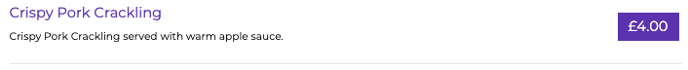

You’ll notice that there is a + symbol on any section:

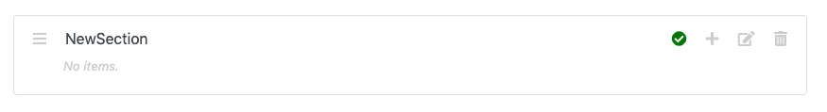

If you hover your mouse over this icon, it *should* display ‘Add Item’, like so:

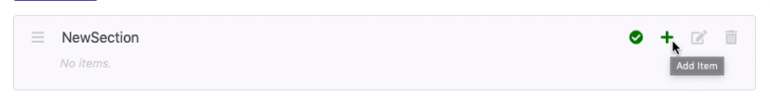

Click this icon. It should display this screen:

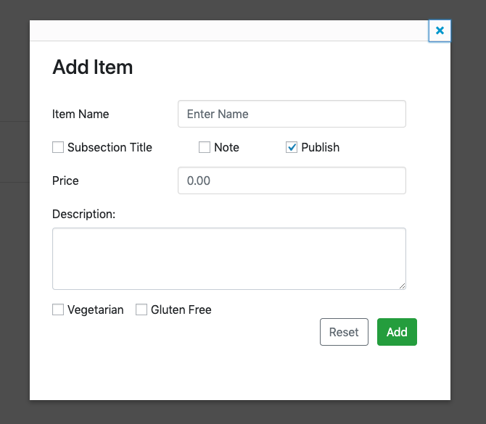

Enter an item name, a price for the item, a description for the item and tick whether or not it is vegetarian and / or gluten free. Like so:

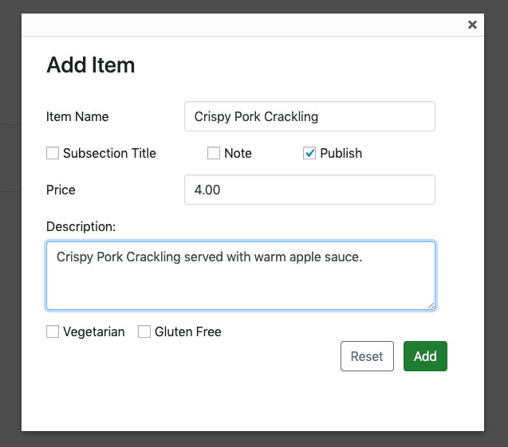

We’re creating a ‘Crispy Pork Crackling’ item.

Click ‘Add’. The item should then show up within that section:

