### How These Look on the Website

Based off of what we’ve added in the previous 3 sections, it will look like this on the actual site:

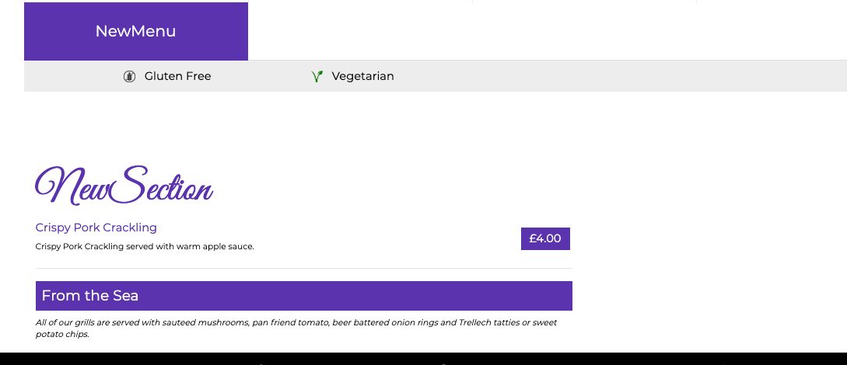

The **FOOD** item:



The **SUBTITLE** item:



The **NOTE** item:

