### Note Item

Note items are used to give additional information. They appear like this on the website menu:



You’ll notice that there is a + symbol on any section:

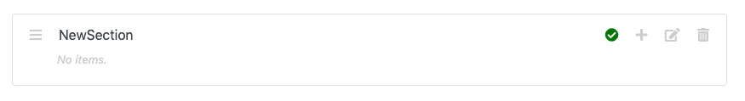

If you hover your mouse over this icon, it *should* display ‘Add Item’, like so:

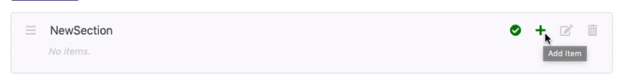

Click this icon. It should display this screen:

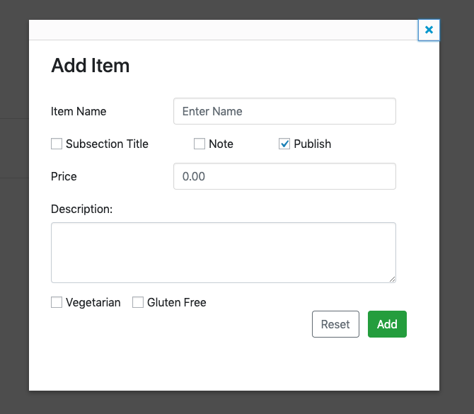

Tick ‘Note’, and you should now see this:

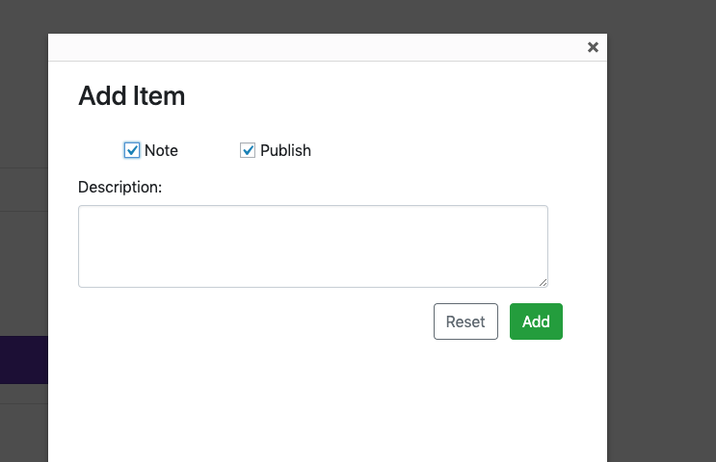

Everything else is removed, as we don’t need anything else for a note.

Enter your note:

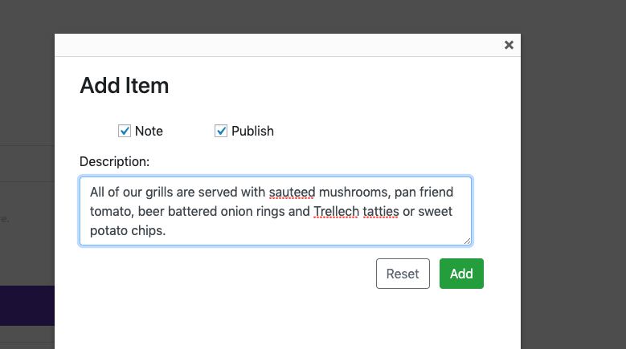

Click ‘Add’. You should see the note appear in the list, with a blue background:

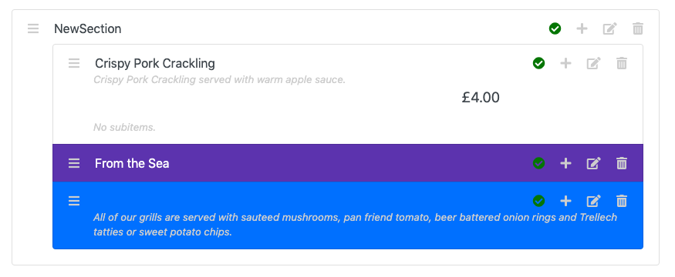

The blue background is to show that it is a note.