### Subtitle Item

Subtitle items can be used to split sections up. Currently, they are used within the ‘mains’ section to separate out ‘Pasta’, ‘From the Sea’, etc. They appear like this on the website menu:



You’ll notice that there is a + symbol on any section:

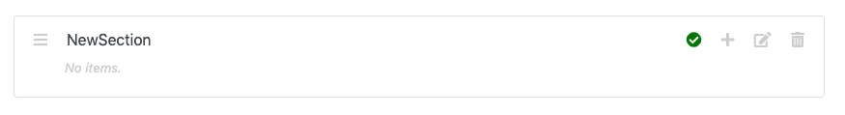

If you hover your mouse over this icon, it *should* display ‘Add Item’, like so:

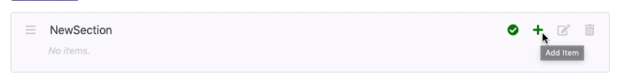

Click this icon. It should display this screen:

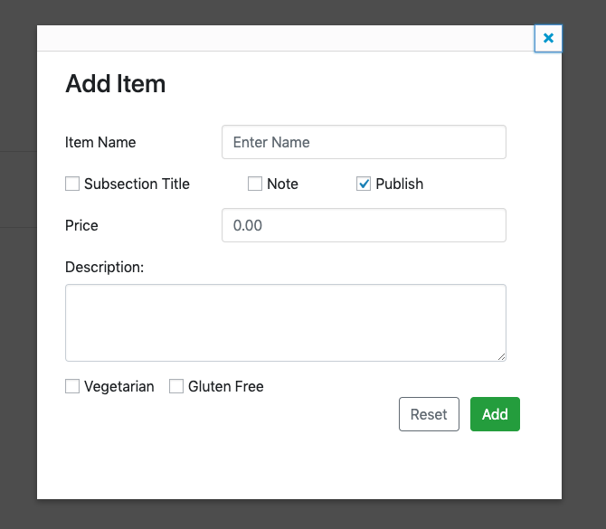

Tick ‘Subsection Title’ and you should now see this:

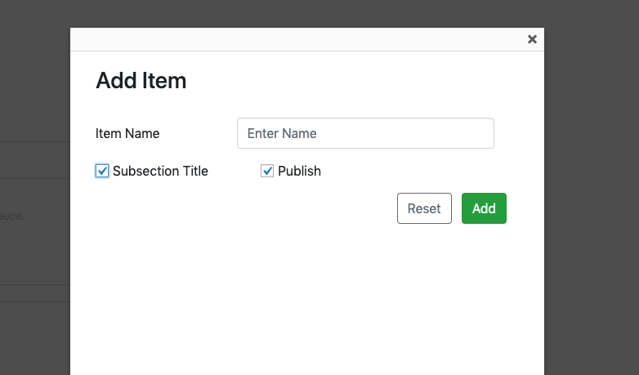

Everything else is removed, as we don’t need anything else for a subtitle.

Enter a name for the subtitle:

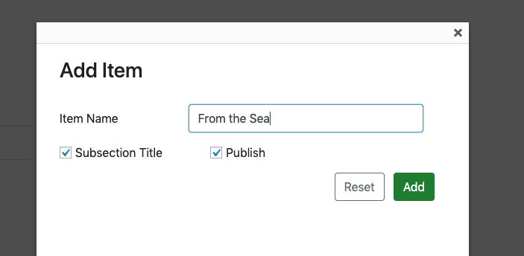

Click ‘Add’. You should see the item appear in the list, with a purple background:

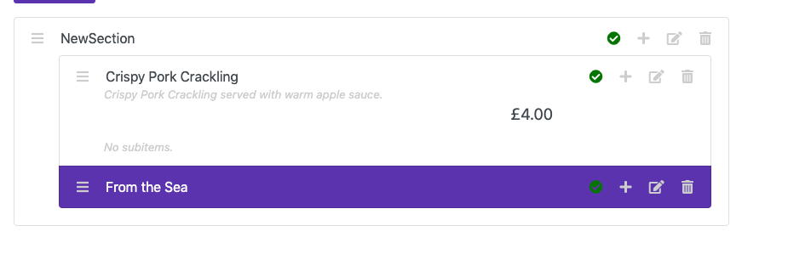

The purple background is to show that it is a subtitle.