## Add Menu

To create a new a menu, click ‘Menu’ on the left-side bar so that we are on this page:

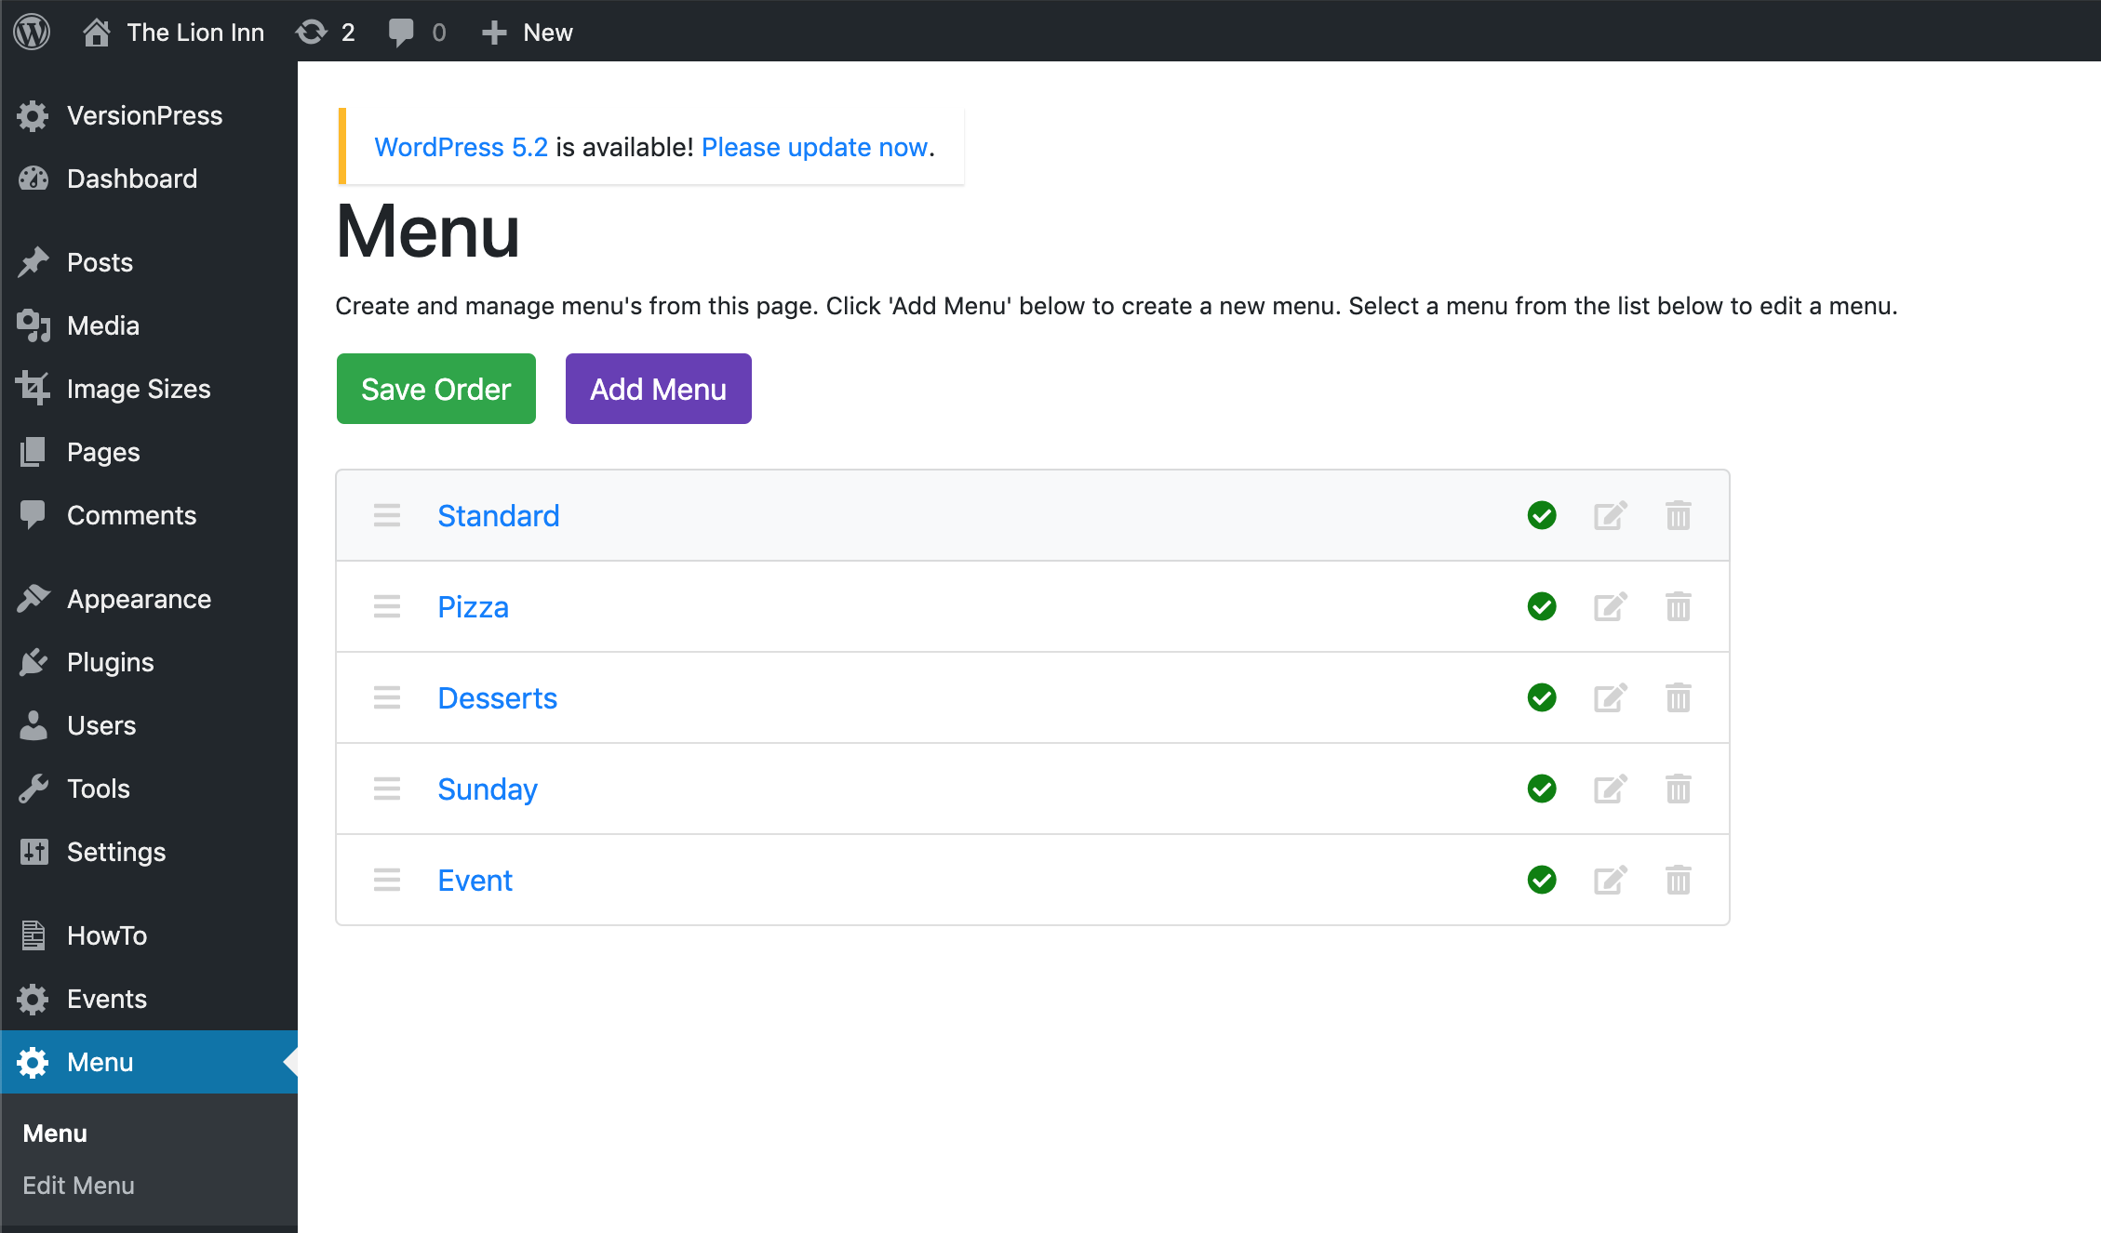

Click the purple ‘Add Menu’ button. You should then see this:

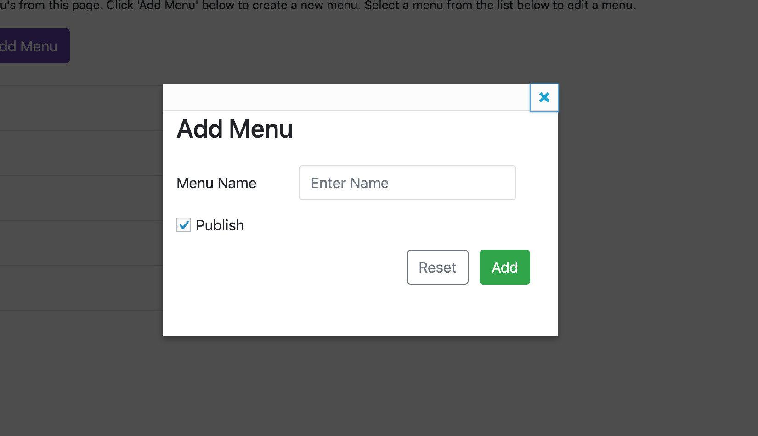

Enter a menu name and untick ‘Publish’ if you don’t want it to be seen on the site. Click ‘Add’. You should then see the new menu in the list.

For example, I will create a new menu called ‘NewMenu’:

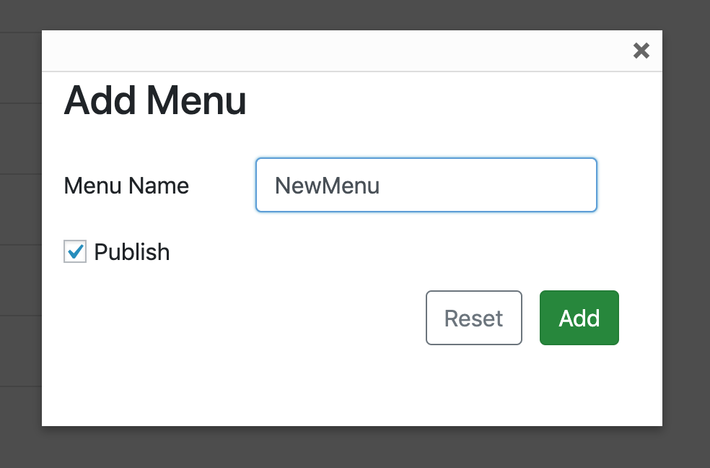

Click ‘Add’.

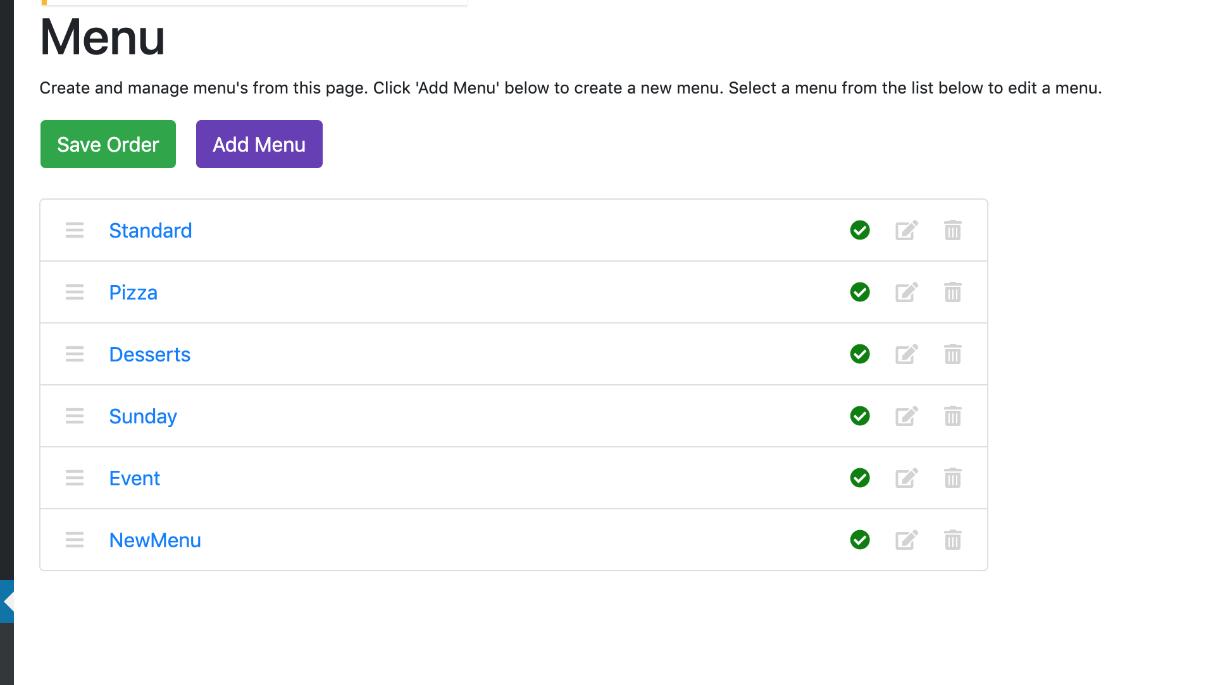

We can now see ‘NewMenu’ in the list above.