### Adding to the Right Side

Adding to the right-hand side of the menu is exactly the same as adding to the left, we just need to make sure we tick ‘Right’ instead of ‘Left’ in the ‘Add Section’ form.

Click the purple ‘Add Section’ button again and fill out the form as desired. **Make sure you tick ‘Right’ instead of left.**

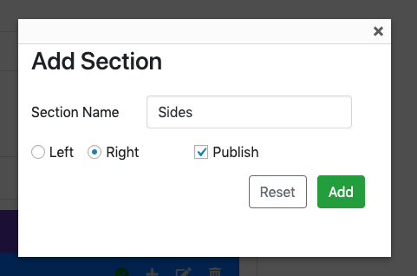

Click ‘Add’. You should now see your newly added section on the right side of the screen:

