## Add Section

Creating a new menu section is very similar to creating a new menu.

Select a menu from the list of menus. For the sake of continuity, we’ll use the ‘NewMenu’ created in the previous section (but you can and will need to add new sections to other menus).

You should be on the ‘Edit Menu’ page, once you have selected a menu.

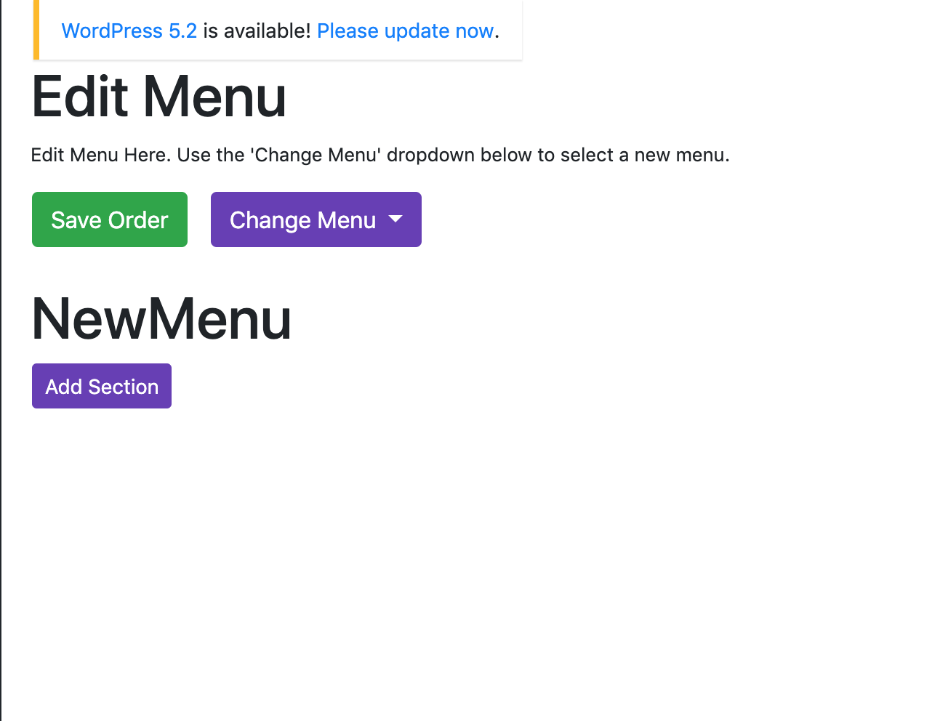

Click the purple ‘Add Section’ button. You should see this:

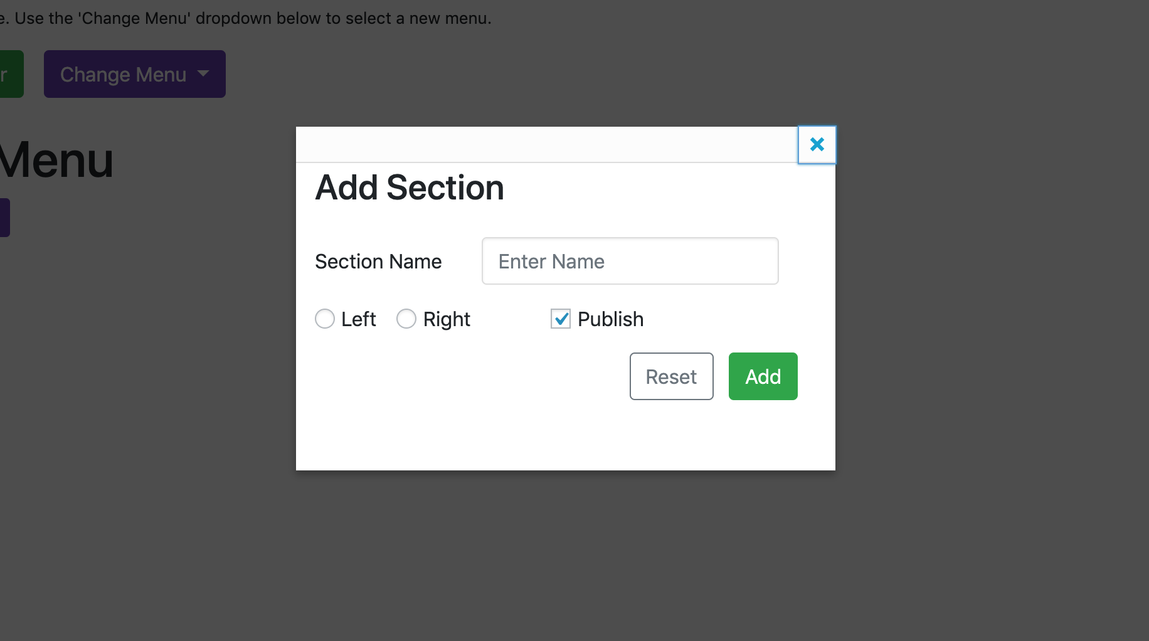

Enter a section name, select which side you want the section to appear on, and decide whether you want to publish it. Click ‘Add’.

For example, I will create a section called ‘NewSection’, and put it on the left side.

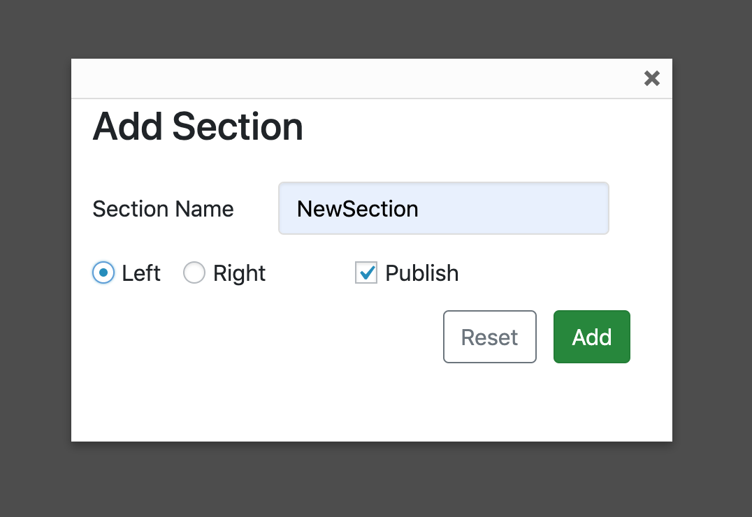

*By default, sections will be on the left side. The menu functionality has been created with the idea that main food dishes are on the left (starters, mains, etc) and ‘extras’ are on the right (sides, coffee, event prices). However, you can put whatever you like on either side.*

The NewSection should appear on the page now:

