## Add Subitem

Subitems provide optional extras for dishes. If there is no monetary difference, or something isn’t optional, it can be added in the description of an item.

For example, apple sauce comes with Crispy Pork Crackling, but we have added it in the description rather than adding a new subitem for it, because it’s part of the dish, rather than being an optional extra:

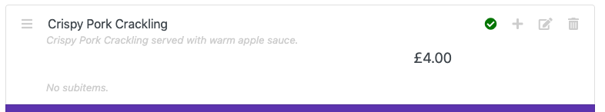

As you can see, it says ‘No subitems’.

Subitems are optional extras, like ‘Cheese’ or ‘Cajun Spice’ for chips or tatties.

Adding a subitem is very similar to adding an item. We use the + icon, but on a FOOD item, rather than a section:

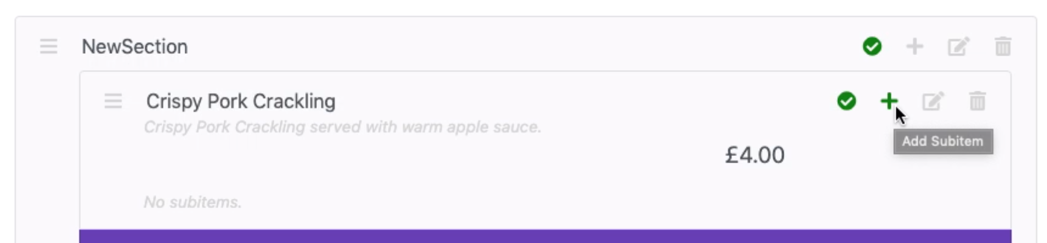

When you hover over it, it should say ‘Add Subitem’. Click this icon and you should see this:

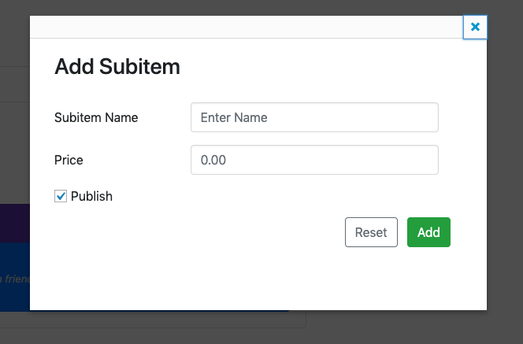

Enter a subitem name and price for the subitem:

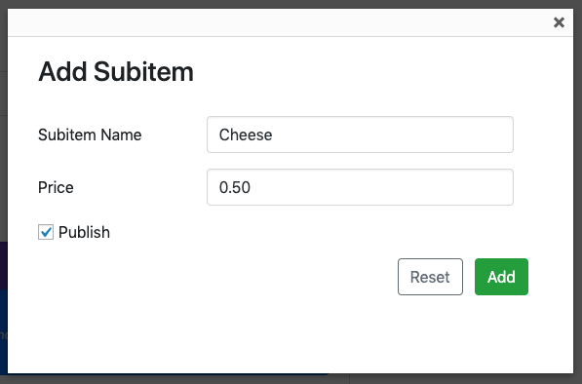

*For items under £1.00, make sure you enter them as 0.50. Otherwise, they may be set to £50.00.*

Click ‘Add’. The subitem should have been added to that item:

